
Name : Maryum Nasim
Reg no: FA24B1-SE-082
Assignment 01

Section: B
Course: Cloud Computing

Topic: Git, Gitea, GitHub, Git LFS, and GitHub Pages

1. Task 1 – Gitea

1.1 Gitea Installation
Ubuntu Server was used as the working environment, where Docker and Docker Compose were installed and configured. The Gitea and PostgreSQL containers were launched, and their running status was checked to ensure both services were working properly. Gitea was tested through a local HTTP request and accessed using the Ubuntu server’s IP address. PostgreSQL was configured as the database for Gitea, and the installation process was completed successfully by creating an administrator account.
Figure 1 – Gitea running on Ubuntu Server

1.2 Push Repository to Gitea
A public repository named Assignment01 was created on Gitea, and a local Git repository was set up on Ubuntu. The repository was initialized using the main branch, and a README.md file was created containing the full name and registration number. After committing the README file, Gitea was added as a remote repository under the name gitea. Finally, the main branch was successfully pushed to the Gitea repository.

Figure 2 – Successful push to Gitea
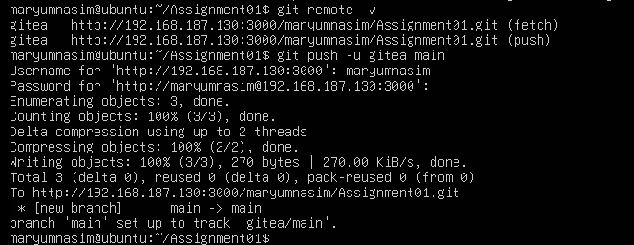

1.3 Gitea Repository Verification
The Assignment01 repository was opened in Gitea to verify its details and contents. The repository name and owner were checked, and its public visibility was confirmed. The README.md file was also reviewed to ensure that it was available and contained the required student information, including the full name and registration number.

Figure 3 – Gitea Assignment01 repository
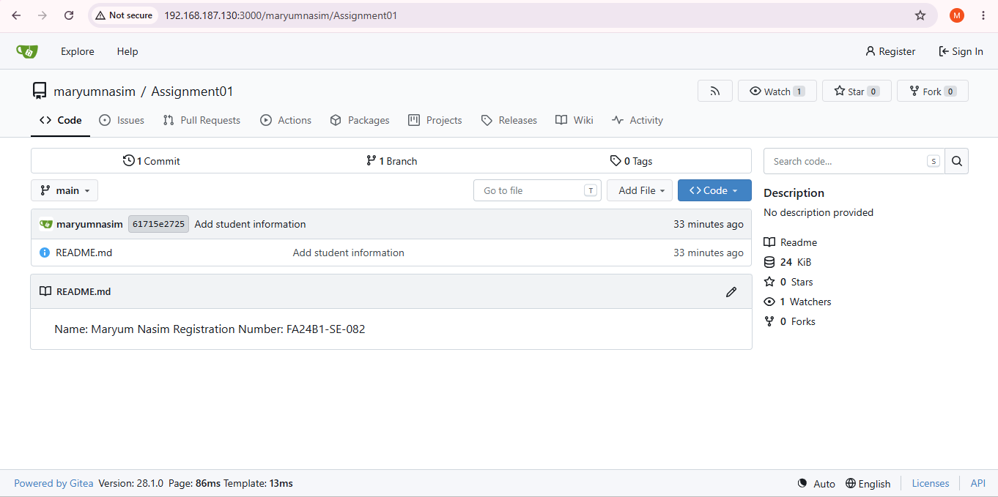

2. Task 2 – GitHub

2.1 Configure Git Remotes
Created a public GitHub repository named Assignment01. Used the same local repository from Task 1. Added GitHub as a second remote named github. Verified both remotes using git remote -v. The repository now had: gitea remote ,github remote

Figure 4 – Gitea and GitHub remotes
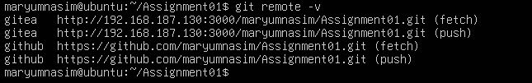

2.2 Push to GitHub
Pushed the main branch to GitHub. GitHub authentication was completed successfully. Push completed without errors.

Figure 5 – Successful GitHub push
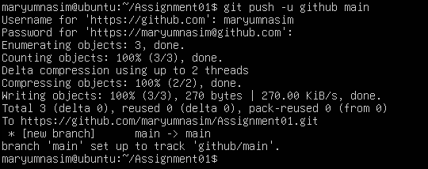

2.3 GitHub Repository Verification
Opened the GitHub Assignment01 repository.
Verified:
  - Repository name
  - Owner
  - Public visibility
  - README file
  - Student information

Figure 6 – GitHub Assignment01 repository

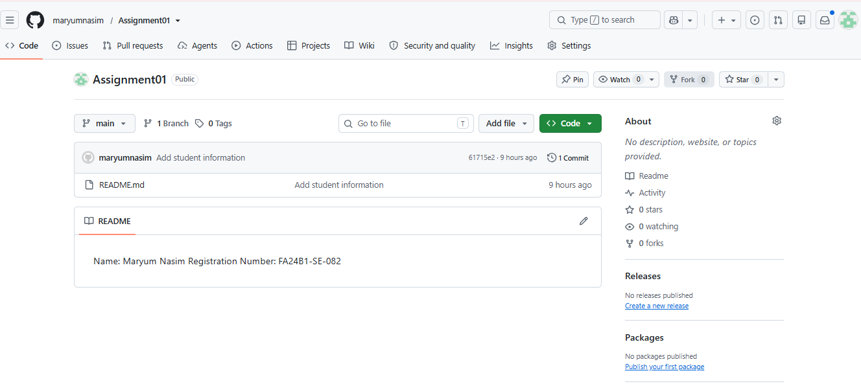

Result
The same local repository was successfully pushed to both Gitea and GitHub.

3. Task 3 – Git LFS

3.1 Git LFS Setup
Initialized Git LFS in the Assignment01 repository.
Verified the installed Git LFS version.
Configured .bin files to be tracked using Git LFS.
Verified the .gitattributes file.

Figure 7 – Git LFS setup
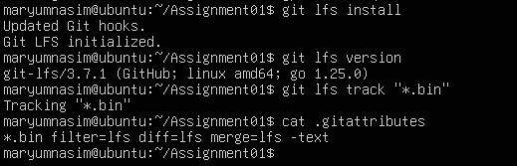

Large File Creation
Created three binary files:
large-file-1.bin – 101 MiB
large-file-2.bin – 102 MiB large-file-3.bin – 103 MiB
Added the files to Git.
Verified that all three files were tracked by Git LFS.

Figure 8 – Git LFS tracked files
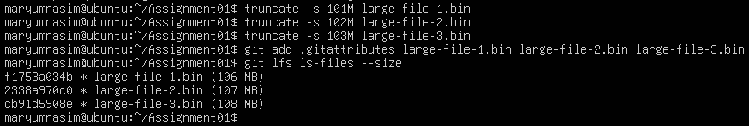

3.3 Git LFS Push
Committed the three large files.
Pushed the commit to GitHub.
Git LFS uploaded the large file objects successfully.
Push completed successfully.

Figure 9 – Successful Git LFS push
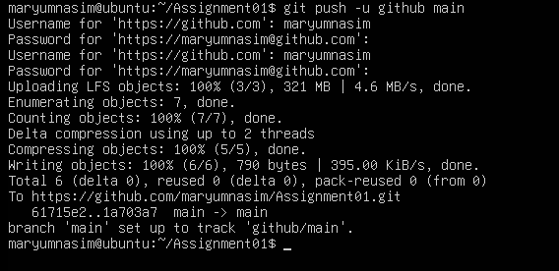

Result
Three files larger than 100 MiB were successfully managed and pushed using Git LFS.

4. Task 4 – GitHub Pages Portfolio

4.1 Portfolio Creation
Created a personal portfolio website using HTML and CSS.
Created the following files: o index.html o styles.css
Added the following sections:
- About Me
- Education
- Skills
- Projects
Used a green, white, and black design.
Created a GitHub repository named salehataj.github.io.
Pushed the portfolio to the main branch.

Figure 10 -Portfolio GitHub repository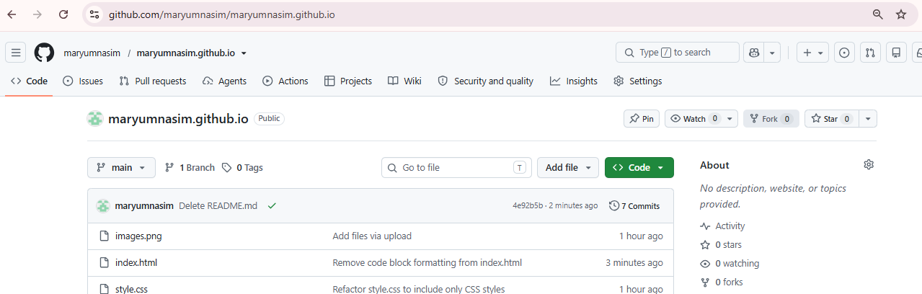

4.2 GitHub Pages Deployment
Opened the repository's Settings → Pages.
Selected deployment from the main branch.
Selected the root directory / (root).
Saved the configuration.
GitHub Pages successfully deployed the website.
Figure -11 GitHub Pages deployment
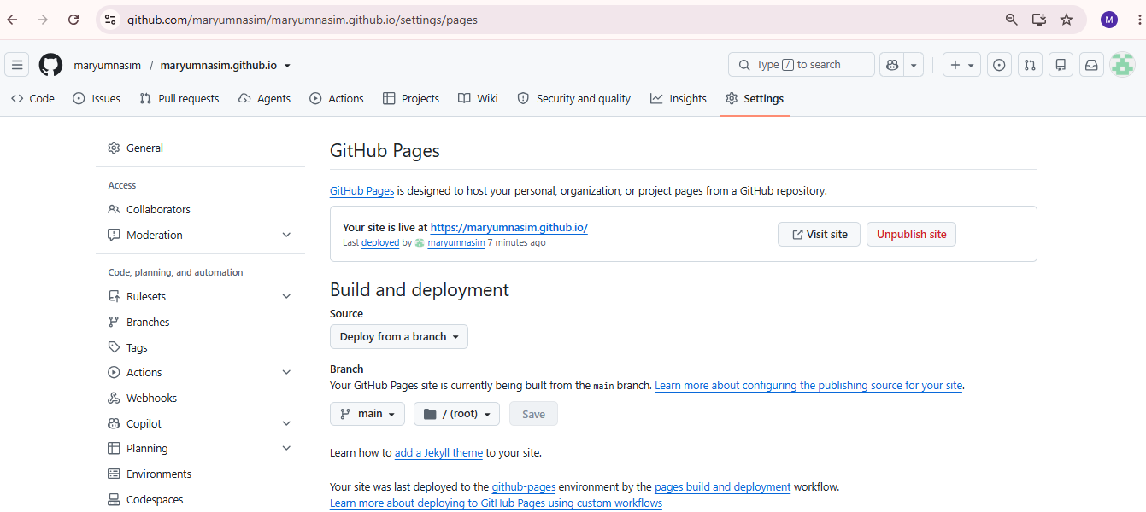

4.3 Live Portfolio
Opened the GitHub Pages URL in the browser.
Verified that the website was publicly accessible.
Confirmed that the portfolio content was displayed correctly.

Figure 12 – Live portfolio website 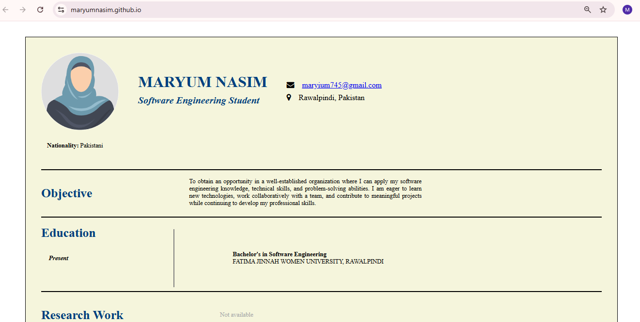

Result
The portfolio website was successfully created and published using GitHub Pages.

