1) Add the __contains__ protocol and show whether or not 'Tim' and 'Sam' are part of our team.

**Please see weekOne.py**

2) Add the __iter__ protocol and show how you can print each member of the classmates object.

**Please see weekOne.py**

3) Determine if the class classmates implements the __len__ method.

**Yes, the class classmates implements the __len__ method. I tried to comment out the whole function/method, and it returns an error. Meaning, the class is using the method to print the len method.**

4) Explain the difference between interfaces and implementation.

**We could think about it like a black box that processes certain data from an input and provides output. The user perspective in an interface is that he could see the input and the output and perhaps the label about the processes being made inside the said black box. The implementation, on the other hand, is the thing inside the black box that provides the operations and actual processes to transform the input into its desired or supposed output. The perspective would lie on the actual processes to transform input to output or the processes and procedures behind the black box.**

5) Using both visual and written descriptions, think through the interface-implementation of a large scale storage system. In many systems today, we have the ability to store information from a single application to a variety of storage devices - local storage (hard drive, usb), the cloud and/or some new medium in the future. How would you design an interface structure such that all of the possible implementations could store data effectively.

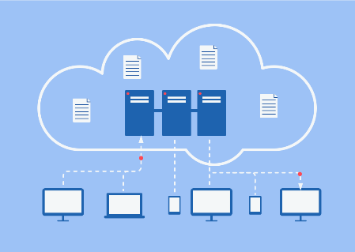**I would design my interface structure as objects and store the data in the cloud so possible implementations could just access objects in the cloud and manipulate them through its attributes and behaviors. In my workplace, our current web-based electronic health record (EHR) is quite new, but you can see significant difference of using object-oriented system with regards to its effectiveness and efficiency, compared to what he had before.**