**Overview**:

Point of Sale System is an app which is being used in store or for online channel to process the checkout of items and process the sale.

**Use Case Diagram:**

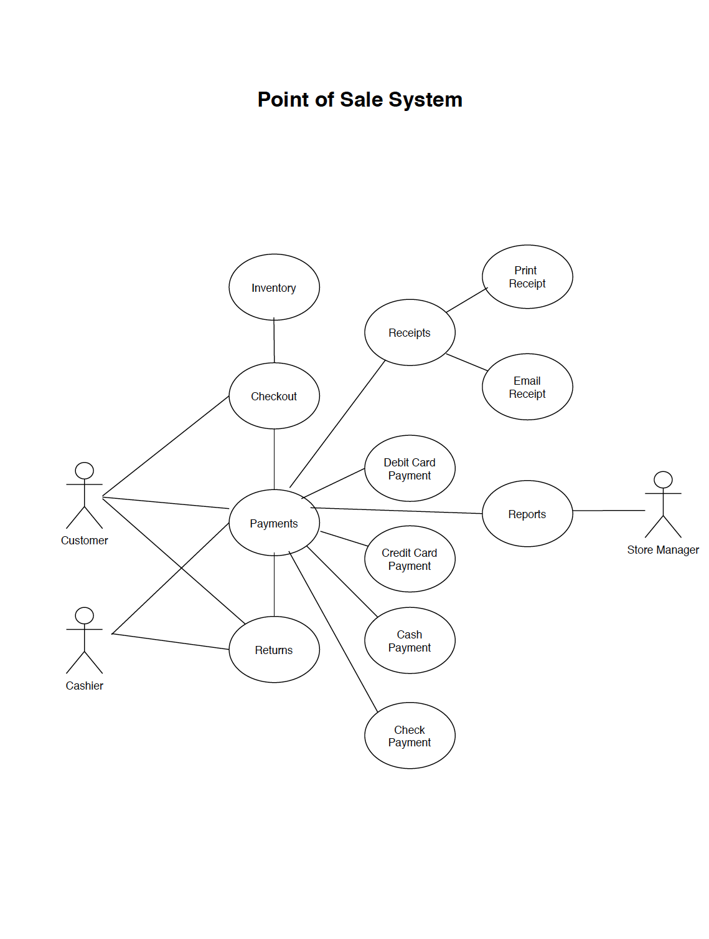

**Actors**:

* **Customer**: This actor represents the person standing in store to check out the items or online user ready to do the check out
* **Cashier**: This actor represents the person standing in store to scan the items and process the in store sale
* Store Manager: This actor represents the person who manages the store and review the reports to make sure enough inventory available in store

**Use Cases:**

1) Online Checkout**:** This use case defines the step for the customer to add item in cart and proceed for checkout online.

2) In Store Checkout: This use case defines the steps for the customer to pick the items from store and add it in cart and proceed for checkout at cashier.

3) Payment: This use case defines the steps to process the payments either by cashier in store or online thru payment gateway

4) Returns: This use case defines the steps to process the refund of an item and return the payment back to user preferred payment option

5) Reports: This use case defines the steps to check the Inventory and Sales Report etc by Store manager.

6) Receipts: This use case defines the steps to generate the paper receipt or send over email.