1. Google Maps

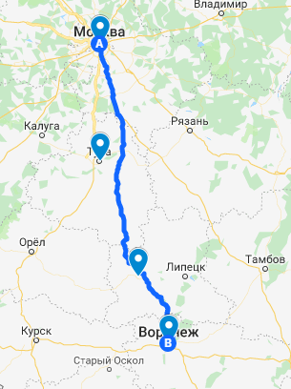

<https://drive.google.com/open?id=1iIfiIpSumWXatGPk87mH6uUq8Z8a3ZyX&usp=sharing>

1. Data Wrapper

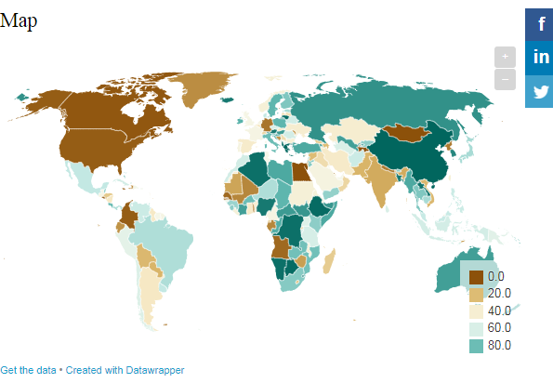

1. GeoJSon

