**Objective**

The primary objective of our project was to develop a deep learning model to predict the outcomes of work visa application, specifically forecasting the number of visas that would be awarded ("Certified") versus those that would be denied. To achieve this, we utilized eight input features: RECEIVED_DATE, DECISION_DATE, EMPLOYER_STATE_PROVINCE, EMPLOYER_CITY, WORKSITE_STATE, WORKSITE_CITY, COUNTRY_OF_CITIZENSHIP, and EMPLOYER_NUM_EMPLOYEES. These features were selected to capture temporal aspects, geographical locations of both employers and worksites, applicant nationality, and employer size, all of which are relevant factors in visa decision-making. The outcome labels were created by transforming the CASE_STATUS column into a binary flag, where a value of 1 indicates a "Certified" status (visa awarded) and 0 represents all other statuses (visa denied). Additionally, we engineered the CASE_APPROVAL_LENGTH feature by calculating the number of days between RECEIVED_DATE and DECISION_DATE to incorporate processing time into the model. This structured approach allowed us to effectively train and evaluate the deep learning model, providing insights into the key determinants of visa approvals and denials.

**Key Findings and Results**

Our deep learning model demonstrated strong predictive performance in distinguishing between certified and denied visa cases, achieving an overall accuracy approaching 98% on the validation and test sets. The hyperparameter tuning process, which explored different optimizers, layer configurations, and learning rates, confirmed that the Adam optimizer and a deeper network architecture yielded superior results. Notably, the training and validation accuracy curves aligned closely, as reflected in the final accuracy and loss plots, suggesting that the model generalized effectively to unseen data and avoided overfitting. The final chart, showing accuracy stabilizing at a high level and loss consistently decreasing across epochs, reinforces the conclusion that our chosen hyperparameters, feature set, and optimization strategies led to a robust predictive model.

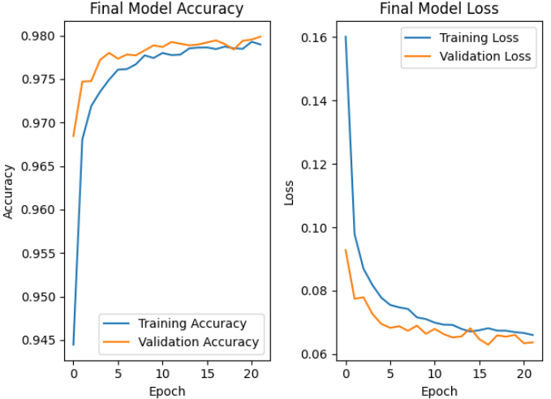

**Insights About Feature Importance**

The SHAP feature importance analysis, as illustrated by the provided summary chart, revealed that time factors play the most critical role in determining visa approval outcomes. Specifically, DECISION_DATE came out as the strongest predictor, with more recent decision dates correlating positively with certification. Similarly, CASE_APPROVAL_LENGTH, representing the time between receiving and deciding the case, showed that longer review periods were often associated with favorable results. RECEIVED_DATE also contributed meaningfully, though its relationship with the final outcome was less straightforward. Beyond time-related variables, EMPLOYER_NUM_EMPLOYEES provided valuable insights, indicating that larger employers tended to secure more approvals. Geographic attributes, including employer and worksite location, ranked next in importance, suggesting regional factors influence visa decisions to a lesser extent. Lastly, COUNTRY_OF_CITIZENSHIP, while still a contributing factor, held minimal sway compared to the other features. Collectively, these findings emphasize that the timing and length of the application process dominate the decision-making landscape, while organizational and geographic features add subtle nuances to the model’s predictions.

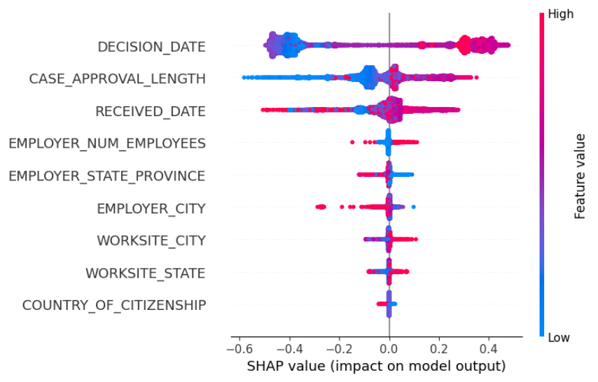

**Challenges and Lessons Learned**

One of the most demanding aspects of this project emerged during the preprocessing stage, where we encountered a high degree of missing values and features that did not apply to all data points. Deciding how to handle these inconsistencies, whether through imputation, dropping certain rows, or restructuring the dataset, was difficult because every solution had some downsides . Furthermore, narrowing the dataset from over a hundred potential features down to just eight was challenging, forcing us to critically evaluate which attributes would have the most predictive power. This project taught us that the modeling phase, while important, is just one component of a successful data prediction project. The bulk of our effort and learning came from the intensive data cleaning, feature selection, and transformation tasks. We gained a deeper appreciation for the critical role that careful preprocessing plays in ensuring that the final model is both accurate and meaningful.

**Implications and Real-World Impact**

The insights derived from the predictive model created from our project have the potential to inform a wide range of stakeholders involved in the visa application and approval process. By understanding which features, such as decision dates, processing lengths, employer size, and geographic factor, most strongly influence outcomes, policymakers and regulatory agencies could refine guidelines or adjust resource allocation to streamline the evaluation of petitions. Employers, too, may leverage these findings to proactively address factors within their control, such as ensuring thorough documentation, optimizing application timing, or strengthening their workforce profiles to increase approval likelihood. Moreover, attorneys and HR professionals could tailor their advice based on data from our model, guiding applicants toward strategies that lead greater results.

**Potential Future Work**

There are several directions for extending and refining this work. Future work could incorporate a broader array of input features, such as industry-specific employment trends, applicant educational backgrounds, or prevailing wage rates, to further enhance the predictive accuracy and robustness of the model. Integrating external data sources, like regional economic indicators or policy changes over time, may make the model more robust to changing political climates. More advanced architectures could be explored by leveraging transformer-based models or attention mechanisms which could help capture more complex relationships and temporal dynamics within the data. Further research into interpretability techniques could offer stakeholders clearer guidance on decision-making processes to ensure the model is both effective and transparent. Lastly, deploying the model as a scalable, user-friendly tool or integrating it into existing decision-support systems would make its benefits accessible to policymakers, employers, and applicants.