**parkwise : smart parking solution**

1. **What is smart parking ?**

It’s a solution designed to help drivers to easily find parking lots, provides contactless payment methods and helps to save time and minimize the traffic that’s caused by people looking for empty parking places.

Users can view a map that overlays street cleaning schedules , open parking spots, the app also lets users keep track of where they parked and notify others when they’re about to leave their space .

**2. parking system’s Functionalities and features**

Smart parking launched SmartCloud after partenering with GoogleCloud IoT Core platform.

This allows a complete solution for connecting , managing and absorbing data from IoT devices. SmartCloud is an innovative overarching service platform that gathers data from thousands of installed sensors and devices, and in turn, processes this information into valuable , real-time reporting events.

Features include google maps-powered guidance to find a car park , aswell as providing detailed, live information around hours and availability , tariffs , directions and distance . by harnessing the power of SmartCloud , we can show real-time location and guidance information from each site our sensors are installed in .

A payment function can also be included where motorists can pay via their smartphone rather than worry about coins and payment machines.

Another bonus to paying by phone is the remote top up feature, whereby the app sends an alert that the paid parking time is running low, so the motorist can add more time without having to return to their car.

**3. INTERATION WITH SENSORS**

Smart parking has designed and developed a range of in-ground , surface-mount and overhead indicator vehicle detection sensors, these can also be installed in any configuration . The technology they employ allows us to accurately capture vehicle’s arrival and departure times, relaying this information to SmartCloud via our SmartSpot gateways.

The concept of sensor integration is close to the sensor fusion term, which is defined as “the art of processing data from multiple sensors with an aim to replicate a physical environment or induce intelligence to control a phenomenon with increased precision and reliability.” Sensor fusion or integration is evolving rapidly as the basis of robust control systems that make sense of imperfect input despite the environment in which it operates. Data from multiple sensors are fused to increase response and accuracy, delivering control systems that until recently could only be theorized, drawing on techniques like artificial intelligence, pattern recognition, digital signal processing, and statistical estimation. Moreover, recent advances in sensor technology and processing techniques, combined with improved hardware, make real-time data fusion possible.

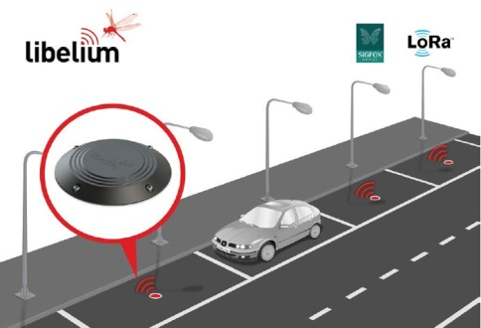

**4. payment methods :**

With the parkwise app , you can use all major credit cards, Paypal , and Apple Pay .

However , some cities and operators do not accept certain forms of payment .