Mini hospital management system API spring boot 2.5(ahmad.marzuki@gmail.com)

https://github.com/marzuki234/hospital-patient--management-api
README.md ada dalam git file tu

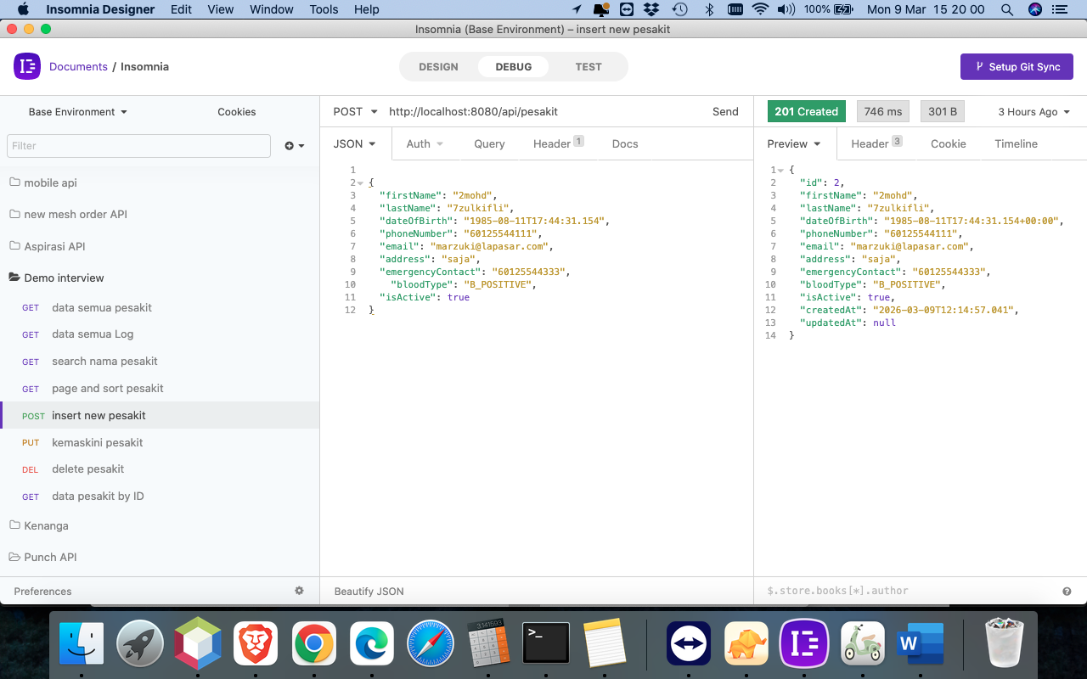
insert patient

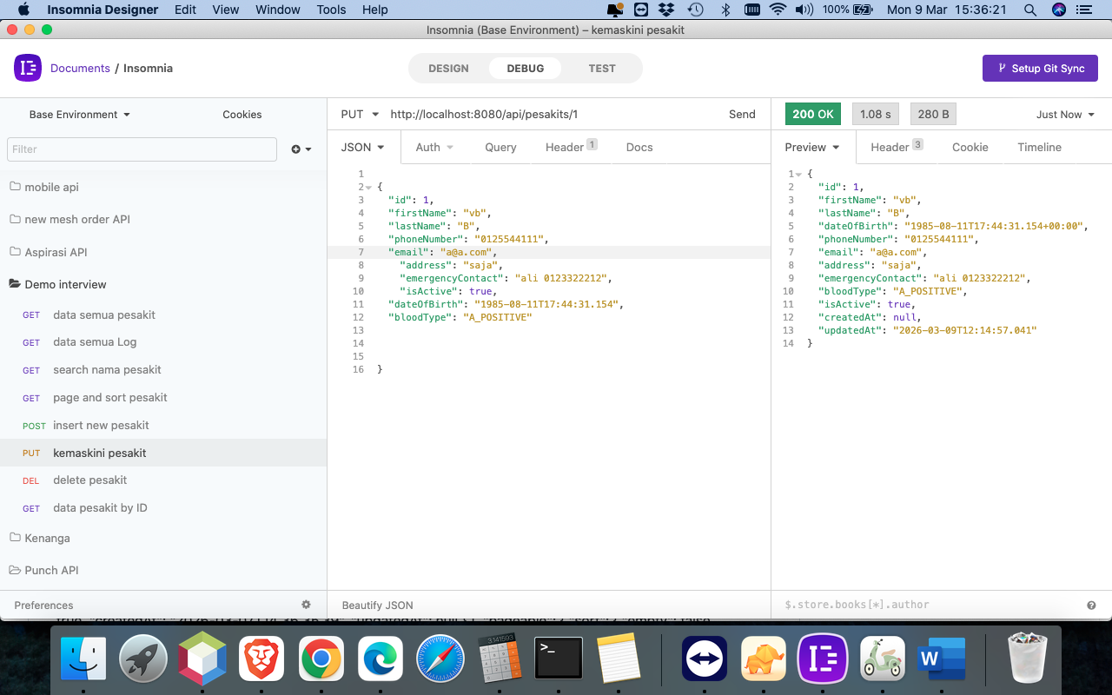
Kemaskini patient

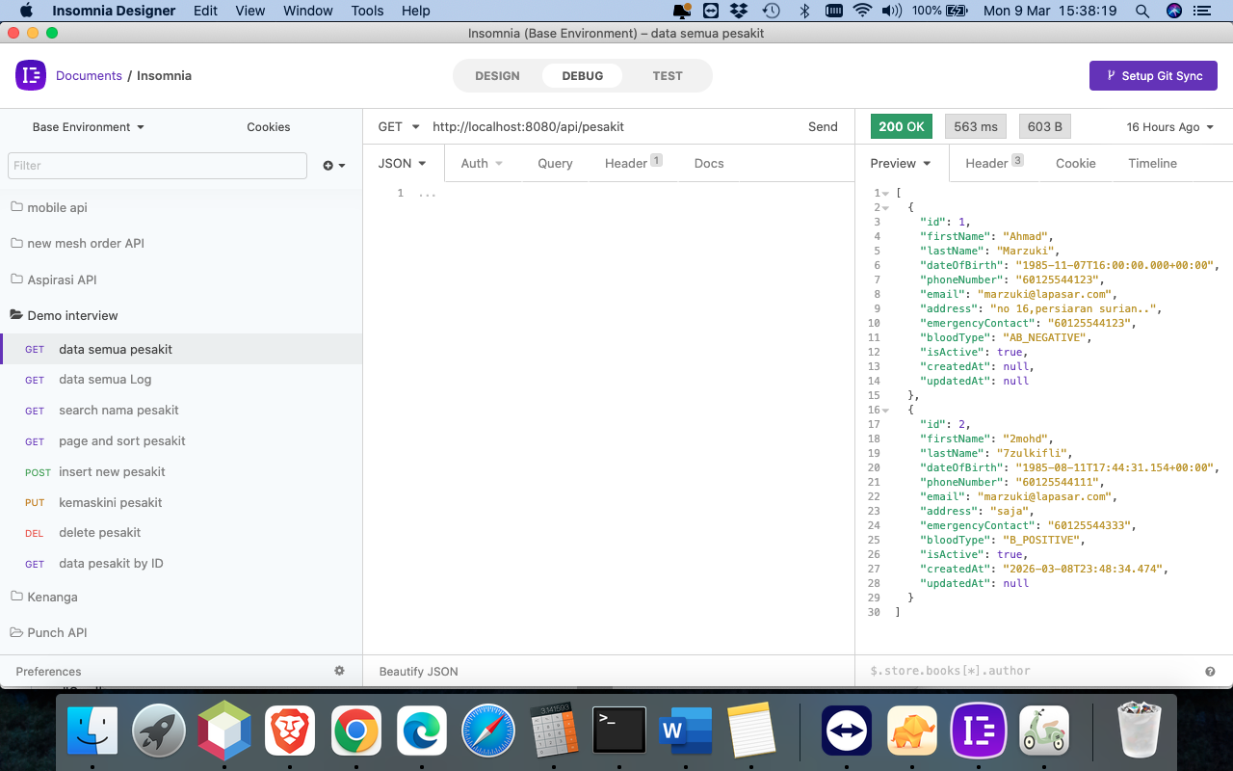
All patients list

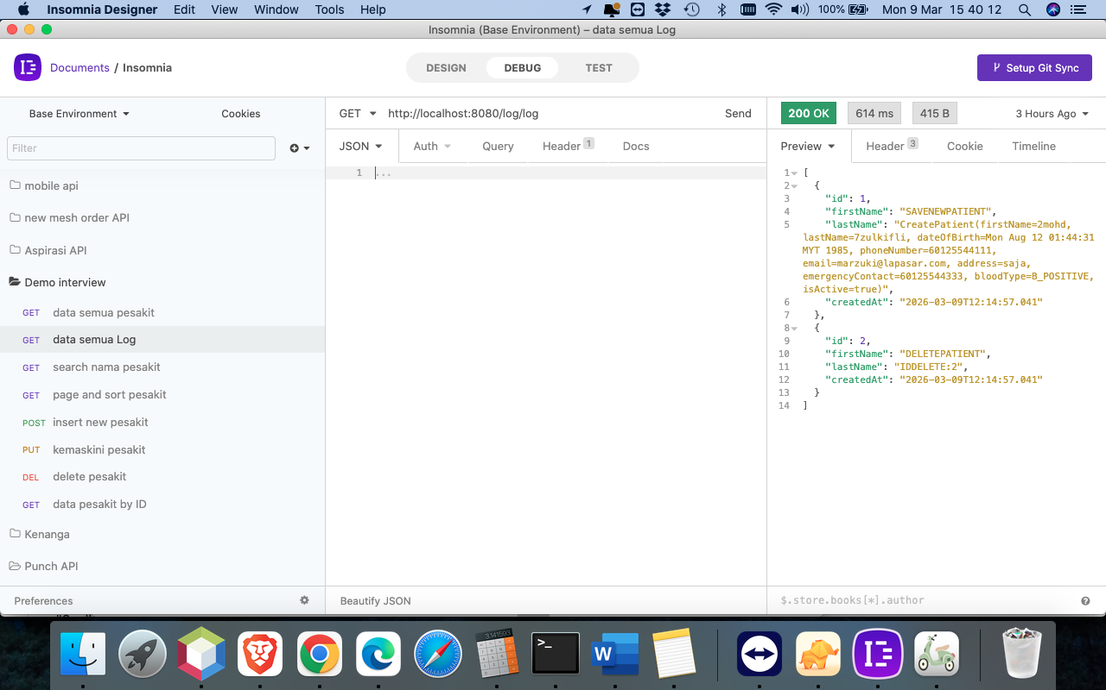
Audit trail log lists

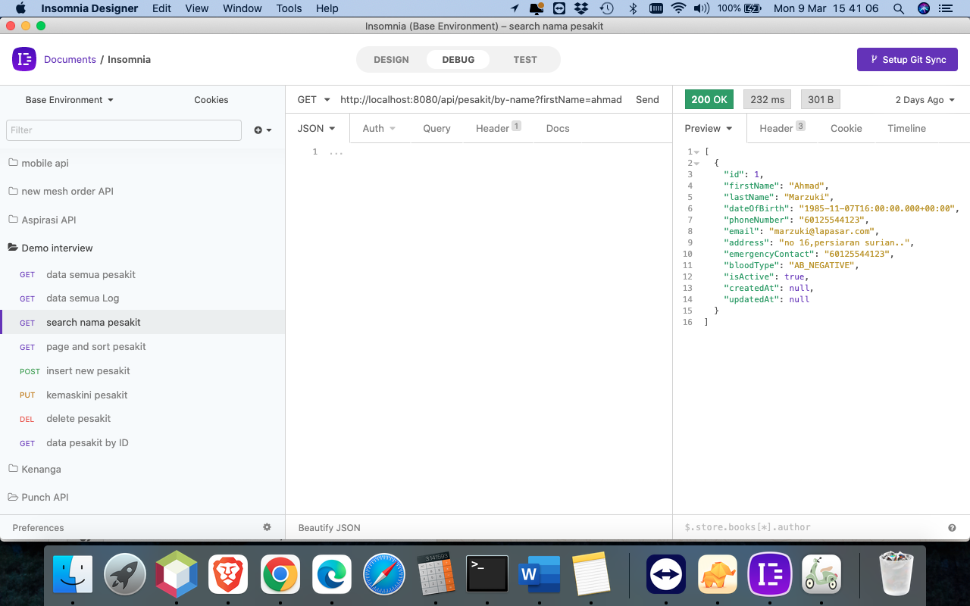
Search name patient

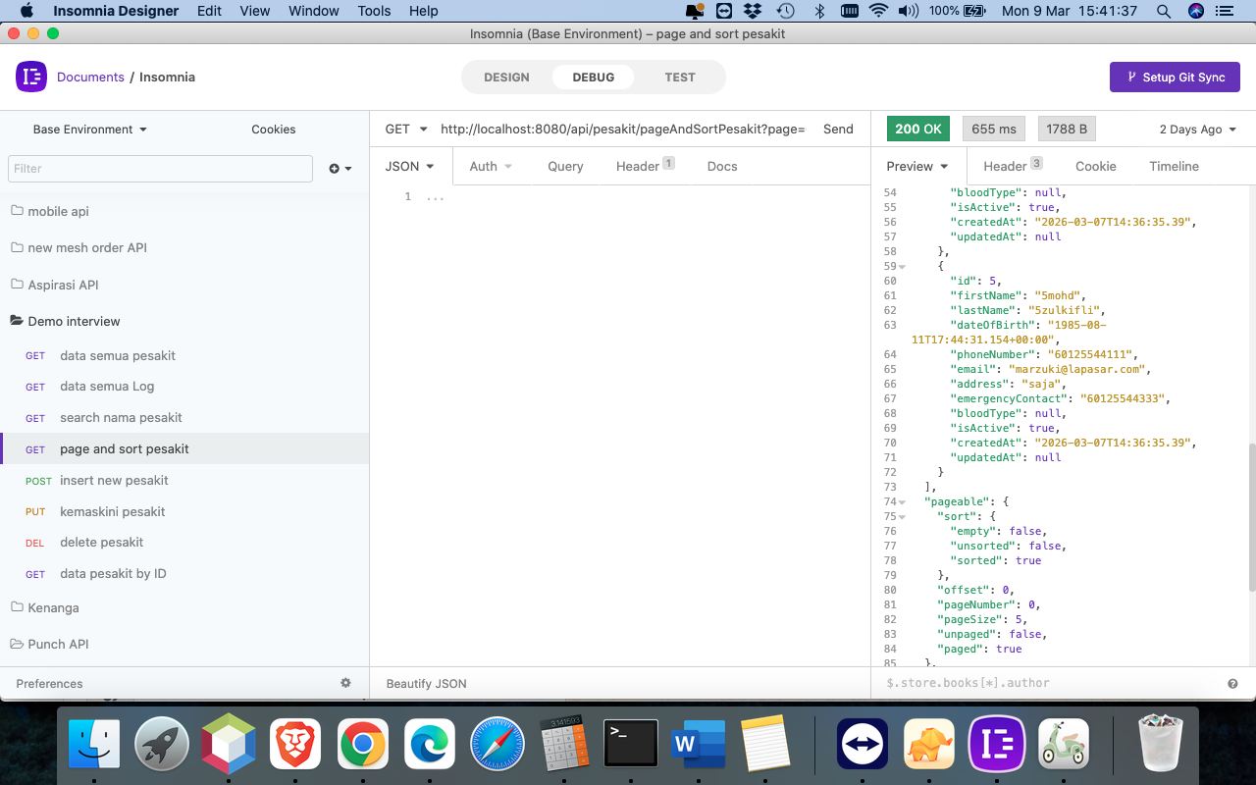
Page and sort list all patients

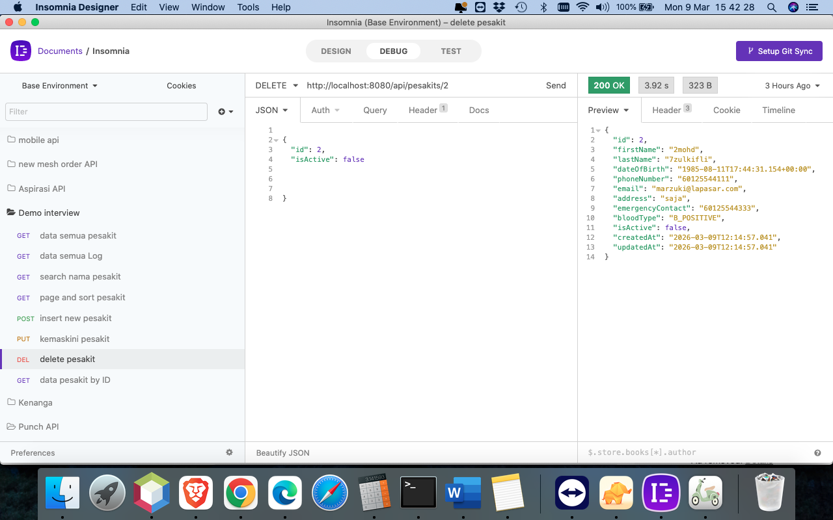
Soft delete patient

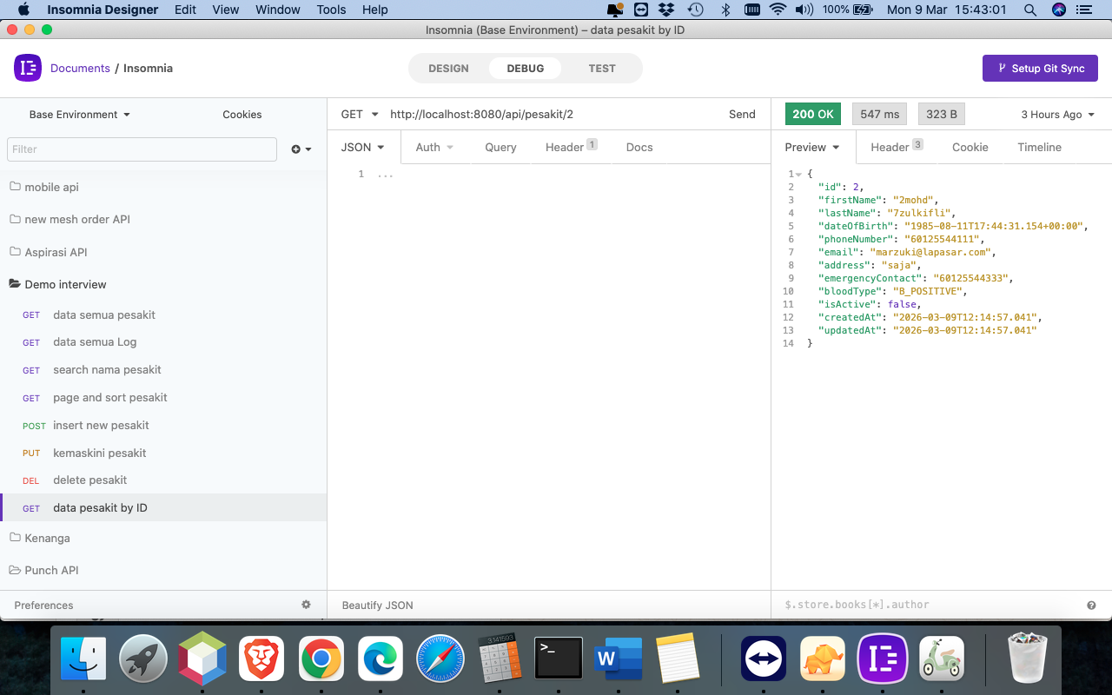
Patient record by id

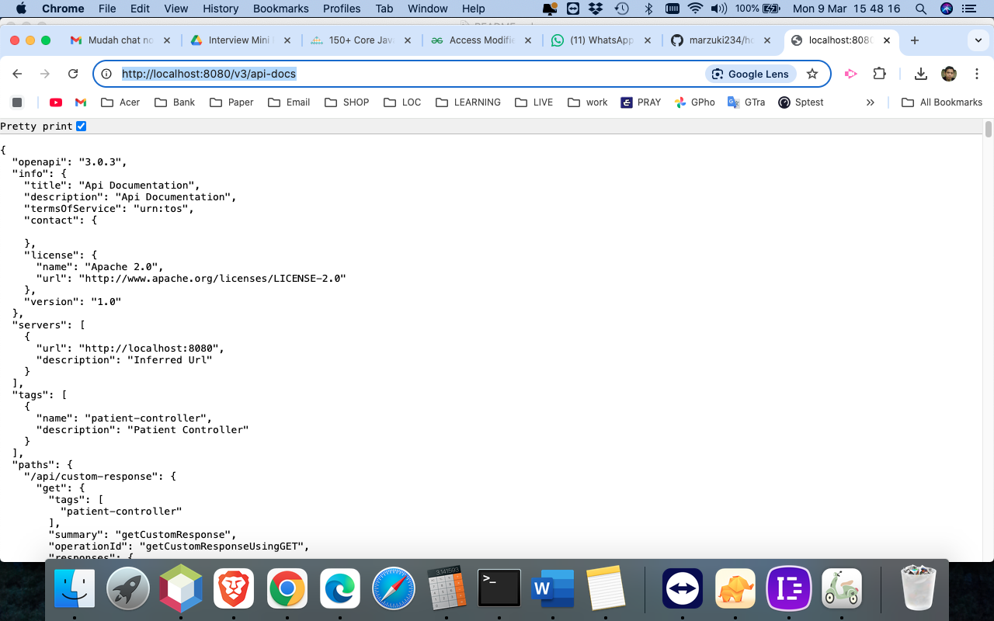
openapi": "3.0.3

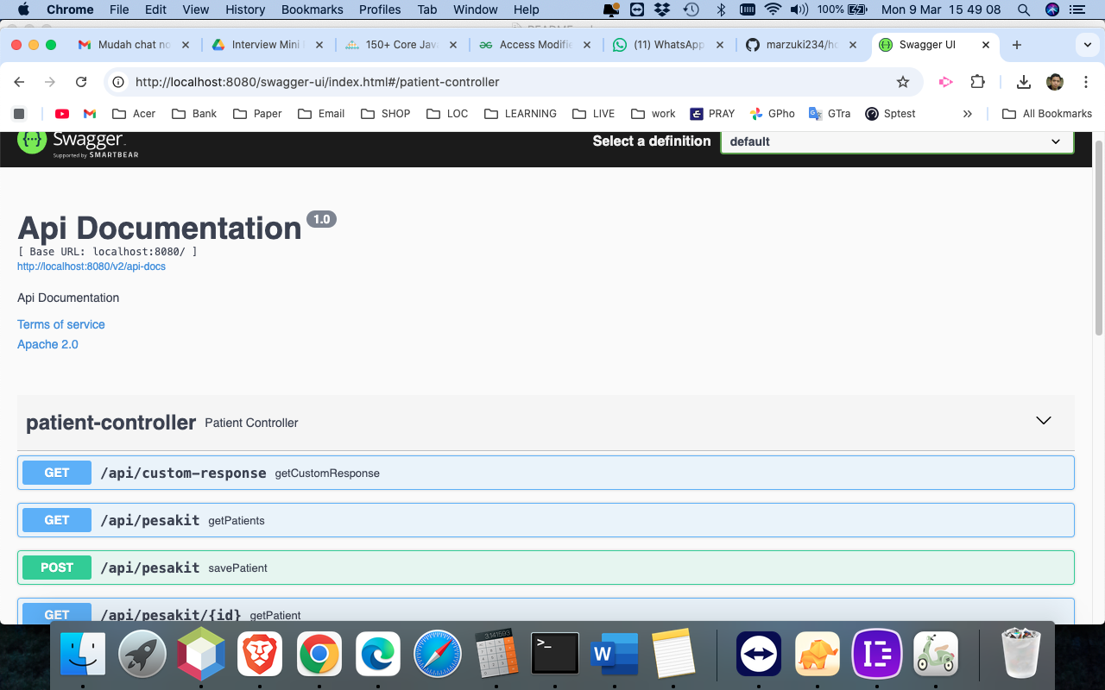
Swagger API documentation

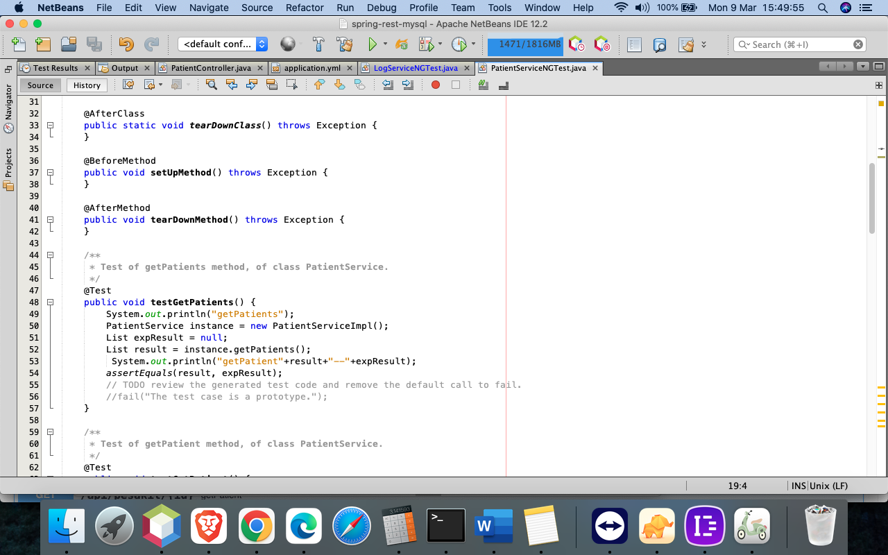
Unit test(integration) patient service

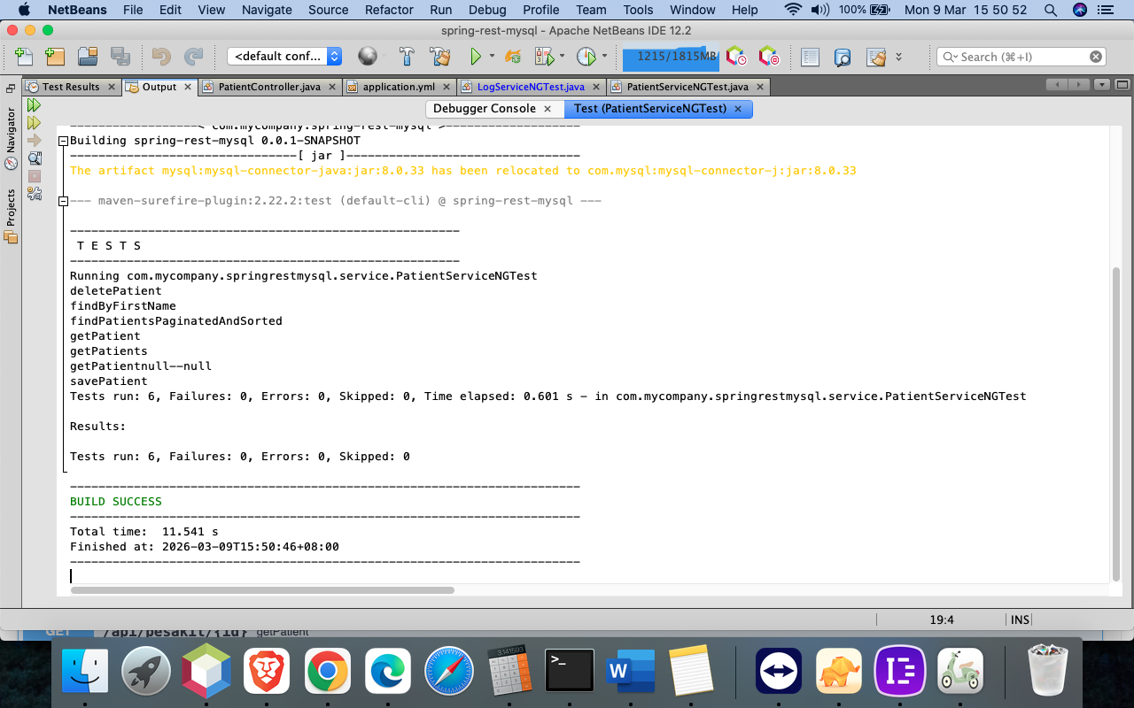
Result Unit test(integration) patient service

# Spring Boot RESTful CRUD API Example with MySQL Database

Steps to ON server spring boot 2.5:

1.Go to your project folder run:
mvn clean package -DskipTests

2.Go to your project folder run:

mvn clean spring-boot:run

now apache is up.can access

List API endpoint url:
1.http://localhost:8080/api/pesakit(lists all patients)
Method:GET
Output format:JSON
input:no input
output:[
{
"id": 1,
"firstName": "Ahmad",
"lastName": "Marzuki",
"dateOfBirth": "1985-11-07T16:00:00.000+00:00",
"phoneNumber": "60125544123",
"email": "marzuki@lapasar.com",
"address": "no 16,persiaran surian..",
"emergencyContact": "60125544123",
"bloodType": "AB_NEGATIVE",
"isActive": true,
"createdAt": null,
"updatedAt": null
}
]

2.http://localhost:8080/log/log(lists all logs audit trail)
Method:GET
Output format:JSON
input:no input
output:[
{
"id": 1,
"firstName": "SAVENEWPATIENT",
"lastName": "CreatePatient(firstName=e3b0c44298fc1c149afbf4c8996fb92427ae41e4649b934ca495991b7852b855mohd, lastName=2zulkifli, dateOfBirth=Mon Aug 12 01:44:31 MYT 1985, phoneNumber=60125544111, email=marzuki@lapasar.com, address=saja, emergencyContact=60125544333, bloodType=null, isActive=true)",
"createdAt": "2026-03-08T00:53:58.789"
}
]
3.http://localhost:8080/api/pesakit/by-name?firstName=ahmad (search Nama pesakit)
Method:GET
Output format:JSON
input:no input
output:[
{
"id": 1,
"firstName": "SAVENEWPATIENT",
"lastName": "CreatePatient(firstName=e3b0c44298fc1c149afbf4c8996fb92427ae41e4649b934ca495991b7852b855mohd, lastName=2zulkifli, dateOfBirth=Mon Aug 12 01:44:31 MYT 1985, phoneNumber=60125544111, email=marzuki@lapasar.com, address=saja, emergencyContact=60125544333, bloodType=null, isActive=true)",
"createdAt": "2026-03-08T00:53:58.789"
}
]
4.http://localhost:8080/api/pesakit/pageAndSortPesakit?page=0&size=5&sortBy=email&sortDirection=desc (lists all patients ada paging dan bleh sort)
Method:GET
Output format:JSON
input:no input
output:
{
"content": [
{
"id": 1,
"firstName": "Ahmad",
"lastName": "Marzuki",
"dateOfBirth": "1985-11-07T16:00:00.000+00:00",
"phoneNumber": "60125544123",
"email": "marzuki@lapasar.com",
"address": "no 16,persiaran surian..",
"emergencyContact": "60125544123",
"bloodType": "AB_NEGATIVE",
"isActive": true,
"createdAt": null,
"updatedAt": null
},
{
"id": 2,
"firstName": "2mohd",
"lastName": "2zulkifli",
"dateOfBirth": "1985-08-11T17:44:31.154+00:00",
"phoneNumber": "60125544111",
"email": "marzuki@lapasar.com",
"address": "saja",
"emergencyContact": "60125544333",
"bloodType": null,
"isActive": true,
"createdAt": "2026-03-07T14:36:35.39",
"updatedAt": null
},
{
"id": 3,
"firstName": "3mohd",
"lastName": "3zulkifli",
"dateOfBirth": "1985-08-11T17:44:31.154+00:00",
"phoneNumber": "60125544111",
"email": "marzuki@lapasar.com",
"address": "saja",
"emergencyContact": "60125544333",
"bloodType": null,
"isActive": true,
"createdAt": "2026-03-07T14:36:35.39",
"updatedAt": null
},
{
"id": 4,
"firstName": "4mohd",
"lastName": "4zulkifli",
"dateOfBirth": "1985-08-11T17:44:31.154+00:00",
"phoneNumber": "60125544111",
"email": "marzuki@lapasar.com",
"address": "saja",
"emergencyContact": "60125544333",
"bloodType": null,
"isActive": true,
"createdAt": "2026-03-07T14:36:35.39",
"updatedAt": null
},
{
"id": 5,
"firstName": "5mohd",
"lastName": "5zulkifli",
"dateOfBirth": "1985-08-11T17:44:31.154+00:00",
"phoneNumber": "60125544111",
"email": "marzuki@lapasar.com",
"address": "saja",
"emergencyContact": "60125544333",
"bloodType": null,
"isActive": true,
"createdAt": "2026-03-07T14:36:35.39",
"updatedAt": null
}
],
"pageable": {
"sort": {
"empty": false,
"unsorted": false,
"sorted": true
},
"offset": 0,
"pageNumber": 0,
"pageSize": 5,
"unpaged": false,
"paged": true
},
"totalPages": 2,
"totalElements": 7,
"last": false,
"numberOfElements": 5,
"size": 5,
"number": 0,
"sort": {
"empty": false,
"unsorted": false,
"sorted": true
},
"first": true,
"empty": false
}

5.http://localhost:8080/api/pesakit (insert new patients)
Method:POST
Output format:JSON

input:

{
"firstName": "2mohd",
"lastName": "7zulkifli",
"dateOfBirth": "1985-08-11T17:44:31.154",
"phoneNumber": "60125544111",
"email": "marzuki@lapasar.com",
"address": "saja",
"emergencyContact": "60125544333",
"bloodType": "B_POSITIVE",
"isActive": true
}
Output:
{
"id": 2,
"firstName": "e3b0c44298fc1c149afbf4c8996fb92427ae41e4649b934ca495991b7852b855mohd",
"lastName": "2zulkifli",
"dateOfBirth": "1985-08-11T17:44:31.154+00:00",
"phoneNumber": "60125544111",
"email": "marzuki@lapasar.com",
"address": "saja",
"emergencyContact": "60125544333",
"bloodType": null,
"isActive": true,
"createdAt": "2026-03-08T00:53:58.789",
"updatedAt": null
}
6.http://localhost:8080/api/pesakits/1 (kemaskini patients)
Method:PUT
Output format:JSON

input:

{
"id": 1,
"firstName": "vb",
"lastName": "B",
"phoneNumber": "0125544111",
"email": "a@a.com",
"address": "saja",
"emergencyContact": "ali 0123322212",
"isActive": true,
"dateOfBirth": "1985-08-11T17:44:31.154",
"bloodType": "A_POSITIVE"

}
Output:
{
"id": 1,
"firstName": "aa",
"lastName": "B",
"dateOfBirth": "1985-08-11T17:44:31.154+00:00",
"phoneNumber": "0125544111",
"email": "a@a.com",
"address": "saja",
"emergencyContact": "ali 0123322212",
"bloodType": null,
"isActive": true,
"createdAt": null,
"updatedAt": "2026-03-07T17:49:47.602"
}

7.http://localhost:8080/api/pesakits/1 (soft delete patients)
Method:DELETE
Output format:JSON

input:

{
"id": 2,
"isActive": false

}
Output:
{
"id": 2,
"firstName": "2mohd",
"lastName": "2zulkifli",
"dateOfBirth": "1985-08-11T17:44:31.154+00:00",
"phoneNumber": "60125544111",
"email": "marzuki@lapasar.com",
"address": "saja",
"emergencyContact": "60125544333",
"bloodType": null,
"isActive": false,
"createdAt": "2026-03-07T13:19:29.371",
"updatedAt": "2026-03-07T13:19:29.371"
}

8.http://localhost:8080/api/pesakit/1 (data patients by ID)
Method:GET
Output format:JSON

Input:no input

Output:
{
"id": 1,
"firstName": "Ahmad",
"lastName": "Marzuki",
"dateOfBirth": "1985-11-07T16:00:00.000+00:00",
"phoneNumber": "60125544123",
"email": "marzuki@lapasar.com",
"address": "no 16,persiaran surian..",
"emergencyContact": "60125544123",
"bloodType": "AB_NEGATIVE",
"isActive": true,
"createdAt": null,
"updatedAt": null
}

openapi 3 url:

http://localhost:8080/v3/api-docs

http://localhost:8080/swagger-ui/index.html

https://www.baeldung.com/spring-rest-openapi-documentation

integration test(JUNIT4 test)
/springboot-rest-mysql/src/test/java/com/mycompany/springrestmysql/service/PatientServiceIT.java

