Dalton Expiry Extractor User Manual

1. Extracting expired loans
   1. Open the “Expiry Extractor” shortcut located on your desktop

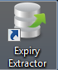

* 1. Select a date range.

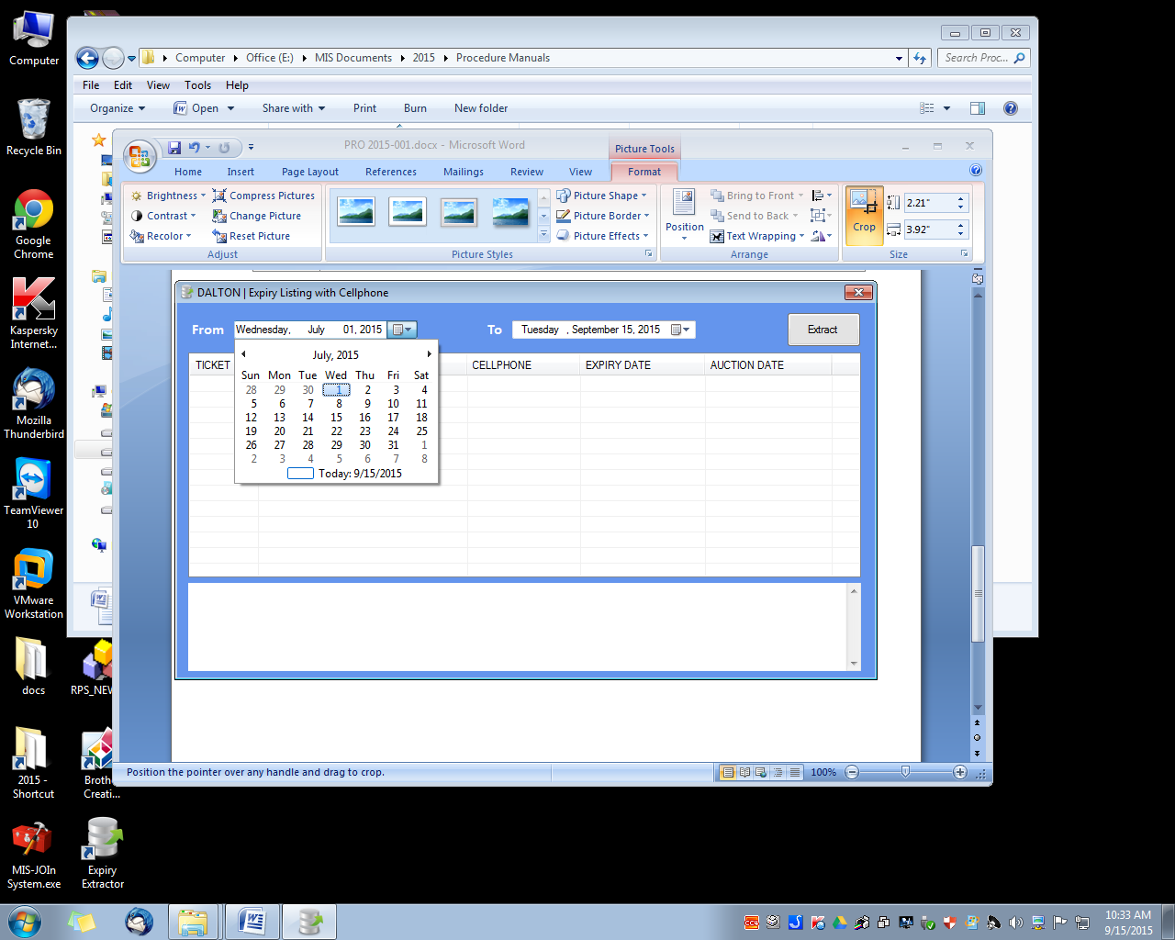

* 1. Then click “Extract”. Wait until a confirmation message extraction

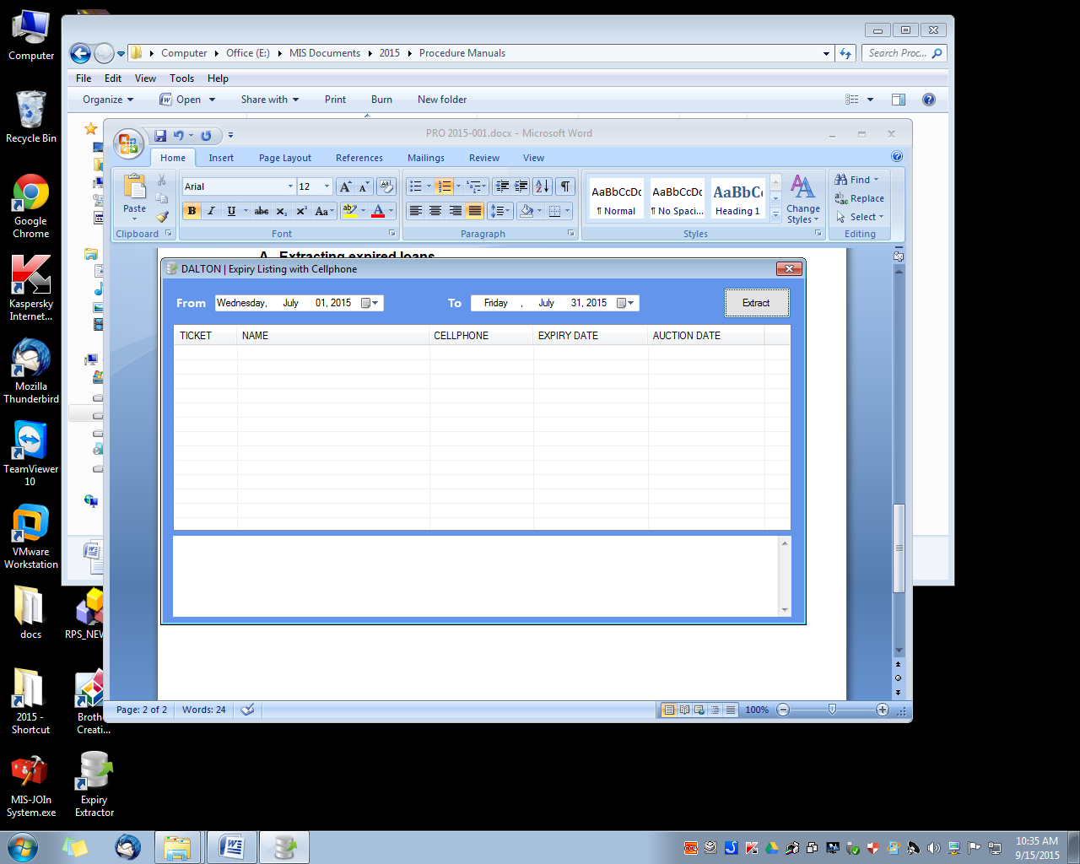]

* 1. Wait until a confirmation message appears.

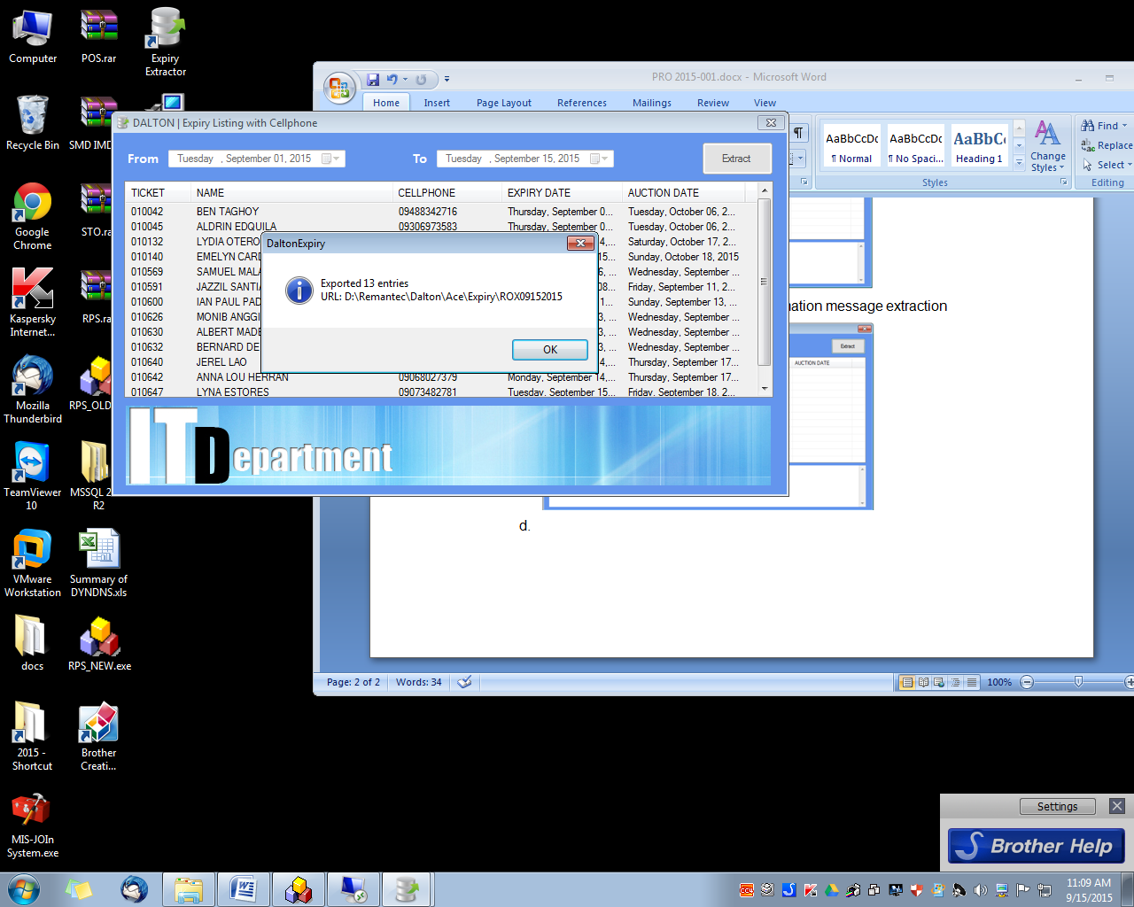

* 1. By default, the Expiry list file will be located at “D:\Remantec\Dalton\(BranchCode)\Expiry” folder. Also it has a shortcut in the Desktop named Expiry.

