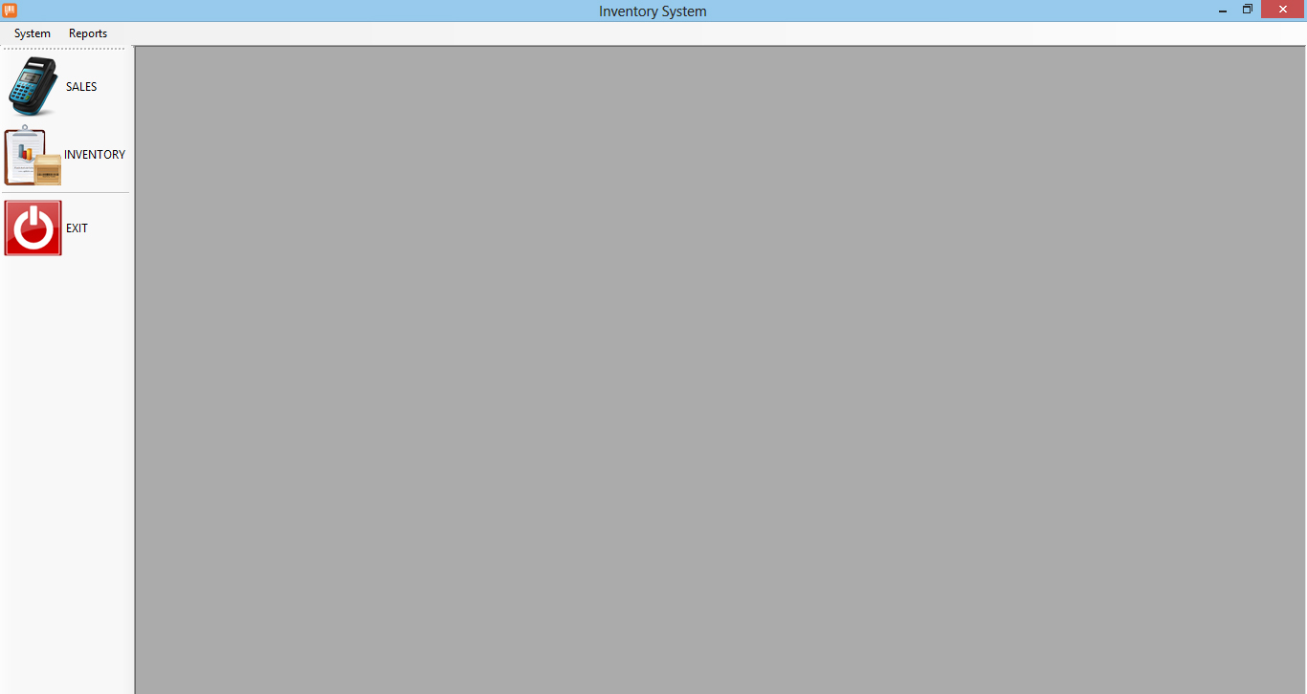

**Exhibit 00 – Main**

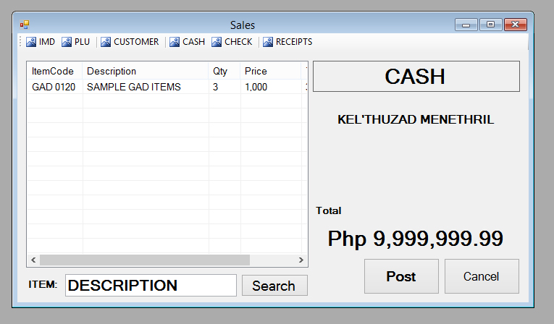

**Exhibit 01 – Sales Module**

Functions:

* Item Master Data (Check the Master Data)
* PLU (Price Look-up) (Check the Item Prices)
* Customer (Note Customer’s Name)
* Cash (Modes of Payment – Cash)
* Check (Modes of Payment – Check)
* Receipts (Display all the Receipt issued)

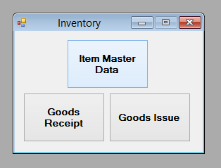

**Exhibit 02 – Inventory Selection Module**

* Item Master Data
* Goods Receipt (Inventory In)
* Goods Issue (Inventory Out)

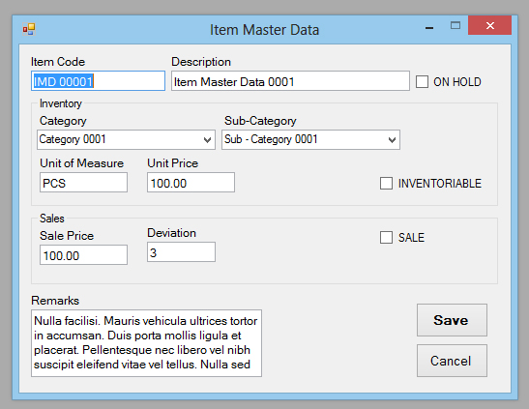

**Exhibit 03 – Item Master Data**

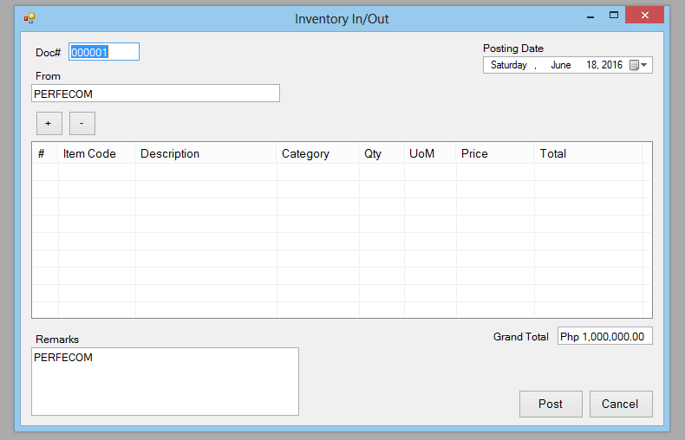

**Exhibit 04 – Goods Receipt/Issue**