**2018 End of Year Results**

**Rating Distribution by Position and Top Player Ratings**

**Factors: [1.10, 0.90, 0.50, 0.30, 0.05]**

**Initial Ratings adjusted for prior year performance – see below.**

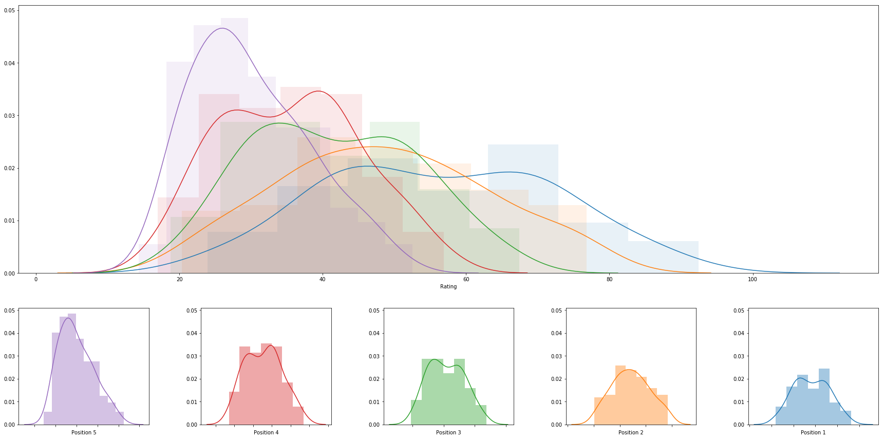

**Top Players – Ratings and Rankings**

|  |  |  |  |  |  |  |  |
| --- | --- | --- | --- | --- | --- | --- | --- |
|  | **rank** | **name** | **college** | **division** | **rating** | **primary position** | **date** |
| **0** | 1 | Abril Bustamante | USC | DI | 92.4303500391538 | 1 | 2018-05-05 |
| **1** | 2 | Nicole McNamara | UCLA | DI | 86.1135562147035 | 1 | 2018-05-06 |
| **2** | 3 | Megan McNamara | UCLA | DI | 86.1135562147035 | 1 | 2018-05-06 |
| **3** | 4 | Tina Graudina | USC | DI | 85.52833489294359 | 1 | 2018-05-05 |
| **4** | 5 | Victoria Paranagua | Florida State | DI | 84.86993899988808 | 1 | 2018-05-05 |
| **5** | 6 | Ka'iwi Schucht | Hawaii | DI | 84.23751527416164 | 1 | 2018-05-06 |
| **6** | 7 | Emily Maglio | Hawaii | DI | 84.23751527416164 | 1 | 2018-05-06 |
| **7** | 8 | Kristen Nuss | LSU | DI | 81.19130389005646 | 1 | 2018-05-04 |
| **8** | 9 | Claire Coppola | LSU | DI | 81.19130389005646 | 1 | 2018-05-04 |
| **9** | 10 | Sasha Karelov | Long Beach State | DI | 79.92898851148391 | 1 | 2018-04-28 |
| **10** | 11 | Vanessa Freire | Florida State | DI | 77.78122536838717 | 1 | 2018-05-05 |
| **11** | 12 | Nele Barber | Long Beach State | DI | 77.42271663171068 | 1 | 2018-04-28 |
| **12** | 13 | Kaylie Mchugh | Tulane | DI | 77.35382247810593 | 1 | 2018-04-21 |
| **13** | 14 | Madeline Mertz | Tulane | DI | 77.35382247810593 | 1 | 2018-04-21 |
| **14** | 15 | Sarah Sponcil | UCLA | DI | 76.8066100133845 | 2 | 2018-05-06 |
| **15** | 16 | Corinne Quiggle | Pepperdine | DI | 76.54549164430772 | 2 | 2018-05-05 |
| **16** | 17 | Sunny Villapando | Stanford | DI | 76.49140793636484 | 1 | 2018-04-27 |
| **17** | 18 | Katie Smith | South Carolina | DI | 76.296541124782 | 2 | 2018-05-04 |
| **18** | 19 | Lily Justine | UCLA | DI | 74.80661001338449 | 2 | 2018-05-06 |
| **19** | 20 | Morgan Martin | Hawaii | DI | 74.69453990845882 | 2 | 2018-05-06 |
| **20** | 21 | Deahna Kraft | Pepperdine | DI | 74.54549164430763 | 2 | 2018-05-05 |
| **21** | 22 | Katie Horton | Florida State | DI | 74.50166622863102 | 2 | 2018-05-05 |
| **22** | 23 | Rachel Nieto | Long Beach State | DI | 73.64232858049635 | 2 | 2018-04-28 |
| **23** | 24 | Teegan Van Gunst | Georgia State | DI | 73.62427063612556 | 1 | 2018-04-21 |
| **24** | 25 | Lea Monkhouse | Hawaii | DI | 73.49306234902711 | 2 | 2018-05-06 |
| **25** | 26 | Sammy Slater | USC | DI | 73.32221359107479 | 2 | 2018-05-05 |
| **26** | 27 | Hailey Luke | Florida State | DI | 73.23522095837858 | 2 | 2018-05-05 |
| **27** | 28 | Federica Frasca | FIU | DI | 73.18867624886937 | 1 | 2018-05-04 |
| **28** | 29 | Margherita Bianchin | FIU | DI | 73.18867624886937 | 1 | 2018-05-04 |
| **29** | 30 | Mima Mirkovic | Cal | DI | 72.61630147566557 | 1 | 2018-04-28 |
| **30** | 31 | Madalyn Roh | Pepperdine | DI | 72.54550764576052 | 1 | 2018-05-05 |
| **31** | 32 | Annika Van Gunst | Georgia State | DI | 72.47881432554969 | 1 | 2018-04-21 |
| **32** | 33 | Aeriel Horton | Houston Baptist | DI | 72.29232420518505 | 1 | 2018-04-22 |
| **33** | 34 | Jessica Wooten | Houston Baptist | DI | 72.29232420518505 | 1 | 2018-04-22 |
| **34** | 35 | Terese Cannon | USC | DI | 71.36208943240604 | 2 | 2018-05-05 |
| **35** | 36 | Brook Bauer | Pepperdine | DI | 70.54550764576047 | 1 | 2018-05-05 |
| **36** | 37 | Adore Anae | Utah | DI | 70.49092447978734 | 1 | 2018-04-27 |
| **37** | 38 | Dani Barton | Utah | DI | 70.49092447978734 | 1 | 2018-04-27 |
| **38** | 39 | Alexia Inman | Cal | DI | 69.6715325910978 | 1 | 2018-04-28 |
| **39** | 40 | Torrey Van Winden | Cal Poly SLO | DI | 69.58768288323243 | 1 | 2018-04-28 |
| **40** | 41 | Tia Miric | Cal Poly SLO | DI | 69.58768288323243 | 1 | 2018-04-28 |
| **41** | 42 | Emily Sonny | Cal Poly SLO | DI | 69.55877585218228 | 2 | 2018-04-28 |
| **42** | 43 | Ali Denney | South Carolina | DI | 68.69760192967698 | 1 | 2018-05-04 |
| **43** | 44 | Shannon Williams | South Carolina | DI | 68.69760192967698 | 1 | 2018-05-04 |
| **44** | 45 | Olivia Macdonald | Arizona | DI | 68.12457246604 | 1 | 2018-04-27 |
| **45** | 46 | Natalie Anselmo | Arizona | DI | 68.12457246603995 | 1 | 2018-04-27 |
| **46** | 47 | Payton Rund | Saint Mary's | DI | 68.04029850962506 | 1 | 2018-04-21 |
| **47** | 48 | Carly Kan | Hawaii | DI | 67.45321674494866 | 3 | 2018-05-06 |
| **48** | 49 | Kimmy Gardiner | Washington | DI | 67.24756224141518 | 1 | 2018-04-28 |
| **49** | 50 | Jordan Anderson | Washington | DI | 67.24756224141518 | 1 | 2018-04-28 |
| **50** | 51 | Sammee Thomas | Stetson | DI | 66.65841147862814 | 1 | 2018-04-21 |
| **51** | 52 | Darby Dunn | Stetson | DI | 66.65841147862814 | 1 | 2018-04-21 |
| **52** | 53 | Sam Manley | Cal Poly SLO | DI | 66.39431837102529 | 2 | 2018-04-28 |
| **53** | 54 | Jessica Gaffney | Cal | DI | 66.31432645354683 | 2 | 2018-04-28 |
| **54** | 55 | Laurel Weaver | Hawaii | DI | 66.05063283058175 | 3 | 2018-05-06 |
| **55** | 56 | Morgan Hughes | Saint Mary's | DI | 66.04029850962509 | 1 | 2018-04-21 |
| **56** | 57 | Savannah Slattery | LMU | DI | 65.52604585851648 | 1 | 2018-04-21 |
| **57** | 58 | Cadie Bates | South Carolina | DI | 65.47804086127739 | 2 | 2018-05-04 |
| **58** | 59 | Morgan Hentz | Stanford | DI | 65.09141520123435 | 2 | 2018-04-27 |
| **59** | 60 | Amelia Smith | Stanford | DI | 65.09141520123435 | 2 | 2018-04-27 |
| **60** | 61 | Haleigh Nelson | LSU | DI | 64.891249094159 | 2 | 2018-05-04 |
| **61** | 62 | Megan Kruidhof | Long Beach State | DI | 64.88177397818546 | 2 | 2018-04-28 |
| **62** | 63 | Courtney Schwan | Washington | DI | 64.87364355726757 | 2 | 2018-04-28 |
| **63** | 64 | Destiny Julye | Washington | DI | 64.52322012858274 | 2 | 2018-04-28 |
| **64** | 65 | Sara Putt | Florida State | DI | 64.4778598631755 | 3 | 2018-05-05 |
| **65** | 66 | Nicole Lott | UNC Wilmington | DI | 64.45942269739646 | 1 | 2018-04-21 |
| **66** | 67 | Maddy Kline | UNC Wilmington | DI | 64.45942269739646 | 1 | 2018-04-21 |
| **67** | 68 | Tiffany Creamer | Georgia State | DI | 64.26158258643508 | 2 | 2018-04-21 |
| **68** | 69 | McKayla Ferris | LMU | DI | 64.04696157268724 | 1 | 2018-04-21 |
| **69** | 70 | Devon May | UAB | DI | 63.99080361095125 | 1 | 2018-04-21 |
| **70** | 71 | Hannah Towne | Grand Canyon | DI | 63.654175532655216 | 1 | 2018-04-19 |
| **71** | 72 | Brooke Weiner | Georgia State | DI | 63.43076248748205 | 2 | 2018-04-21 |
| **72** | 73 | Courtney Bowen | Stanford | DI | 63.36739584086014 | 3 | 2018-04-27 |
| **73** | 74 | Molly Turner | Grand Canyon | DI | 63.30196506165988 | 1 | 2018-04-19 |
| **74** | 75 | Kenley Adams | UAB | DI | 63.2936402479887 | 1 | 2018-04-21 |
| **75** | 76 | Iya Lindahl | Cal | DI | 63.229312020717735 | 2 | 2018-04-28 |
| **76** | 77 | Cassie House | TCU | DI | 63.097568232272764 | 1 | 2018-04-15 |
| **77** | 78 | Haven Hill | TCU | DI | 63.097568232272764 | 1 | 2018-04-15 |
| **78** | 79 | Haley Hallgren | USC | DI | 63.04921108123021 | 3 | 2018-05-05 |
| **79** | 80 | Macy Jerger | Florida State | DI | 62.805703327459476 | 3 | 2018-05-05 |
| **80** | 81 | Lindsey Knudsen | Saint Mary's | DI | 62.323854662591565 | 2 | 2018-04-21 |
| **81** | 82 | Sara Kovac | LMU | DI | 62.06075497489773 | 2 | 2018-04-21 |
| **82** | 83 | Jessie Prichard | LMU | DI | 61.941929170872505 | 2 | 2018-04-21 |
| **83** | 84 | Taylor Nelson | Cal Poly SLO | DI | 61.790176299202884 | 3 | 2018-04-28 |
| **84** | 85 | Carly Perales | Stetson | DI | 61.407238288197014 | 2 | 2018-04-21 |
| **85** | 86 | Sunniva Helland-Hansen | Stetson | DI | 61.40723828819691 | 2 | 2018-04-21 |
| **86** | 87 | Savvy Simo | UCLA | DI | 60.7831720607993 | 3 | 2018-05-06 |
| **87** | 88 | Emily Bible | Saint Mary's | DI | 60.32385466259157 | 2 | 2018-04-21 |
| **88** | 89 | Amanda Silva | FAU | DI | 60.28755320258038 | 1 | 2018-04-21 |
| **89** | 90 | Carly Scarborough | FAU | DI | 59.95367029325593 | 1 | 2018-04-21 |
| **90** | 91 | Tarin Mergener | Tulane | DI | 59.296611752229516 | 2 | 2018-04-21 |
| **91** | 92 | Hunter Domanski | LSU | DI | 59.22384771378158 | 3 | 2018-05-04 |
| **92** | 93 | Lan Nguyen | Tulane | DI | 58.993169820946676 | 2 | 2018-04-21 |
| **93** | 94 | Janell Walley | Boise State | DI | 58.69650786935412 | 1 | 2018-04-21 |
| **94** | 95 | Sabryn Roberts | Boise State | DI | 58.69650786935409 | 1 | 2018-04-21 |
| **95** | 96 | Jessalyn Kinlaw | FAU | DI | 58.54095803828602 | 2 | 2018-04-21 |
| **96** | 97 | Carly Dehoog | Washington | DI | 58.163121648609 | 3 | 2018-04-28 |
| **97** | 98 | Shayne Mcpherson | Washington | DI | 58.163121648609 | 3 | 2018-04-28 |
| **98** | 99 | Hayley Tippett | Central Arkansas | DI | 58.043331498527635 | 1 | 2018-04-22 |
| **99** | 100 | Megan Nash | Central Arkansas | DI | 58.043331498527635 | 1 | 2018-04-22 |

**Adjustments from Prior Year**

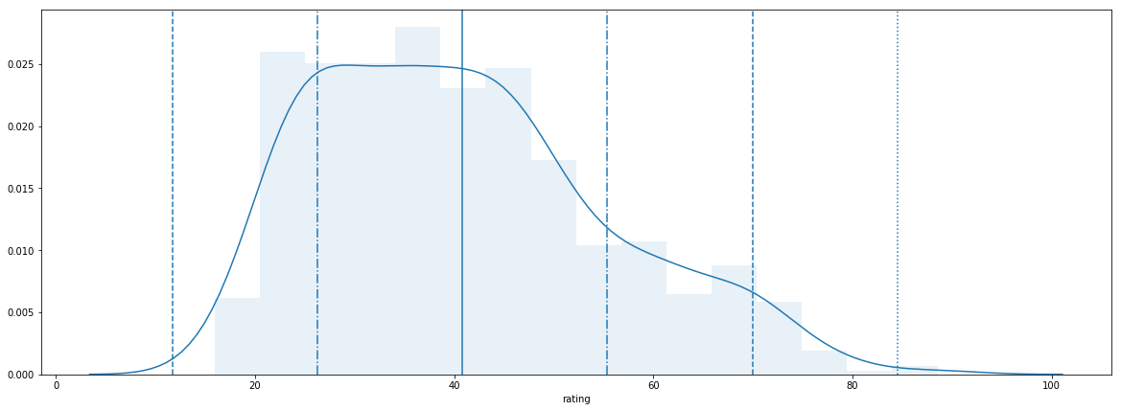

|  |  |  |  |
| --- | --- | --- | --- |
|  | **name** | **last_season_end_rating** | **new_season_start_rating** |
| **0** | Kelly Claes | 88.53968496819505 | 28 |
| **1** | Sara Hughes | 88.53968496819505 | 28 |
| **2** | Crissy Jones | 81.44413545915913 | 27 |
| **3** | Federica Frasca | 79.21249875105623 | 27 |
| **4** | Leigh Andrew | 78.13404199340911 | 27 |
| **5** | Vanessa Freire | 77.61074423971876 | 27 |
| **6** | Nicole McNamara | 77.51130956788397 | 27 |
| **7** | Megan McNamara | 77.20339742621319 | 27 |
| **8** | Savannah Slattery | 75.01436221535944 | 27 |
| **9** | Brooke Kuhlman | 74.70911261395949 | 27 |
| **10** | Sarah Sponcil | 74.22361655902333 | 27 |
| **11** | Allie Wheeler | 73.10079892321512 | 27 |
| **12** | Madalyn Roh | 72.71611352264908 | 27 |
| **13** | Delaney Knudsen | 72.71611352264905 | 27 |
| **14** | Lindsey Knudsen | 72.49012665141518 | 27 |
| **15** | Payton Rund | 72.49012665141512 | 27 |
| **16** | Tia Scambray | 72.14877668287649 | 27 |
| **17** | Emily Sonny | 72.080320845172 | 27 |
| **18** | Hannah Hubbard | 72.080320845172 | 27 |
| **19** | Adlee Van Winden | 71.79958015749638 | 27 |
| **20** | Adrianna Culbert | 71.71100367074791 | 27 |
| **21** | Claire Coppola | 71.69824324316853 | 27 |
| **22** | Kristen Nuss | 71.69824324316852 | 27 |
| **23** | Jessalyn Kinlaw | 71.03672315294169 | 27 |
| **24** | Margherita Bianchin | 70.80031668873727 | 27 |
| **25** | Brittany Howard | 70.73177243201184 | 27 |
| **26** | Corinne Quiggle | 70.73177243201184 | 27 |
| **27** | Taylor Nelson | 70.38097962603538 | 27 |

**Ratings to Start Upcoming Season**

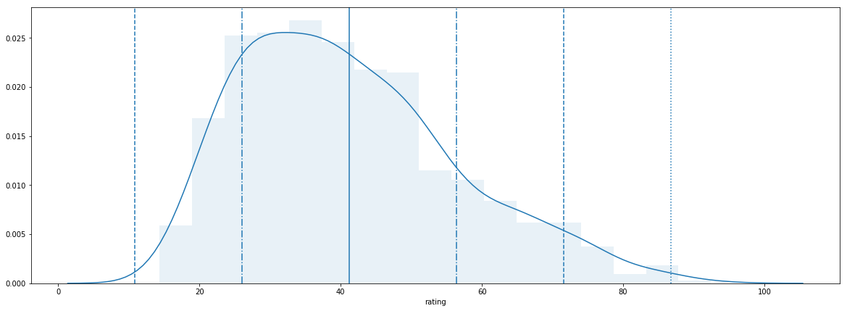

|  |  |  |  |
| --- | --- | --- | --- |
|  | **name** | **last_season_end_rating** | **new_season_start_rating** |
| **0** | Abril Bustamante | 92.4303500391538 | 28 |
| **1** | Nicole McNamara | 86.1135562147035 | 27 |
| **2** | Megan McNamara | 86.1135562147035 | 27 |
| **3** | Tina Graudina | 85.52833489294359 | 27 |
| **4** | Victoria Paranagua | 84.86993899988808 | 27 |
| **5** | Ka'iwi Schucht | 84.23751527416164 | 27 |
| **6** | Emily Maglio | 84.23751527416164 | 27 |
| **7** | Kristen Nuss | 81.19130389005646 | 27 |
| **8** | Claire Coppola | 81.19130389005646 | 27 |
| **9** | Sasha Karelov | 79.92898851148391 | 27 |
| **10** | Vanessa Freire | 77.78122536838717 | 27 |
| **11** | Nele Barber | 77.42271663171068 | 27 |
| **12** | Kaylie Mchugh | 77.35382247810593 | 27 |
| **13** | Madeline Mertz | 77.35382247810593 | 27 |
| **14** | Sarah Sponcil | 76.8066100133845 | 27 |
| **15** | Corinne Quiggle | 76.54549164430772 | 27 |
| **16** | Sunny Villapando | 76.49140793636484 | 27 |
| **17** | Katie Smith | 76.296541124782 | 27 |
| **18** | Lily Justine | 74.80661001338449 | 27 |
| **19** | Morgan Martin | 74.69453990845882 | 27 |
| **20** | Deahna Kraft | 74.54549164430763 | 27 |
| **21** | Katie Horton | 74.50166622863102 | 27 |
| **22** | Rachel Nieto | 73.64232858049635 | 27 |
| **23** | Teegan Van Gunst | 73.62427063612556 | 27 |
| **24** | Lea Monkhouse | 73.49306234902711 | 27 |
| **25** | Sammy Slater | 73.32221359107479 | 27 |
| **26** | Hailey Luke | 73.23522095837858 | 27 |
| **27** | Federica Frasca | 73.18867624886937 | 27 |
| **28** | Margherita Bianchin | 73.18867624886937 | 27 |
| **29** | Mima Mirkovic | 72.61630147566557 | 27 |
| **30** | Madalyn Roh | 72.54550764576052 | 27 |
| **31** | Annika Van Gunst | 72.47881432554969 | 27 |
| **32** | Aeriel Horton | 72.29232420518505 | 27 |
| **33** | Jessica Wooten | 72.29232420518505 | 27 |