**Rating Distribution by Position and Top Player Ratings**

**Factors: [1.7, 1.2, .7, .45, .1]**

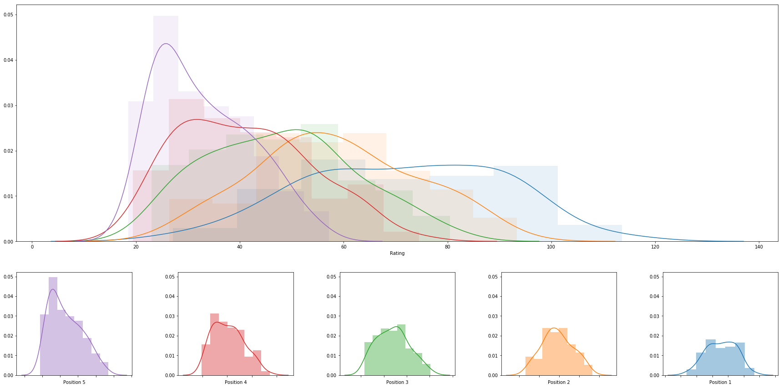

|  |  |  |  |  |  |  |  |  |
| --- | --- | --- | --- | --- | --- | --- | --- | --- |
|  | **rank** | **name** | **college** | **division** | **rating** | **Starting rating next year** | **primary position** | **date** |
| **0** | 1 | Sara Hughes | USC | DI | 113.56652047551567 | 28 | 1 | 2017-05-07 |
| **1** | 2 | Kelly Claes | USC | DI | 113.56652047551567 | 28 | 1 | 2017-05-07 |
| **2** | 3 | Crissy Jones | Washington | DI | 105.5529263991607 | 27 | 1 | 2017-04-28 |
| **3** | 4 | Federica Frasca | FIU | DI | 102.11274388978921 | 27 | 1 | 2017-04-23 |
| **4** | 5 | Leigh Andrew | Florida State | DI | 101.53682456461274 | 27 | 1 | 2017-05-06 |
| **5** | 6 | Nicole McNamara | UCLA | DI | 98.94762284056849 | 27 | 1 | 2017-04-28 |
| **6** | 7 | Megan McNamara | UCLA | DI | 97.57774910525532 | 27 | 1 | 2017-04-28 |
| **7** | 8 | Savannah Slattery | LMU | DI | 96.91934257777629 | 27 | 1 | 2017-04-22 |
| **8** | 9 | Brooke Kuhlman | Florida State | DI | 95.4657193337801 | 27 | 1 | 2017-05-06 |
| **9** | 10 | Hannah Hubbard | Cal Poly SLO | DI | 95.29843957959068 | 27 | 1 | 2017-04-29 |
| **10** | 11 | Emily Sonny | Cal Poly SLO | DI | 95.29843957959062 | 27 | 1 | 2017-04-29 |
| **11** | 12 | Sarah Sponcil | LMU | DI | 94.18528335772669 | 27 | 1 | 2017-04-22 |
| **12** | 13 | Madalyn Roh | Pepperdine | DI | 93.63270332449342 | 27 | 1 | 2017-05-07 |
| **13** | 14 | Delaney Knudsen | Pepperdine | DI | 93.63270332449342 | 27 | 1 | 2017-05-07 |
| **14** | 15 | Lindsey Knudsen | Saint Mary's | DI | 93.37609498985334 | 27 | 1 | 2017-04-22 |
| **15** | 16 | Payton Rund | Saint Mary's | DI | 93.37609498985334 | 27 | 1 | 2017-04-22 |
| **16** | 17 | Vanessa Freire | Florida State | DI | 93.33137012310921 | 27 | 2 | 2017-05-06 |
| **17** | 18 | Kristen Nuss | LSU | DI | 92.43265825947432 | 27 | 1 | 2017-05-05 |
| **18** | 19 | Claire Coppola | LSU | DI | 92.43265825947432 | 27 | 1 | 2017-05-05 |
| **19** | 20 | Adrianna Culbert | South Carolina | DI | 92.08482638059456 | 27 | 1 | 2017-04-22 |
| **20** | 21 | Tia Scambray | Washington | DI | 91.98361839601716 | 27 | 1 | 2017-04-28 |
| **21** | 22 | Jessalyn Kinlaw | FAU | DI | 91.76579754341545 | 27 | 1 | 2017-04-22 |
| **22** | 23 | Margherita Bianchin | FIU | DI | 91.34665770041495 | 27 | 1 | 2017-04-23 |
| **23** | 24 | Nele Barber | Long Beach State | DI | 89.61728058734616 | 27 | 1 | 2017-05-05 |
| **24** | 25 | Rachel Nieto | Long Beach State | DI | 89.61728058734616 | 27 | 1 | 2017-05-05 |
| **25** | 26 | Bianca Arellano | ASU | DI | 89.20532554023114 | 27 | 1 | 2017-04-27 |
| **26** | 27 | Whitney Follette | ASU | DI | 89.20532554023114 | 27 | 1 | 2017-04-27 |
| **27** | 28 | Mikayla Tucker | Hawaii | DI | 88.93426005688703 | 27 | 1 | 2017-05-06 |
| **28** | 29 | Morgan Martin | Hawaii | DI | 88.93426005688703 | 27 | 1 | 2017-05-06 |
| **29** | 30 | Chelsea Ross | Georgia State | DI | 88.47795288742235 | 27 | 1 | 2017-04-22 |
| **30** | 31 | Allie Wheeler | USC | DI | 88.1098713999089 | 27 | 2 | 2017-05-07 |
| **31** | 32 | Mckenna Witt | Arizona | DI | 88.10426327516828 | 27 | 1 | 2017-04-28 |
| **32** | 33 | Madison Witt | Arizona | DI | 88.10426327516828 | 27 | 1 | 2017-04-28 |
| **33** | 34 | Adlee Van Winden | Cal Poly SLO | DI | 87.71459586400626 | 27 | 2 | 2017-04-29 |
| **34** | 35 | Maggie Skjelbred | Stetson | DI | 87.34263426348149 | 25 | 1 | 2017-04-23 |
| **35** | 36 | Delaney Rohan | Georgia State | DI | 86.31189157755531 | 25 | 1 | 2017-04-22 |
| **36** | 37 | Katie Smith | South Carolina | DI | 86.23158637117078 | 25 | 1 | 2017-04-22 |
| **37** | 38 | Megan Rice | FAU | DI | 86.07167131328838 | 25 | 1 | 2017-04-22 |
| **38** | 39 | Kaylie Mchugh | Tulane | DI | 85.68811553563279 | 25 | 2 | 2017-04-29 |
| **39** | 40 | Tea Juric | Tulane | DI | 85.68811553563279 | 25 | 2 | 2017-04-29 |
| **40** | 41 | Taylor Nelson | Cal Poly SLO | DI | 85.64901527876027 | 25 | 2 | 2017-04-29 |
| **41** | 42 | Kristin Lind | Stetson | DI | 84.95742767487333 | 25 | 2 | 2017-04-23 |
| **42** | 43 | Darby Dunn | Stetson | DI | 84.95742767487333 | 25 | 2 | 2017-04-23 |
| **43** | 44 | Brittany Howard | Pepperdine | DI | 84.06834797474085 | 25 | 2 | 2017-05-07 |
| **44** | 45 | Corinne Quiggle | Pepperdine | DI | 84.06834797474085 | 25 | 2 | 2017-05-07 |
| **45** | 46 | Molly Turner | Grand Canyon | DI | 83.85238364598712 | 25 | 1 | 2017-04-15 |
| **46** | 47 | Lan Nguyen | Tulane | DI | 82.28205912407964 | 25 | 1 | 2017-04-29 |
| **47** | 48 | Sophie Bukovec | USC | DI | 81.95483799566435 | 25 | 2 | 2017-05-07 |
| **48** | 49 | Tjasa Kotnik | Grand Canyon | DI | 81.8524797735671 | 25 | 1 | 2017-04-15 |
| **49** | 50 | Nikki Taylor | Hawaii | DI | 80.84845459436765 | 25 | 2 | 2017-05-06 |
| **50** | 51 | Katarina Raicevic | UNF | DI | 80.72078903243562 | 25 | 1 | 2017-04-23 |
| **51** | 52 | Courtney Miller | UNF | DI | 80.72078903243562 | 25 | 1 | 2017-04-23 |
| **52** | 53 | Terese Cannon | USC | DI | 80.49673665829769 | 25 | 3 | 2017-05-07 |
| **53** | 54 | Nicolette Martin | USC | DI | 80.49673665829769 | 25 | 3 | 2017-05-07 |
| **54** | 55 | Ka'iwi Schucht | Hawaii | DI | 80.38359498429648 | 25 | 2 | 2017-05-06 |
| **55** | 56 | Courtney Schwan | Washington | DI | 80.35196504875744 | 25 | 2 | 2017-04-28 |
| **56** | 57 | Emmy Allen | LSU | DI | 79.50553662078097 | 25 | 2 | 2017-05-05 |
| **57** | 58 | Madeline Mertz | Tulane | DI | 78.77505461471965 | 25 | 1 | 2017-04-29 |
| **58** | 59 | Nicole Lott | UNC Wilmington | DI | 78.7483365562566 | 25 | 1 | 2017-04-22 |
| **59** | 60 | Katie Hogan | FIU | DI | 78.44327432824362 | 25 | 1 | 2017-04-23 |
| **60** | 61 | Taija Thomas | FIU | DI | 78.39735963049083 | 25 | 2 | 2017-04-23 |
| **61** | 62 | Mackenzie Allen | FGCU | DI | 78.32107970741708 | 25 | 1 | 2017-04-23 |
| **62** | 63 | Amanda Carroll | FGCU | DI | 78.32107970741708 | 25 | 1 | 2017-04-23 |
| **63** | 64 | Tanna Aljoe | UNC Wilmington | DI | 77.93696470875904 | 25 | 1 | 2017-04-22 |
| **64** | 65 | Elise Zappia | UCLA | DI | 77.9184107798644 | 25 | 3 | 2017-04-28 |
| **65** | 66 | Samantha Harris | Stetson | DI | 77.56717237958874 | 25 | 1 | 2017-04-23 |
| **66** | 67 | Kathryn Plummer | Stanford | DI | 77.33841153505627 | 25 | 1 | 2017-04-27 |
| **67** | 68 | Jenna Gray | Stanford | DI | 77.33841153505627 | 25 | 1 | 2017-04-27 |
| **68** | 69 | Haley Pa'akaula | Georgia State | DI | 76.91573612300981 | 25 | 2 | 2017-04-22 |
| **69** | 70 | Emily Krogman | Mercer | DI | 76.9116076158214 | 25 | 1 | 2017-04-23 |
| **70** | 71 | Toni Penrod | Mercer | DI | 76.9116076158214 | 25 | 1 | 2017-04-23 |
| **71** | 72 | Jessica Wooten | Houston Baptist | DI | 76.6885629094103 | 25 | 1 | 2017-04-29 |
| **72** | 73 | Aeriel Horton | Houston Baptist | DI | 76.6885629094103 | 25 | 1 | 2017-04-29 |
| **73** | 74 | Kamila Tan | UCLA | DI | 76.5461087496186 | 25 | 2 | 2017-04-28 |
| **74** | 75 | Sarah Chase | Saint Mary's | DI | 76.10516787240745 | 25 | 2 | 2017-04-22 |
| **75** | 76 | Emily Bible | Saint Mary's | DI | 76.10516787240745 | 25 | 2 | 2017-04-22 |
| **76** | 77 | Madison Berridge | ASU | DI | 75.82291065880561 | 25 | 2 | 2017-04-27 |
| **77** | 78 | Oluoma Okaro | ASU | DI | 75.82291065880558 | 25 | 2 | 2017-04-27 |
| **78** | 79 | Ali Denney | South Carolina | DI | 75.58238934673086 | 25 | 2 | 2017-04-22 |
| **79** | 80 | Hadley Swartz | ULM | DI | 75.52607491650949 | 25 | 1 | 2017-04-22 |
| **80** | 81 | Victoria Paranagua | Florida State | DI | 75.1987702366237 | 25 | 3 | 2017-05-06 |
| **81** | 82 | Madi Yeomans | UCLA | DI | 75.17016695035272 | 25 | 2 | 2017-04-28 |
| **82** | 83 | Katie Lindelow | LSU | DI | 75.09405851627614 | 25 | 3 | 2017-05-05 |
| **83** | 84 | Francesca Goncalves | Florida State | DI | 74.54592668356227 | 25 | 4 | 2017-05-06 |
| **84** | 85 | Jaelyn Greene | TCU | DI | 74.50967576917884 | 25 | 1 | 2017-04-22 |
| **85** | 86 | Amy Neal | TCU | DI | 74.50967576917884 | 25 | 1 | 2017-04-22 |
| **86** | 87 | Hayley Tippett | Central Arkansas | DI | 74.3986890363477 | 25 | 1 | 2017-04-22 |
| **87** | 88 | Sasha Karelov | Long Beach State | DI | 73.90057976747488 | 25 | 2 | 2017-05-05 |
| **88** | 89 | Kobi Pekich | Long Beach State | DI | 73.90057976747488 | 25 | 2 | 2017-05-05 |
| **89** | 90 | Tahleia Bishop | Coastal Carolina | DI | 73.74550351921299 | 25 | 1 | 2017-04-15 |
| **90** | 91 | Natasa Savovic | Coastal Carolina | DI | 73.74550351921299 | 25 | 1 | 2017-04-15 |
| **91** | 92 | Laurel Weaver | Hawaii | DI | 72.27803956638094 | 25 | 3 | 2017-05-06 |
| **92** | 93 | Destiny Julye | Washington | DI | 72.09363804599664 | 25 | 2 | 2017-04-28 |
| **93** | 94 | Izzy Carey | UCLA | DI | 71.9747832657289 | 25 | 4 | 2017-04-28 |
| **94** | 95 | Torrey Van Winden | UCLA | DI | 71.83816183712894 | 25 | 3 | 2017-04-28 |
| **95** | 96 | Cristina Finan | Jacksonville | DI | 71.73765438188559 | 25 | 1 | 2017-04-22 |
| **96** | 97 | Katie Zimmerman | South Carolina | DI | 71.06308049804878 | 25 | 2 | 2017-04-22 |
| **97** | 98 | Emily Maglio | Hawaii | DI | 70.99975425853692 | 25 | 3 | 2017-05-06 |
| **98** | 99 | Anete Brinke | Long Beach State | DI | 70.5403123121878 | 25 | 3 | 2017-05-05 |
| **99** | 100 | Erika Zembyla | UAB | DI | 70.50427441152196 | 25 | 1 | 2017-04-22 |