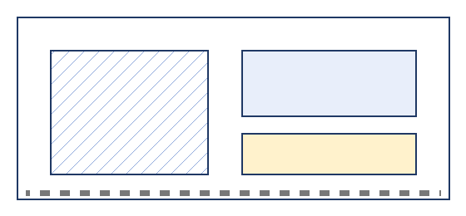

Distribution Centre Lease Summary
Prepared for the facilities committee.

Site overview
The site is organised so that inbound and outbound flows never cross. Trucks enter from the east gate, unload at the north hall and leave through the south lane, while staff parking and the visitor entrance stay on the west side. The site is organised so that inbound and outbound flows never cross. Trucks enter from the east gate, unload at the north hall and leave through the south lane, while staff parking and the visitor entrance stay on the west side.

Access and parking
Access is controlled at both gates. The lease includes 120 parking spaces, of which 24 are reserved for electric vehicles.
The site is organised so that inbound and outbound flows never cross. Trucks enter from the east gate, unload at the north hall and leave through the south lane, while staff parking and the visitor entrance stay on the west side. The site is organised so that inbound and outbound flows never cross. Trucks enter from the east gate, unload at the north hall and leave through the south lane, while staff parking and the visitor entrance stay on the west side.

Maintenance
The site is organised so that inbound and outbound flows never cross. Trucks enter from the east gate, unload at the north hall and leave through the south lane, while staff parking and the visitor entrance stay on the west side. The site is organised so that inbound and outbound flows never cross. Trucks enter from the east gate, unload at the north hall and leave through the south lane, while staff parking and the visitor entrance stay on the west side. The site is organised so that inbound and outbound flows never cross. Trucks enter from the east gate, unload at the north hall and leave through the south lane, while staff parking and the visitor entrance stay on the west side.

Space schedule
Building | Level | Use | Area (m²)
North hall | Ground | Loading docks | 1,850
North hall | First | Offices | 920
South hall | Ground | Cold storage | 1,240
South hall | First | Packing | 1,100
Total floor area |  |  | 5,110

Rent schedule
Year | Base rent | Service charge | Total
2027 | EUR 412,000 | EUR 38,500 | EUR 450,500
2028 | EUR 424,360 | EUR 39,600 | EUR 463,960
2029 | EUR 437,090 | EUR 40,800 | EUR 477,890

