Geological Storage of CO₂: Sensitivity and Risk Analysis
Meisam Ashraf
Dissertation for the degree of Philosophiae Doctor (PhD)

Department of Mathematics University of Bergen
October 2013
Scientiﬁc environment
This dissertation is submitted as a partial fulﬁllment of the requirements for the degree Doctor of Philosophy (PhD) at the University of Bergen. It is part of the project Mathematical Modeling and Risk Assessment of CO2 storage, MatMoRA, which was funded by the Norwegian Research Council of Norway, Statoil and Norske Shell under grant no. 178013/I30 and lead by Professor Helge Dahle at the Department of Mathematics, University of Bergen (UiB).
The working environment have been SINTEF-ICT in Oslo, CIPR in Bergen, and SIMTECH in Stuttgart. Professor Knut-Andreas Lie, chief scientist at SINTEF-ICT, has been the main adviser and Professor Jan M. Nordbotten at the Department of Mathematics, UiB, along with Halvor M. Nilsen, research scientist at SINTEF, have been co-advisers. With warm supports from Professor Rainer Helmig, head of Department of Hydromechanics and Modelling of Hydrosystems at Stuttgart University, last parts of the work is beneﬁted from advices of professor Wolfgang Nowak, head of Stochastic Modelling of Hydrosystems, Dr. Sergey Oladyshkin, postdoctoral fellow at SIMTECH, and Professor Holger Class at Stuttgart University.
Acknowledgements
I dedicate this to my father.
First and foremost, Knut-Andreas Lie was more than an adviser for me, whom I had the chance and honor to work with closely and in a daily-based manner. I learned a lot from discussions with Halvor M. Nilsen, initially my only friend in Norway. Jan
M. Nordbotten always inspired me in my works. Helge Dahle warmly helped me with every aspect of my studies. I have enjoyed working with Segrey Oladyshkin, Wolfgang Nowak, and Holger Class while spending a semester in Stuttgart University.
I would like also to acknowledge the sponsors of the MatMora project deﬁned in the University of Bergen in partnership with SINTEF-ICT and the University of Stuttgart, and the German Research Foundation (DFG) for ﬁnancial support of the project within the Cluster of Excellence in Simulation Technology (EXC310/1) at the University of Stuttgart.
Meisam Ashraf Trondheim, October 2013
Abstract
Geological CO2 storage is a key technology to be utilized for preventing industrial CO2 emission into the atmosphere. A successful storage operation requires safe geological structures with large storage capacity. The practicality of the technology is challenged by various operational concerns from site selection to monitoring the injected CO2 in the long-term.
The research in this report is aimed to address the signiﬁcance of a sophisticated geological modeling that can help in prediction of the storage performance. In the ﬁrst part, we investigate the signiﬁcance of assessing the geological uncertainty and its consequences in the site selection and early stages of the storage operations. This includes the injection period and the early migration time of the injected CO2 plume. The key part of the research is the extensive set of realistic geological realizations used in the analysis. The heterogeneity is modeled by the most inﬂuential geological parameters in a shallow-marine system. Among those parameters are the aggradation angle, levels of barriers in the system, faults, lobosity, and progradation direction.
A typical injection scenario is simulated over 162 realizations and major ﬂow responses are deﬁned to measure the success of the early stages of CO2 storage operations. These responses include the volume of trapped CO2 by capillarity, dynamics of the plume in the medium, pressure responses, and risk of leakage through a failure in the sealing cap-rock. Impact of geological uncertainty on these responses is investigated by comparing all cases for their performance. The results show large variations in the responses due to changing the geological parameters. Among the main inﬂuential parameters are the aggradation angle, the progradation direction, and the faults in the medium.
A sophisticated geological uncertainty study requires large number of detailed simulations that are time consuming and computationally costly. The second part of the research introduces a work-ﬂow that employs an approximating response surface method, which is called arbitrary polynomial chaos (aPC). The aPC is fast and sophisticated enough to be used practically in the process of sensitivity analysis and uncertainty and risk assessment. We demonstrate the work-ﬂow by combining the aPC with a global sensitivity analysis technique, namely the Sobol indices, which is a variance-based method and has proven to be practical for complicated physical problems. Probabilistic uncertainty analysis is performed by applying the Monte-Carlo process using the aPC. The results show that the aPc can be used successfully in an extensive geological uncertainty study.
List of papers
- M. Ashraf, K.A. Lie, H.M. Nilsen and A. Skorstad, "Impact of geological heterogeneity on early-stage CO2 plume migration: CO2 spatial distribution sensitivity study", submitted to the International Journal of Greenhouse Gas Con-trol(IJGGC).
- M. Ashraf, "Impact of geological heterogeneity on early-stage CO2 plume migration: pressure sensitivity study", submitted to the International Journal of Greenhouse Gas Control(IJGGC).
- M. Ashraf, S. Oladyshkin, W. Novak, "Geological storage of CO2: Application, feasibility and efﬁciency of global sensitivity analysis and risk assessment using the arbitrary polynomial chaos." , Published in the International Journal of Greenhouse Gas Control (2013).

Contents
Scientiﬁc environment i
Acknowledgements iii
Abstract v
List of papers vii
1 Introduction 1
1.1 Introduction................................ 2
1.2 Carbonstorage .............................. 3
1.3 Modelingprocedure ............................ 4
1.4 UncertaintySources ............................ 6
1.5 Geologicalmodeling ........................... 6
1.5.1 Geologicaldescription ...................... 7
1.5.2 Geologicalparameters ...................... 9
1.6 Flowequations .............................. 16
1.6.1 Singlephaseﬂow ......................... 17
1.6.2 Two-phaseﬂow .......................... 19
1.7 Flowregimes ............................... 23
1.7.1 Injectionandearlymigration . . . . . . . . . . . . . . . . . . . 24
1.7.2 Longtermmigration ....................... 26
1.8 Flowmodeling .............................. 27
1.8.1 Numericalscheme ........................ 27
1.8.2 Flowscenarios .......................... 29
1.8.3 Flowresponses .......................... 31
1.8.4 ECLIPSEinputﬁle ........................ 33
1.9 Sensitivityandriskanalysis ........................ 44
1.9.1 Stochasticanalysis ........................ 44
1.9.2 Arbitrary polynomial chaos expansion . . . . . . . . . . . . . . 44
1.9.3 Sensitivityanalysis ........................ 47
1.9.4 Riskanalysis ........................... 49
1.10Generalsummary ............................. 49
1.10.1 Implementationofthework-ﬂow . . . . . . . . . . . . . . . . 49
1.10.2 Genericapplicationofresults . . . . . . . . . . . . . . . . . . 50
List of Figures
1.1 Green-house gases act like a blanket trapping part of the heat received fromthesun. ............................... 3
1.2 Geological sequestration is a proposed solution for mitigating the industrialCO2emissions........................... 4
1.3 Modelingprocedurediagram. ....................... 5
1.4 Heterogeneities in ﬂuvial and beach depositions. Arrow in Figure (b) shows that the deposition mass is less heterogeneous than the ﬂuvial systems................................... 8
1.5 Stratigraphic heterogeneity levels in lateral and vertical directions. Modiﬁedfrom[46]. ............................ 11
1.6 Unfaulted ﬁne grid perspective view. Colors depict rock types, see Figures1.7and1.8. ............................ 11
1.7 Perspective view of the rock type variations for a selected case mapped onauniformgrid. ............................. 12
1.8 Six different rock types used in modeling the stratigraphic heterogeneities.ComparetoFigure1.7 ..................... 12
1.9 Histogram of lateral transmissibility for different facies and the entire ﬁne model for a selected case. Scales are logarithmic in units cP.m³/day/bar. ............................... 13
1.10 Logarithmic of lateral transmissibility plotted for four layers in ﬁne grid versus their representative layer in the coarse grid. Plots are top view and units are cP.m³/day/bar. .................... 14
1.11 Top view illustration of faults used in the faulted grids. The fault plotted in red corresponds to the upper boundary of the model on the crest. . . . 14
1.12 Lobosity levels are deﬁned based on the shoreline shape, which is caused by the interplay between ﬂuvial and wave forces. . . . . . . . . 15
1.13 Barrierlevelscausedbyperiodicﬂoods. . . . . . . . . . . . . . . . . . 15
1.14Aggradationanglelevels. ......................... 16
1.15Progradationlevels. ............................ 16
1.16Flowdomainandboundaries. ....................... 17
1.17 Permeability is an indication of how easy it is for the ﬂuids to ﬂow troughthemedium. ............................ 18
1.18 Wettability and interfacial tension in water-CO2 system. Water is the wettingphaseinthisexample. ...................... 19
1.19Multi-phaseﬂowintheporescale. .................... 19
1.20 Two-phase ﬂow and relative permeability. . . . . . . . . . . . . . . . . 20
1.21 Capillary pressure can be expressed as a function of wetting saturation. The plot is a typical curve of capillary pressure function with a maximum of Pcmax............................ 21
1.22 Capillary pressure distribution in the transition zone. . . . . . . . . . . 21
1.23 Saturation distribution in the capillary transition zone. . . . . . . . . . . 22
1.24 FlowregimesingeologicalCO2storage. . . . . . . . . . . . . . . . . . 27
1.25 Transmissibility calculation for two cells a and b. . . . . . . . . . . . . 28
1.26 Wellmodelinginsideasimulationcell. . . . . . . . . . . . . . . . . . . 28
1.27 Top, bottom, and upper side boundaries are closed and the rest are open totheﬂow. ................................. 30
1.28Externalpressuredrive. .......................... 31
1.29MobileandresidualCO2volume. .................... 31
1.30 We use a 2D Gaussian distribution for leakage probability on the cap-rock..................................... 32
1.31 Transmissibility in the vertical direction for two selected cases. The left plots correspond to case A in Table 1.4, and the right plots belong to case B. Colors are in log scale and the scale in Figures (a) and (b) are powers of ten in cP.m³/day/barunits. ................. 34
1.32 Transmissbility in the lateral direction for two selected cases. The left plots correspond to case A in Table 1.4, and the right plots belong to case B. Colors are in log scale and the scale in Figures (a) and (b) are powers of ten in cP.m³/day/barunits. ................... 35
1.33 CO2 distribution at the end of injection for two selected cases. The left plots correspond to case A in Table 1.4, and the right plots belong to caseB. ................................... 36
1.34 CO2 distribution at the end of simulation for two selected cases. The left plots correspond to case A in Table 1.4, and the right plots belong tocaseB. ................................. 37
1.35 Flow sign in the Y direction at the end of injection for two selected cases. The left plots correspond to case A in Table 1.4, and the right plots belong to case B. Blue color corresponds to down-dip direction, red to up-dip direction, and green represents the stagnant ﬂuid. . . . . . 38
1.36 Mobile CO2 distribution at different times for two selected cases. Cases A and B are described in Table 1.4. Compare with Figures 1.31 and
1.32 for transmissibility values in different directions. Colors represent thesamerangesshowninFigure1.34. . . . . . . . . . . . . . . . . . . 39
1.37 Pressure development during injection and early migration. Pressure differences from hydrostatic pressure are shown for two selected cases. Values are in bar. Cases A and B are described in Table 1.4. Compare with Figures 1.31 and 1.32 for transmissibility values in different directions.................................. 40
1.38 Marker codes used to plot the simulation results of all cases together. . . 41
1.39 Flow-chart of work process implemented in an automated procedure. . . 50
Chapter 1
Introduction
1.1 Introduction
“We won’t have a society if we destroy the environment”
– Margaret Mead, American cultural anthropologist, 1901-1978
Climate changes resulting from the contribution of human CO2 emissions as green-house gas has been shown by studies such as [36]. The underground sequestration of the CO2 produced from localized sources like power-plants and oil and gas recovery sites is proposed as a possible solution to reduce the rate of CO2 emission into the atmosphere [11, 35]. The technology required to inject CO2 is similar to what is in use in the oil, gas, and mining industry. However, there are some challenges that are speciﬁc to carbon storage operations. Primary, the temporal and spatial scales in these problems are larger. Secondary, the risk of leakage of stored CO2 up to the surface via natural features like fractures and faults or via man-made features such as leakage through ill-plugged wells and broken cap-rock due to high pressure imposed to the system during the injection operations is a major concern.
The main objectives of carbon storage operations are to maximize the storage volume and the volumetric injection rate, and to minimize the risk of leakage of the stored CO2. The CO2 storage operations require multidisciplinary collaborations. The work-ﬂow from initial phases of a project until end of storage operations are divided between government and private sector, research organizations and industry. In particular, it is the task of the research community to investigate the safety of CO2 sequestration and provide the methodology for CO2 fate prediction [5].
Bachu [5] discusses a road-map of site selection for geological CO2 sequestration. He deﬁnes the process in three steps: to assess the general suitability of the site, to perform an inventory study on the source point and storage location and the operational transport issues, and ﬁnally to investigate the safety and assess the capacity of the storage. Issues about safety and storage capacity are looked at differently from the perspective of immediate and ultimate results. For example, when talking about the risk of leakage, we might consider the leakage through ill-plugged wells or fractures during the injection time as the immediate risk. On the other hand, leakage caused by plume migration long time after the injection and contamination to other aquifer systems are considered as ultimated risks.
To predict the fate of the injected CO2, it is crucial to study the dynamics of ﬂow in the storage medium. Dynamical study of ﬂow includes quantiﬁcation of acting forces in a geological heterogeneous medium as well as in solving a complicated system of mathematical equations. It seems convenient to replace the geological heterogeneous medium with an equivalent homogeneous medium to simplify the solution of the ﬂow equations. However, proper modeling of geological heterogeneity is a major control on reservoir assessment and carbon storage studies [6, 19, 49, 50].
In this thesis, we report a series of studies performed within a PhD program under the MatMora project. MatMora is a strategic project that is deﬁned to address the needs of mathematical tools to develop a modeling work-ﬂow. The work in this thesis is focusing on the fundamental uncertainty in geological description. The work is reported in a series of papers, and the objective is to perform a sensitivity analysis on a set of geological parameters used to describe the geology of shallow-marine depositional systems. Although the focus is on a particular depositional system, the procedure can be implemented for other systems of interest.
We start the introduction section by discussing the global warming and its causes, and the carbon storage as an interim proposed solution to mitigate the increasing level of industrial CO2 emission to the atmosphere. Section 1.3 provides the work-ﬂow of the works reported in the thesis. A brief overview of literature is given and the work is discussed in that section.
In Section 1.5, we review a systematic deﬁnition for uncertainty from the literature and after that, the geological uncertainty and parameters are described. Flow equations for single-phase and two-phase
1.2 Carbon storage
Figure 1.1: Green-house gases act like a blanket trapping part of the heat received from the sun.
ﬂow problems are discussed in Section 1.6. In Section 1.7, various ﬂow regimes occurring during geological storage of CO2 are described brieﬂy by discussing the force balance within the medium at different times.
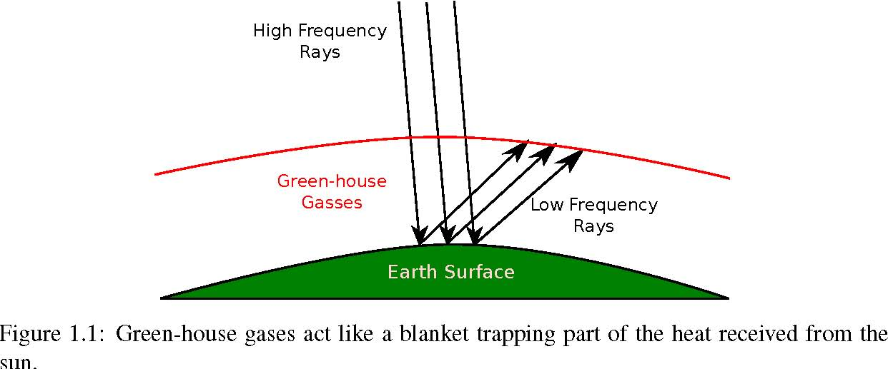
The introduction to the thesis continues in Section 1.8 by a discussion of ﬂow simulation scenario and assumptions taken in the work. We use a set of ﬂow responses that monitor the performance of the operation in a typical carbon storage problem, with a special emphasis on the injection and early migration of CO2 in the medium. Flow dynamics and a linear sensitivity analysis performed on the simulation results are discussed in this section.
Section 1.9 provides an overview on the techniques that can be used for rapid ﬂow simulation. We use a response surface method to evaluate the ﬂow responses. This proxy model is then used in a global sensitivity analysis and Monte-Carlo risk assessment process. The introduction ends by introducing the MATLAB functions used in our work-ﬂow.
1.2 Carbon storage
There are a number of theories that explain the causes of climate change. Milankovich theory [29] relates the energy received from the sun to the cyclical variation of earth orbit around the sun, and earth rotation around its axis. The earth orbit changes eccentricity between circular and elliptical. This inﬂuences the difference between earth and sun, and on its maximum inﬂuence can lead to about 20% difference in the energy received from the sun. The second variation occurs in the rotation of earth around its plane axis. This rotation wobbles approximately every 13600 years and the summer solstice switches from June to January. Also, a tilt variation of earth rotational axis happens approximately after every 41000 years. This can cause warmer winters and colder summers in high latitudes [29]. The solar radiation changes by a small amount of 0.1% over a 11 year cycle. Also on the scales of tens to thousands of years variations in the earth orbit result in seasonal changes and that in the past caused glacial and inter-glacial cycles.
The theory of green house effect relates the earth climatic change to the fact that the long wave radiation from earth back to atmosphere is absorbed by the green-house gases, mainly carbon dioxide, water vapor, and methane existing in the atmosphere. This results in trapping of heat energy and an increase in atmosphere temperature level (Figure 1.1) [29].
Human manipulations in the nature has led to approximately 100 ppm increase in carbon dioxide level in the atmosphere. Most scientists believe that we are already experiencing the global warming due to green house effects. The IPCC Second Assessment report states that the observed warming trend since the late 19th century is unlikely to be entirely natural in origin and is partly due to anthropogenic causes [14].
Figure 1.2: Geological sequestration is a proposed solution for mitigating the industrial CO2 emissions.
Carbon capture and storage (CCS) has got a major attention in the industry and the scientiﬁc communities. According to the International Energy Agency (IEA), the cost of mitigating climate change by 2050 is estimated to be 70% higher without implementing CCS [39].
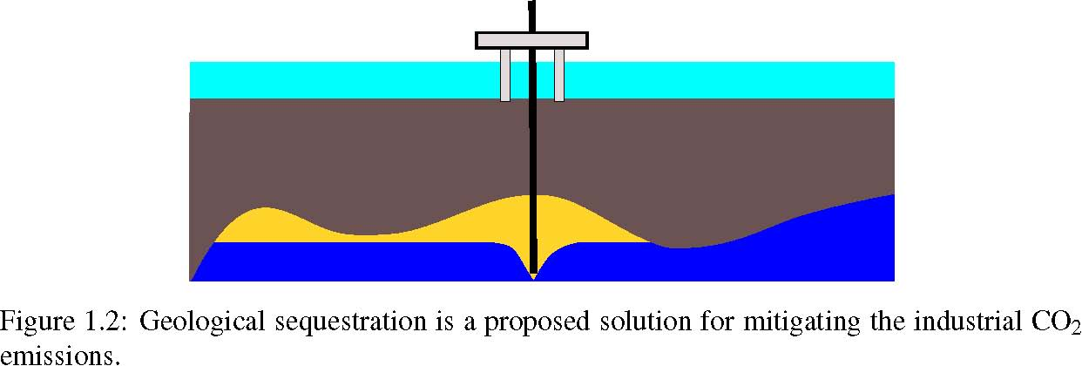
The CCS is considered as an interim solution, because it is valid due to fossil fuel consumption, and the long term strategy of replacing fossil fuel with renewable energy will terminate the validity of the CCS. Therefore, initiating CCS has to be done in a reasonable fashion such that it does not slow down the research for renewable energy. Another concern regarding CCS is the acceleration of coal and fossil fuel consumption with the excuse of availability of CCS technology.
Sequestration of CO2 at the ocean ﬂoor and also in deep underground aquifers (Figure 1.2) are some of the options available for permanent storage of CO2. Large availability of storage volumes and potential for almost permanent storage makes the geological sequestration an appropriate option. Nevertheless, this alternative is not free from economical, social and industrial concerns.
In the last decades, the scientiﬁc community has been putting efforts into convincing the public about the feasibility of these operations. A fair public acceptance must be based on social awareness. Any plan to increase the acceptance level in a society starts by measuring the current knowledge level of that society. The EU has conducted a survey to assess the public awareness in 12 European states. This survey is published in the recent Eurobarometer report in May 2011. People’s awareness and acceptance of climate change and its causes, and the methods to avoid or mitigate the problems, in particular the CCS technology, was examined in the survey. The majority of European participants are either fairly or very well informed about causes and consequences of climate change. However, the awareness of the CCS in between the European respondents was low. Two third of the participants in the survey have had not heard at all about the CCS.
The same survey suggests that the overall trust in Europe in the sources of information regarding the CCS is best in universities and other scientiﬁc institutions. Governments are investing in research, not only to move toward industrialization of the CCS, but also to make it well received by public. This highlights the importance of researching the storage of CO2 and the way it is needed both for industrial demands and social concerns.
1.3 Modeling procedure
Predicting the fate of CO2 storage involves identiﬁcation and quantiﬁcation of the relevant uncertainties and risk assessment process. The procedure starts with a geological description and continues with modeling of ﬂow in geological formations. After constructing a deterministic ﬂow model, the stochastic nature of the problem is analyzed by studying the variation in the model outcome due to uncertainties in the system.
Figure 1.3 shows the modeling work-ﬂow implemented in this thesis. The steps are categorized in three parts: geological uncertainty, ﬂow dynamics, and stochastic analysis. The relations between the steps are plotted by arrows in the ﬂow-chart. In this section, we brieﬂy describe each step. More details
1.3 Modeling procedure
Figure 1.3: Modeling procedure diagram.
will follow in the next sections.
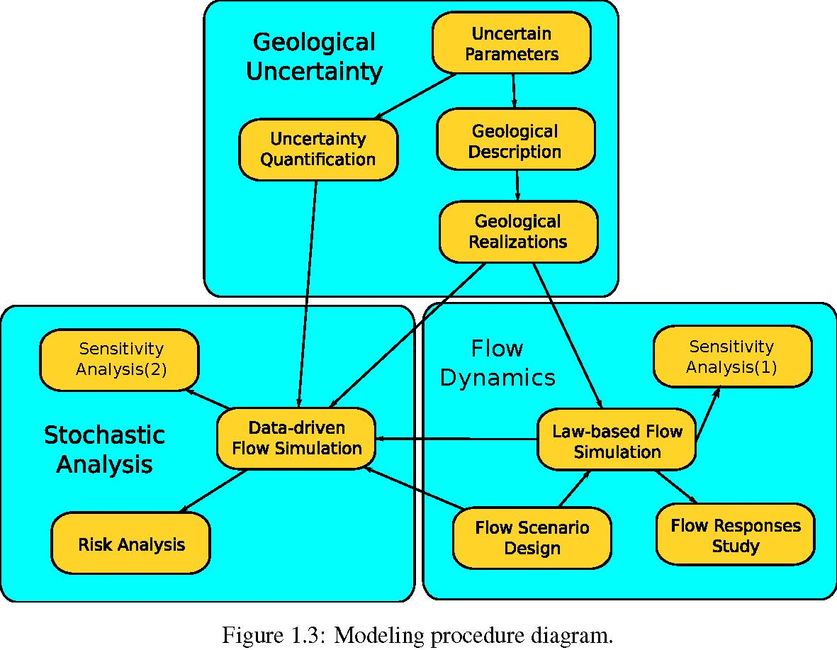
Uncertain parameters: In the ﬁrst step, we identify the uncertain parameters of the model to study their inﬂuence in the modeling outcome. It is possible that our knowledge of model sensitivity to the parameters is limited. Then, in a conservative approach we choose a larger number of parameters and by doing a primary sensitivity analysis with a fast technique, we ﬁlter out the important parameters. Herein, the focus is on geological parameters that are determined to be the most inﬂuential sources of geological uncertainty for a shallow-marine environments [38].
Uncertainty quantiﬁcation: After identiﬁcation of the uncertain geological parameters, we assign a likelihood to each of the parameters. It is hardly possible to have a unique likelihood template that applies to every geological location. Thus, we note that probabilities of existence for an uncertain geological feature can change from place to place. The uncertainty enters the modeling in the form of parameter frequency histograms. The conventional practice is to consider an analytical distribution function to be assigned to the parameters. However, the sampling procedure normally ends in scarce frequency histograms that are difﬁcult to ﬁt into a unique analytical distribution function.
Geological description: Geological uncertainty study is normally done by series of runs to measure the sensitivity of the model to the parameter variations. Results are valid, only if the geology used in the work-ﬂow is representative of reality. The process of geological description results in a large number of realizations to be used in the next steps of the study. Herein, we will use a set of equiprobable geological realizations of a shallow-marine reservoir.
Flow scenario design: Herein we deﬁne the initial and boundary conditions of the CO2 injection problem. Also, we specify the injection scenarios. Possible simplifying physical assumptions will be taken here. Each scenario is implemented for all geological realizations.
Law-based ﬂow modeling: After deﬁning the injection problem, we simulate the ﬂow dynamics in the chosen realizations. We use a two-phase ﬂow model and a standard commercial simulator. Data-driven ﬂow modeling: Modeling the ﬂow dynamics via formulations of physical laws normally results in complicated equations with many degrees of freedom. The computational cost of solving these equations is high, in particular for uncertainty related studies that require a large number of simulations to cover the variation in the uncertain parameters. So called data-driven methods, are mathematical functions that are speciﬁed by correlating a set of unknown ﬂow attributes to their corresponding uncertain parameter values. These methods need to be tuned by a law-based method before employment. Because these methods are designed to be only dependent on the uncertain parameters, they are normally low in computational costs. However, they may exhibit the pitfall of not following the physical rules and in some cases produce unrealistic results.
Flow responses study: Once the simulation results are obtained from the ﬂow modeling procedure, it is possible to calculate the important ﬂow responses from simulation results. The fate of carbon storage and assessment of the operations can be inferred from these responses. Storage capacity, injection rate, and leakage risk are evaluated from ﬂow responses. Responses include pressure distribution over time. CO2 plume development, and other quantities describing the dynamics of ﬂow.
Sensitivity and risk analysis: The sensitivity analysis is performed in two ways: ﬁrstly by using three-dimensional, two-phase ﬂow simulations on all realizations available for demonstrating the geological variability. In the second method, we employ an approximating polynomial to perform global sensitivity analysis and stochastic uncertainty studies. Using the relatively fast data-driven method, we perform a Monte-Carlo process on 10000 simulation cases.
1.4 Uncertainty Sources
Sources of uncertainty can exist in every part of the CO2 storage modeling process. Herein, we brieﬂy describe each of the possible contributions to the uncertainty in modeling within various parts.
Uncertainty in physical modeling: We might ignore some phenomena during the physical modeling of CO2 storage that can be inﬂuential in the ﬂow behavior. This might happen due to lack of awareness of the phenomena or by underestimating the signiﬁcance of it. For example, we might ignore the heat exchange within the system, assuming that heat transfer does not play an important role in the ﬂow performance. If some parameters in the modeling are sensitive to the heat and change by temperature variations, the assumption to ignore heat transfer effect can introduce considerable bias in the outcome of the modeling.
Mathematical formulation and numerical approximation: Modeling CO2 injection and migration in a realistic geological formation results in a complicated mathematical system that in most of the cases can not be solved analytically. The numerical approach to approximate the original mathematical system, normally introduces errors in approximation. Mathematical analysis can help in estimating the error or its order, but it might not be doable for complicated models.
A speciﬁed physical problem can be formulated mathematically in more than one way. The choice of primary unknowns to be found can change the mathematical form and nature of the equations. Degrees of non-linearity and coupling between unknowns in the equations can vary in different formulations.
Geological uncertainty: The high costs of data acquisition and technical limitations introduce a huge amount of geological uncertainties in CO2 storage modeling. The injected CO2 may travel in a large spatial scale. Providing enough geological information and the medium attributes is a big challenge.
User introduced uncertainty: These type of uncertainties are caused by the errors introduced by a user for his/her biased choice of modeling tools and interpretations of modeling results.
1.5 Geological modeling
The central part of a successful CO2 storage modeling is to provide aquifer models that depict the geological heterogeneity in a realistic manner. This requires having an inclusive understanding about model
1.5 Geological modeling
sensitivity with respect to different geological parameters and quantiﬁcations of geological uncertainty and its impacts on the process.
The conventional practice of geological modeling includes using geostatistical models. It is possible that two different heterogeneity patterns produce the same geostatistical model, as discussed by Caers [12]. Therefore, a geostatistical model does not represent a unique reservoir image and if we do not include additive information in the process, we might end-up with an unrealistic heterogeneity texture[12, 19]. The primary attention in our work has been on this issue and to provide a more realistic way of geological uncertainty analysis for CO2 sequestration by including information of geological features and textures in the process.
1.5.1 Geological description
Geological storage of CO2 requires large accommodation of subsurface volumes. Only sedimentary basins, which hold relative large pore volumes, are generally suitable for this mean. However, not all sedimentary basins are similarly appropriate for CO2 sequestration.
Convergent basins along active tectonic areas pose a higher risk of CO2 leakage due to volcanism, earthquakes, and active faults. Divergent basins located on the stable lithosphere are much less prone to earthquakes or other catastrophic event that can lead to accidental releases of large CO2 quantities. Therefore, speciﬁc considerations must be done in selecting site locations with respect to security of subsurface storage.
Sedimentary basins are composed of various lithological facies. Stratigraphic architecture and sand-body geometry control the capacity and effectiveness of CO2 sequestration. As a result of various tectonic depositional and erosional process, low and high permeability rocks are accumulated on top of each other and can form stratigraphic ﬂow-path leading to various directions and speed of subsurface ﬂow. Three types of formations can be characterized: aquifers, aquitards, and aquicludes.
Aquifers are high permeability strata that provide major beddings for ﬂow transport. Good rock quality in continuous sandbodies allow for efﬁcient CO2 storage in an acceptable capacity volumes. Aquitards are made of low permeability strata that provide beddings with orders of magnitude slower ﬂow than aquifers. Layers of aquifers and aquitards are formed by thick accumulation of sediments that undergo burial, compaction, lithiﬁcation and uplift over millions of years. They can be covered by aquicludes, which are evaporative beds that are impervious to ﬂuid ﬂow. Typical seal rocks include, from most ductile to most brittle: salt, anhydrite, krogen-rich shales, dense mudstone, tightly cemented sandstones, anhydrite-ﬁlled dolomite, carbonate, or silica-cemented sandstones, and cherts.
Aquifer pressure is normally close to hydrostatic, because of the conductivity within the medium allows for pressure equilibrium over long time. High pressurized compartments can exist in highly sealed structures. The pressure of the sedimentary basin has a signiﬁcant impact on its suitability for CO2 storage [5]. Trapping mechanism for CO2 is in two main parts: stratigraphic and structural traps. Stratigraphic trapping is primarily controlled by the geometry of depositional facies and sand body continuity. These factors control the permeability distribution within the medium that controls the efﬁciency of injection and storage of CO2. Structural heterogeneity factors include faults, folds, and fracture intensity. The dip angle of formation layers control the buoyancy forces that govern on CO2 plume migrating along the conductive layers. Fractures can enhance the mobility of the plume and sealing faults can provide structural traps for long-term CO2 storage. Anticline structures also can be permanent traps for stored CO2.
Depositional environment varies between ﬂuvial to marine systems. The texture and degree of sandiness of beach deposits are functions of the shore proﬁle, typically consisting of a gently sloping formation layering in a transition from near shore to deep offshore. Deposits range from sandy, coarse grain structure near the shore, to muddy, burrowed, ﬁne grained sand in the lower off shore. High energy near the shore that is a result of interplay between wave, ﬂuvial, and tidal forces, ﬁlters out the larger grains in the deposition.
Therefore, formations closer to the shore contain large continuous sand bodies that have good qual
Figure 1.4: Heterogeneities in ﬂuvial and beach depositions. Arrow in Figure (b) shows that the deposition mass is less heterogeneous than the ﬂuvial systems.
ity rock. This is the reason for shallow-marine systems to be appropriate traps for hydrocarbons and analogously, good candidates for CO2 storage.
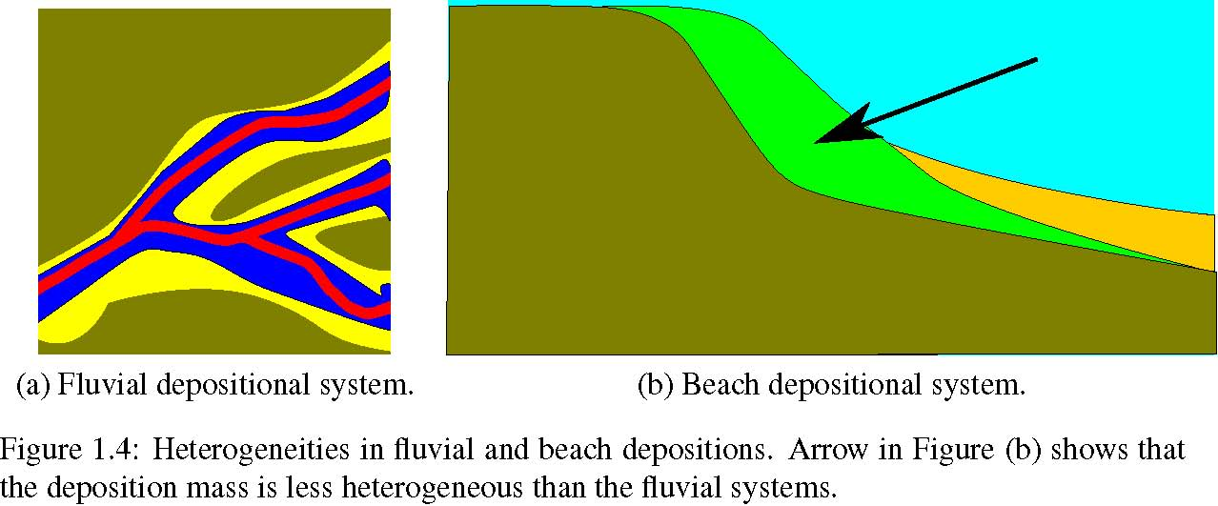(a) Fluvial depositional system. (b) Beach depositional system.
The beach facies normally are homogeneous rocks with internal heterogeneity due to tidal systems. In contrast, mixed-load ﬂuvial deposits that contain both mud and sand are more heterogeneous than beach systems. The presence of numerous mud drapes as a result of periodic ﬂoods, serve as barriers to ﬂuid ﬂow. Heterogeneity in the ﬂuvial systems exist on multiple scales, from small-scale variations of rock type near the river bed, to the large-scale heterogeneity in ﬂuvial channel-ﬁll sandstones and over-bank deposits. Heterogeneity also occurs within these systems in the form of muddy abandoned channel-ﬁll deposits.
In theory, we prefer a medium that allows for more lateral movement to overcome the buoyancy bypassing of the ﬂow. Heterogeneity in the vertical direction, such as shale inter-bed barriers can serve for this and disperse the ﬂow in the lateral direction. Structural heterogeneities can have a similar impact. In addition, splitting a large plume into smaller plumes lowers the risk of leakage of huge CO2 amounts via potential breakings in the integrity of the sealing barriers or abandoned wells.
CO2 injectivity is related to sequestration capacity and effectiveness, and can be deﬁned by the conductive cross-sectional area. Stratigraphic factors that enhance injectivity are high permeability and injection interval thickness. In addition, the lateral permeability architecture can inﬂuence the injectivity quality. The lower the injectivity is, the higher will be the pressure buildup in the medium due to injection.
Over the last two decades, there have been a large number of studies concerning the subsurface storage of CO2. Several authors investigate the efﬁciency of geological CO2 storage based on regional data in a speciﬁc site location. A case study from the Texas Gulf Coast [37] investigates the sequestration capacity and efﬁciency in accordance to the geological heterogeneity. The study performs a site-scale assessment of brine aquifers for geological CO2 sequestration. Injection is considered in the Frio formation which is a sandstone-rich, high quality, overlain by a thick, regionally extensive shale in the upper Texas Gulf Coast. Migration of CO2 during injection (20 years), and post-injection (40 years) is studied in different geological realizations. The heterogeneity represented by stochastic modeling of geological sediments. Structural heterogeneity is modeled by layers dip angle and faults at different locations. Six models are made based on regional available geological information. The study shows that in a homogeneous rock volume, CO2 ﬂow paths are dominated by buoyancy, bypassing much of the lateral rock volume. If the permeable rock is inter-bedded with multiple low permeability layers, the ﬂow paths are dispersed, enhancing the lateral movements of CO2 and allowing for larger percentage of contact with rock volume. The study suggests that dip angle enhances buoyancy forces and decreases storage capacity, while compartmentalization by faulting appears to increase sequestration capacity at the cost of increased pressure, and consequently, increased risk of CO2 leakage.
A number of pilot sites are established worldwide to test the large-scale injection of CO2 in the
1.5 Geological modeling
subsurface formation. The In Salah project [59] in Algeria is an industrial-scale injection project into a fracture-inﬂuenced, matrix-dominated sandstone formation. The reservoir matrix comprises tidal deltaic sandstone. The project beneﬁts from relatively high level of data acquisition: wireline and LWD well logs, image logs and production and geophysical monitoring [59]. In addition, the most valuable monitoring method has been the use of satellite airborne radar above the injection well. Also, chemical tracers are used in the injected CO2 to differentiate the natural CO2 in place from the injected volumes, when the CO2 breaks through other wells. The detailed analysis highlights the geological controls on the movement and dispersion of CO2 plumes. The injection is performed via a horizontal well perpendicular to the geomechanical stress ﬁeld and the faults present in the domain. This, along with the fracture network, enhance the plume migration-about three times faster than the ﬂow in a homogeneous domain. Results from In Salah illustrate the value of reducing geological uncertainty by employing sufﬁcient logging tools and monitoring techniques.
The CO2-SINK project at Ketzin Germany [28] is another pilot site for practicing subsurface CO2 injection. The injection is performed in the Stuttgart formation that is geologically heterogeneous within an anticline structure. The Stuttgart formation is made of sandy channel facies of good rock quality alternate with muddy ﬂood-plain-facies. A thick cap-rock section covers the Stuttgart formation.
Practically, including all details of every scale into a ﬂow simulation model is impossible. Various simpliﬁcations have been made to account for heterogeneities in modeling. Some earlier studies consider two dimensional modeling, with homogeneous or geostatistically populated permeabilities. The study in [45] simulates an escape rate of CO2 in a homogeneous medium similar to Utsira formation in Norway. By changing the horizontal permeability, they demonstrate that most of the injected CO2 volume accumulates in a ﬁne layer beneath the cap-rock due to buoyancy forces in the long-term CO2 migration process. However, this study assumes no vertical heterogeneities. A layered heterogeneity is examined in [68]. They used a log normal distribution of permeability in a simpliﬁed two dimensional grid to account for viscous and gravity forces. Results suggest that the sweep efﬁciency of CO2 in the porous medium is low, and heterogeneity, in particular the vertical transmissibility, can have a big impact on the storage efﬁciency.
To examine the impact that the geological heterogeneity degree can have on the CO2 sequestration modeling, [26] constructed a suite of three-dimensional simulation models, with varying net to gross ratios. A radial variogram, with a shale length of 300 m, was used to populate ﬁve models of varying degrees of net-sand-to-gross-shale ratios. The models were up-scaled, using ﬂow-based methods, to make the computation feasible. The study concludes that formations containing shale barriers are effective in containing an injected CO2 plume within the formation and that heterogeneity serves to limit the reliance of the formation seal as the only mechanism for containment.
1.5.2 Geological parameters
From the ﬂow modeling perspective, sources of geological uncertainty can manifest themselves in the rock parameters that go in the ﬂow equation such as permeability and porosity. However, to represent the geological uncertainty, it is not enough to randomize these parameters. This approach might work in simple geological models, but it can fail to give plausible results for the realistic heterogeneous problems with uncertain structural and depositional descriptions.
In response to the EU priorities of reducing time to ﬁrst oil and of improving overall hydrocarbon recovery efﬁciency, the interdisciplinary SAIGUP study was initiated to increase the understanding of the inﬂuence of geological uncertainties in oil ﬁeld recoveries. SAIGUP stands for ’sensitivity analysis of the impact of geological uncertainties on production forecasting in clastic hydrocarbon reservoirs’. The context in SAIGUP is deﬁned for shallow-marine depositional systems. The main objective of the SAIGUP project has been to perform a quantitative sensitivity analysis to measure the impact of sedimentological and structural variations within geological descriptions on oilﬁeld recovery estimates [38, 46, 47]. Herein, we will use six different rock types to investigate the impact of geological heterogeneities on CO2 sequestration. The rock properties within each facies are populated based on real data.
Table 1.1: Grid speciﬁcations for ﬁne and coarse scales in the SAIGUP modeling process.
Parameter Fine Scale Coarse Scale Number of cells in the x direction Number of cells in the y direction Number of cells in the z direction Number of total cells Number of active cells Model x dimension Model y dimension Model z dimension 80 240 80 1,500,000 1,500,000 3 km 9 km 80 m 40 120 20 96,000 79,000 3 km 9 km 80 m
Variations are considered in a horizontal-vertical matrix in three levels of heterogeneities, low, medium, and high, as illustrated in Figure 1.5. The design focused on special considerations. For example, making complex enough heterogeneities to be a plausible representative of realistic models, and producing large enough number of realizations with sufﬁcient overlapping to be able to perform a quantitative sensitivity analysis.
Sedimentological variability is modeled in small and large scales and combined to provide realistic variations of reservoir heterogeneities. All models are considered in a progradational sedimentary environment. A regular grid is used for all of the realizations in two gridding resolutions, ﬁne and coarse, and the total bulk volume is the same in all cases. Each geological realization contains about 1.5 million cells in the ﬁne model. Figure 1.6 shows the ﬁne grid model for a selected realization with medium level of heterogeneity. A major fault in the model breaks the structure and makes large vertical depth difference in the two parts of the model (from about 1500 m to 3000 m). Thickness of the model is much smaller than these depth differences. To make it easier to see the property variations on the grid in the vertical direction, we map the properties on a ﬂat uniform geometry (Figure 1.7).
Figure 1.8 shows the spatial distribution of the six modelled facies in the selected realization, and Figure 1.9 shows the histogram of lateral transmissibility within each facies and the total model in the logarithm scale. Each facies is modeled separately in some levels of upscaling starting from the lamina scales, before populating on the ﬁne grid. Flow based upscaling techniques are used, and the suitability of the methods depends on the balance of forces. When the medium is conductive due to high permeability, the viscous dominated steady state method is used. In the rocks with lower transmissibility where the capillary forces are dominant, the capillary equilibrium is assumed [46].
On the last step, the ﬁne populated grid is mapped on to the coarse grid that is to be used for the ﬂow solver. Since the grid size in the ﬁne model is too expensive computationally for ﬂow simulations, the lateral dimension is doubled in each cell while every four layers are lumped into one layer in the vertical direction. Figure 1.10 shows the top view of lateral transmissibility in logarithmic scale for four consecutive layers of a selected case, and their corresponding upscaled layer in the coarse grid. Table
1.1 shows the grid speciﬁcations in the coarse and ﬁne SAIGUP models. A detailed discussion about the upscaling the Sedimentological and structural parameters for SAIGUP simulation models can be found at [46].
Structural aspects are modeled via fault modeling. Within the SAIGIP setup, faults are considered in different levels of intensity, orientation, and transmissibility. The orientations may vary in both lateral directions, and we consider a grid that contains faults in both directions (Figure 1.11).
Although these models were designed to study the impact of geological heterogeneity on oil recovery, they may also be used to model a scenario in which CO2 is injected into an abandoned reservoir. Therefore, we have selected ﬁve parameters from the setup and varied these parameters by combining different levels for our CO2 storage study. These features are lobosity, barriers, aggradation angle, progradation, and fault. In the following, we describe each feature brieﬂy.
1.5 Geological modeling
Figure 1.5: Stratigraphic heterogeneity levels in lateral and vertical directions. Modiﬁed from [46].
Figure 1.6: Unfaulted ﬁne grid perspective view. Colors depict rock types, see Figures 1.7 and
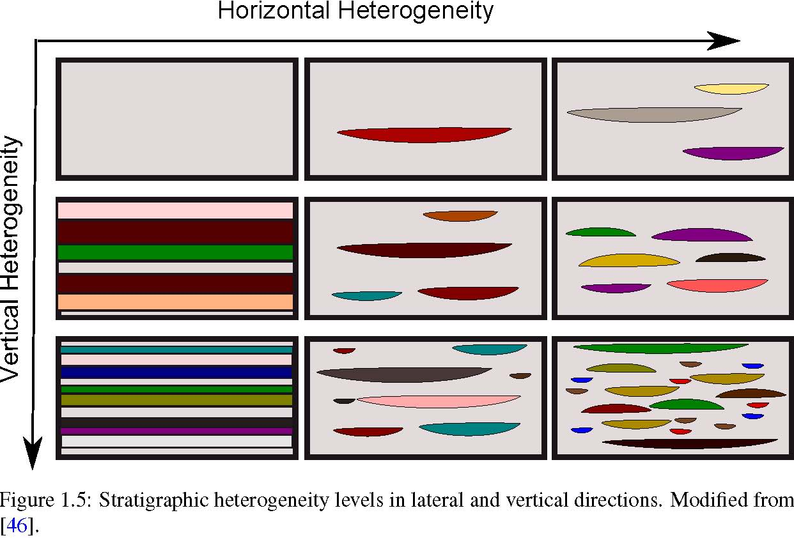
Figure 1.7: Perspective view of the rock type variations for a selected case mapped on a uniform grid.
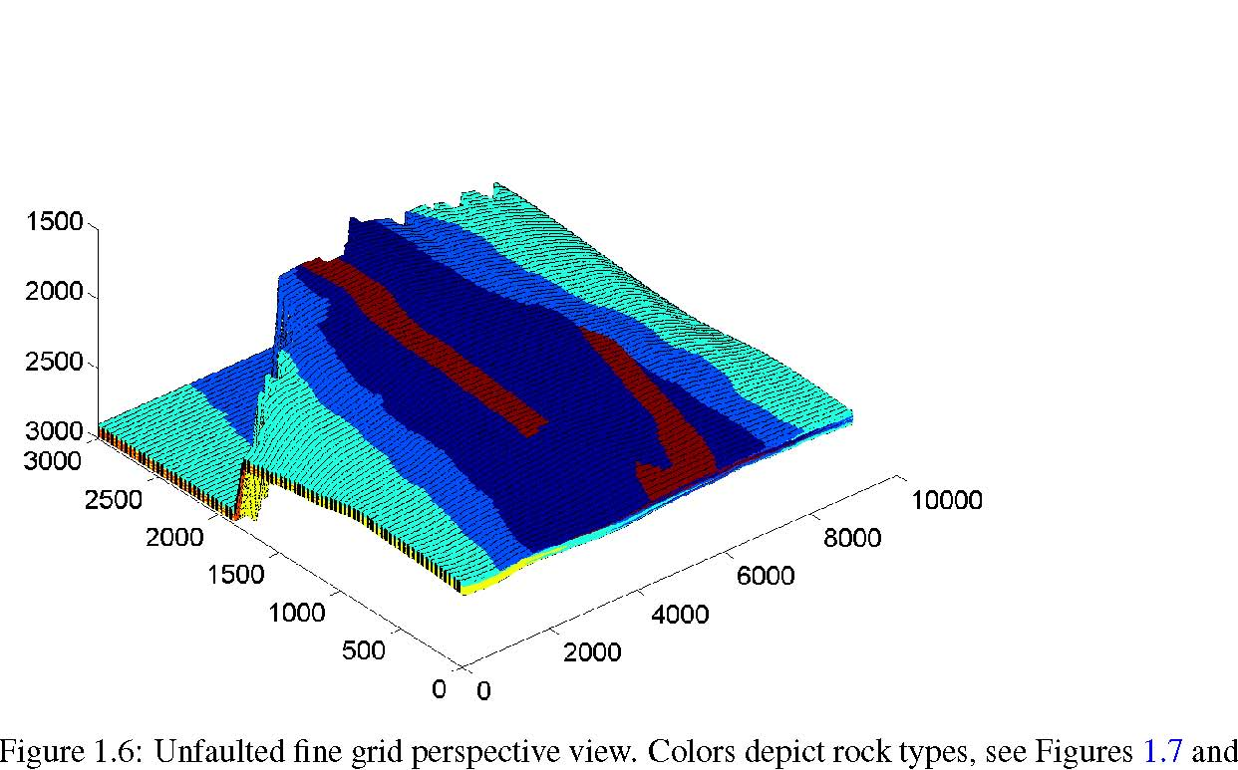1.8.
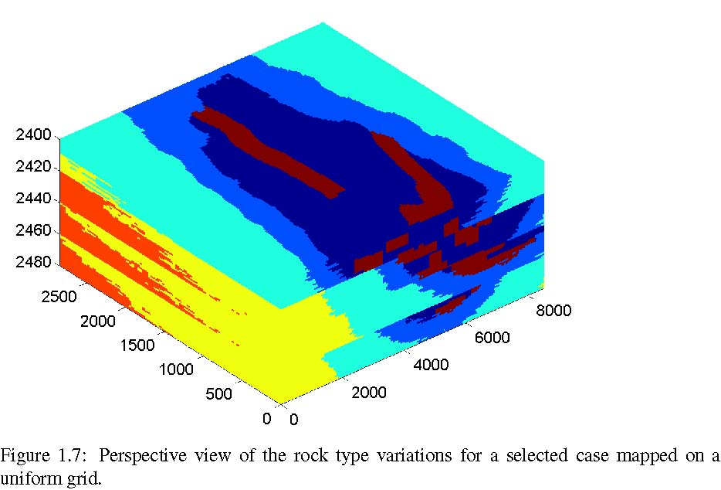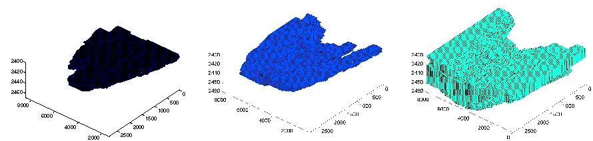(a) Coastal Plain (b) Lower Shoreface (c) Upper Shoreface
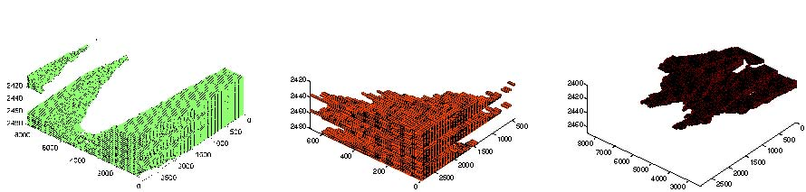(d) Offshore Transition (e) Offshore (f) Channels
Figure 1.8: Six different rock types used in modeling the stratigraphic heterogeneities. Compare to Figure 1.7 .
1.5 Geological modeling
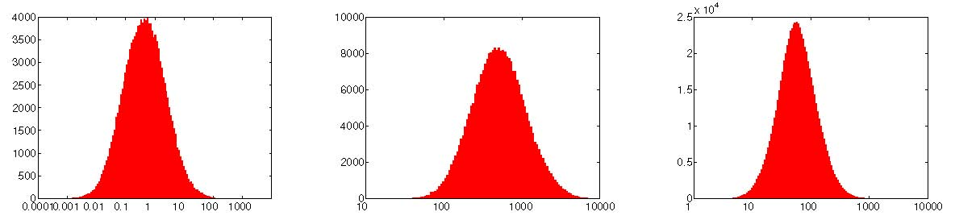(a) Coastal Plain (b) Lower Shoreface (c) Upper Shoreface
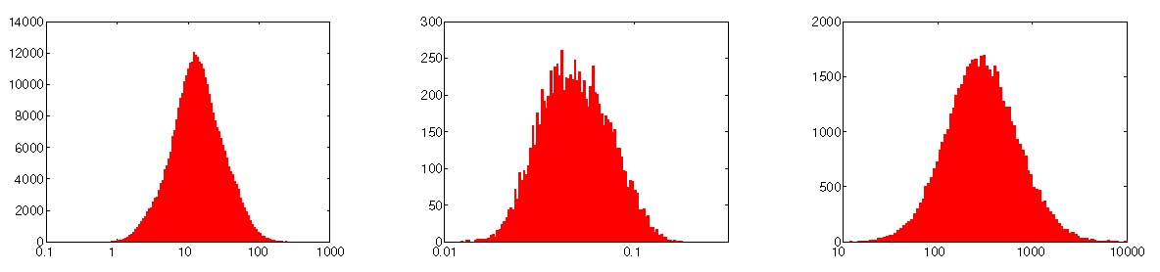(d) Offshore Transition (e) Offshore (f) Channels
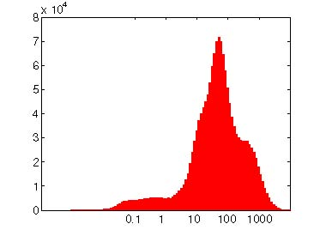(g) All facies
Figure 1.9: Histogram of lateral transmissibility for different facies and the entire ﬁne model for a selected case. Scales are logarithmic in units cP.m³/day/bar.
(a) Coarse grid.
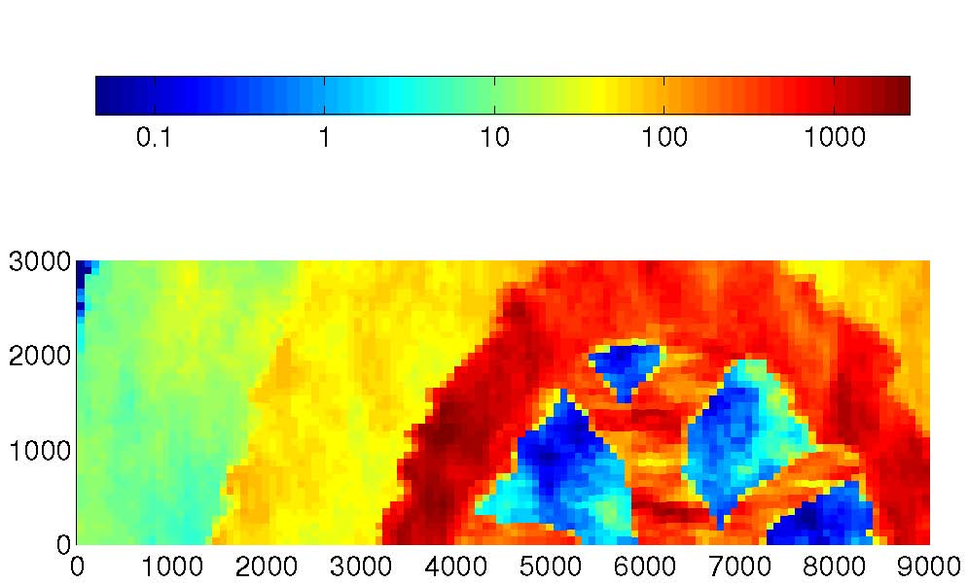
Figure 1.11: Top view illustration of faults used in the faulted grids. The fault plotted in red corresponds to the upper boundary of the model on the crest.
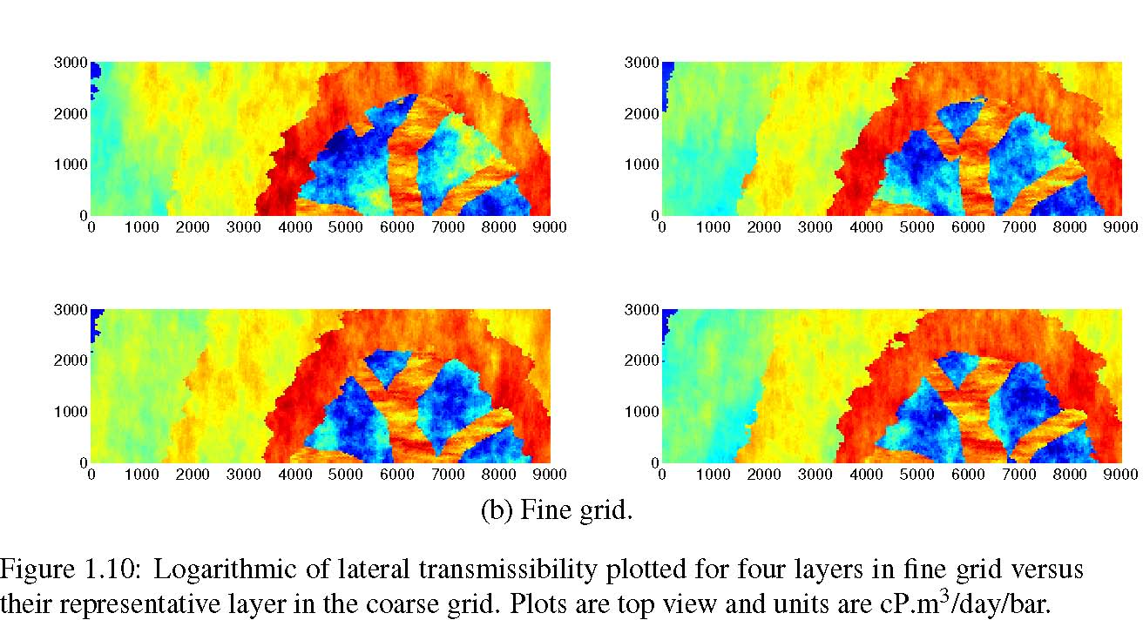(b) Fine grid.
1.5 Geological modeling
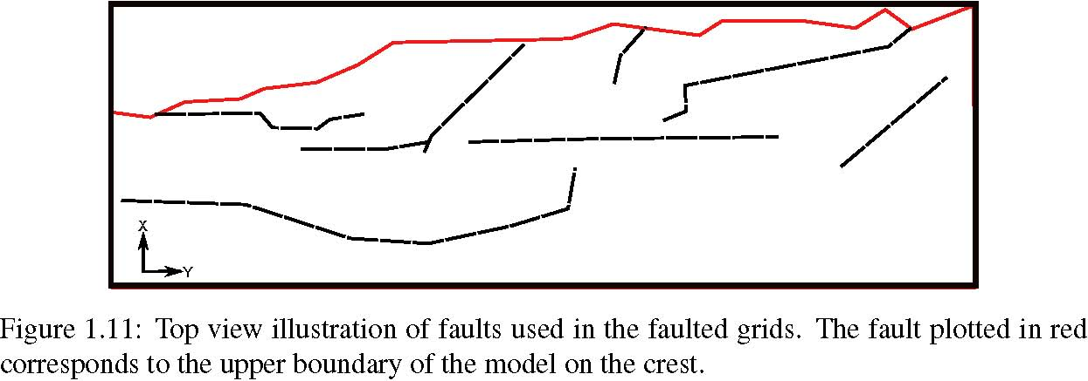
(a) Lob1. (b) Lob2. (c) Lob3.
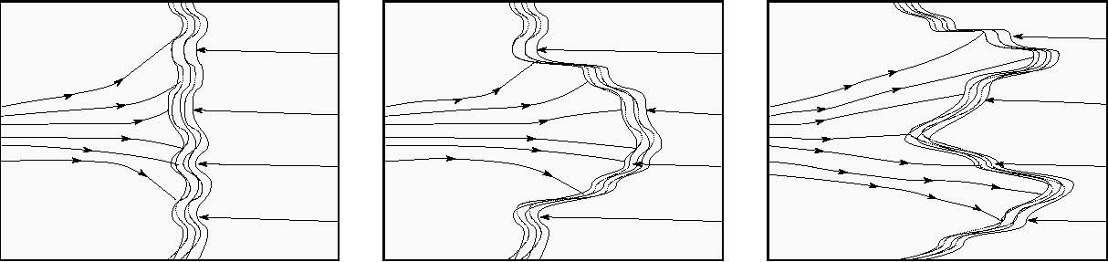
Figure 1.12: Lobosity levels are deﬁned based on the shoreline shape, which is caused by the interplay between ﬂuvial and wave forces.
Lobosity: Lobosity is a metric for describing the interplay between ﬂuvial and wave processes in a shallow-marine depositional system. As the river enters the mouth of the sea, the shore-line shapes where the river ﬂux crashes with the waves from sea. The balance between the sediment supply from rivers and the available accommodation space in the shallow sea deﬁnes the shore-line shape. Sea waves smear out the shore-line, while ﬂuvial ﬂux from river makes branches into the sea. Less wave effect produces more pronounced lobe shapes around the river entrance into the sea.
The channels made into the sea mouth by ﬂuvial supplies contain good quality rocks with relatively higher porosity and permeability and poor quality rock types are located between the conductive branches. Reservoir quality decreases with distance from the shore-face. Lobosity variation can inﬂuence the CO2 injection operation and plume distribution in the aquifer. In this study, models of three levels of lobosity are used: ﬂat shoreline, one lobe and two lobes, see Fig. 1.12.
Barriers: Barriers are mud-draped surfaces sitting between reservoir sections that are caused by periodic ﬂoods in a shallow-marine depositional system. Mud-drapes extend in both vertical and lateral directions and are potential signiﬁcant barriers to ﬂow. In the SAIGUP domain used here, these barriers were modeled by deﬁning areas between layers with zero transmissibility multipliers. This areal coverage was designed in three levels: low (10%), medium (50%), and high (90%). We use the same variations in this study, see Fig. 1.13.
Figure 1.13: Barrier levels caused by periodic ﬂoods.
Aggradation angle: In shallow-marine systems, the sediment supply from rivers deposits in a spectrum of large size grains in the land side toward ﬁne grains deep in the basin. Amount of deposition supplied by the river compared to the accommodation space that the sea provides deﬁnes the transition of different rock-types between the river and the sea. If the river ﬂux or sea level ﬂuctuates, the
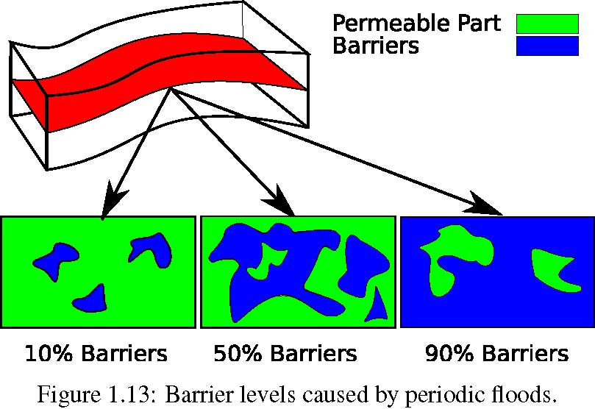
equilibrium changes into a new bedding shape based on the balance of these factors.
Figure 1.14: Aggradation angle levels.
When the river ﬂux increases, it shifts the whole depositional system into the sea causing an angle between transitional deposits that are stacked on eachother because of this shifting. This angle is called aggradation angle. Three levels of aggradation are modeled here: low, medium and high (Fig. 1.14). As we will see later, aggradation can have a major role in inﬂuencing the CO2 ﬂow direction in the medium.
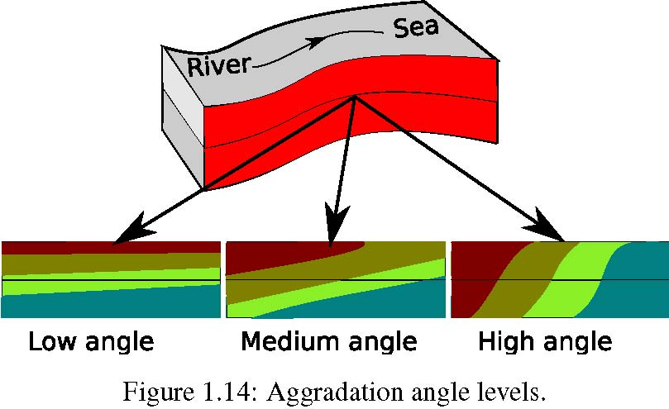
Progradation: Progradation is the depositional-dip direction between the see and the river. Two types are considered here: up and down the dominant structural dip. Progradation combined with lobosity can inﬂuence the plume development in the medium, as the injected CO2 plume migrates upward to the crest goes through heterogeneities (Fig. 1.15).
Figure 1.15: Progradation levels.
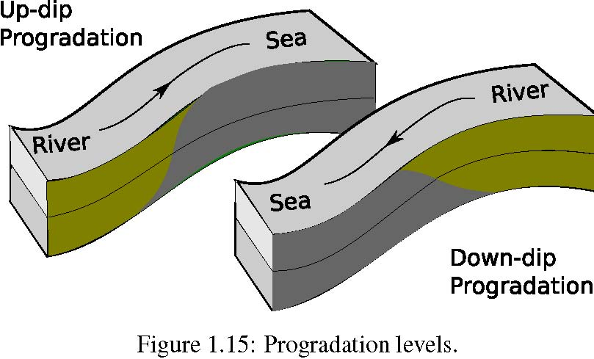For more information about the geological modeling, see the special issue of the Petroleum Geosciences that is devoted to the SAIGUP study [47]. One selected realization of the SAIGUP models is available for download [64] and this model is used as an example in MATLAB Reservoir Simulation Toolbox (MRST) [66].
1.6 Flow equations
After introducing the parameters that make our geological model, we need to deﬁne the ﬂow problem. In this section we discuss various formulations of the governing equations describing single and two phase
1.6 Flow equations
ﬂow in porous medium. Solution to these type of equations is implemented in the ECLIPSE black-oil simulator that we use to model the ﬂow. We introduce the functionalities and axillary equations required to close the ﬂow equation system. This section also includes a brief mathematical discussion on the ﬂow equations. We discuss various ﬂow regimes in the medium in the next section.
1.6.1 Single phase ﬂow
Assume a porous domain Ω with boundary Γ as shown in Figure 1.16. We write the continuity equation in general form for a single phase ﬂowing in the domain:
Accumulation + In-Out Flux = Source/Sink (1.1)

∂
(φρ)dτ +(ρv · n)dσ =qdτ (1.2)Ω ∂t ΓΩ
In Equation 1.2, φ is the rock porosity, ρ is the ﬂuid density, v is the ﬂow velocity, and n is the normal vector to the boundary. The term q denotes the mass source or sink in the system. Integrations are taken over arbitrary domain Ω with boundary Γ (Figure 1.16). Flow velocity is considered at the representative elementary volume (REV) scale for porous media [7].
The resistance of a porous medium against ﬂow results in a velocity that can be calculated from pressure and gravity gradient and ﬂuid properties in the medium. This is governed by Darcy’s law for single phase ﬂow:
K
v = −· (∇P + ∇D). (1.3)
µ
In Equation 1.3, K is the permeability of the medium. Permeability is a function of pore size distribution and connectivity and in the macro scale, it is a measure of medium conductivity when a ﬂuid is ﬂowing through the medium ( Figure 1.17). D is the gravity term that is a function of ﬂuid speciﬁc gravity and elevation in vertical direction.
Figure 1.16: Flow domain and boundaries. Substituting velocity term from Equation 1.3 into Equation 1.2 gives:
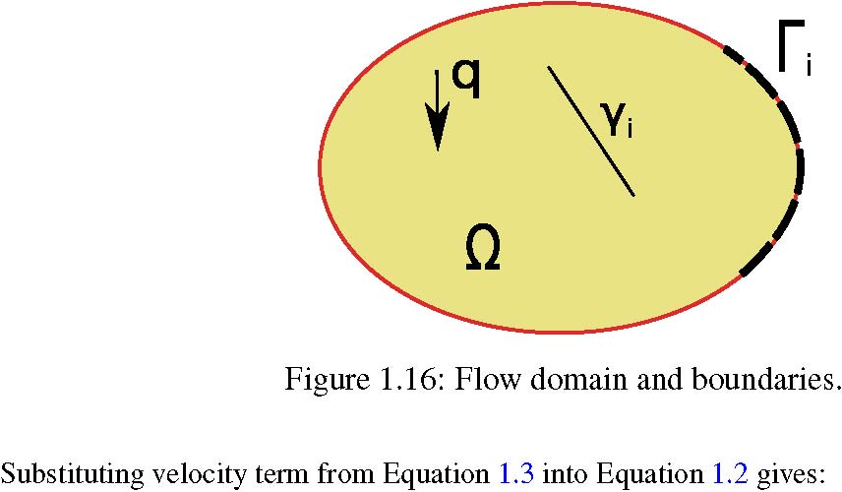
∂ K
(φρ)dτ −(ρ( · (∇P + ∇D)) · n)dσ =qdτ. (1.4)Ω ∂t Γµ Ω
As a primary unknown in Equation 1.4, the pressure depends upon the boundary conditions (as the second term left hand side of Equation 1.4 is an integration over the boundaries of the domain). Also, any geological discontinuities in the medium (γi in Figure 1.16) appears in Equation 1.4 through the K tensor and can inﬂuence pressure behavior in the domain.
Figure 1.17: Permeability is an indication of how easy it is for the ﬂuids to ﬂow trough the medium.
The second term in Equation 1.4 can be converted into an integration over domain Ω, using divergence theorem resulting in the following:
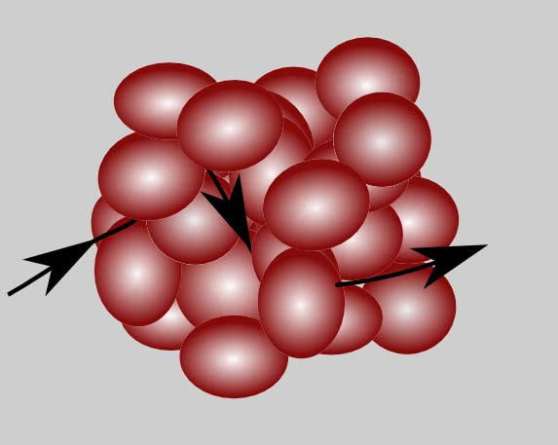
∂
[(φρ)+ ∇ · (ρv)]dτ = qdτ. (1.5)Ω∂t Ω
Equation 1.5 is valid for arbitrary domain Ω, hence the equality is valid for the integrands almost everywhere in domain Ω in the general situation:
∂
(φρ)+ ∇ · (ρv)= q. (1.6)
∂t
Fluid and rock change in volume with pressure variations. These dependencies are deﬁned by a parameter called total compressibility, which is approximated by a combination of rock and ﬂuid compress
ibilities: CT ≈ Crock +Cf luid , (1.7) where Crock = ∂φ ∂P , (1.8) and Cf luid = 1 ρ ∂ρ ∂ P . (1.9)
In Equation 1.8, Crock can be assumed constant in moderate pressure changes depicting a linear relation between pressure and porosity. Also, Equation 1.9 can be expanded resulting in the following [52]:
P
ρ = ρ0()^{m}exp[Cf luid(P − P0)]. (1.10)
P0
Assuming slight compression gives [61]: ρ c ρ0 +Cf luid ρ0(P − P0). (1.11) By substituting from Equations 1.7, 1.9, 1.8, and Equation 1.3 into Equation 1.6, density vanishes and by deﬁning volumetric source/sink η, we have the single-phase diffusivity equation:
∂PK
CT − ∇ · [(∇P − ∇D)] = η. (1.12)
∂t µ
1.6 Flow equations
Figure 1.18: Wettability and interfacial tension in water-CO2 system. Water is the wetting phase in this example.
Figure 1.19: Multi-phase ﬂow in the pore scale.
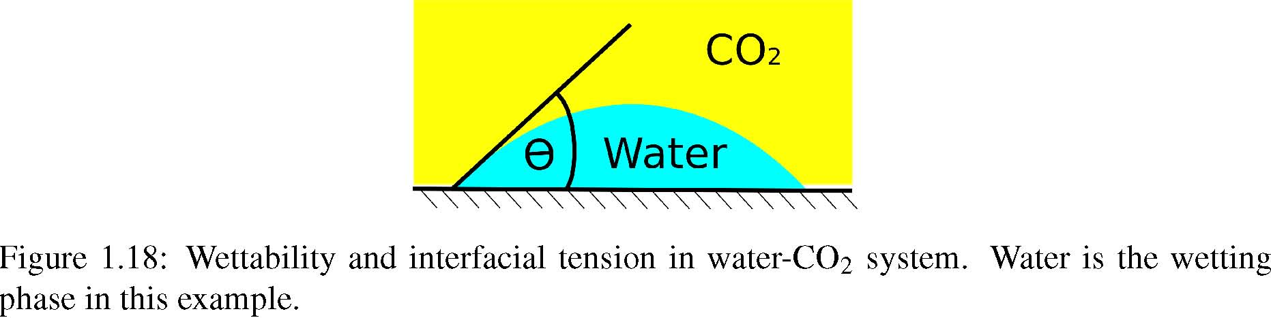
1.6.2 Two-phase ﬂow
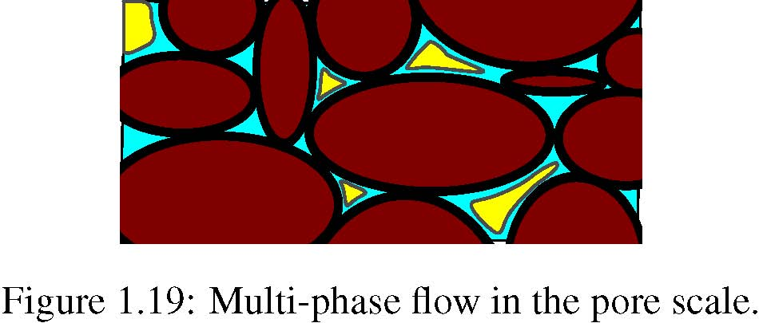
In a two-phase ﬂow of CO2 and water within porous media, interactions between phases lead to loss of energy. This introduces speciﬁc phenomena occurring in the pore scale that have impact on the macro scale ﬂow performance. More complicated equations appear in modeling the two-phase ﬂow compared to the single-phase problem. First, we describe some of the conceptual two-phase phenomena in the pore scale and then we will continue by deriving the ﬂow equations for two phases in the system, i.e., CO2 and water.
When CO2 and water get in contact at the pore scale, an interface forms between them such that the energy in the system is minimized. Water and CO2 are also in contact with the porous medium and the interface between them forms an angle from the solid phase in the water phase (shown by θ in Figure 1.18) that depends on their ability for wetting the rock. This is called wettability and the phase with the preference of wetting the solid phase is called the wetting phase. The other phase is called the non-wetting phase. Conventionally, θ is measured inside the denser ﬂuid. If θ < ^{π} ₂ then the denser phase is the wetting phase. Wettability in a porous medium depends on the ﬂuids and the rock. It can have a signiﬁcant inﬂuence in the phase displacement within the medium. For water-CO2 system, normally water is the wetting phase.
At very low water saturations, the water phase forms molecular ﬁlms surrounding the rock grains. In this situation, the water phase is immobile and can not make a continuous phase moving through the porous medium. As water saturation in the medium increases, the layers covering the rock grains grow in size until the saturation exceeds a critical level, above which the water phase is able to ﬂow in the medium. This saturation is called the critical or connate water saturation. In a water-wet rock, once the critical water saturation is reached (for example, during the ﬁrst deposition of sediments), it can not go below that level by being displaced via a non-wetting phase. Therefore, when we inject CO2 into an aquifer, there will always be some residual water saturation in the regions invaded by CO2.
As a non-wetting phase, CO2 ﬂows in the middle part of the pore space as shown in Figure 1.19. If CO2 saturation decreases in the medium, it reaches a critical level under which it can not make a continuous phase ﬂowing through the pore-network. Tiny drops of CO2 are trapped in the middle of the pore space and only very large pressure difference across the pore can move it out of the pore. This level of CO2 saturation is called the residual saturation. Higher residual saturation is more interesting for the purpose of immobilizing more volumes of injected CO2 in the aquifer, which reduces the risk of CO2 leaking through any breakings in the geological formation and channeling toward surface.
Relative ease for the phase to ﬂow within the medium is described by the relative permeability parameter. Relative permeability is a function of wettability and phase saturation. High phase saturation indicates a higher space available for the phase to ﬂow through that space. A sample of CO2-water relative permeability functions are shown in Figure 1.20. A library of relative permeability curves for CO2-water system for various rock-types is available at [8].
Figure 1.20: Two-phase ﬂow and relative permeability.
The difference in surface tension between water and CO2 causes a pressure acting on the interface of the two ﬂuids. This pressure is called capillary pressure. In addition, capillary pressure depends on the geometry of pores. Since the pore geometry is very irregular, it is more convenient to use simpler geometry to derive the concept of capillary pressure. Therefore, experimental work in the laboratory is required to specify the capillary pressure functionality in a special case.
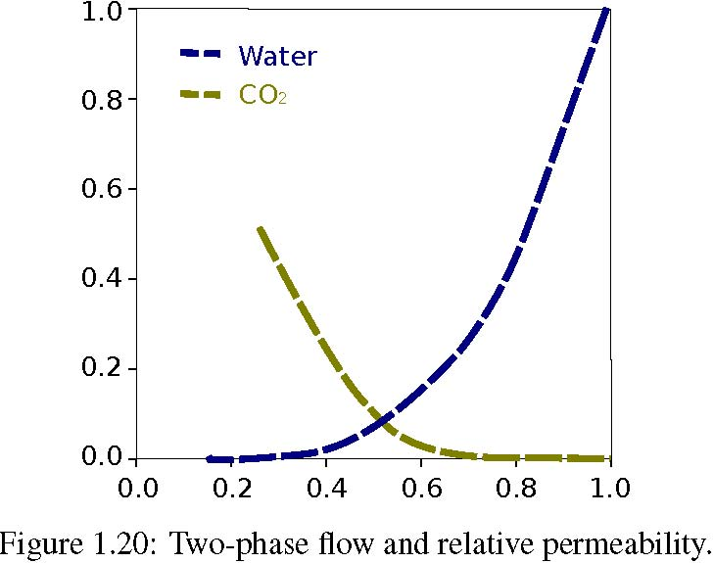
Assuming a geometry of pipe to represent a pore structure, after balancing the forces in the pore-system capillary pressure can be written in the following form:
2σ
Pc = cosθ, (1.13)
r
where σ is the interfacial tension, θ is the angle between the interface and the solid phase, and r is the radius of the pore. Capillary pressure is a jump in phase pressure across the interface of the two phases. Therefore, we can relate it to the phase pressures: Pc = Pnw − Pw. (1.14)
Here, Pnw is the non-wetting phase pressure and Pw is the wetting phase pressure.
Capillary pressure can be expressed in an empirical relation as a function of wetting phase saturation. Lower capillary pressure is expected for higher wetting saturations, and capillary pressure values go up for lower wetting saturations (Figure 1.21).
Assume hydrostatic equilibrium for a porous domain in which water and CO2 are segregated due to buoyancy effect. If capillary forces are considerable in the domain, the sharp interface between water and CO2 in the macro scale will be replaced by a transition zone with a spectrum of saturations between phases (Figure 1.23). Due to the hydrostatic equilibrium, phase pressure at each depth can be related to the hydrostatic pressure of that phase:
Pw = ρwgz, (1.15)
Pco₂ = ρco₂ gz. (1.16)
Having the phase pressure, capillary pressure can be calculated by Equation 1.14. As capillary pressure is a function of wetting saturation, the phase saturations can be back-calculated from this functionality and the phase saturation distribution over the medium can be found (Figure 1.22):
Sw = P⁻¹(Sw). (1.17)
c
1.6 Flow equations
Figure 1.21: Capillary pressure can be expressed as a function of wetting saturation. The plot is a typical curve of capillary pressure function with a maximum of Pcmax
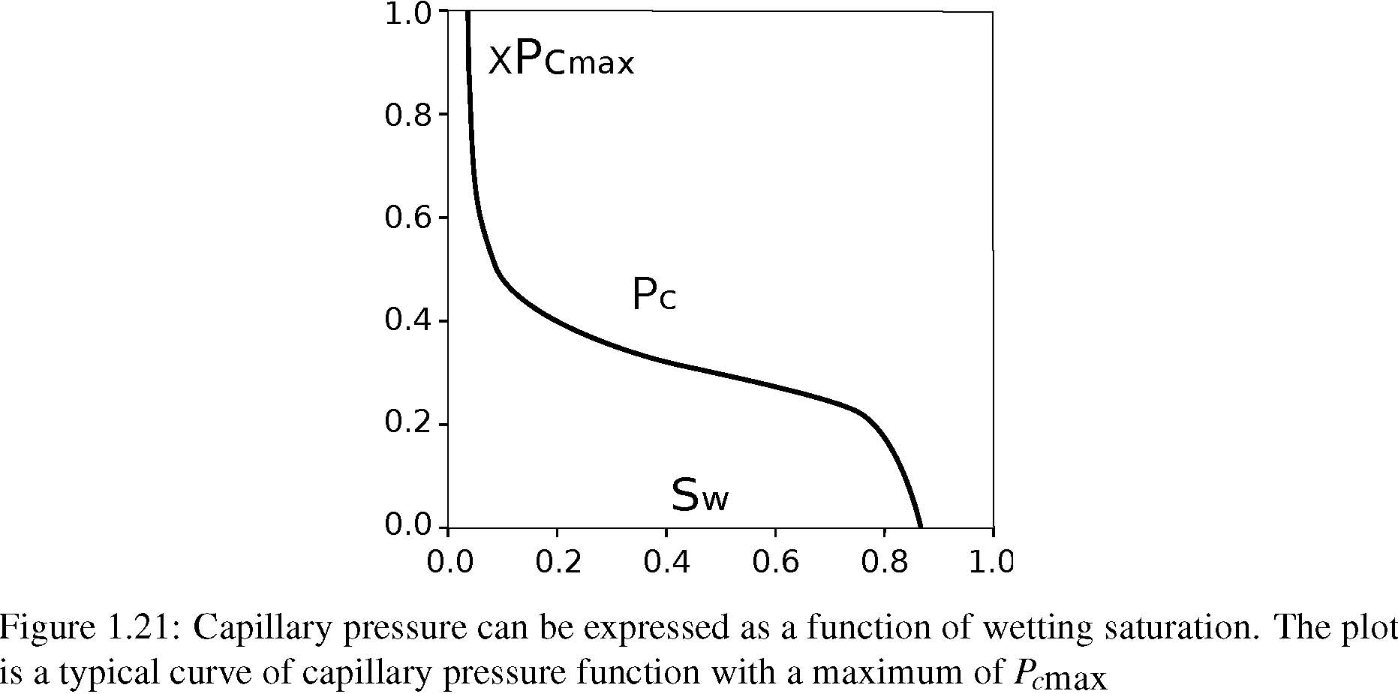Figure 1.22: Capillary pressure distribution in the transition zone.
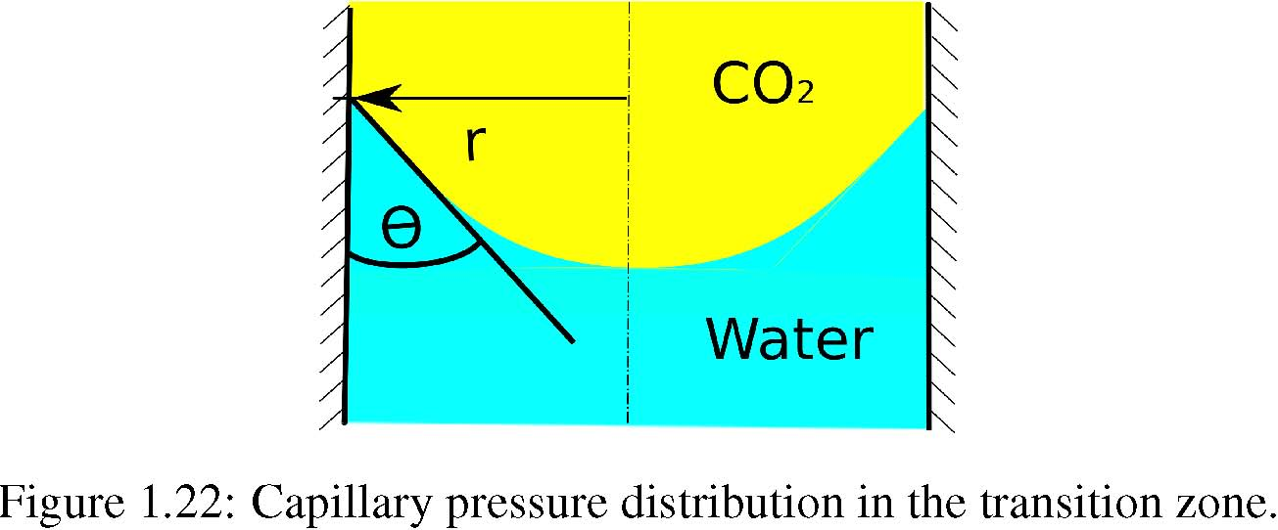Figure 1.23: Saturation distribution in the capillary transition zone.
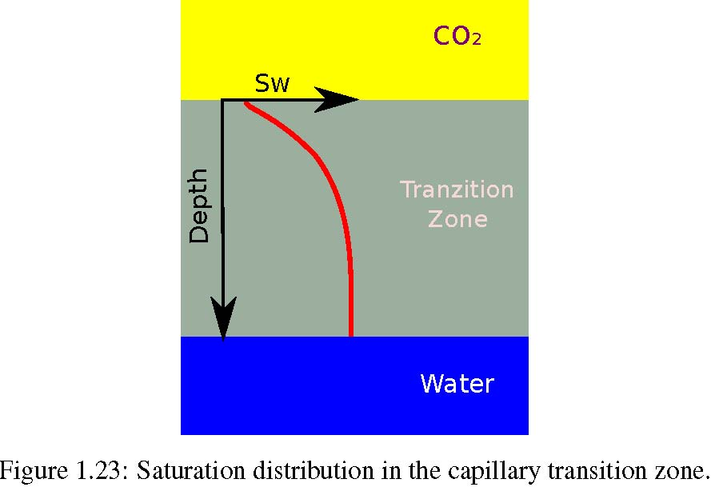We can derive mass and momentum balance for two-phase ﬂow, similar to what we have seen for single-phase ﬂow. The equations must be written for each phase. In Equation 1.4, the accumulation term must be considered only for one phase mass calculated by multiplying the total accumulation mass by phase saturation (Sα ). Also the velocity is the phase velocity vα , and the source/sink term must be written for the phase mass rate qα .
For phase α = {water,CO2}, we have:
∂
(φρα Sα )dτ +(ρα vα · n)dσ = qdτ. (1.18)Ω ∂t ΓΩ
Darcy equation for two phases α = {water,CO2} can be written in the following form:
Keα
vα = −· (∇Pα + ∇Dα ). (1.19)
µα
Here, Keα is the effective permeability for phase α and can be calculated from:
Keα = KabsKrα , (1.20)
where Kabs is the absolute rock permeability and Krα is the relative permeability of phase α. Pα is the phase pressure and Dα is the gravity term for the phase speciﬁc gravity.
Similar to Equation 1.6, differential form of mass balance equation for each of phases α = {water,CO2} is as follows:
∂
(φρα Sα )+ ∇ · (ρα vα )= qα . (1.21)
∂t In this equation, qα is the source/sink mass rate for phase α. The phase saturations are related by the following equation:
Swater + Sco₂ = 1. (1.22)
Fluid properties change by pressure and temperature. Density is mainly a function of pressure and viscosity depends upon temperature. These functions, called by convention equation of state (EOS), must be coupled to the system to honor ﬂuid attribute variability [18, 31].
Mass exchange between phases may happen leading to change in composition. That also inﬂuences the ﬂuid properties. In the immiscible ﬂuids, the mass exchange can be in small order leading to slight changes in ﬂuid properties. That can be modeled as a linear function with respect to pressure and temperature.
1.7 Flow regimes
Extensive mass exchange between phases results in more nonlinear ﬂuid property variations that require a detailed equation of state. Also for highly miscible ﬂuids and high mass transfer between phases, it might be better to write mass and momentum balance equations for components within phases in addition to phase equations.
There are a number of approaches to formulate the primary unknowns in the system of ﬂow equations. The direct way is to replace phase velocities from Equation 1.19 into Equation 1.21, leaving the phase pressures and water saturation as the primary unknowns. This ends in a set of strongly coupled equations.
A popular approach for formulating the set of ﬂow equations is the fractional ﬂow method [10]. In this method the total multiphase ﬂow problem is treated as a single-phase ﬂux of multi-phase mixture. Therefore, individual phases are described as a function of total ﬂow. This leads to separate equations for pressure and saturation.
Pressure is deﬁned for the total ﬂow either globally or pseudo-globally and relates to the phase pressure and saturation with auxiliary equations. The fractional ﬂow approach keeps the governing equations in the form of single ﬂow equations, and numerical schemes for single-phase ﬂow can be revised into efﬁcient schemes for multi-phase problems.
Pressure and saturation equations have different mathematical nature: pressure has a diffusive character of an elliptical nature, which is numerically more stable than the saturation equation. Saturation equation is of convection-diffusion form with hyperbolic character in the convection part. The convection operator in saturation equation can be highly non-linear due to strong coupling of saturation and phase velocity. This nonlinearity can lead to shocks and discontinuities in the saturation solution.
As an example of fractional ﬂow formulation, global pressure Pt is deﬁned based on phase pressures:
Sw Pt = ¹ (PW + PCO2) − ( fw − ¹ )P c(Sw)dSw, (1.23)²Sw|Pc=0²
where water fractional ﬂow fw is deﬁned as:
Krw
fw(Sw)= ^{µw} . (1.24)
Krw ₊ ^{K}rco2 µco2 µco2
The total velocity is deﬁned as: vt = vw + vco₂ . (1.25)
If capillary and gravity effects are negligible, saturation equation can be solved analytically, e.g. via Buckley-Leverett technique, or method of characteristics.
1.7 Flow regimes
A major part of our studies includes modeling physical phenomena occurring within ﬂow through porous media. Various phenomena occurs during a complete sequence of CO2 sequestration. During injection the forces imposed by the injector dominate the ﬂow behavior in a region around the injector. When CO2 plumes develop in a thin layer moving along the stratigraphical structure, a large interface between water and CO2 enhances the diffusion phenomena and lets more CO2 be dissolved into water. Convection of water with dissolved CO2 leads to complicated ﬂow regimes.
The injected CO2 undergoes various stages until it is stored underground. We consider two stages in our studies: injection, early migration, and long-term migration. Many forces act on ﬂow within medium, each of which requires a set of modeling parameters. Simplifying assumptions for ﬂow modeling can be justiﬁed at each stage with relevance to the dominating forces in the medium.
The following can be recognized as forces acting on the medium at the scale at which Darcy velocity is deﬁned:
- Forces due to pressure gradients, mostly imposed by injectors (and/or producing wells).
- Buoyancy due to density contrasts between ﬂowing phases. Gravity acts in the vertical direction.
- Capillary forces due to inter-facial tensions.
- Hysteresis due to sequencing of imbibition and drainage during ﬂow in the porous medium.
- Convection forces due to gradients of density within one phase.
- Diffusion due to concentration gradients of one component.
- Reaction due to chemical reactions between phases and rock.

Modeling all forces acting on a porous medium is not practical, and we need to look at each ﬂow regime separately by neglecting some forces that have a minor role. Herein, we discuss the main forces during injection and within long term migration.
1.7.1 Injection and early migration
Injection of CO2 in the underground happens by forcing CO2 mass through an injector into the medium. This poses a pressure gradient around the injector causing ﬂow within the near bore region. Some authors call the force due to pressure difference ‘viscous force’, since viscosity has an important role in transferring the stress due to pressure difference in the porous medium resulting in ﬂuid mobility. We use the same term throughout this thesis.
Viscous and gravity forces are the two major forces acting on the region around the injector during injection. Depending on ﬂuid properties and distance from injection point, force balance changes. Gravity causes rapid phase separation resulting in upward movement of CO2. Gravity forces dominate two-phase regions far from the injector with lower viscous ﬂow velocity compared to near well locations, where the ﬂow velocity is high. At each position in the medium, a force balance results in a total force vector that may cause ﬂow in a particular direction ( Figure 1.24a).
Attempts in the literature on evaluating force interplay during a multiphase ﬂow regime incorporating injection in the porous medium, employ sensitivity analysis on ﬂow attributes such as ﬂow velocity and pressure. There a number of publications that discusses reducing a complicated ﬂow problem into a simpliﬁed problem by taking plausible assumptions [9, 15, 17, 24, 25, 53, 57, 71, 72]. Utilizing analytical solutions gives the ﬂexibility of examining a wide range of parameter variations within the model, enjoying a fast evaluation of the corresponding ﬂow behavior. Semi-analytical and numerical sensitivity analysis are also practiced in the literature to involve more physical modeling features in the ﬂow performance evaluations[2, 3, 60].
The ﬂow equations can be normalized to a dimensionless version that is used in many studies discussing the capillary and gravity inﬂuence on the ﬂow. Herein, we give the method reported in [25]. If we assume incompressible ﬂow in a one-dimensional domain Ω without any source/sink, Equation
1.21 reduces to the following for the wetting phase:
∂sw ∂vw
φ += 0, (1.26)
∂t ∂x
and Darcy equation for one dimension ﬂow becomes:
krw ∂Pw
vw = −K (+ ρwgz). (1.27)
µw ∂t
Here, z is the elevation and g is the gravitational acceleration. The system is closed by Equations 1.22 and 1.14 . We can deﬁne the dimensionless variables as follows:
x tvt pc
X∗ = ; T ∗ = ; and P∗ = , (1.28)
c
LLφπc
1.7 Flow regimes
where L is a length constant in the problem and πc is a capillary pressure normalizing constant. After reformulating Equation 1.26, fractional ﬂow can be written in the following form:
∂Sw
fw = G(Sw)+C(Sw) , (1.29)
∂X∗
where Sw is the normalized wetting phase saturation, G is the gravity contribution, and C is the capillary contribution to the ﬂow. The gravity and capillary contributions, G and C, are expressed by quantities relative to the viscous force [33] and we have:
G(Sw)= Fw(1 − NGkrnw), (1.30)

dPc
C(Sw)= NnwFwkrnw , (1.31)
dSw
wherein:
krnw µw ₎−1
Fw =(1 + , (1.32)µnw krw

kπc
Nc = , (1.33)µnwLvt
NG = (k k(ρw − ρnw)gz µnwvt ). (1.34) Having these deﬁnitions, Equation 1.26 reshapes into: ∂ Sw ∂T ∗ + dG(Sw) dSw ∂Sw ∂ X∗ + ∂ ∂X∗ C(Sw) ∂Sw ∂X∗ = 0. (1.35)
Applying speciﬁc type of capillary pressure and relative permeability function may lead to simpliﬁed forms of Equation 1.35 with the possibility of having an analytical solution [72].
Some important conclusions in the literature from sensitivity studies on capillary, gravity and viscous forces are summarized here and inferred for CO2 injection application:
- Gravity and capillary pressure will only inﬂuence the ﬂow speed signiﬁcantly for slow displacement rates. Therefore, around the injection point where normally ﬂuids are ﬂowing with a relatively high speed, viscous forces are dominant.
- If capillary is of any signiﬁcance, ignoring capillary forces in modeling the injection of CO2 results in a pessimistic CO2 sweep efﬁciency. Capillary helps in the spreading of CO2 in the frontal CO2-water interface.
- Less capillary forces in the porous medium allows more space for CO2. This enhances the density segregation due to gravity forces.

The main focus in the series of work in this thesis has been to assess the ﬂow inﬂuence by heterogeneity during injection time and early CO2 migration. For CO2 injection problems, one objective is to maximize the rate of injection and aligned with that we use relatively high injection rates in our studies. Therefore, we did not include capillarity forces for modeling the high displacement rates within heterogeneities, which can be justiﬁed by the results in the literature.
Table 1.2: Spatial scales for CO2 storage. Ranges are extracted from [13].
Feature Spatial scale Capillary fringe 10cm–>10m Plume radius 10km–>100km Pressure perturbation 50km–>500km Migration distance 50km–>500+km
Table 1.3: Temporal scales for CO2 storage. Ranges are extracted from [13, 32].
Feature Temporal scale Density segregation 1 month–>5+ years Capillary segregation 1 year–>50 years Injection period 5 years–>50 years Convective mixing 20 years–>1000 years Plume migration few hundred years–>1000 years Mineral reaction 500 years–>100000 years
1.7.2 Long term migration
The injected CO2 volume in the geological formation will travel below the sealing cap by buoyancy forces due to the density difference between water and CO2. One concern is to have CO2 stored safely, and the mobile CO2 is at risk of leaking through any imperfections in the sealing layers and abandoned wells. Molecular diffusion occurs at the interface of water and CO2 and this mass transfer from the CO2 plume into water increases the water density. Transition of CO2 from mobile phase into water with dissolved CO2 is helping the safe storage of CO2: the heavier water with dissolved CO2 has the tendency of moving downward. Time scale for this convective mixing is of the order of several hundreds years (Table 1.3). Yet, this is not the end and the dissolved CO2 can react with the porous medium ending up in a solid phase and it can be stored permanently in a process called mineral trapping. This is an extremely slow process and it can take thousands of years [32].
Mixing of CO2 and water in the long-term happens through phases with various time scales and physical phenomena. Diffusion of CO2 in water continues and layer of water with dissolved CO2 builds up below the CO2 plume until it forms heavy parts convecting in the form of unstable ﬁngers, as shown in Figure 1.24b.
The onset time for the convective mixing is important in terms of storage safety. This time depends on the Rayleigh number in the medium:
KgΔρH
Ra = . (1.36)
Dcφµ Here, Δρ is the density difference between the water and CO2 phases and Dc is the diffusion coefﬁcient of CO2 into water phase. The higher density sitting on top of lower density makes an unstable system and the medium must have a minimum Rayleigh number to have a growing instability for a small perturbation in the medium. Heterogeneities in the medium can initiate perturbations, reducing the instability onset time [20, 34]. Therefore, heterogeneity is an important factor that must be considered when we are choosing an aquifer for CO2 storage. Capillary fringe in the plume can enhance the onset of the convective mixing. It can speed up the process up to ﬁve times [22]. The ﬂow equations for convective mixing are a set of mass and momentum balance for component c = {Water, CO2} within phase α = {Wetting,Non-Wetting}:
∂ ∑φSαρα X_{α} ^{c} + ∇ · ∑ρα X_{α} ^{c}vα = 0, (1.37)
∂t
αα
1.8 Flow modeling
and
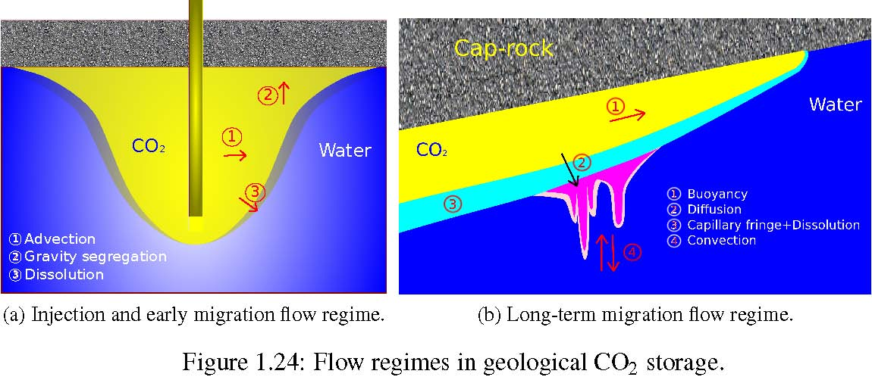(a) Injection and early migration ﬂow regime. (b) Long-term migration ﬂow regime.
kr_{α} K
vα = − [∇Pα − ρα gz] (1.38)
µα where X_{α} ^{c} is the mole fraction of component c in phase α [21].
1.8 Flow modeling
We use a standard porous media simulator [63] to solve the ﬂow equations in the medium. The simulator is based on a ﬁnite volume method and the following assumptions are made:
- Two compressible phases are considered in the medium: water and super critical CO2.
- No mass exchange occurs between the two phases.
- No heat exchange is considered.

1.8.1 Numerical scheme
The simulator uses a standard two-point ﬁnite difference scheme to solve Equation 1.21 on a corner-point grid. The Darcy equation for two-phase flow can be expressed based on a difference. The equation governing the flow into cell a from the neighboring cell b is as follows:
Fabα = TabMaα Δψα . (1.39)
Here, Tab is the transmissibility of the medium between the two cells. Maα is the mobility of phase α that is taken upstream of the ﬂow from cell a and Δψα is the potential term difference between two cell centers.
Transmissibility for two neighboring cells (i.e., sharing a face area, see Figure 1.25) is calculated by harmonic average of transmissibilities from the center of each cell to the center of the common face between the two cells:
1
Tab = ₁₁ . (1.40)
+
Ta Tb
Each half transmissibility Ta or Tb is calculated by an inner product between the permeability of the cell Ka, the mutual area Aab between cells, and the distance from cell center to the mutual face center da:
Ta = Ka · da · Aab. (1.41)
Figure 1.25: Transmissibility calculation for two cells a and b.
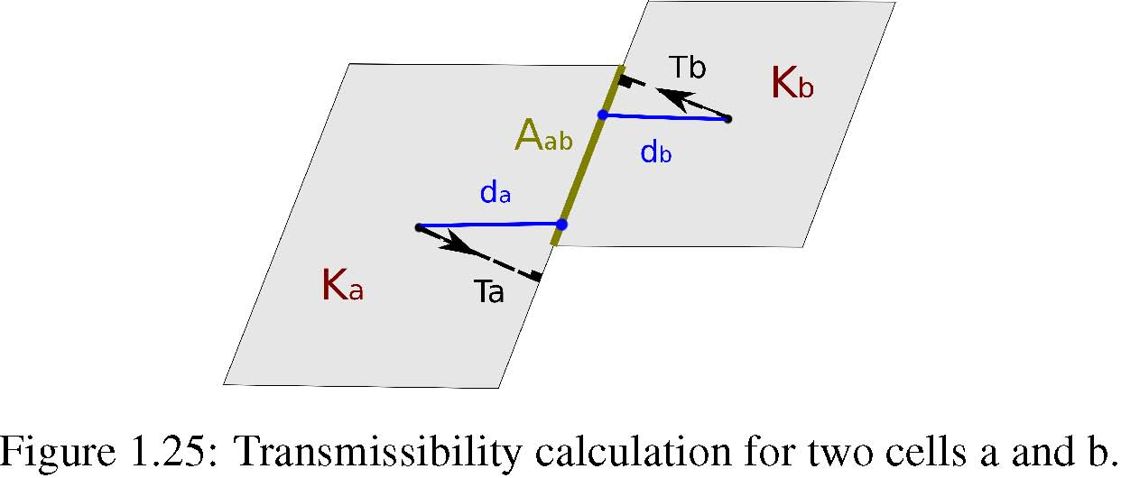Figure 1.26: Well modeling inside a simulation cell.
The mobility term in Equation 1.39 is deﬁned as follows:
krα
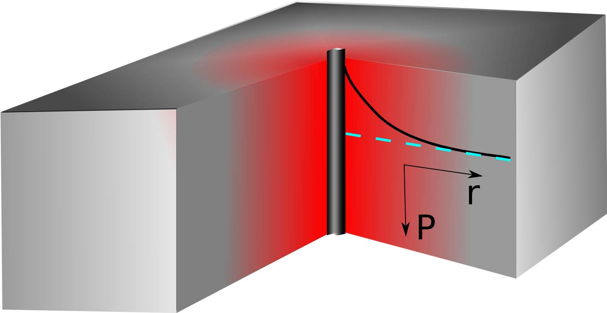
Maα = , (1.42)
Bαµα
where krα is the relative permeability of phase α, µα is the viscosity of phase α, and Bα is the formation volume factor of phase α, which is deﬁned as :
Volume at surface condition Vsα
Bα == . (1.43)
Volume at formation condition Vrα
This deﬁnition is connected to compressibility of the ﬂuid, i.e., to changes in volume at the surface and at the geological formation condition, but it is deﬁned in this way in the simulator to consider cases where a ﬂuid, such as oil loses its dissolved gas while being produced at surface pressure. Since we assume no mass exchange between phases in our study, here the formation volume factor works like compressibility of the ﬂuid. Formation volume factor is a function of pressure. Slight compressibility is considered for phases in our study, and phase density is deﬁned as a function of pressure:
ρ0α
ρα (P)= . (1.44)
Bα (P)
Here, ρ0α is the density of phase α at surface conditions.
Wells are deﬁned as sources or sinks in Equation 1.21. In reality, wells are a void space drilled in the porous medium and the ﬂow into the well-bore and up to the surface for production wells (and vice-versa for injectors) goes through a pressure change that must be modeled separately from the porous medium.
Figure 1.26 shows a schematic pressure distribution around the injector. The well radius is much smaller than the simulation cell containing the well and the pressure in the bottom-hole is different than the cell pressure. The well bottom-hole pressure can be related to the cell pressure containing the well by a separate approximation that can be coupled with the ﬂow equations in the grid model. Flow equation for phase α between the cell center and the well for an injector is written as follows:
ηα = Tw · Mα · [Pw − Pi]. (1.45)
1.8 Flow modeling
Here, ηα is the volumetric injection rate of phase α, Pw is the injector bottom-hole pressure, Pi is the cell pressure, Tw is the transmissibility between the cell and the injection well-bore, and Mα is the mobility of injection ﬂow into the cell.
A region can be assumed by a radius re at which the pressure is equal to the cell pressure. By approximating the ﬂow near the well-bore using Equation 1.12, the transmissibility for this region can be found from the analytical solution to Equation 1.12:
K · h
Tw = , (1.46)
ln( ^{re} )
rw
Where h is the medium thickness, K is the medium rock permeability, and rw is the well radius. Here, we assume that the well is completed and connected in the entire thickness h of the cell and there is no skin effect in the well. The Equation 1.46 can be extended to model wells with partial completions and skins. The effective radius re in Equation 1.46 is estimated from The Peaceman formula and can be related to the cell geometry:
1
1 12
Ky ₍Kx
δ_{x} ²(_{Kx} )2 + δ_{y} ² _{Ky} )2re = 0.28. (1.47)
(^{Ky} )4¹ +(^{Kx} )4¹
Kx Ky
Here, Kx and Ky are the permeabilities in x and y directions and δx and δy are the cell sizes in these directions. This equation assumes a vertical well and a diagonal permeability tensor. It can be modiﬁed for more general cases.
1.8.2 Flow scenarios
All of the SAIGUP realizations have dimensions of 3 km × 9 km × 80 m. The model spatial scales capture the typical geological features in a shallow-marine system, such as shore-line shape and aggradation angle variations. Various scales of heterogeneity can considerably impact the ﬂow behavior. The lateral extent of the model is smaller than the scales used for CO2 storage studies. In some storage sites, the lateral extent that the CO2 travels can go to few hundreds of kilometers. This makes our study limited in the spatial domain around the injector. For the same reason, in the temporal scale, we are more focused on injection and early migration time. We examine a number of injection scenarios to study the spatial distribution of CO2 in the medium during injection and early migration periods.
The study of pressure is essential for injection operations. A detailed pressure study requires larger scales than what is used here. We choose open boundaries for the model to compensate for the actual large extents of a typical storage location. The choice of open boundary is not valid in domains that are bounded by structural seals. In fact, for the closed and semi-closed domains the pressure is a major control on the storage capacity along with other parameters. The results of our pressure study can change signiﬁcantly by choosing different boundary conditions.
We use large pore volumes on the outer closed cells to represent the boundary. This makes the pressure relax earlier than it does in a large domain. Even with such an artifact, the effect of heterogeneities is clearly seen in a considerable fraction of cases with an extreme pressure build-up. We investigate the operational concerns related to pressure build-up for a typical injection scenario. Our pressure study can be used for devising mitigation plans by deﬁning operational constraints for injectors. We perform an extensive probabilistic analysis on the CO2 pressure behavior in the medium that can be applied in a further study with speciﬁc concerns about the pressure analysis.
We consider the injection of 20% of the total pore volume of the model (excluding the large volumes at the boundaries), which amounts to 40 MM m³. This volume is injected into all realizations in three different scenarios. In the ﬁrst scenario, the injection is forced to ﬁnish in 30 years and the pressure in the system and an unlimited rise is permitted. Linear relative permeability functions are considered in this scenario. The purpose of the ﬁrst scenario is to examine the ﬂow distribution in the medium inﬂuenced by geological heterogeneity. Linear assumption for relative permeabilities is taken to speed up the ﬂow within the medium. We have used quadratic relative permeability function in the second scenario. This scenario has shown a considerable increase in the pressure responses for many cases during CO2 injection into the aquifer. This is mainly due to lower CO2 mobility at low saturations compared to the linear relative permeability. Albeit, the CO2 moving under a cap-rock will effectively have a linear relative permeability.
Figure 1.27: Top, bottom, and upper side boundaries are closed and the rest are open to the ﬂow.
The third injection scenario is similar to the ﬁrst studied scenario, except that the injector is controlled by pressure rather than volumetric rate. Thus, injection time is variable depending on the injectivity of the medium.
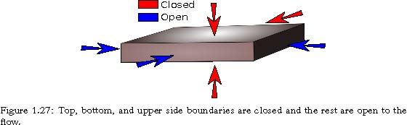
Only one injector is considered in the study. With one injector, it is easier to study the ﬂow behavior and the plume development within the medium. The injector is located in the ﬂank and to increase the sweep efﬁciency for the up-moving CO2 plume, the injector is completed only in the lower part of the aquifer. The injector location and the completed layers are ﬁxed for all of the realizations. The studies here aim to identify the inﬂuence of uncertainty on injectivity and ﬁxing a place for injection helps in achieving this goal. As mentioned earlier, injectivity is a big player in the success of the operations. Uncertainty might be less near the well-bore region, than in the larger scale in the domain, but requires costly operation data aquisition. Fixing the location of the well serves to specify the probability of having a feasible injectivity in different heterogeneities.
There are few locations of distorted geometries in the faulted realizations that may be considered as structural traps for the injected CO2. The topography in the SAIGUP realizations is simple and does not cover the variational space to be used in a sensitivity analysis. The slight inclination in the structural geometry of the medium, from the ﬂank up to the crest, leads the injected CO2 to accumulate in the crest and below the faulted side of the aquifer. The structural trapping due to variational morphology is studied in IGEMS, which is a sister project to MatMora (for example, see [67]).
In a homogeneous medium, we expect the CO2 to accumulate under the cap-rock. A small fraction of the injected CO2 will escape through the open boundary near the injection well and the rest of it will stay within the medium in two forms that we refer to as mobile and residual volumes. As the CO2 moves through the rock, part of it stays in the smaller pores due to the capillary trapping process and cannot be discharged by brine. The other parts move through the larger pores and can be displaced by water in an imbibition process. This volume is called mobile. As we are interested in storing the CO2 permanently and safely, increasing the trapped volume is in line with the objective of minimizing the leakage risk and maximizing the storage capacity. Likewise, the more mobile volume of CO2 exists in the medium, the higher the risk of leakage.
Deﬁning the boundary conditions of the aquifer of interest can inﬂuence ﬂow behavior in the system. Computational costs make it more feasible to model the ﬂow locally and in the part of the aquifer that is going through more pronounced changes in ﬂow behavior. Therefore, we can choose the boundaries of the model inside the aquifer in a volume that is containing the injection wells and the areas affected by them. Hydrostatic open boundary condition is a choice for the system boundaries to include the aquifer parts that fall outside the boundaries (Fig. 1.28).
1.8 Flow modeling
The underground network of aquifer systems can be connected via geological channeling and conductive features. Some aquifers might be active and connected to the surface and expand in volume by variations in water inﬂux due to seasonal rains. This can impose an external force on the system boundaries considered in storage problems. Fig. 1.28 shows the water inﬂux through the boundaries of the system due to external aquifer activities. We consider the external support by imposing a higher pressure than the hydrostatic pressure on the boundary of the model.
Figure 1.28: External pressure drive.
1.8.3 Flow responses
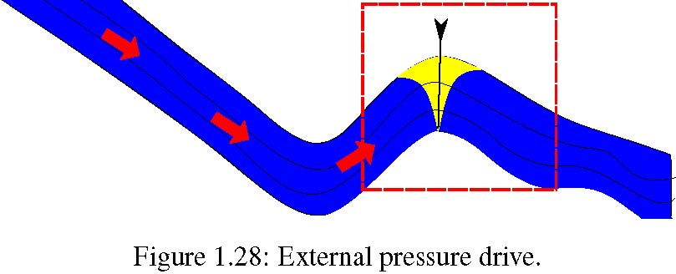
The primary unknowns in the ﬂow model are the CO2 pressure and the saturation distribution at different times. From the simulation output, we can derive quantities that address the feasibility of CO2 injection. These quantities include a number of ﬂow responses related to the CO2 injection and migration problems. Each of these responses are directly or indirectly a measure of success for the operation within a speciﬁc realization. In the following we give a brief description of each of them:
Boundary ﬂuxes: The ﬂux out of open boundaries is a measure of sweep efﬁciency for the CO2 plume. Channeling can lead to early CO2 breakthrough at the boundaries and we prefer cases with less out-ﬂuxes through open boundaries. The out-ﬂux through the open boundary that is closer to the injector is a potential loss for the injected volume. After the injection stops, some of the CO2 that has left the domain comes in again due to gravity segregation effect.
Total mobile and residual CO2 volume: If the CO2 saturation is below the critical value, it will be immobile in the bulk ﬂow, although not in the molecular sense. Less mobile CO2 means less risk of leakage and more residual volumes (with saturations less than the critical) resulting from a more efﬁcient volume sweep as preferable. We use critical saturation of 0.2 for both water and CO2. During injection time the ﬂow process is mainly drainage but after injection imbibition also happens and increases the residual trapped CO2.
Figure 1.29: Mobile and residual CO2 volume.
Total number of CO2 plumes and largest plume: To estimate the risk of leakage from the cap-rock, we assume that all mobile CO2 connected to a leakage point will escape out of the reservoir. Hence, it is preferable if the total mobile CO2 volume is split into smaller plumes rather than forming a big mobile plume. We looked at the largest plume size, the number of plumes, and other statistical parameters.
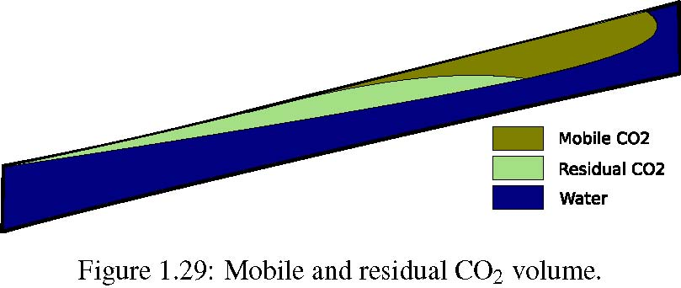
Figure 1.30: We use a 2D Gaussian distribution for leakage probability on the cap-rock.
Average aquifer pressure: This is one of the most important responses to be considered. The pressure response in general shows a sharp jump at the start of injection and a declining trend during the injection and plume migration.
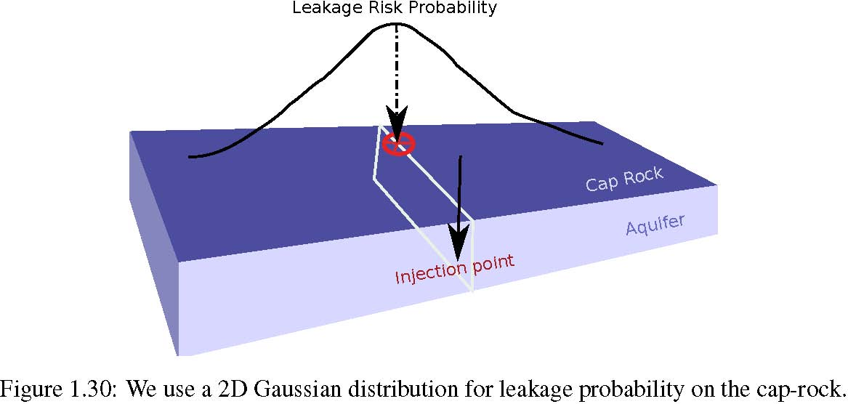
As soon as the injection starts, a pulse of pressure goes through the medium, introducing a pressure buildup in the aquifer. When the pressure wave reaches the open boundary, the aquifer pressure starts declining to a level maintained by the injector. When the injector stops operation, the pressure support will be removed and the pressure drops and declines until it reaches equilibrium.
Leakage risk: During injection operation the foremost important issue is the aquifer pressure, which as discussed earlier, may lead to fractures in the cap-rock. On the other hand, the cap-rock break depends on lithology and sealing thickness and differs from point to point. Some weaker locations can be the most probable to break and start leaking if any mobile CO2 exists there.
An uncertainty assessment process consisting of geo-mechanical modeling of aquifer combined with ﬂow modeling can cost a large amount of computations. To avoid expensive computations, the idea in this thesis is to model the possible breakings on the cap-rock (considering the stress stream in the medium) by introducing a probability measure on the cap-rock. This measure can be used to evaluate different cases for their risk of leakage, considering the CO2 distribution under the cap-rock.
Here, we deﬁne the probability of leakage as a measure on the cap-rock that assigns a value to each point of the cap-rock, modeling the relative weakness of the cap-rock and the medium at that point. If for example both the cap-rock and the aquifer are continuous homogeneous layers with constant thickness, then the point of cap-rock that sits on the highest point of the injection slice can be the most probable place for leakage in the case of dramatic pressure increase in the well; the stress stream is more in the injection slice and the CO2 accumulation occurs on the topmost part of the aforementioned slice. Then one may consider a 2D-Gaussian probability distribution on the cap-rock, centered above the injection slice.
If the medium is heterogeneous or tilted, the injected CO2 may be distributed in different number and sizes of plumes below the cap-rock. Therefore, in addition to the probability of breaking for each point of cap-rock, one must consider the CO2 connected volume that is attached to that point.
Since we have neither the cap-rock model nor the geo-mechanical properties of the SAIGUP models, we use a simple 2D-Gaussian leakage probability distribution centered at a point on the crest which is in the same slice as the injection point (Fig. 1.30). We calculate the probability of each cell in the top layer and using the simulation results for the case, we weight it by the CO2 saturation of that cell and the plume size that the cell is attached to. Summing up the values of the topmost cells, we assign a single number to the case which we call ‘leakage risk of the case’. One may weight the case risk value with the average pressure in the system, such that higher pressure gives a bigger weight.
1.8 Flow modeling
Table 1.4: Geological heterogeneities for two selected cases.
Case Fault Lobosity Barrier Aggradation Angle Progradation Direction A unfaulted medium medium medium down-dip B unfaulted high medium low up-dip
Results are discussed by comparing all cases in plots. However, the conclusions are made based on detailed ﬂow study in some picked cases. For example, Figures 1.31 to 1.35 show the rock properties and CO2 distribution in the domain at end of injection and end of simulation in two different cases. The heterogeneity description of the selected cases, called A and B, is given in Table 1.4.
CO2 distribution in Figures 1.33 and 1.34 show that heterogeneity in case B has enhanced the lateral ﬂow compared to case A. Direction of the ﬂow can be seen in Figure 1.35. It is clear that heterogeneity can inﬂuence the imbibition and drainage process during and after injection. This, in turn, impacts the residual trapping process.
Figure 1.36 demonstrates the plume evolution during simulation in two different cases, i.e., case A and B. The mobile CO2 is plotted here and it shows that the injected CO2 moves more in the vertical direction in case A, ending up in a big mass accumulated under the cap-rock. On the contrary, the heterogeneity in case B enhances the lateral movement of the plume, resulting in a laterally spread plume within the medium.
Figure 1.37 shows the development of pressure in the same cases. We see that injection in case B causes a dramatic pressure build-up due to the poor vertical transmissibility. The pressure build-up spreads out within the medium in case A, while it is trapped in the injection layers for case B.
One way to report the described responses and their relations to the uncertain parameters in one graph is to use scatter plots. Each case will then be represented by a marker sign with attributes dedicated to the set of geological parameter levels used in that case. Figure 1.38 shows some of the codes used in the study. This will be used later in the thesis and in the papers reporting from our study.
1.8.4 ECLIPSE input ﬁle
In this section, important parts of the ECLIPSE input ﬁles that are used in modeling the ﬂow are given. We will go through different sections of the ECLIPSE input ﬁle. It is assumed that the reader is familiar with the syntax and terminology used in the ECLIPSE simulation. See [63] for more information about ECLIPSE keywords. We use the version 2009 of ECLIPSE-100 black-oil module.
Several ﬂow scenarios were examined before concluding in a few number of scenarios to be used in the study. Two main scenarios are considered that differ mainly in deﬁning the well operational speciﬁcations. We will explain more about these cases in the SCHEDULE section. Only the important parts of the input ﬁle are given such that it is possible to reproduce the runs.
The model starts by specifying the general simulation settings: grid dimensions, phases involed in the study, simulation start date, and so on. We consider no mass exchange between water and CO2. Therefore, it is enough to represent the ﬂow by oil-water system where oil represents the CO2 phase. We use CO2 properties for oil:
RUNSPEC
40 120 20 /
WATER
1 ’JAN’ 2000 /
(a) Perspective view of model A (b) Perspective view of model B
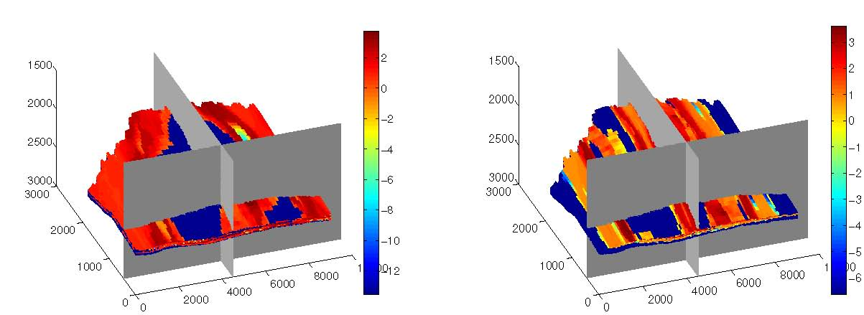
(c) The X slice at the injection point (see (a)). (d) The X slice at the injection point (see (b)).
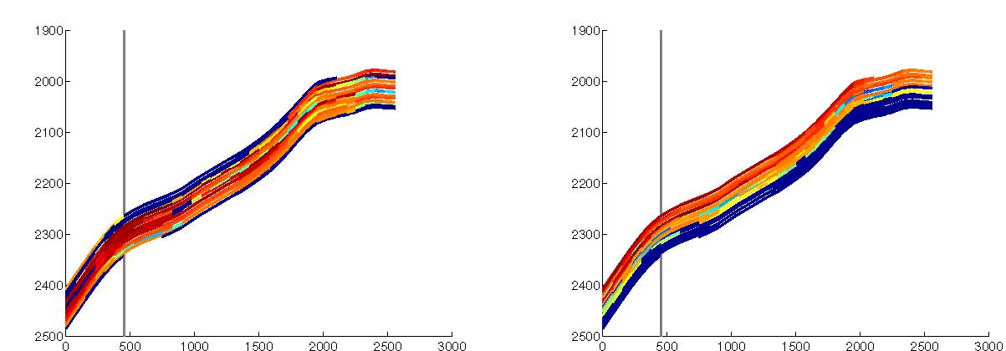
(e) The Y slice at the injection point (see (a)). (f) The Y slice at the injection point (see (b)).
1.8 Flow modeling
(a) Perspective view of model A (b) Perspective view of model B
(c) The X slice at the injection point (see (a)). (d) The X slice at the injection point (see (b)).
(e) The Y slice at the injection point (see (a)). (f) The Y slice at the injection point (see (b)).
(a) Perspective view of model A (b) Perspective view of model B
(c) The X slice at the injection point (see (a)). (d) The X slice at the injection point (see (b)).
(e) The Y slice at the injection point (see (a)). (f) The Y slice at the injection point (see (b)).
1.8 Flow modeling
(a) Perspective view of model A (b) Perspective view of model B
(c) The X slice at the injection point (see (a)). (d) The X slice at the injection point (see (b)).
(e) The Y slice at the injection point (see (a)). (f) The Y slice at the injection point (see (b)).
(a) Perspective view of model A (b) Perspective view of model B
(c) The X slice at the injection point (see (a)). (d) The X slice at the injection point (see (b)).
(e) The Y slice at the injection point (see (a)). (f) The Y slice at the injection point (see (b)).

1.8 Flow modeling
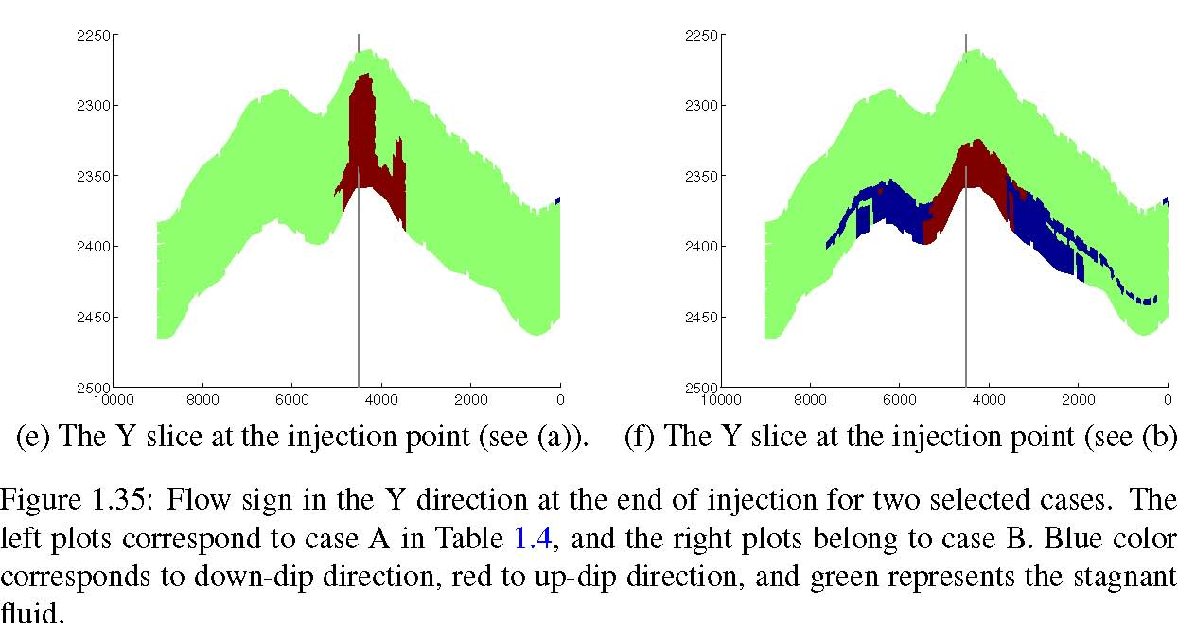
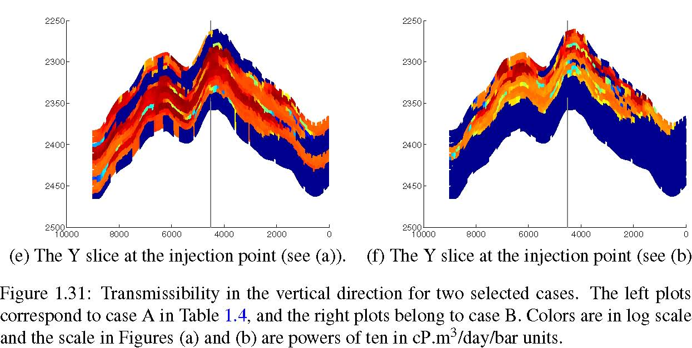
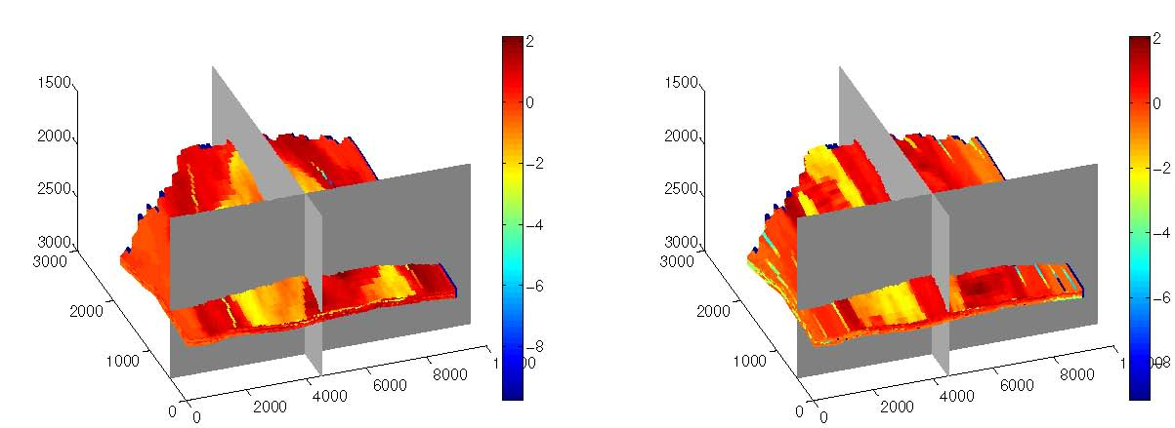
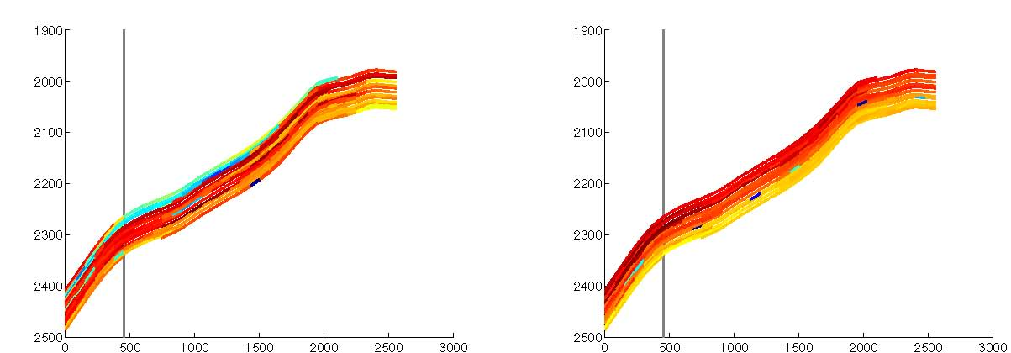
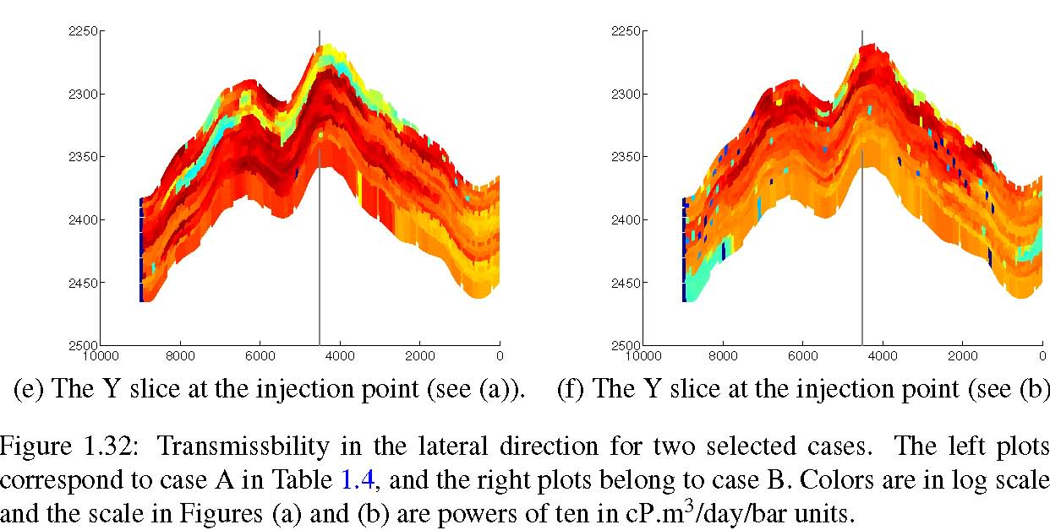
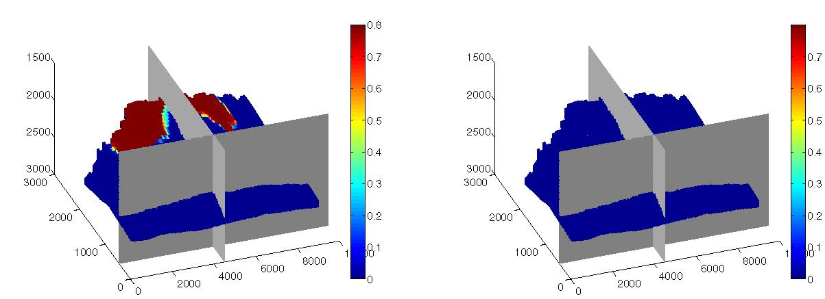
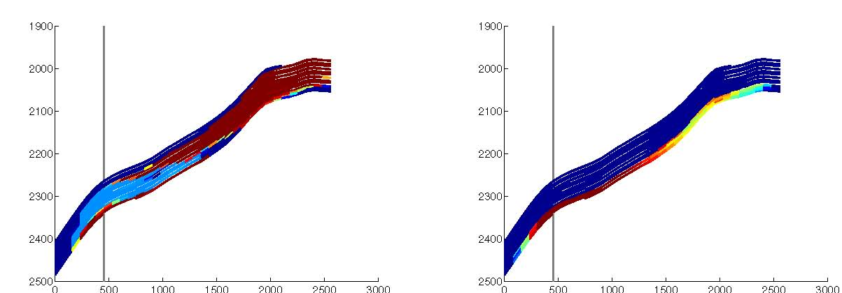
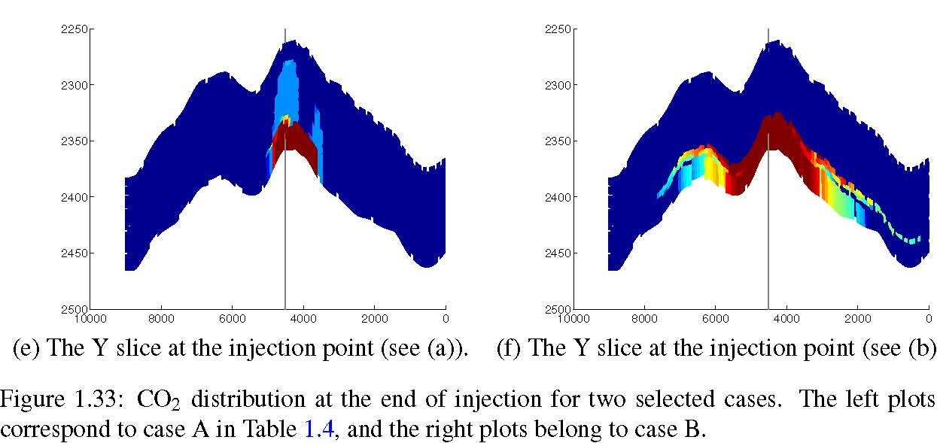
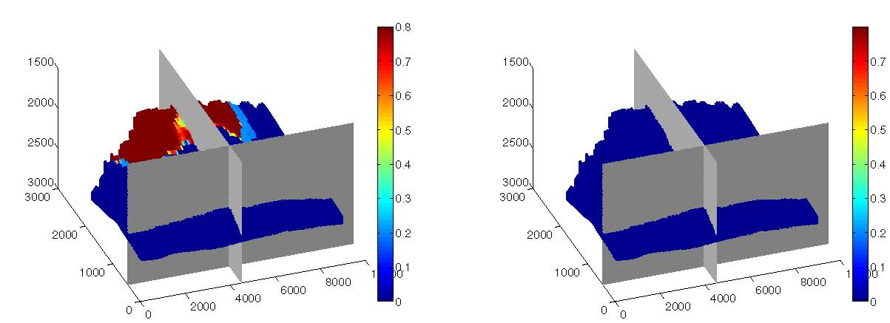
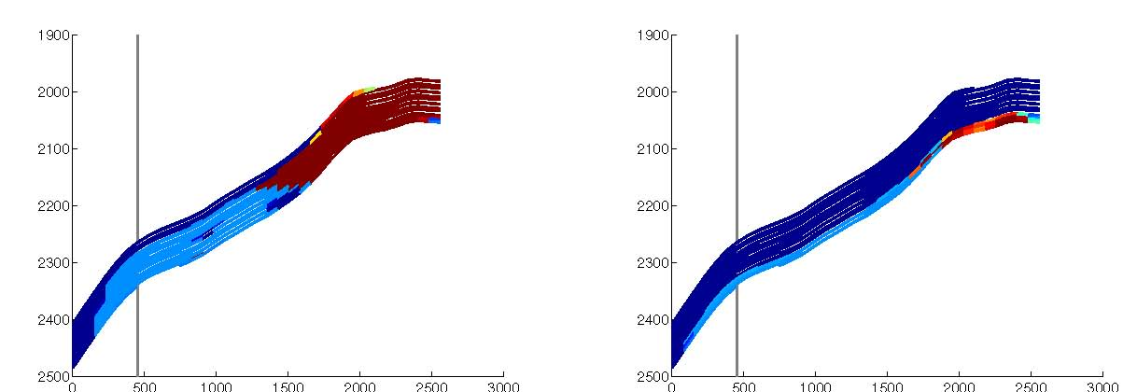
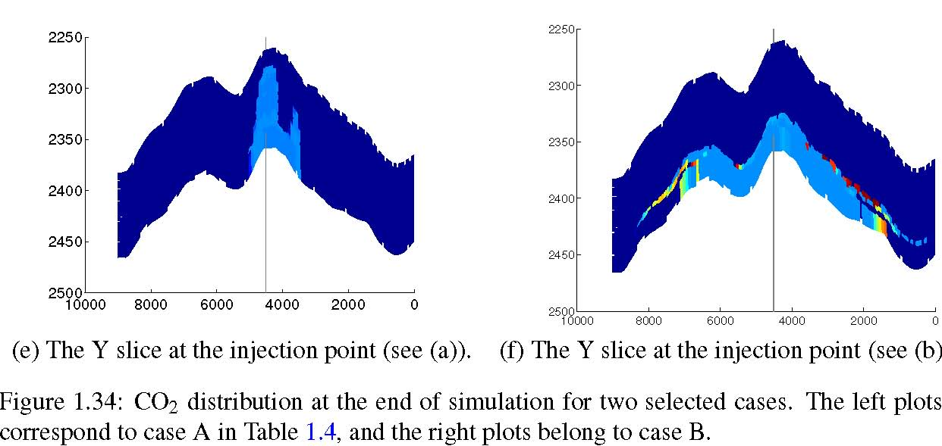
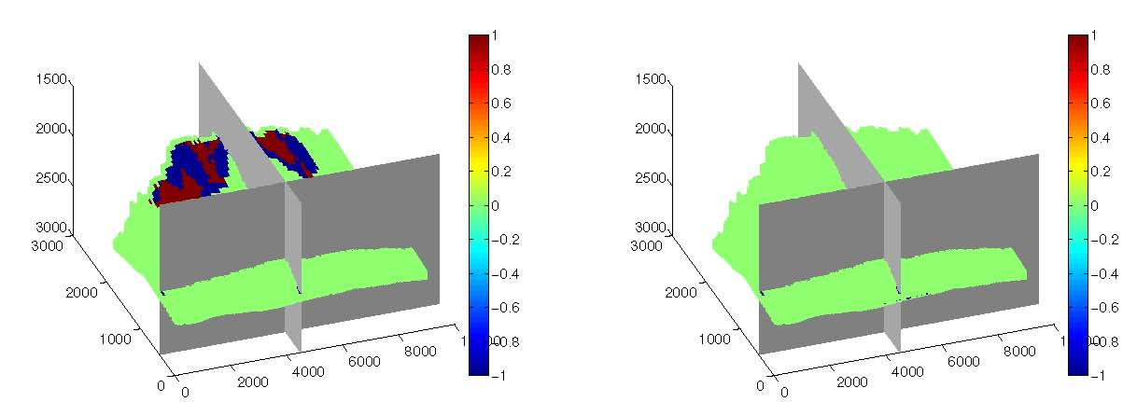
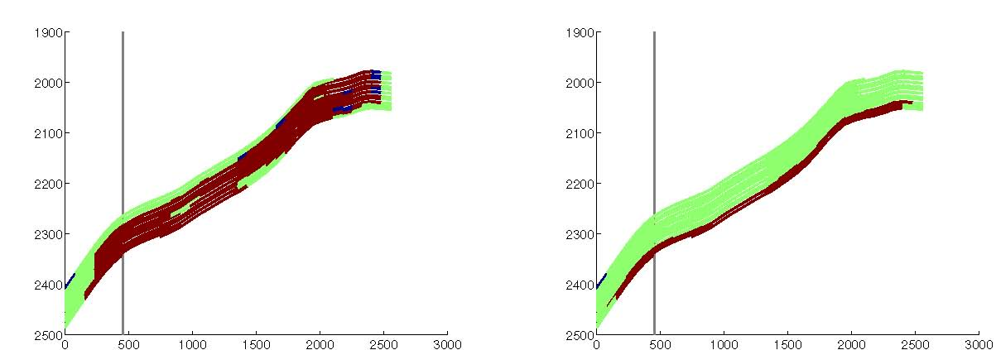
1.8 Flow modeling
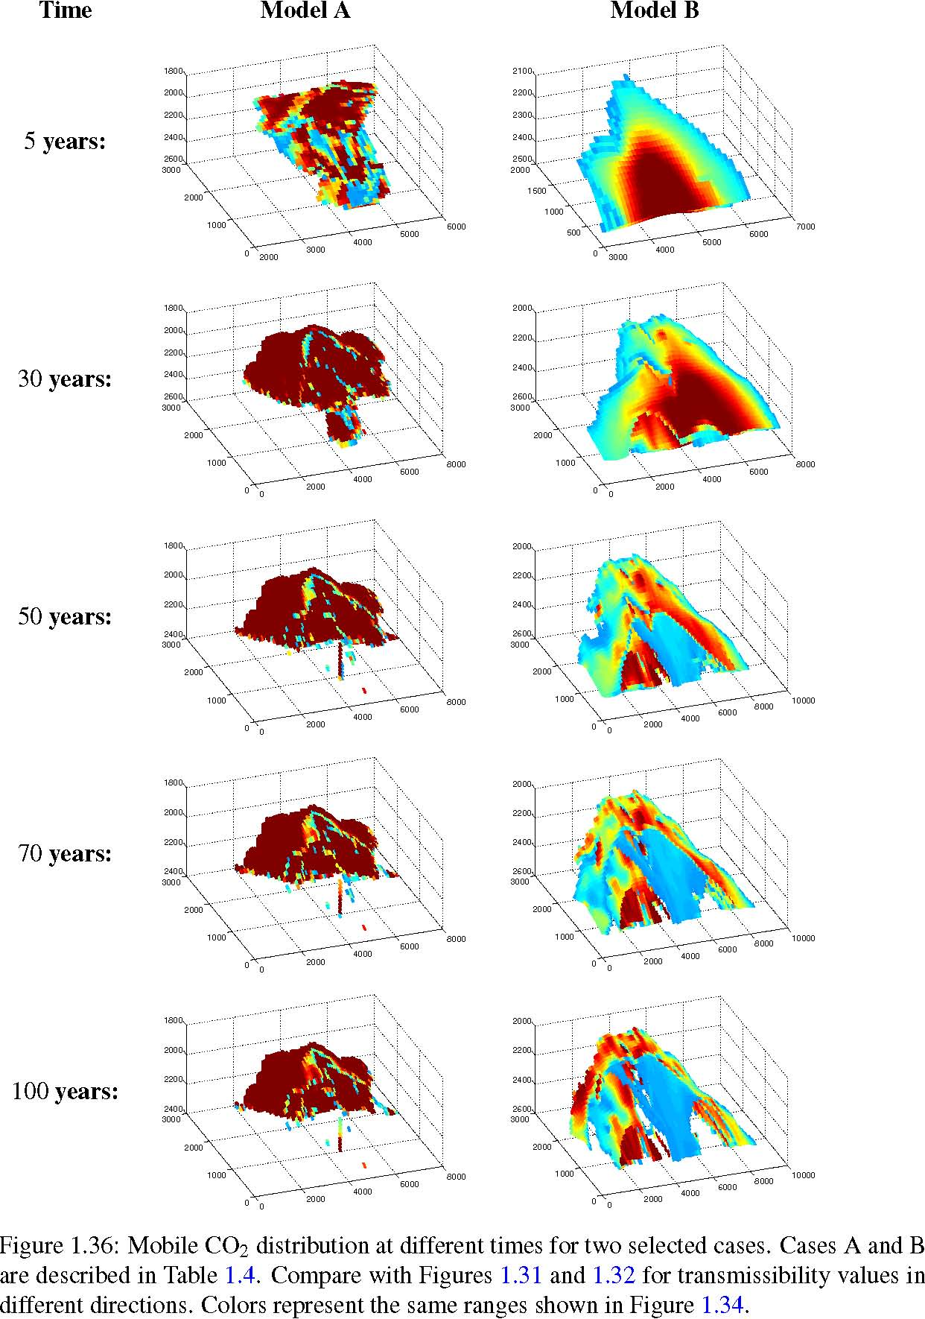
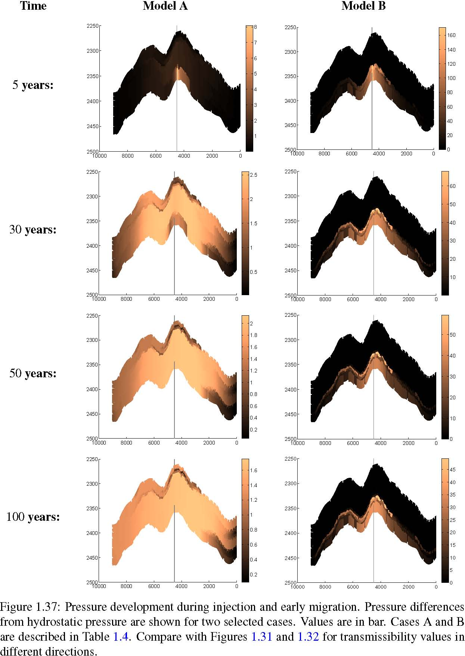
Figure 1.38: Marker codes used to plot the simulation results of all cases together.
The grid information are given for each realization. The set of keywords generated in the SAIGUP study are included in the input ﬁle. Each included ﬁle contains data for a speciﬁc keyword. Each ﬁle is named after the keyword name it includes with the extension ’INC’. For example, ’PORO.INC’ contains the PORO keyword, which contains the porosity value for each cell in the model. Only two INCLUDE keywords are printed here to improve the readability of the code. In the second INCLUDE we provide the pore volume multipliers for the cells on the boundary of the model. This is used to represent hydrostatic open boundaries for three sides of the model.
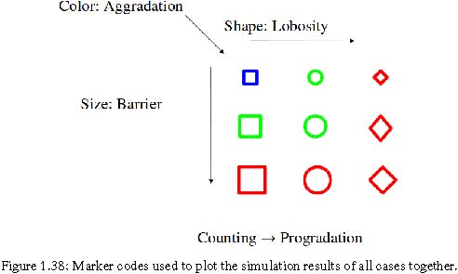

GRID
’COORD. INC ’ / ’ZCORN. INC ’ / ’ACTNUM. INC ’ / ’NTG. INC ’ / ’PORO. INC ’ / ’PERMX.INC’ / ’PERMY.INC’ / ’PERMZ.INC’ / ’MULTX.INC’ / ’MULTY.INC’ / ’MULTZ.INC’ /
In the EDIT section, we provide the fault transmissibility multipliers for each faulted case.
EDIT
INCLUDE ’EDITNNC . INC ’ /
In the PROPS section the relative permeability data are provided in two sets of tables with two different endpoints for CO2 to consider the hysteresis effect. In the SOLUTION section, we use the ﬁrst table to initialize the model with 100% water everywhere, and in the SCHEDULE section we use the second table to consider the residual CO2 in a drainage process followed by an imibibition. In the presented scenario, linear relative permeabilities are used. Another scenario contains quadratic relative permeabilities that are given to the model. Zero capillary pressure is used here. PVT data for CO2 (modeled by OIL) and water phases, ﬂuid viscosities, densities, and the rock-ﬂuid compressibility models are provided here.
PROPS
SWFN
1 1.0 0
0.2 0.0 0
Introduction
SOF2
0.800 1.0000
0.800 1.0000
200.0 1.0 3.03E−06 0.4 0.0 /
400.0 0.95 0.04
/
400.0 0.30E−06 /
In the REGIONS section we deﬁne different domains in the model. We specify the main domain that excludes the cells considered to represent the open boundaries. This is later used in the calculations of ﬂow responses. Also, the saturation table is assigned here, to be used in the initialization of the model as explained earlier.
REGIONS
INCLUDE
’LRGNS. INC ’ / SATNUM
96000∗1/
The model is initialized here for the ﬁrst time step by considering the hydrostatic equilibrium in the medium prior to CO2 injection.
SOLUTION
In the SUMMARY section we specify the output vectors to be used in our analysis.
SUMMARY
FOIP FWIP
/ RWIP
/ RWSAT
/ RPR
/
/ WOIR
/ WVIR
/
1.8 Flow modeling
Finally, in the main part of the model, we deﬁne the simulation scenario by providing the injector completion speciﬁcations and injection plan for the well. Here we see the SCHEDULE section that is considered for ﬁxed injection rate over 30 years, followed by 70 years of early migration.
SCHEDULE
96000 ∗2/
’I’ ’G’ 660 1∗ ’OIL’ / /
’I’ 6 60 17 20 ’OPEN’ 0 .0 0.1/ /
’I’ ’OIL’ ’OPEN’ ’RESV’ 1∗ 3650.0 / / RPTRST
0.1/ TSTEP 120∗90 /
’I’ ’OIL’ ’SHUT’ ’RESV’ 1∗ 0.0 / / TSTEP 280∗90 /
END
In the other scenario we control the well by pressure constraint and we continue the injection until the aimed total CO2 volume is injected in the aquifer, or the simulation time reaches 100 years:
SCHEDULE
96000 ∗2/
’I’ ’G’ 660 1∗ ’OIL’ / /
’I’ 6 60 17 20 ’OPEN’ 3 .0 0.1/ /
’I’ ’OIL’ ’OPEN’ ’RESV’ 1∗ 3650.0 400/ / RPTRST BASIC = 3 FREQ=8 FLOWS /
STPINJ FOIT > 40000000 /
WCONINJE ’I’ ’OIL’ ’SHUT’ ’RESV’ 1∗ 0.0 / /
ENDACTIO TSTEP
0.1/
120∗90 / RPTRST BASIC=3 FREQ=8/ TSTEP 280∗90 /
END
We used a similar approach to the ﬁrst scenario presented here with small modiﬁcations for the stochastic analysis that we will introduce in the next section.
1.9 Sensitivity and risk analysis
Mathematical models developed to approximate the injected CO2 in the storage sites consist of several steps. This includes the determination of parameters, which are the most inﬂuential on the model outputs. Sensitivity analysis can serve as a guide to any further use of the model.
In the initial sensitivity analysis performed on geological uncertain parameters of our studies, we use the large number of detailed ﬂow simulations and measure the variability of model responses with respect to each level of the uncertain parameters.
We can obtain histograms of response Γ for three different levels of parameter α (i.e., low, medium, and high) by performing simulations over all geological realizations. Measuring the mean response value on each histogram results in an average for all cases with a ﬁxed level for parameter α. Having three average points for low, medium, and high levels of parameter α, a line can be ﬁtted to those points that approximates the trend of variations of response Γ versus the increase in levels of parameter α.
Assuming an equal probability for each level, the model output variations are examined by looking at each response at two important simulation times, i.e., end of injection and end of simulation. Assessing the uncertainty with input variations over a relatively high resolution demands a fast ﬂow modeler. We use a response surface method that is explained in the next section in details.
1.9.1 Stochastic analysis
Phenomenon for which variables are uncertain can be modeled as a stochastic process. Uncertainty reduction in different parts of the modeling requires a better understanding and description of input parameters and dependency rules within the system. Parameters can be ranked in the order of their inﬂuence on the model output. Knowing the most inﬂuential parameters helps in treating the stochastic nature of the process. Sensitivity analysis serves in identiﬁcation and evaluation of important model parameters.
As discussed in the earlier sections, various sources of uncertainties are embedded within CO2 storage modeling and operations. The focus of our research has been on geological uncertainty and its consequences. The procedure used here to identify the relative importance of uncertain geological parameters via sensitivity analysis and the corresponding risk assessment is a general work-ﬂow that can be applied to any type of uncertainties in the model inputs.
1.9.2 Arbitrary polynomial chaos expansion
Our research continues by employing a stochastic response surface method that approximates the ﬂow responses by projecting them on high-dimensional polynomials. In particular, we use arbitrary polynomial chaos (aPC) expansions, which consists of orthogonal polynomial bases that are constructed according to the uncertainties in the input parameters. The approach is ﬂexible with respect to the quantiﬁcation of probabilities for uncertain parameters and can be applied in studies with limited knowledge of probabilities.
The reduced model approximated by aPC is considerably faster than the original detailed one, thus providing a promising start point for global sensitivity analysis and probabilistic risk assessment. Variance-based global-sensitivity analysis methods have shown success in non-linear and complex problems [58]. The system can be decomposed into approximating functions of input parameters, and this makes it easy to implement methods based on variance. The bottleneck of variance-based approaches can be their computational costs. In our case, the variance in output responses can be set equal to the variance of polynomial components calculated for each input parameter. Polynomials are inexpensive to evaluate compared with a full simulation. This makes it efﬁcient to implement a variance based sensitivity analysis using polynomial approximation. Furthermore, the approach has been significantly simplified by the fact that the polynomial properties of the response surface are known. The speed of polynomial approximation makes it feasible to perform an intensive probabilistic risk assessment via a Monte-Carlo process over a high-resolution input variation.
1.9 Sensitivity and risk analysis
Statistical accuracy of a Monte-Carlo process is highly sensitive to the resolution of variational inputs. A response surface method assisting a Monte-Carlo procedure must be constructed on a dense Cartesian grid, which will be computationally demanding. We explore an alternative method: A polynomial chaos expansion (PCE). This method only requires a minimum number of model evaluations to construct the approximating response surface. The approach we use is based on the aPC as described in [54]. The main idea is to construct the approximating response surface by projecting the response on orthogonal polynomial bases within the uncertain parameter space. Therefore, uncertainty in input parameters is involved in the process from the initial steps of the work-ﬂow. This approach is an advanced statistical regression method that offers an efﬁcient and accurate way of including nonlinear effects in stochastic analysis; see e.g., [23, 27, 73]. The method is examined for accuracy and one attractive feature of PCE is the high-order approximation of error propagation as well as its computational speed
[55] when compared to Monte-Carlo processes.
Earlier PCE techniques put the restriction of speciﬁed types of uncertainty distribution functions to be used in the work-ﬂow. In contrast, the arbitrary polynomial chaos (aPC) is ﬂexible enough to accommodate for a wide range of data distribution [54]. The aPC can work even in cases with limited uncertainty information reduced in a few statistical moments of samples. They can be speciﬁed either analytically (as probability density, cumulative distribution functions), numerically as histograms, or as raw data sets. In terms of performance, the aPC approach shows an improved convergence applied to input distributions that fall outside the range of classical PCE.
In general, an approximation of system response Γ can be written as a function of the uncertain input parameters Θ:
Γ ≈ ϒ(Θ). (1.48)
Uncertainty of input parameters Θ can be represented by a mapping h from random variable space ξ to random input space Θ
Θ = h(ξ). (1.49)
As discussed earlier, h can be an analytical or numerical representation.
The response of the system can be expanded into the space of the approximating polynomial bases. This expression is speciﬁed by constant coefﬁcients ci:
nc Γ ≈ ∑ciΠi(Θ). (1.50) i=1
Here, nc is the number of expansion terms, ci are the expansion coefﬁcients, and Πi are the multidimensional polynomials for the variables Θ =[θ1,...,θn]. The number nc of unknown coefﬁcients ci depends on the degree d of the approximating polynomial, and the number of considered parameters n:
(d + n)!
nc = . (1.51)
d! × n!
Polynomials Πi in the Expansion 1.50 consist of polynomial bases Pl, with l ranging from zero up to the approximation degree d. These bases are orthogonal, i.e., every pair of non-identical bases fulﬁll the following condition:
ωPlPmdτ(Θ)= δlm, (1.52)
I∈Ω
where ω is a weight function, δ is the Kronecker delta function, and τ is the measure for input variable space. We choose the weight to be one, i.e., ω := 1.
The orthogonal polynomial basis satisfying Equation (1.52) can be obtained from the solution of the following linear system of equations [54]:
⎡
⎤
⎤
⎡
⎤⎡
_{P}(k)
0
0
µ0 µ1 ... µk
⎢⎢⎢⎢⎣
µ1 µ2 ... µk+1
... ... ... ...
µk−1 µk ... µ2k−1
⎥⎥⎥⎥⎦
⎢⎢⎢⎢⎢⎣
_{P}(k)
1
...
_{P}(k) k−1
⎥⎥⎥⎥⎥⎦
=
⎢⎢⎢⎢⎣
0
...
0
⎥⎥⎥⎥⎦
.
(1.53)
00 ... 1 _{P}(k) 1 k
Here, µk is the k^{th} non-central (raw) statistical moment of the random input variable, which is deﬁned as:
µk = Θ^{k}dτ(Θ). (1.54)
Θ∈Ω Thus, arbitrary polynomial chaos expansion base on Equation 1.53 only demands the existence of a ﬁnite number of moments, and does not require the exact knowledge or even existence of probability density functions. An interesting aspect is that, only moments up to twice the order of the expansion matter. This means that there is no need for any kind of assumptions for data probability distribution leading to subjectivity artifacts as discussed earlier.
The PCE techniques are divided into intrusive [30, 48, 70] and non-intrusive [40, 42, 43, 55] approaches. Intrusive techniques require modiﬁcations in the system of governing equations (e.g., the ﬂow model system). In some cases, this can end up in semi-analytical methods that are used for simpler stochastic analysis studies (e.g., stochastic Galerkin method). However, the intrusive approaches can be very complex and analytically cumbersome and cannot be implemented for industrial applications. In contrast to intrusive techniques, the non-intrusive methods are vastly used in practical studies. These methods do not require any symbolic manipulations of the governing equations. The sparse quadrature and the probabilistic collocation method (PCM, [43, 55]) are among the non-intrusive technique. In a simple sense, PCM can be considered as a mathematically optimized interpolation of model output for various parameter sets. The polynomial interpolation is based on minimal model evaluations in an optimally chosen set of parameter locations that are called collocation points. Hence, the challenge in these techniques is to ﬁnd a balance between accuracy and speed to evaluate the uncertainty in the physical processes.
The collocation formulation has the advantage of treating the model as a black-box. This formulation requires the corresponding output to be known in the collocation set of input parameters.
According to [69], the optimal choice of collocation points corresponds to the roots of the polynomial of one degree higher (d + 1) than the order used in the chaos expansion (d). This strategy is based on the theory of Gaussian integration (e.g., [1]).
For multi-parameter analysis, the full tensor grid of available points from the original integration rule is (d + 1)^{n}, which is larger than the necessary number M of collocation points. This might be used for low-order (1st ,2nd) analysis of limited number of parameters. However, for a large number of parameters and high order of polynomial approximations, the full grid becomes computationally cumbersome. In the collocation approach, the minimal set of points is chosen from the most probable regions based on the parameter uncertainty information (See [43, 54, 55]).
We implement the probabilistic collocation method for computing the coefﬁcients ci in Equation
1.50. The weighted-residual method in the random space is deﬁned as [43]:
nc
Γ − ∑ciΠi(Θ))w(Θ)p(Θ) dτ = 0, (1.55)
i=1
where w(Θ) is the weighting function and p(Θ) is the joint probability density function of Θ. By substituting the weight function in Equation 1.55 with Delta function, the equation reduces to
nc
Γc − ∑ciΠi(Θc)= 0. (1.56)
i=1
1.9 Sensitivity and risk analysis
In this equation, Γc and Θc are the responses and input parameters in the collocation points. Having the Θc chosen based on the probability distributions of input parameters, and Γc from the minimal model evaluations on Θc, we can solve Equation 1.56 and ﬁnd the coefﬁcients ci.
1.9.3 Sensitivity analysis
Sensitivity analysis helps in understanding the degree of dependency of system responses to the input parameters. When the value of the input parameters are uncertain, the model predictions will consist of uncertainties that must be eliminated for a robust and precise prediction. Therefore, sensitivity analysis can be useful both in optimizing the system performance and in studying the variation in performance coming from the stochastic nature of the system.
Global sensitivity analysis covers the entire variational space for uncertain parameters, while other methods, like the gradient-based methods, are limited in the scope inﬂuence of the parameters.
Variance-based methods are very popular among different types of sensitivity analysis methods. Variance-based methods provide global sensitivity and work for general non-linear problems. When the response is decomposed into simpler components (for instance, polynomial bases), it is easier to decompose the unconditional variance in the output into terms due to individual parameters and the interaction between them. It is possible then to rank the input parameters based on their contribution to the output variance [58, 62].
Following the linear sensitivity analysis performed initially in the study on the extensive detailed simulations, we tackle the global sensitivity analysis based on the aPC technique. This approach is well described in [54, 56]. Morris method [51] considers a uniform importance of input parameters within predeﬁned intervals. We use a weighted global sensitivity in a more ﬂexible approach accounting for arbitrary bounds and parameters with different importance deﬁned by weighting functions. The big advantage of aPC-based sensitivity methods is their low computational costs for obtaining global sensitivity analysis. The aPC based-method places the parameter sets for model evaluation at an optimized spacing in parameter space. This can be interpreted as ﬁtting polynomials to the model response. These polynomials approximate the model over the entire parameter space in a weighted least-square sense. This is beneﬁcial for computing a tangent or local second derivatives (compare FORM, SORM methods, e.g., [41]) that approximate the model well just around one point in the parameter space.
As an advantage, in variance based methods one can work with arbitrary system as a black-box and calculations are based on inputs and outputs only. More recent works are concerned about expediting calculation pace [16, 54, 56]. The idea is to replace the system with an approximating function, which gives beneﬁts in sensitivity calculations, because it is easy to relate the output variances to the input variables.
We expand the variance of output solution into components. Assume that we break the system output into components:
Γ = Γ0 + ∑Γi + ∑∑Γij + ... (1.57) i ij>i
A single index shows dependency to a speciﬁc input variable, whereas more than one index shows interaction of input variables. If we consider input vector Θ to be of n components θi for i = 1,..,n, then Γi = fi(θi) and Γij = fi j(θi,θj). In practice, we consider a ﬁnite number of terms in Equation (1.57). The ﬁrst order sensitivity index, so called Sobol index, is deﬁned as follows [62]:
V[E(Γ | θi)]
Si = , (1.58)
V(Γ)
where E(Γ | θi) is the conditional expectation of output Γ given θi and V is the variance operator. Since θi can be ﬁxed at any value in its uncertainty interval, each of those values produce a distinct expectation E(Γ | θi). Equation 1.58 is a measure for variations of these expectations, which indicates the direct contribution of parameter θi in the output variance. For more than one index, a higher-order Sobol index can be deﬁned as:
V[E(Γ | θi,θj)] − V[ E(Γ | θi)] − V[E(Γ | θj)]
Si j = . (1.59)
V(Γ)
Here, V[E(Γ | θi,θj)] is the variance of output expectations after ﬁxing θi and θj. This index represents signiﬁcance of variation in output generated from uncertainty in input variables together, i.e., the interaction of uncertain parameters. If we add all indices that contain variable θi, the sum is called the total Sobol index:
STi = Si + ∑Si j + ∑∑Si jk + ... (1.60)
}j=i =i }
}jk=i
To clarify the subject, we go through a simple analytical example given in [4]. Suppose that the exact expression for response Γ is known and can be written as a polynomial with parameters θ1, θ2, and θ3:
24 4
Γ(θ1,θ2,θ3)= θ1 + θ2 + θ1θ2 + θ2θ3 . (1.61)
The Sobol indices can be calculated from functions F that are deﬁned based on orthogonality condition used to decompose the solution and for input with Gaussian distribution Φn in uncertainty domain R^{n} they are as follows:
F0 = Γ(Θ)Φn(Θ)dΘ, (1.62)
Rn
Rn−1 ^{Γ}|θ_{i} ^{Φ}n−1^{(θ}∼i^{)dθ}∼i
Fi = − F0, (1.63)
Φ1(θi)
Rn−2 ^{Γ}|θ_{i},θ _{j} ^{Φ}n−2^{(θ}∼i,∼ j^{)dθ}∼i^{dθ}∼ jFi, j = − F0 − Fi(θi) − Fj(θj). (1.64)
Φ2(θi,θj)
Γ_{|θi} and Γ_{|θi,θ j} are the Γ values at ﬁxed θi and {θi,θj} respectively. θ∼i is the vector of dummy variables corresponding to all but the component θi of uncertain parameters Θ.
Let us denote the variances by D:
D = V[F(Θ)] = F²(Θ)dΘ − F0, (1.65)
that can be decomposed into:
Di = Fi ²(θi)dθi, (1.66)
and Di, j = Fi j ²(θi,θj)dθidθj. (1.67)
Then the Sobol indices can be found from:
Di
Si = , (1.68)
D
Di, j
Si, j = . (1.69)
D
Finally, the total Sobol index can be found from Equation 1.60. Applying the calculations of Equations
1.62 to 1.67 for our example (i.e., the expression in Equation 1.61) we can obtain the following Sobol
indices, assuming Gaussian distributions for the parameters over the interval [0,1]:
S1 = 0.0005 S2 = 0.4281 S3 = 0.0000
S12 = 0.0007 S13 = 0.0000 S23 = 0.5708
S123 = 0.0000 and the total sobol indices are:
1.10 General summary
ST 1 = 0.0012 ST 2 = 0.9996 ST 3 = 0.5708 . The total Sobol index can be used as a sensitivity measure to rank parameters for their inﬂuence in the results variation. In this example, we can see that the ranking which is suggested by the total Sobol indices is consistent with what can be inferred directly from the simple expression in Equation 1.61: θ2 is the most inﬂuential parameter, because it appears in three terms, one of which with a forth degree. Interactions are represented by two indices, and S13 is zero, because there exist no term in Equation
1.61 that contains both θ1 and θ3.
With known polynomial coefﬁcients, Sobol indices are easy to calculate. When the number of parameters is large, it is possible to do initial sensitivity analysis with lower degree polynomials to ﬁlter out pertinent parameters. Then the analysis continues on the ﬁltered parameters with a higher degree polynomial approximation.
1.9.4 Risk analysis
The risk is the impact of uncertainty on objectives. Quantifying the risk requires calculating this impact, which consists of two parts: quantiﬁcation of the uncertainty and evaluation of the system consequences. Risk R of a process is quantitatively deﬁned as the consequence C caused by the process multiplied by the probability P of that consequence to happen:
R = P ×C. (1.70)
In the case of CO2 injection into deep aquifers, the amount of CO2 that stays mobile and undissolved in the medium for a time after injection can be considered as a consequence. This bears the potential of leakage up to the surface if exposed to a geological leakage point. The risk could be the expected amount of CO2 that will leak through ill-plugged abandoned wells or cracks in the sealing rocks.
We consider looking at responses and the probability of them to happen. We initially examine this probability by drawing the histogram of response values obtained from detailed simulations on large numbers of realizations. These simulations corresponded to important times, like end of injection and end of simulation. Yet larger numbers of points in the uncertain parameter space are studied employing the data-driven aPC method, which requires a considerably shorter time for evaluating the responses than it takes for a full simulation. This way it is possible to perform an intensive Monte-Carlo process in a full tensor grid of input parameter variational space, resulting in a high-resolution output probability distribution.
1.10 General summary
The work objectives have been two folds:
- Assessing the signiﬁcance of geological modeling in CO2 injection and early migration studies.
- Introducing a framework for extensive realistic sensitivity analysis and risk assessment of geological CO2 storage.

The signiﬁcance of geological uncertainty is discussed by extensive study on CO2 ﬂow in different geological models. Sensitivity analysis and risk assessment have resulted in ranking of the studied geological parameters for various ﬂow responses in the medium. The work-ﬂow implemented in this work is a stepwise procedure,that can be generalized to be used in any similar large-scale analysis.
1.10.1 Implementation of the work-ﬂow
This thesis incorporated working with large number of realizations, various ﬂow scenarios, and different procedures and softwares. While the study progresses, new ideas and challenges rises that require manipulation of parts of the work-ﬂow. In order to achieve the deﬁned goals of the research, an automated work-ﬂow is required that connects different parts of the study and converts data type in-between them. This makes the study feasible in terms of saving time for any necessary modiﬁcations.
Figure 1.39: Flow-chart of work process implemented in an automated procedure.
MATLAB programming language is used for implementing the work-ﬂow in this research. The main reason for this choice, apart from the rich facilities available within MATLAB toolboxes, is to use many functions within the MATLAB Reservoir Simulation Toolbox (MRST) [44, 65] available as free and open-source software in MATLAB language. For ﬂow simulation commercial software is used, which is a standard simulator for oil and gas industry and research. The simulator is using ﬁnite difference for ﬂow modeling.
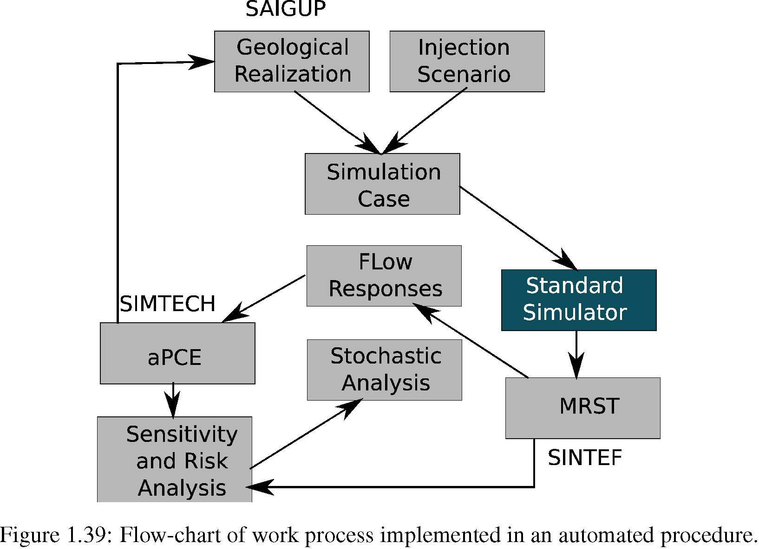
Figure 1.39 shows the elements of the work-ﬂow implemented by a large number of MATLAB functions. Functions from MRST at SINTEF and the stochastic tools of SIMTECH group in Stuttgart University are utilized and merged into the work-ﬂow. The design is made such that the work-ﬂow is ﬂexible and general. Some research has been undertaken by replacing the commercial simulator with in-house simulators at SINTEF, however, the main study was performed using a commercial standard simulator.
1.10.2 Generic application of results
The main focus of the work is two fold:
- Signiﬁcance of geological uncertainty in the early stages of CO2 storage operations.
- Applying a mathematical tool to perform sensitivity analysis and probabilistic risk study for assessing the geological uncertainty impacts on the success of CO2 storage.

We rank the most inﬂuential geological parameters. The demonstrated work-ﬂow can be used in any study concerning the site selection and early stages of CO2 storage. However, there are some limitations in our presentation of the work-ﬂow that need to be considered when this work is to be consulted for any similar study.
The first limitation is the SAIGUP model size. CO2 storage studies requires large models that can cover the CO2 spatial traveling extents within the aquifer. Therefore, our study is limited to the domain around the injector.
1.10 General summary
An over-pressurized injection can introduce breakings in the sealing cap-rock, aimed for the use of structural strapping of CO2. It is more feasible to use minimum number of wells to minimize the costs of the project and also the risk of CO2 leakage via drilled wells after they are abandoned. Therefor, a typical injection scenario includes a few number of injectors with no production well to balance the injection pressure. Both the elliptic nature of pressure equation and the small compressibility of the medium result in a large area inﬂuenced by injection pressure. Therefor, the pressure related studies need a large size of model to study the inﬂuence of the impulse imposed by the injector on the entire region connected to that impulse.
To overcome this limitation in the SAIGUP models, we exaggerated the volume of the cells in the boundaries of the model that are supposed to be open. The large pore volumes on the boundaries avoid extreme pressure build-up due to injecting in a closed system. On the other hand, the study is limited to the region near the well. Since the high pressures are happening near the injector, this is more interesting to study for a pressure build-up around the well rather than looking at the entire region inﬂuenced by the injection pressure.
The pressure behavior is very sensitive to the way the boundaries are deﬁned. In reality, there are different systems of aquifers. Some of them are large with huge pore-volumes. To model these aquifers, we can use smaller size models with open boundaries. However, some aquifers are medium and small in size. To model these aquifers, we can assume semi-close and close boundaries. For any aquifer system, we can deﬁne the boundary by exaggerating the pore volume of the cells on the boundaries of the model. The transmissbilites of the boundary cells can be also modiﬁed to represent the size of the aquifer system. This controls the amount of pressure relaxation in the medium through the boundaries. If CO2 exists in the boundaries, relative permeability functions at the boundary can be modiﬁed in addition to the transmissibilities.
The open boundaries in our study are considered to be fully open. This makes the pressure relax through the boundaries and the results of our pressure study are inﬂuenced by this choice. While we have observed a considerable portion of cases with extreme pressures due to heterogeneity effects, the pressures reported in our study are moderate compared to not fully opened boundaries. The sensitivity analysis is based on comparing cases for their pressure values. Therefor, the outcome of sensitivity analysis should be valid regardless of the boundary choices. The size limitation in the SAIGUP models resulted in an extension to the current study in a project, which is called IGEMS [67].
The IGEMS models have larger size compared to the SAIGUP models. There is only one major structural trap in the SAIGUP models that allows for most of the injected CO2 to accumulate under the cap-rock. This is not sufﬁcient for studying the effect of variations in the top-surface topography on the CO2 movement in the medium. The IGEMS study has focused on the structural trapping due to deformations in the top-surface morphology and faults. The results show that the structural trapping can be important in the amount of storage due to structural trapping and it can control the speed of the plume migrating under the top sealing cap-rock.
In the vertical scale the study can be improved by using a higher grid resolution. Variations in the vertical direction exist in considerably smaller scales than the lateral direction. In particular, this is more crucial for the long-term migration of CO2 where a thin plume of CO2 migrates beneath a sealing layer due to the buoyancy forces.
Another issue to be mentioned is the assumption for geological uncertainties that are used in the stochastic analysis. We consider near uniform distributions for the probabilities of uncertain parameter values. While there is no loss of generality, there are too comments that could improve our analysis:
- In general, the uncertainty probability can be different than uniform distribution. Actually, this information is very case dependent and can change from one location to another.
- One advantage of the aPC method is the ﬂexibility to apply for arbitrary forms of uncertainty data. Choosing various distributions for the geological parameters would be more demonstrative of the aPC method strength.

Choosing uniform uncertainty distributions for our study is due to our limitation to use the SAIGUP models that are made based on equi-probable values for the geological uncertain parameters. A general stochastic process using the aPC must be considered in the following steps:
- Use the techniques from the aPC to derive appropriate sample points for geological parameters.
- Construct geological models at these sample points.
- Perform ﬂow simulations for each sample point.
- Construct the proxy model.
- Perform global sensitivity analysis using the Sobol indices method and the proxy model.
- Perform the Monte-Carlo using the aPC study to assess the uncertainty and risk.

Of note, in Figure 1.39 is the link between designing geological realizations and implementation of aPCE method. The sensitivity analysis and risk assessment procedure must start from the ’aPCE’ box in Figure 1.39, by ﬁnding the collocation points from the given geological uncertainty, and then based on those collocation points we design the geological realizations. However, for the availability of a large set of SAIGUP realizations that were generated before this study, our start point was from the ’Geological Realization’ box in Figure 1.39. This change in start point resulted in assuming a given geological uncertainty knowledge that suits the SAIGUP geological design. Nevertheless, we practice the procedure in a scope of geological modeling and ﬂow analysis that is novel in its kind and can be consulted for further extensive studies.
Bibliography
[1] ABRAMOWITZ, M., AND STEGUN, I., A. Handbook of Mathematical Functions with Formulas, Graphs, and Mathematical Tables. New York: Dover, 1965. 1.9.2
[2] ALKAN, H., CINAR, Y., AND ÜLKER, E. Impact of capillary pressure, salinity and in situ conditions on co 2 injection into saline aquifers. Transport in porous media 84, 3 (2010), 799–819. 1.7.1
[3] ALLEN, F., AND PUCKETT, D. Theoretical and experimental studies of rate-dependent two-phase immiscible ﬂow. SPE Production Engineering 1, 1 (1986), 62–74. 1.7.1
[4] ARWADE, S., MORADI, M., AND LOUHGHALAM, A. Variance decomposition and global sensitivity for structural systems. Engineering Structures 32, 1 (2010), 1–10. 1.9.3
[5] BACHU, S. Sequestration of CO2 in geological media: criteria and approach for site selection in response to climate change. Energy Conversion and Management 41, 9 (2000), 953–970. 1.1,
1.5.1
[6] BASHORE, W., ARAKTINGI, U., LEVY, M., AND SCHWELLER, W. The importance of the geological model for reservoir characterization using geostatistical techniques and the impact on subsequent ﬂuid ﬂow. In SPE Annual Technical Conference and Exhibition (1993). 1.1
[7] BEAR, J. Dynamics of ﬂuids in porous media. Dover publications, 1988. 1.6.1
[8] BENSON LAB, S. U. Relative pereability explorer(rpe). http://pangea.stanford.edu/research/bensonlab/relperm/index.html. 1.6.2
[9] BENTSEN, R. Effect of neglecting viscous coupling and dynamic capillary pressure on the one-dimensional ﬂow of two immiscible phases through a porous medium. SPE paper, 026016 (1993). 1.7.1
[10] BINNING, P., AND CELIA, M. Practical implementation of the fractional ﬂow approach to multi-phase ﬂow simulation. Advances in water resources 22, 5 (1999), 461–478. 1.6.2
[11] BRADSHAW, J., AND COOK, P. Geological sequestration of carbon dioxide. Environmental Geosciences 8, 3 (2001), 149. 1.1
[12] CAERS, J., AND ZHANG, T. Multiple-point geostatistics: a quantitative vehicle for integrating geologic analogs into multiple reservoir models. AAPG (2002). 1.5
[13] CELIA, M., AND NORDBOTTEN, J. Geological Storage of CO2: Modeling Approaches for Large-Scale Simulation. Wiley, 2011. 1.2, 1.3
[14] CHANGE, I. P. O. C. IPCC Second Assessment. A Synthesis Report. Geneva: WMO (1995).
1.2
[15] CHEN, Z., BODVARSSON, G., AND WITHERSPOON, P. An integral equation formulation for two-phase ﬂow and other nonlinear ﬂow problems through porous media. In SPE Annual Technical Conference and Exhibition (1990). 1.7.1
[16] CRESTAUX, T., ET AL. Polynomial chaos expansion for sensitivity analysis. Reliability Engineering & System Safety 94, 7 (2009), 1161–1172. 1.9.3
[17] DONG, M., AND DULLIEN, F. Effect of capillary forces on immiscible displacement in porous media. In SPE Annual Technical Conference and Exhibition (1999). 1.7.1
[18] DUAN, Z., AND ZHANG, Z. Equation of state of the H2O, CO2, and H2O-CO2 systems up to 10 GPa and 2573.15 K: Molecular dynamics simulations with ab initio potential surface. Geochimica et cosmochimica acta 70, 9 (2006), 2311–2324. 1.6.2
[19] EATON, T. On the importance of geological heterogeneity for ﬂow simulation. Sedimentary Geology 184, 3-4 (2006), 187–201. 1.1, 1.5
[20] ELENIUS, M., AND JOHANNSEN, K. On the time scales of nonlinear instability in miscible displacement porous media ﬂow. Computational Geosciences (2012), 1–11. 1.7.2
[21] ELENIUS, M., TCHELEPI, H., AND JOHANNSEN, K. CO2 trapping in sloping aquifers: High resolution numerical simulations. In XVIII International Conference on Water Resources, CIMNE, Barcelona (2010). 1.7.2
[22] ELENIUS, M. T., NORDBOTTEN, J. M., AND KALISCH, H. Effects of a capillary transition zone on the stability of a diffusive boundary layer. IMA Journal of Applied Mathematics 77,6 (2012), 771–787. 1.7.2
[23] FAJRAOUI, N., RAMASOMANANA, F., YOUNES, A., MARA, T. A.AND ACKERER, P., AND GUADAGNINI, A. Use of Global Sensitivity Analysis and Polynomial Chaos Expansion for Interpretation of Non-reactive Transport Experiments in Laboratory-Scale Porous Media. Water Resour. Res. (2011), doi: 10.1029/2010WR009639. 1.9.2
[24] FARAJZADEH, R., AND BRUINING, J. An Analytical Method for Predicting the Performance of Gravitationally-Unstable Flow in Heterogeneous Media. In SPE EUROPEC/EAGE Annual Conference and Exhibition (2011). 1.7.1
[25] FAYERS, F., AND SHELDON, J. The effect of capillary pressure and gravity on two-phase ﬂuid ﬂow in a porous medium. TRANS AIME 216 (1959), 147. 1.7.1
[26] FLETT, M., GURTON, R., AND WEIR, G. Heterogeneous saline formations for carbon dioxide disposal: Impact of varying heterogeneity on containment and trapping. Journal of Petroleum Science and Engineering 57, 1-2 (2007), 106–118. 1.5.1
[27] FOO, J., AND KARNIADAKIS, G. Multi-element probabilistic collocation method in high dimensions. Journal of Computational Physics 229, 5 (2010), 1536–1557. 1.9.2
[28] FÖRSTER, A., NORDEN, B., ZINCK-JØRGENSEN, K., FRYKMAN, P., KULENKAMPFF, J., SPANGENBERG, E., ERZINGER, J., ZIMMER, M., KOPP, J., BORM, G., ET AL. Baseline characterization of the CO2SINK geological storage site at ketzin, germany. Environmental Geosciences 13, 3 (2006), 145–161. 1.5.1
[29] FOUKAL, P., FRÖHLICH, C., SPRUIT, H., AND WIGLEY, T. Variations in solar luminosity and their effect on the earth’s climate. Nature 443, 7108 (2006), 161–166. 1.2
[30] GHANEM, R., AND SPANOS, P. A stochastic galerkin expansion for nonlinear random vibration analysis. Probabilistic Engineering Mechanics 8 (1993), 255–264. 1.9.2
[31] GREENWOOD, H. The compressibility of gaseous mixtures of carbon dioxide and water between 0 and 500 bars pressure and 450 and 800 centigrade. American Journal of Science 267 (1969), 191–208. 1.6.2
[32] GUNTER, W., WIWEHAR, B., AND PERKINS, E. Aquifer disposal of CO2-rich greenhouse gases: extension of the time scale of experiment for CO2-sequestering reactions by geochemical modelling. Mineralogy and Petrology 59, 1 (1997), 121–140. 1.3, 1.7.2
[33] HADLEY, G., AND HANDY, L. A theoretical and experimental study of the steady state capillary end effect. In Fall Meeting of the Petroleum Branch of AIME (1956). 1.7.1
[34] HASSANZADEH, H., POOLADI-DARVISH, M., AND KEITH, D. Modelling of convective mixing in CO2 storage. Journal of Canadian Petroleum Technology 44, 10 (2005). 1.7.2
[35] HITCHON, B., GUNTER, W., GENTZIS, T., AND BAILEY, R. Sedimentary basins and greenhouse gases: a serendipitous association. Energy Conversion and Management 40,8 (1999), 825–843. 1.1
[36] HOUGHTON, J., ET AL. Climate change 2001: the scientiﬁc basis, vol. 881. Cambridge University Press Cambridge, 2001. 1.1
[37] HOVORKA, S. D., DOUGHTY, C., BENSON, S. M., PRUESS, K., AND KNOX, P. R. The impact of geological heterogeneity on CO2 storage in brine formations: a case study from the Texas Gulf Coast. Geological Society, London, Special Publications 233, 1 (2004), 147–163. 1.5.1
[38] HOWELL, J., SKORSTAD, A., MACDONALD, A., FORDHAM, A., FLINT, S., FJELLVOLL, B., AND MANZOCCHI, T. Sedimentological parameterization of shallow-marine reservoirs. Petroleum Geoscience 14, 1 (2008), 17–34. 1.3, 1.5.2
[39] IEA. Key World Energy Statistics 2009. doi: 10.1787/9789264039537-en. 1.2
[40] ISUKAPALLI, S., S., ROY, A., AND GEORGOPOULOS, P., G. Stochastic response surface methods (srsms) for uncertainty propagation: Application to environmental and biological systems. Risk Analysis 18, 3 (1998), 351–363. 1.9.2
[41] JANG, Y., S., SITAR, N., AND KIUREGHIAN, A., D. Reliability analysis of contaminant transport in saturated porous media. Water Resources Research 30, 8 (1994), 2435–2448. 1.9.3
[42] KEESE, A., AND MATTHIES, H. G. Sparse quadrature as an alternative to Monte-Carlo for stochastic ﬁnite element techniques. Proceedings in Applied Mathematics and Mechanics 3 (2003), 493–494. 1.9.2
[43] LI, H., AND ZHANG, D. Probabilistic collocation method for ﬂow in porous media: Comparisons with other stochastic methods. Water Resources Research 43 (2007), 44–48. 1.9.2
[44] LIE, K.A., KROGSTAD, S., LIGAARDEN, I.S., NATVIG, J.R., NILSEN, H.M., AND SKAFLESTAD, B. Open-source MATLAB implementation of consistent discretisations on complex grids. Computational Geosciences (2011), 1–26. 1.10.1
[45] LINDEBERG, E. Escape of CO2 from aquifers. Energy Conversion and Management 38 (1997), S235–S240. 1.5.1
[46] MANZOCCHI, T., CARTER, J., SKORSTAD, A., FJELLVOLL, B., STEPHEN, K., HOWELL, J., MATTHEWS, J., WALSH, J., NEPVEU, M., BOS, C., ET AL. Sensitivity of the impact of geological uncertainty on production from faulted and unfaulted shallow-marine oil reservoirs: objectives and methods. Petroleum Geoscience 14, 1 (2008), 3–11. (document), 1.5.2, 1.5
[47] MATTHEWS, J., CARTER, J., STEPHEN, K., ZIMMERMAN, R., SKORSTAD, A., MANZOCCHI, T., AND HOWELL, J. Assessing the effect of geological uncertainty on recovery estimates in shallow-marine reservoirs: the application of reservoir engineering to the SAIGUP project. Petroleum Geoscience 14, 1 (2008), 35–44. 1.5.2, 1.5.2
[48] MATTHIES, H., G., AND KEESE., A. Galerkin methods for linear and nonlinear elliptic stochastic partial differential equations. Computer Methods in Applied Mechanics and Engineering 194 (2005), 1295–1331. 1.9.2
[49] MELICK, J., GARDNER, M., AND ULAND, M. Incorporating geologic heterogeneity in 3d basin-scale models for CO2 sequestration: Examples from the powder river basin, ne wyoming and se montana. In SPE International Conference on CO2 Capture, Storage, and Utilization (2009). 1.1
[50] MILLIKEN, W., LEVY, M., STREBELLE, S., AND ZHANG, Y. The effect of geologic parameters and uncertainties on subsurface ﬂow: deepwater depositional systems. In SPE Western Regional and Paciﬁc Section AAPG Joint Meeting (2008). 1.1
[51] MORRIS, M., D. Morris factorial sampling plans for preliminary computational experiments. Technometrics, 33 (1991), 161–174. 1.9.3
[52] MUSKAT, M. The Flow of Homogeneous Fluids Through Porous Media. Mac Graw Hill, New York, 1937. 1.6.1
[53] NORDBOTTEN, J.M., CELIA, M.A., AND BACHU, S. Injection and storage of CO2 in deep saline aquifers: Analytical solution for CO2 plume evolution during injection. Transport in Porous Media 58, 3 (2005), 339–360. 1.7.1
[54] OLADYSHKIN, S., CLASS, H., HELMIG, R., AND NOWAK, W. A concept for data-driven uncertainty quantiﬁcation and its application to carbon dioxide storage in geological formations. Advances in Water Resources 34 (2011), 1508–1518, doi: 10.1016/j.advwatres.2011.08.005. 1.9.2, 1.9.2, 1.9.2, 1.9.3
[55] OLADYSHKIN, S., CLASS, H., HELMIG, R., AND NOWAK, W. An integrative approach to robust design and probabilistic risk assessment for CO2 storage in geological formations. Computational Geosciences 15, 3 (2011), 565–577, doi: 10.1007/s10596-011-9224-8. 1.9.2,
1.9.2
[56] OLADYSHKIN, S., DE BARROS, F. P. J., AND NOWAK, W. Global sensitivity analysis: a ﬂexible and efﬁcient framework with an example from stochastic hydrogeology. Advances in Water Resources In Press (2011), doi: 10.1016/j.advwatres.2011.11.001. 1.9.3
[57] RAPOPORT, L., AND LEAS, W. Properties of linear waterﬂoods. TRANS AIME 198, 1953 (1953), 139–148. 1.7.1
[58] REUTER, U., AND LIEBSCHER, M. Global sensitivity analysis in view of nonlinear structural behavior. In Proceedings of the 7th LS-Dyna Forum, Bamberg (2008). 1.9.2, 1.9.3
[59] RIDDIFORD, F., WRIGHT, I., BISHOP, C., ESPIE, T., AND TOURQUI, A. Monitoring geological storage the In Salah gas CO2 storage project. In Proceedings of 7th international conference on greenhouse gas control technologies (GHGT-7), Vancouver, Canada (2004). 1.5.1
[60] ROSADO-VAZQUEZ, F., RANGEL-GERMAN, E., AND RODRIGUEZ-DE LA GARZA, F. Analysis of capillary, gravity and viscous forces effects in oil/water displacement. In International Oil Conference and Exhibition in Mexico (2007). 1.7.1
[61] SAHIMI, M. Flow and transport in porous media and fractured rock: From classical methods to modern approaches. Wiley-VCH, 2011. 1.6.1
[62] SALTELLI, A. Global sensitivity analysis: the primer. Wiley, 2007. 1.9.3, 1.9.3
[63] SCHLUMBERGER. Eclipse technical description manual, 2009. 1.8, 1.8.4
[64] SINTEF ICT. A SAIGUP realization example. http://www.sintef.no/Projectweb/MRST/ Downloadable-Resources/Download-SAIGUP-Data-Set/. 1.5.2
[65] SINTEF ICT. MRST. http://http://www.sintef.no/MRST. 1.10.1
[66] SINTEF ICT. MRST model of a SAIGUP realization. http: //www.sintef.no/Projectweb/MRST/Tutorials/Realistic-Reservoir-Model-II/.
1.5.2
[67] SYVERSVEEN, A.R., NILSEN, H.M., LIE, K.A., TVERANGER, J., AND ABRAHAMSEN, P. A Study on How Top-Surface Morphology Inﬂuences the Storage Capacity of CO2 in Saline Aquifers. Geostatistics (2012), 481–492. 1.8.2, 1.10.2
[68] VAN DER MEER, L. The CO2 storage efﬁciency of aquifers. Energy Conversion and Management 36, 6 (1995), 513–518. 1.5.1
[69] VILLADSEN, J., AND MICHELSEN, M. L. Solution of differential equation models by polynomial approximation. Prentice-Hall, 1978. 1.9.2
[70] XIU, D., AND KARNIADAKIS, G. E. Modeling uncertainty in ﬂow simulations via generalized polynomial chaos. Journal of Computational Physics 187 (2003), 137–167. 1.9.2
[71] YANG, W. An analytical solution to two-phase ﬂow in porous media and its application to water coning. SPE Reservoir Eng. J., 1 38 (1992). 1.7.1
[72] YORTSOS, Y., AND FOKAS, A. An analytical solution for linear waterﬂood including the effects of capillary pressure. Old SPE Journal 23, 1 (1983), 115–124. 1.7.1, 1.7.1
[73] ZHANG, D., AND LU, Z. An efﬁcient, high-order perturbation approach for ﬂow in random media via karhunen-loeve and polynomial expansions. Journal of Computational Physics 194 (2004), 773–794. 1.9.2
䘀椀最甀爀攀...........................................................................
...........................................................................................
....................................
.......................................................................................................................................
.........................................................................................
................................................................................
.....................................................................................
..................................................................................................................................
..............................................
..................................
..............................
...............................................................................................
..................................................................................
.................................................................................................
........................................
......... .....................................
.............................................................................................................................................
.............................................................
..............................................................
........................................................
..............................................................................................
...............................................................................
.................................
......................................
......... ................................................................
.......................................................................
....................................................................

