# General summary

The work objectives were as follows:

* Assessing the significance of geological uncertainty in the early stages of CO2 storage operations.
* Applying a mathematical tool to perform global sensitivity analysis and probabilistic risk assessment of geological uncertainty effects on the success of CO2 storage.
* Introducing a framework for extensive realistic sensitivity analysis and risk assessment of geological CO2 storage.

The significance of geological uncertainty is examined through an extensive study of CO2 flow in different geological models. Sensitivity analysis and risk assessment provided a ranking of the studied geological parameters for various flow responses in the chosen medium. The workflow implemented in this study is a stepwise procedure that can be generalized for use in any similar large-scale analysis.

## Implementation of the workflow

This thesis incorporated working with a large number of realizations, various flow scenarios, and different procedures and software. While the study was in progress, new ideas and challenges required the manipulation of new steps in the workflow. To achieve the defined goals of the research, an automated workflow was designed that connected different parts of the study. This enhanced the efficiency of performing necessary modifications to the workflow.

The MATLAB programming language is used for implementing the workflow in this research. The main reason for this choice, apart from the rich facilities available within the MATLAB toolboxes, is to utilize the numerous functions within the MATLAB Reservoir Simulation Toolbox (MRST) that is available as free and open-source software. For flow simulations, commercial software is used, which is a standard simulator for the oil and gas industry and research.

Figure 1 shows the workflow elements implemented using numerous MATLAB functions. Functions from MRST at SINTEF and the stochastic tools from the SIMTECH group at Stuttgart University are utilized and merged into the workflow. The workflow design is constructed to be flexible and general. Some research at SINTEF has been performed by replacing the commercial simulator with in-house simulators. However, the main study is performed using a commercial standard simulator.

## Generic application of results

We rank the most influential geological parameters for early stages of CO2 storage operations. The demonstrated workflow can be used in any study concerning the site selection and early stages of geological CO2 storage. However, there are some limitations in our presentation of the workflow that must be considered when this work is applied in similar studies.

The first limitation is the SAIGUP model size. CO2 storage studies require large models that can cover the CO2 spatial traveling extent within the aquifer. Therefore, our study is limited to the domain around the injector.

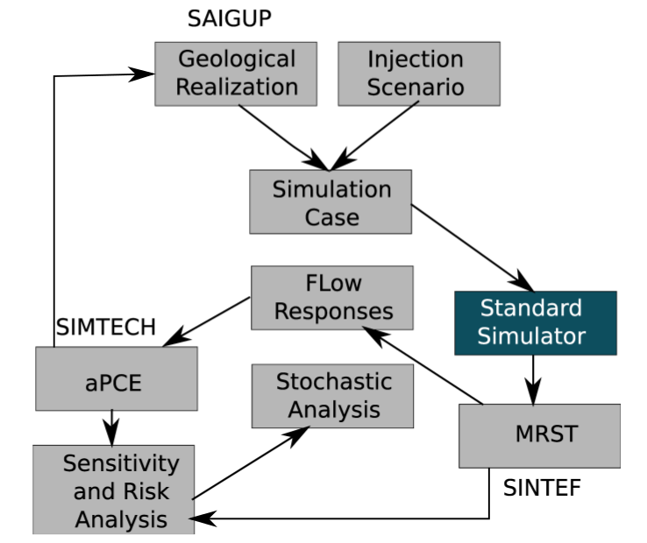

Figure 1: Flowchart of workflow implemented in an automated procedure.

An over-pressurized injection can introduce breakings in the sealing cap-rock that is used for structural CO2 trapping. It is more feasible to use a minimum number of wells to minimize the project costs and the risk of CO2 leakage through abandoned wells. Therefore, a typical injection scenario includes a few injectors with no production well to balance the injection pressure. The elliptic nature of the pressure equation and the small compressibility of the medium produce a large area influenced by the injection pressure. Therefore, pressure-related studies require a large model domain to study the effect of the impulse imposed by the injector on the entire region connected to the impulse.

To overcome this limitation in the SAIGUP models, we exaggerated the cell volumes at the model boundaries that are supposed to be open. The large pore volumes on the boundaries avoid extreme pressure build-up caused by injecting into a closed system. However, the study is limited to the region near the well. Because the high pressures occur near the injector, it is more interesting to study pressure build-up around the well rather than examining the entire region influenced by the injection pressure.

The pressure behavior is very sensitive to the way the boundaries are defined. In reality, there are different aquifer systems. Some aquifers are large with very large pore volumes. To model these aquifers, we can use smaller model domains with open boundaries. However, some aquifers are medium and small in size. To model these aquifers, we can assume semi-closed and closed boundaries. For any aquifer system, we can define the boundary by exaggerating the pore volume of the cells along the model boundaries. The transmissibilities of the boundary cells can also be modified to represent the size of the aquifer system, controlling the amount of pressure relaxation in the medium through the boundaries.

If CO2 exists in the boundaries, relative permeability functions at the boundary can be modified in addition to the transmissibilities. The open boundaries in our study are considered completely open. This assumption allows pressure to relax through the boundaries. However, the results of our pressure study are influenced by this choice. While we have observed a many cases with extreme pressures due to heterogeneity effects, the pressures reported in our study are moderate compared to partially closed boundaries. The sensitivity analysis is based on comparing the pressure values of the different cases. Therefore, the outcome of the sensitivity analysis should be valid regardless of the boundary choices. The size limitation in the SAIGUP models resulted in an extension to the current study, which is called IGEMS [68].

The IGEMS models are larger compared to the SAIGUP models. There is only one major structural trap in the SAIGUP models that allows for most of the injected CO2 to accumulate under the cap-rock. This is not sufficient for studying the effect of variations in the top-surface topography on CO2 movement in the medium. The IGEMS study has focused on the structural trapping due to deformations in the top-surface morphology and faults. The results show that structural trapping can be important in controlling the extent of CO2 storage due to structural trapping and controlling the speed of the plume migrating under the top sealing cap-rock.

In the vertical direction, the SAIGUP models can be improved with a higher grid resolution. Variations in the vertical direction exist at considerably smaller scales than in the horizontal. In particular, this is more important for the long-term CO2 migration in which a thin plume of CO2 migrates beneath a sealing layer due to buoyancy forces.

Another issue to be mentioned is the geological uncertainty assumption used in the stochastic analysis. We consider nearly uniform distributions for the probabilities of uncertain parameter values. While there is no loss of generality, there are two comments that could improve our analysis:

• In general, the uncertainty probability may not directly follow a uniform distribution. Actually, this information is very case dependent and can change from one location to another.

• One advantage of the aPC method is its flexibility to be applied for arbitrary forms of uncertainty data. Choosing various distributions for the geological parameters would better demonstrate the strength of the aPC method.

Because we are limited to the SAIGUP models that are based on equally probably values for the geological parameters, uniform uncertainty distributions are chosen. A general stochastic process using the aPC must be considered in the following steps:

• Use the techniques from the aPC method to derive appropriate sample points for the geological parameters.

• Construct geological models at these sample points.

• Perform flow simulations for each sample point.

• Construct the proxy model.

• Perform global sensitivity analysis using the Sobol indexes method and the proxy model.

• Perform the Monte Carlo simulations using the aPC study to assess the uncertainty and risk.

The link between designing geological realizations and the implementation of the aPCE method is depicted in Figure 1.40. The sensitivity analysis and risk assessment procedure must start from the ’aPCE’ box in Figure 1. The collocation points from the given geological uncertainty are first found, and then, based on those collocation points, we design the geological realizations. However, due to the availability of a large set of SAIGUP realizations generated before this study, our starting point was from the ’Geological Realization’ box in Figure 1.40. This change resulted in assuming a given geological uncertainty knowledge that suits the SAIGUP geological design. Nevertheless, we practice the procedure in a geological modeling and flow analysis scope that is novel and can be consulted for further extensive studies.