Flow scenarios

All of the SAIGUP realizations have dimensions of 3 km × 9 km × 80 m. The model spatial scales capture the typical geological features in a shallow-marine system, such as shore-line shape and aggradation angle variations. Various scales of heterogeneity can considerably impact the flow behavior. The lateral extent of the model is smaller than the scales used for CO2 storage studies. In some storage sites, the lateral extent that the CO2 travels can go to few hundreds of kilometers. This makes our study limited in the spatial domain around the injector. For the same reason, in the temporal scale, we are more focused on injection and early migration time. We examine a number of injection scenarios to study the spatial distribution of CO2 in the medium during injection and early migration periods.

Pressure study is essential for injection operations. A detailed pressure study requires larger scales than what is used here. We choose open boundaries for the model to compensate for the actual large extents of a typical storage location. The choice of open boundary is not valid in domains that are bounded by structural seals. In fact, for the close and semi-close domains the pressure is a main control on the storage capacity along with other parameters. The results of our pressure study can change significantly by choosing different boundary conditions.

We represent the boundary by large pore volumes on the outer closed cells and this makes the pressure to relax earlier than it does in a large domain. Even with such artifact, the effect of heterogeneities is clearly seen in a considerable fraction of cases with an extreme pressure build-up. We investigate the operational concerns related to pressure build-up for a typical injection scenario. Our pressure study can be used for devising mitigation plans by defining operational constraints for injectors. We perform an extensive probabilistic analysis on the CO2 pressure behavior in the medium that can be applied in a further study with specific concerns about the pressure analysis.

We consider the injection of 20% of the total pore volume of the model(excluding the large volumes at the boundaries), which amounts to 40 MM m3 . This volume is injected into all realizations in three different scenarios. In the first scenario, the injection is forced to finish in 30 years and the pressure in the system is allowed to rise unlimitedly. Linear relative permeability functions are considered in this scenario. The purpose of the first scenario is to examine the flow distribution in the medium influenced by geological heterogeneity. Linear assumption for relative permeabilities is taken to speed up the flow within the medium. We have used quadratic relative permeability function in another scenario. This scenario has shown a considerable increase in the pressure responses for many cases during CO2 injection into the aquifer. This is mainly due to lower CO2 mobility at low saturations compared to the linear relative permeability. Albeit, the CO2 moving under a cap-rock will effectively have a linear relative permeability.

The third injection scenario is similar to the first studied scenario, except that the injector is controlled by pressure rather than volumetric rate. Thus, injection time is variable depending on the injectivity of the medium.

One injector is considered in the study. With one injector, it is easier to study the flow behavior and the plume development within the medium. The injector is located in the flank and to increase the sweep efficiency for the up-moving CO2 plume, the injector is completed only in the lower part of the aquifer. The injector location and the completed layers are fixed for all of the realizations. The studies here aim to identify the influence of uncertainty on injectivity and fixing a place for injection helps in achieving this goal. As mentioned earlier, injectivity is a big player in the success of the operations. Uncertainty might be less in the near well-bore region than in the larger scale in the domain, but yet requires costly operation data aquisition. Fixing the location of the well serves specifiying the probability of having a feasible injectivity in different heterogeneities.

There are few locations of distorted geometries in the faulted realizations that may be considered as structural traps for the injected CO2 . The topography in the SAIGUP realizations is simple and does not cover the variational space to be used in a sensitivity analysis. The slight inclination in the structural geometry of the medium, from the flank up to the crest, leads the injected CO2 to accumulate in the crest and below the faulted side of the aquifer. The structural trapping due to variational morphology is studied in IGEMS, which is a sister project to MatMora (for example, see [68]).

In a homogeneous medium, we expect the CO2 to accumulate under the cap-rock. A small fraction of the injected CO2 will escape through the open boundary near the injection well and the rest of it will stay within the medium in two forms that we refer to as mobile and residual volumes. As the CO2 moves through the rock, part of it stays in the smaller pores by capillary trapping process and can not be discharged by brine. The other parts move through the larger pores and can be displaced by water in an imbibition process. This volume is called mobile. As we are interested in storing the CO2 permanently and safely, increasing the trapped volume is in line with the objective of minimizing the leakage risk and maximizing the storage capacity. Likewise, the more mobile volume of CO2 exists in the medium, the more will be the risk of leakage.

Defining the boundary condition of the aquifer of interest can influence the flow behavior in the system. Computational costs make it more feasible to model the flow locally and in the part of the aquifer that is going through more pronounced changes in flow behavior. Therefore, we can choose the boundaries of the model inside the aquifer in a volume that is containing the injection wells and the areas effected by them. Hydrostatic open boundary condition is a choice for the system boundaries to include the aquifer parts that fall outside the boundaries (Fig. 1.28).

The underground network of aquifer systems can be connected via geological channeling and conductive features. Some aquifers might be active and connected to the surface and expand in volume by variations in water influx due to seasonal rains. This can impose an external force on the system boundaries considered in a storage problem. Fig. 1.28 shows the water influx through the boundaries of the system due to external aquifer activities. We consider the external support by imposing a higher pressure than the hydrostatic pressure on the boundary of the model.

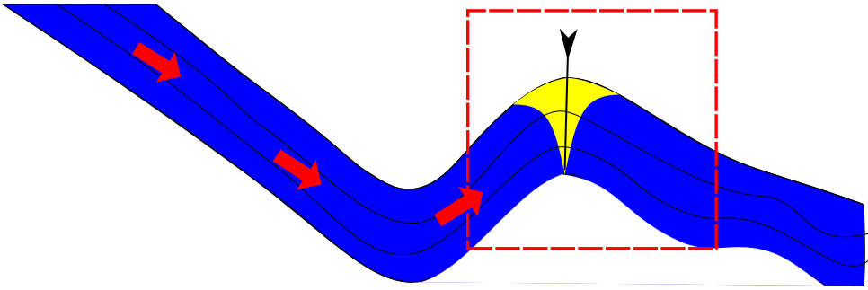

Figure :