# General summary

The work objectives have been the following:

* Assessing the significance of geological uncertainty in the early stages of CO2 storage operations.
* Applying a mathematical tool to perform global sensitivity analysis and probabilistic risk study for assessing the geological uncertainty impacts on the success of CO2 storage.
* Introducing a frame-work for extensive realistic sensitivity analysis and risk assessment of geological CO2 storage.

The significance of geological uncertainty is discussed by extensive study on CO2 flow in different

geological models. Sensitivity analysis and risk assessment have resulted in ranking of the studied

geological parameters for various flow responses in the medium. The work-flow implemented in this

work is a stepwise procedure that can be generalized to be used in any similar large scale analysis.

## Implementation of the work-flow

This thesis incorporated working with large number of realizations, various flow scenarios, and different procedures and soft-wares. While the study was in progress, new ideas and challenges raised that required manipulation of new parts in the work-flow. In order to achieve the defined goals of the research, an automated work-flow was designed that connected different parts of the study. This enhanced the efficiency of performing necessary modifications to the work-flow.

MATLAB programming language is used for implementing the work-flow in this research. The main reason for this choice, apart from the rich facilities available within MATLAB toolboxes, is to use many functions within the MATLAB Reservoir Simulation Toolbox (MRST) available as free and open-source software in MATLAB language. For flow simulation, a commercial software is used, which is a standard simulator for oil and gas industry and research.

Figure 1 shows the elements of the work-flow implemented by a large number of MATLAB functions. Functions from MRST at SINTEF and the stochastic tools of SIMTECH group in Stuttgart university are utilized and merged into the work-flow. The design is made such that the work-flow is flexible and general. Some research has been done by replacing the commercial simulator with in-house simulators at SINTEF, but the main study was performed using a commercial standard simulator.

## Generic application of results

We rank the most influential geological parameters for early stages of CO2 storage operations. The demonstrated work-flow can be used in any study concerning the site selection and early stages of geological CO2 storage. However, there are some limitations in our presentation of the work-flow that need to be considered when this work is to be consulted for any similar study.

First limitation is the SAIGUP model size. CO2 storage studies requires large models that can cover the CO2 spatial traveling extents within the aquifer. Therefore, our study is limited to the domain around the injector.

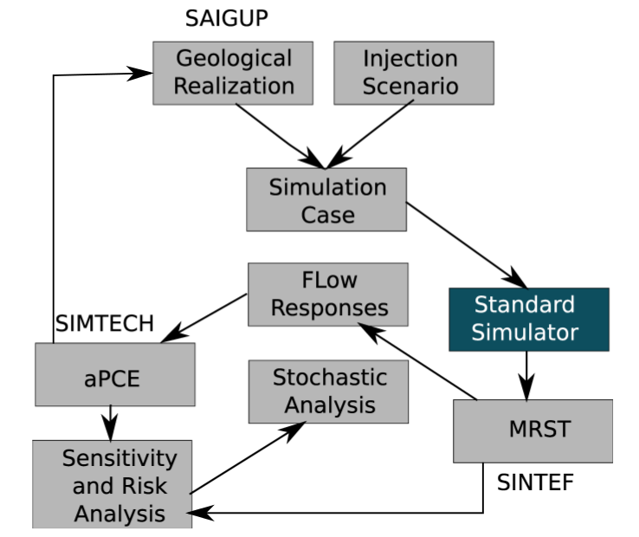

Figure 1: Flow-chart of work process implemented in an automated procedure.

An over-pressurized injection can introduce breakings in the sealing cap-rock that is aimed to be used for structural strapping of CO2 . It is more feasible to use minimum number of wells to minimize the costs of the project and also the risk of CO2 leakage via drilled wells after they are abandoned. Therefore, a typical injection scenario include few number of injectors with no production well to balance the injection pressure. The elliptic nature of pressure equation and the small compressibility of the medium result in a large area influenced by injection pressure. Therefore, the pressure related studies need a large size of model to study the influence of the impulse imposed by the injector on the entire region connected to that impulse.

To overcome this limitation in the SAIGUP models, we exaggerated the volume of the cells in the boundaries of the model that are supposed to be open. The large pore volumes on the boundaries avoid extreme pressure build-up due to injecting in a closed system. On the other hand, the study is limited to the region near the well. Since the high pressures are happening near the injector, this is more interesting to study for a pressure build-up around the well rather than looking at the entire region influenced by the injection pressure.

The pressure behavior is very sensitive to the way the boundaries are defined. In reality, there are different systems of aquifers. Some of them are large with huge pore-volumes. To model these aquifers, we can use smaller size models with open boundaries. However, some aquifers are medium and small in size. To model these aquifers, we can assume semi-close and close boundaries. For any aquifer system, we can define the boundary by exaggerating the pore volume of the cells on the boundaries of the model. The transmissbilites of the boundary cells can be also modified to represent the size of the aquifer system. This controls the amount of pressure relaxation in the medium through the boundaries.

If CO2 exists in the boundaries, relative permeability functions at the boundary can be modified inaddition to the transmissibilities. The open boundaries in our study are considered to be fully open. This makes the pressure to relax through the boundaries and the results of our pressure study are influenced by this choice. While we have observed a considerable portion of cases with extreme pressures due to heterogeneity effects, the pressures reported in our study are moderate compared to not fully opened boundaries. The sensitivity analysis is based on comparing cases for their pressure values. Therefore, the outcome of sensitivity analysis should be valid regardless of the boundary choices. The size limitation in the SAIGUP models resulted in an extension to the current study in a project, which is called IGEMS [68].

The IGEMS models have larger size compared to the SAIGUP models. There is only one major structural trap in the SAIGUP models that allows for most of the injected CO2 to accumulate under the cap-rock. This is not sufficient for studying the effect of variations in the top-surface topography on the CO2 movement in the medium. The IGEMS study has focused on the structural trapping due to deformations in the top-surface morphology and faults. The results show that the structural trapping can be important in the amount of storage due to structural trapping and it can control the speed of the plume migrating under the top sealing cap-rock.

In the vertical scale the SAIGUP models can be improved by using a higher grid resolution. Variations in the vertical direction exist in considerably smaller scales than the lateral direction. In particular, this is more crucial for the long-term migration of CO2 where a thin plume of CO2 migrates beneath a sealing layer due to the buoyancy forces.

Another issue to be mentioned is the assumption for geological uncertainties that are used in the stochastic analysis. We consider near uniform distributions for the probabilities of uncertain parameter values. While there is no loss of generality, there are too comments that could improve our analysis:

• In general, the uncertainty probability can be different than uniform distribution. Actually, these information are very case dependent and can change from one location to another.

• One advantage of the aPC method is the flexibility to apply for arbitrary forms of uncertainty data. Choosing various distributions for the geological parameters would be more demonstrative of the aPC method strength.

Choosing uniform uncertainty distributions for our study is due to our limitation to use the SAIGUP models that are made based on equi-probable values for the geological uncertain parameters. A general stochastic process using the aPC must be considered in the following steps:

• Use the techniques from the aPC to derive appropriate sample points for geological parameters.

• Construct geological models at these sample points.

• Perform flow simulations for each sample point.

• Construct the proxy model.

• Perform global sensitivity analysis using the Sobol indexes method and the proxy model.

• Perform the Monte-Carlo using the aPC study to assess the uncertainty and risk.

One thing to notice in Figure 1.40 is the link between designing geological realizations and implementation of aPCE method. The sensitivity analysis and risk assessment procedure must start from the ’aPCE’ box in Figure 1, by finding the collocation points from the given geological uncertainty, and then based on those collocation points we design the geological realizations. However, for the availability of a large set of SAIGUP realizations that were generated before this study, our start point was from the ’Geological Realization’ box in Figure 1.40. This change in start point resulted in assuming a given geological uncertainty knowledge that suits the SAIGUP geological design. Nevertheless, we practice the procedure in a scope of geological modeling and flow analysis that is novel in its kind and can be consulted for further extensive studies.