Nathan Williams  
4/22/2016

Homework 10

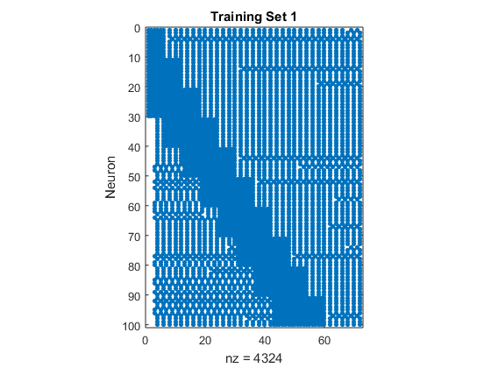

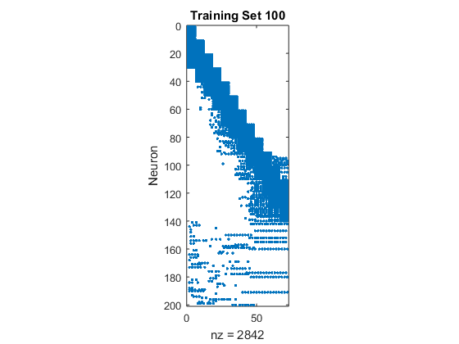

(a) (b)

**Figure 1. Sparsity patterns for (a) the first training set and (b) the last training set.** As indicated by the sparsity patterns, the model learned quite a bit between the first and last training sets. Though the pattern was evident after just the first training set, there was still quite a bit of noise. In these images, the data was spliced in order to make the data more interpretable.

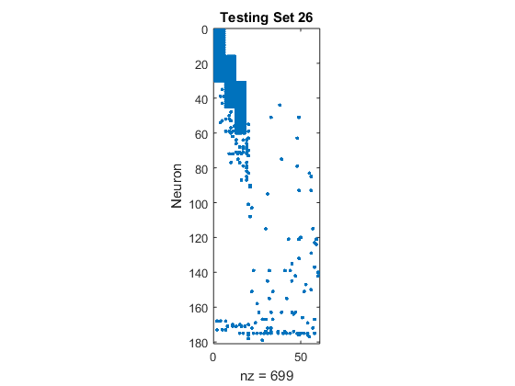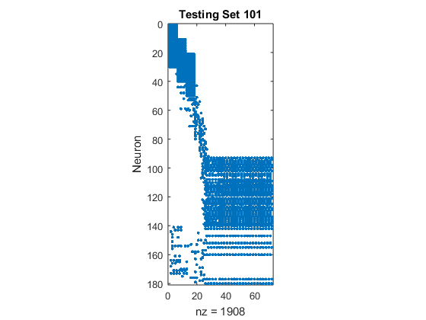

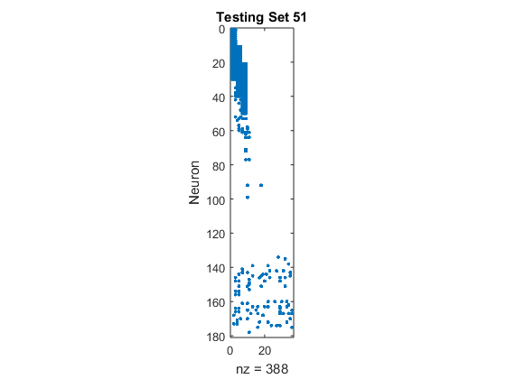

(a) (b) (c)

**Figure 2. Sparsity patterns for the testing sets.** (a), (b), and (c) correspond to testing sets 26, 51, and 101, respectively. There is little difference between the performance of the model on testing sets 26 and 51, but an interesting value is revealed in the data for testing set 101. At about 90 neurons, the model appears to reach learning capacity as chaos takes over from the somewhat orderly formation up to that point.

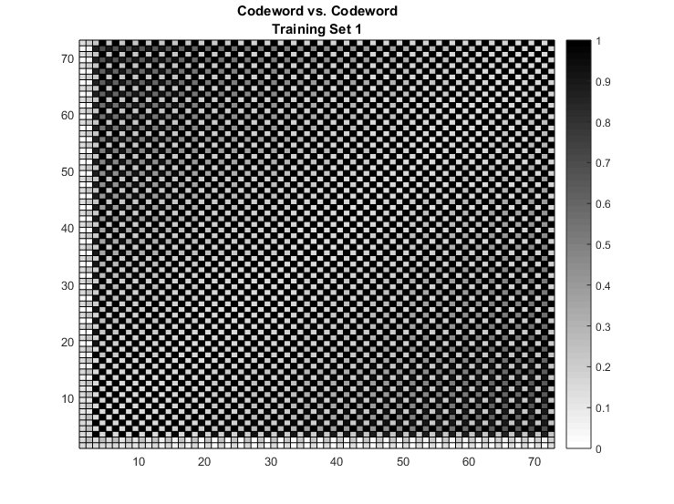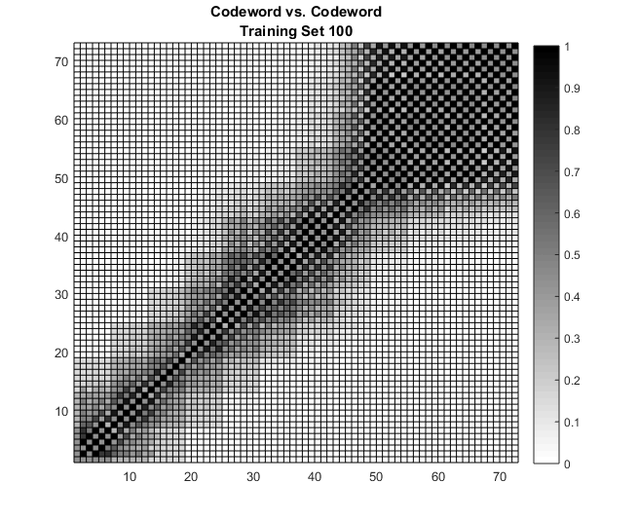

(a) (b)

**Figure 3. *Codeword vs. Codeword* diagrams for (a) the first training set and (b) the last training set.** As indicated by the lack of order in (a), the network had not learned anything after training set 1. This agrees with the conclusions reached for Figure 1a. In contrast, (b) shows clear signs of learning with distinguishable geometry resembling a diagonal line.