Michael Sarlo

Lab Practical

Part 1

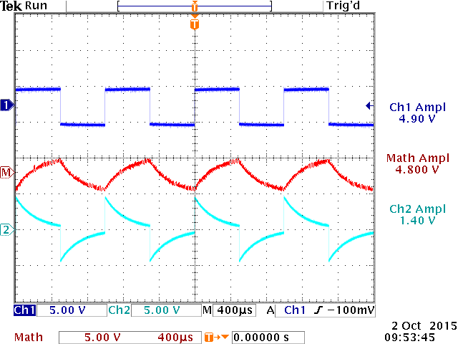

Part 2