Michael Sarlo

Homework #7

12-2 a)

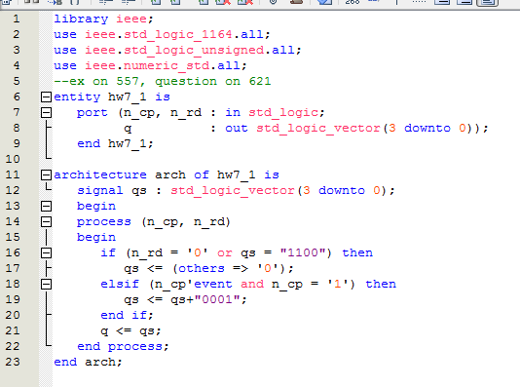

12-2b)



12-2c) 3ns

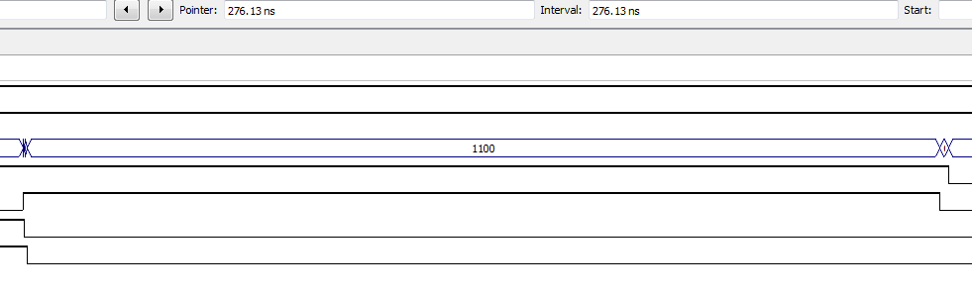

12-3)

vhdl

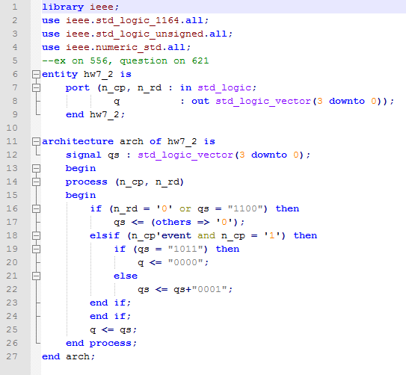

waveform

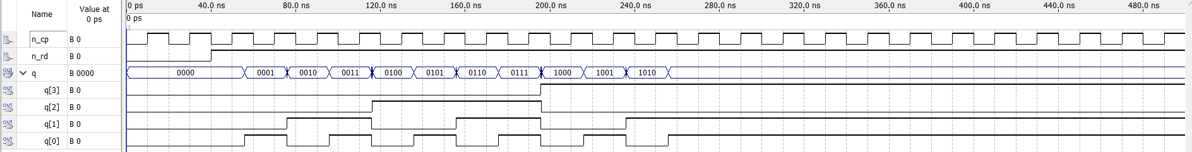

13-2) if d= 0100, after 2 clock cycles, q will be q = 0001

13-12)

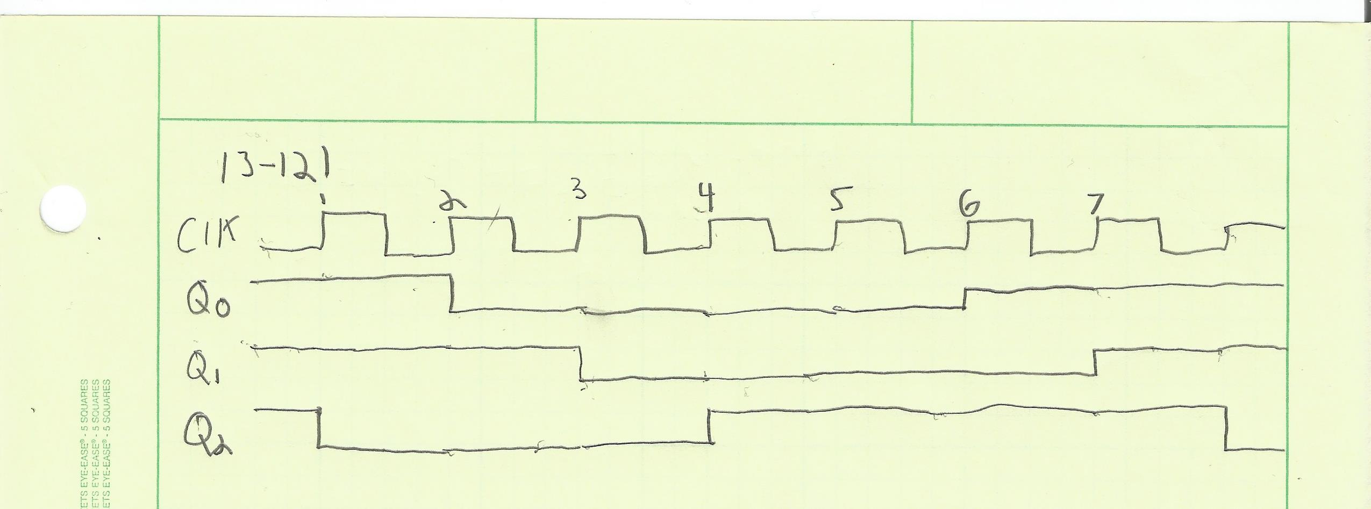

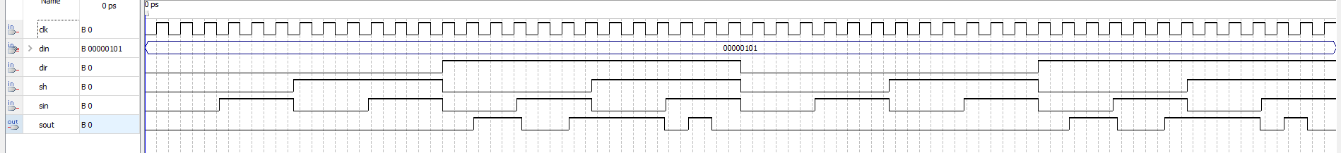5)

