Michael Sarlo

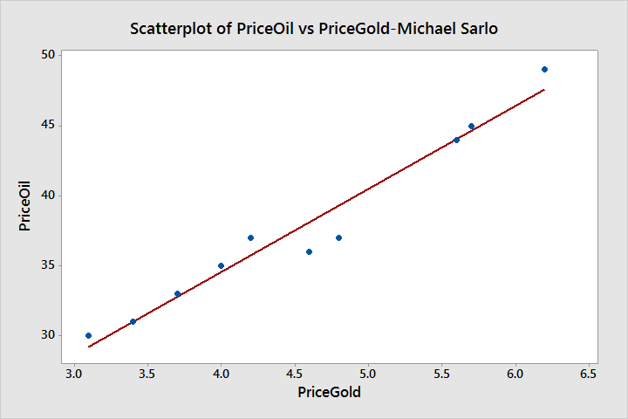

Regression Equation

PriceGold = -1.575 + 0.1619 PriceOil