Table of Contents
Prelog 3
Structure 3
Work results and version control 3
Environment and process 3
Project organisational structure 3
Involved persons 3
Role description 3
Scope 3
Initial position 3
Functional requirements 3
User authentication 3
Technical requirements 3
Means and methods 3
Prior knowledge 4
Preliminary work 4
New learning content 4
Time plan 4
Work journal 4
Tuesday, 07.04.2026 4
Wednesday, 08.04.2026 4
Thursday, 09.04.2026 4
Friday, 10.04.2026 4
Tuesday, 14.04.2026 4
Wednesday, 15.04.2026 4
Thursday, 16.04.2026 4
Friday, 17.04.2026 4
Tuesday, 21.04.2026 4
Wednesday, 22.04.2026 5
Personal FAZIT 5
Project 5
Summery 5
Task 5
Implementation 5
Result 5
IPERKA 5
Inform (Informieren) 5
Expected outcome 5
Emerged uncertainties 5
Plan (Planen) 5
Needs assessment 5
Implementation concept 6
Test concept 6
Decide (Entscheiden) 6
Add ticker to watchlist 6
Search tickers 6
(Whatever ticker related stuff) 6
Realise (Realisieren) 6
Environment and structure 6
Database 6
Backend 6
Frontend 6
Containerisation 6
Testing 6
Control (Kontrollieren) 6
Test protocol 7
List of illustrations 7
List of sources 7
Glossary 7
Attachment 7

Prelog

Structure

Work results and version control

Environment and process

Project organisational structure

Involved persons

Role description

Scope

Initial position

Functional requirements

User authentication

Technical requirements

Means and methods

Prior knowledge

Preliminary work

New learning content

Time plan

Work journal

Tuesday, 07.04.2026

Wednesday, 08.04.2026

Thursday, 09.04.2026

Friday, 10.04.2026

Tuesday, 14.04.2026

Wednesday, 15.04.2026

Thursday, 16.04.2026

Friday, 17.04.2026

Tuesday, 21.04.2026

Wednesday, 22.04.2026

Personal FAZIT

Project

Summery

Task

Implementation

Result

IPERKA

Inform (Informieren)

This section of the document describes the planning phase of this project.

In this project, I will be developing an application that provides a comprehensive interface for its users to track their stock investments. The application shall include the features of watchlists, stock searching, stock price visualisation, and commenting. Authentication and authorisation shall not be implemented for this application. The application shall be single user based. The application shall be developed with Angular and Typescript for its frontend, Spring Boot and Java for its backend and PostgreSQL for its database. Containerisation shall be done with the help of the Podman application. The application shall be tested thoroughly with Angular component tests, JUnit tests, integration tests, as well as end-to-end tests. The database shall be run in a Podman container. The backend application shall be packaged and executed as a Podman container. The frontend application shall be accessed through a web browser and started locally. The application shall not include real-time stock data tracking, notification functionality, authentication, multi-user functionality, financial transaction functionality, or mobile device support.

Expected outcome

- Fully functional app with no runtime error
- Watchlist functionality that allows users to group selected stocks, watchlists will be saved on local database
- Stock searching functionality that allows users to type in a stock’s company name or ticker symbol to find it
- Stock price visualisation functionality that displays a stock’s price data as a graph
- Commenting system that allows users to create, edit and delete comments for an individual stock
- Toggling functionality between light mode and dark mode

Emerged uncertainties

- Stock searching my company name might be too difficult due to Stooq only offering data based on ticker symbol
- Interval of data displayed not yet defined for long time spans of stock prices

Plan (Planen)

Needs assessment

Implementation concept

Data model:

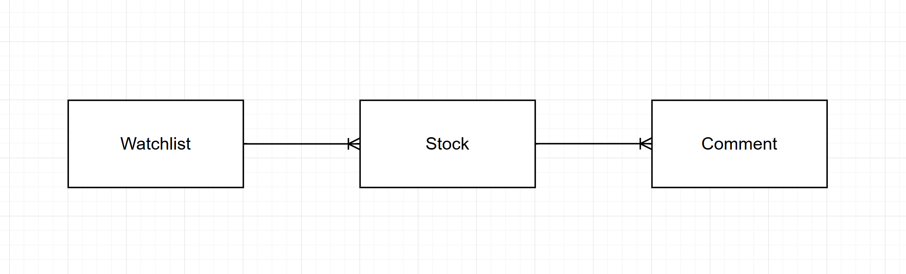

Test concept

Decide (Entscheiden)

Multi-user or single-user

Which Graph library

Which stock data API

Realise (Realisieren)

Environment and structure

Database

Backend

Frontend

Containerisation

Testing

Control (Kontrollieren)

Test protocol

List of illustrations

List of sources

Glossary

Attachment

