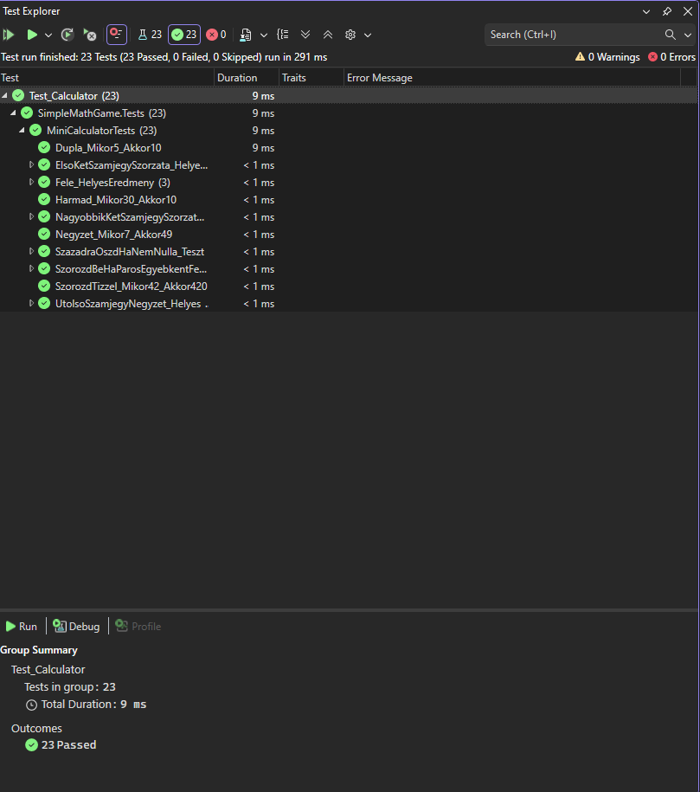
Test Explorer Results:

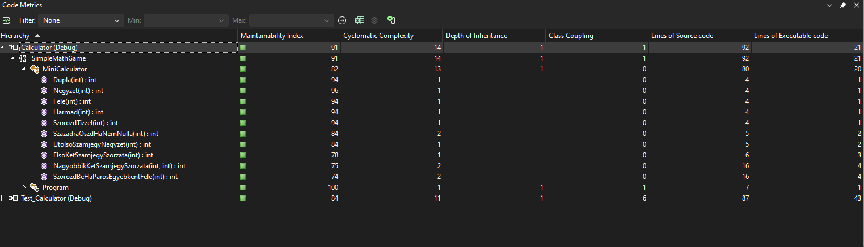
Code Metrics Results

1.Parancs
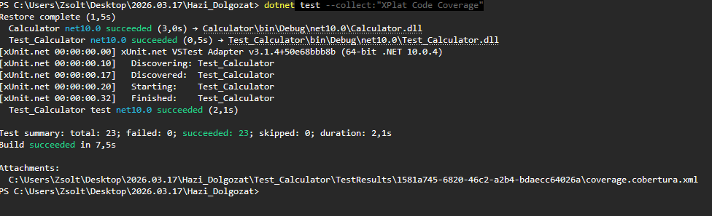
2.Parancs

