Lab
Volatility 3 — memory forensics framework (Python3)

Why: memory forensics is advanced and sought-after (malware analysis, incident response).
Project idea: “Memory forensic playbook” — run Volatility on captured memory images, find injected processes, dumped credentials, and include Jupyter notebook showing commands + analysis.

Skill tags: Forensics, incident response, memory analysis.

Lets Do This
Overview
Volatility is a python based tool that is used for memory analysis, malware detection, and incident response and create a report on that scanning.

Objectives :
- Memory Analysis
- Marware Detection
- Digital Forensics

First of all we will look at the code analogy and know that how it works then we will execute it to see the proper working.
We have to import libararies first in order to fetch functions in python.
import psutil
import os
import json
import platform
import subprocess
import tempfile
import hashlib
from datetime import datetime
import socket
import re
import ctypes
import sys
- We have to create main class structure in which we define forensics function to work.
class AdvancedMemoryForensics:
"""
Advanced memory forensics tool with malware detection and file output
"""

def __init__(self):
# Initialization components
self.scan_results = {} # Stores all scan results
self.suspicious_items = [] # Suspicious items found
self.malware_findings = [] # Confirmed malware findings
self.output_dir = tempfile.mkdtemp(prefix="memory_scan_")
self.is_admin = self._check_admin_privileges()
self.report_file = os.path.join(self.output_dir, "forensics_report.txt")
- Privilege & System Check to see user control
def _check_admin_privileges(self)
def _write_to_report(self, content, console_output=True)

- Process Analysis Module
def scan_running_processes(self)
def _detect_malware_process(self, process)
def _is_suspicious_process(self, process)
- Process enumeration and analysis
- DLL/library scanning
- Network connection monitoring
- Real-time malware detection

- DLL Analysis Module
def scan_loaded_dlls_advanced(self)
def _detect_malware_dll(self, dll_info, process_name)
def _get_windows_dlls(self, pid)
def _get_linux_libraries(self, pid)
def _is_suspicious_dll(self, dll_info)
- Signature-based detection
- Behavioral analysis
- Heuristic patterns
- Anomaly detection

- Network Analysis Module
def scan_network_connections(self)
def _detect_malware_connection(self, connection)
def _is_suspicious_connection(self, connection)
- Windows DLL analysis
- Linux shared library scanning
- Platform-specific memory structures

- Reporting Module
def generate_comprehensive_report(self)
def _assess_overall_risk(self)
def _generate_recommendations(self)
- Text-based reports
- JSON output for automation
- Risk assessment

- Performance Optimizations
from concurrent.futures import ThreadPoolExecutor
def parallel_process_scan(self):
with ThreadPoolExecutor(max_workers=4) as executor:
futures = [
executor.submit(self.scan_running_processes),
executor.submit(self.scan_network_connections),
]

- Implement parallel processing for faster scans
- other scans

Enhanced Detection:
def load_yara_rules(self, rules_path):
pass

- Add YARA rule support for pattern matching
- Implement YARA rule matching for advanced detection

As we have go through the code now we will check how it works by executing the code.
- Run the terminal as administrator and use the command python volatiltity_3.py in cmd and it will ask us to press enter to in order to continue scanning as we can see.
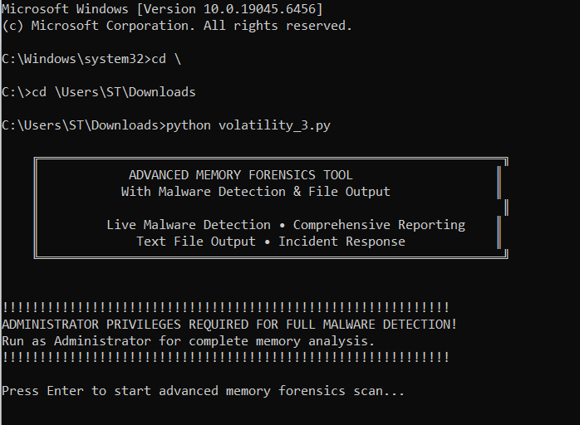

As we can see it has started memory scans and giving us the dumps in the memory
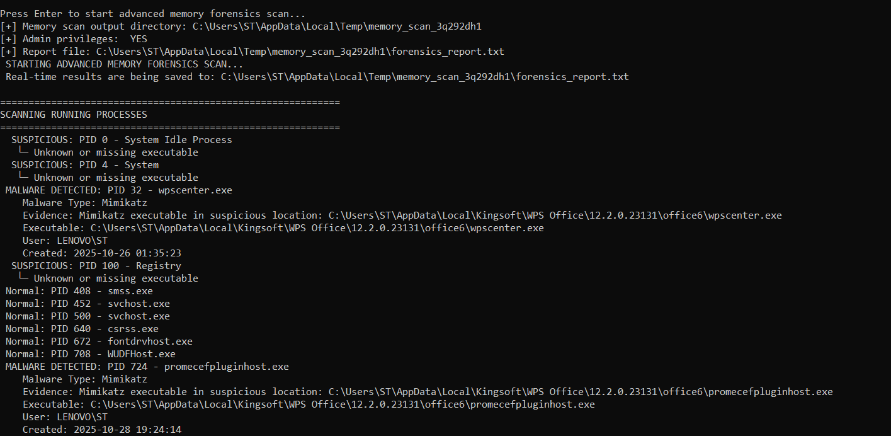

Here after the scanning of dumps in the memory it will start to scan dll files in the computer and detect if any malware is available or not
Then press enter to continue network scan
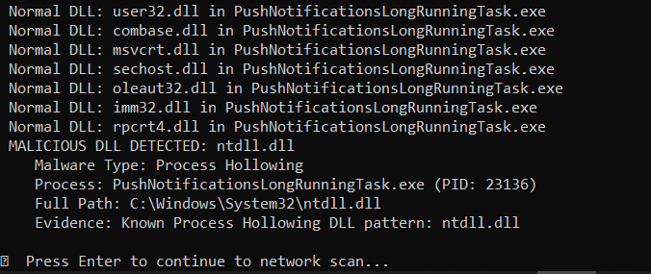

In network scanning it will scan our complete network and it will told us if something look suspicious.
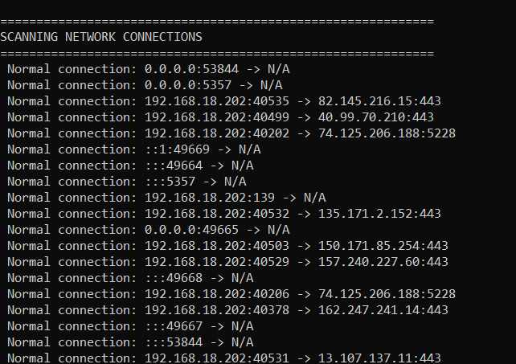

After all the scanning will be completed it will ask us to generate report of the complete scanning and it will save this into a single file which we can read out anytime.
