Home Page

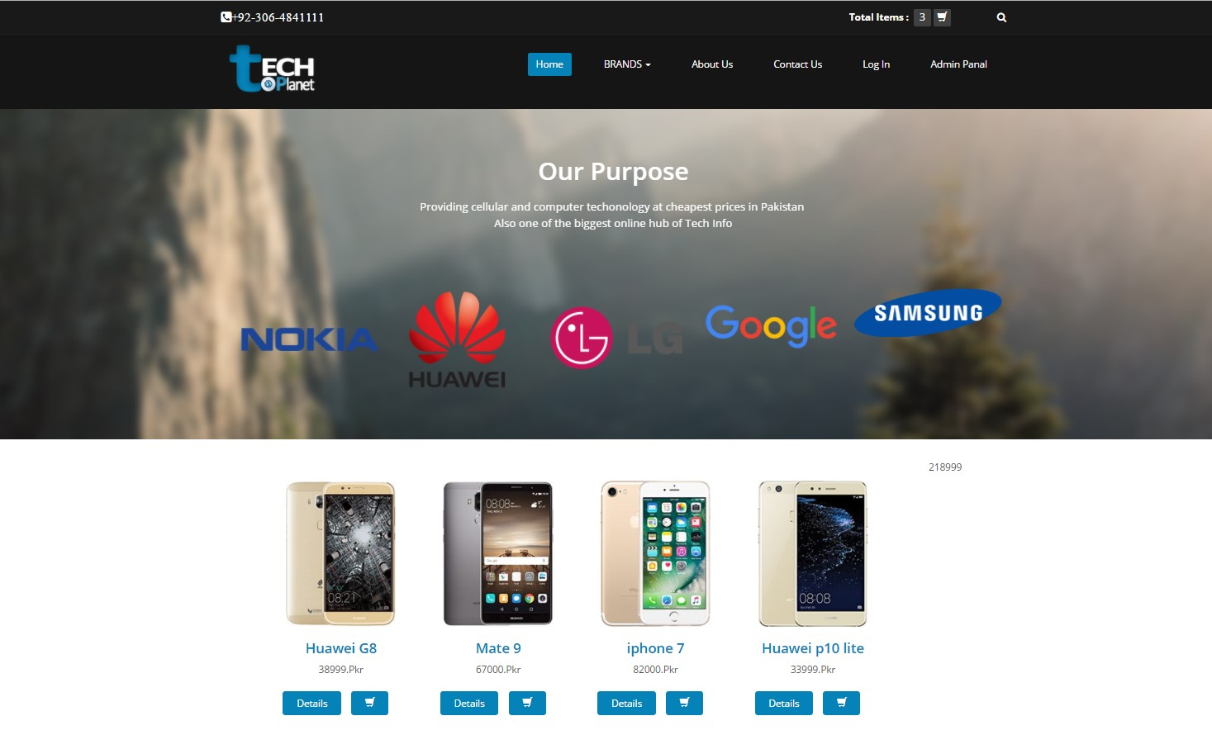

This is the home page of techPlanet website that shows the tabs of the whole website. It shows a search button to find a specific device by writing its name or some keywords regarding that device. It has some devices to show to the user. A user can view the detail of a device or he can add that device to the cart by clicking on the bucket icon below the picture of a smartphone.

Brands Page

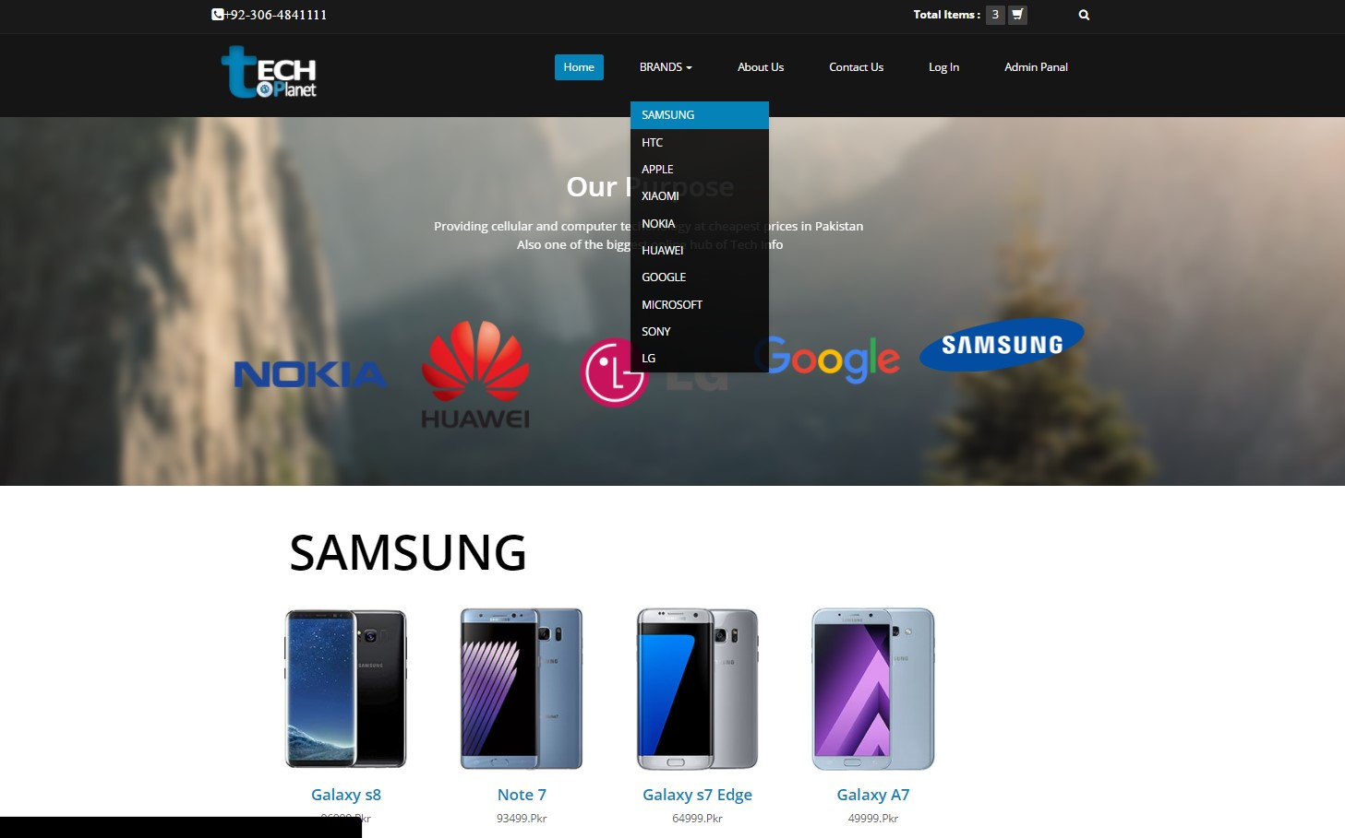

This page shows the devices available in the website for a customer to buy. It helps the user for finding a specific device of a specific brand. It does that by aligning the products according to their brand. A user can click on a specific brand to see all the available products of that brand

Sign Up Page

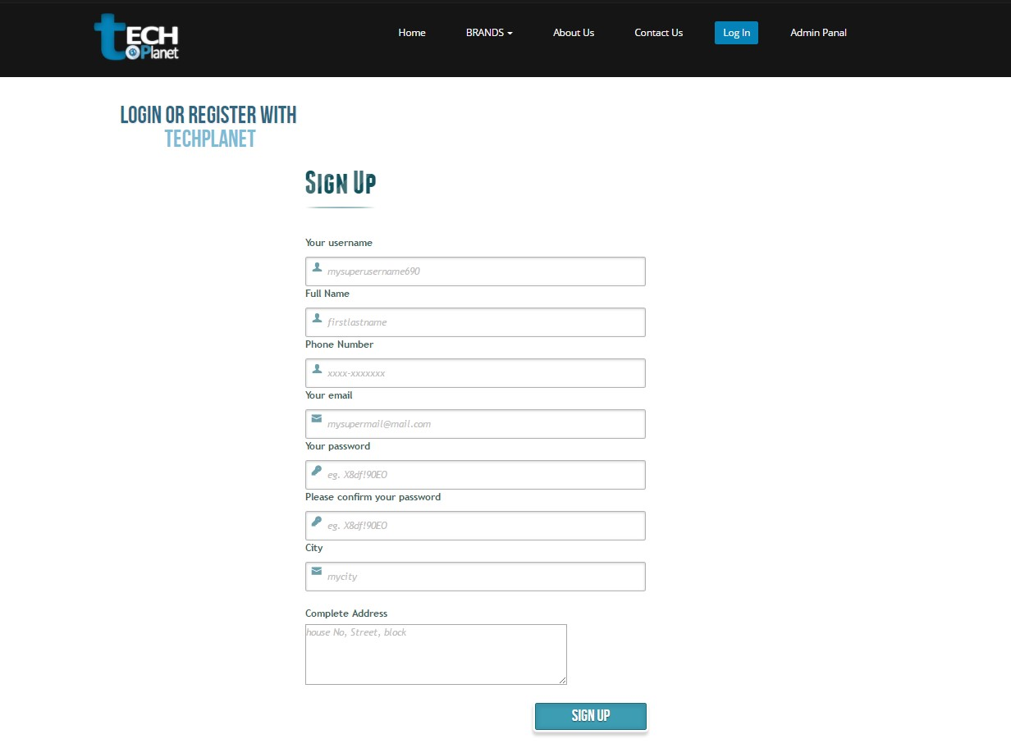

For buying the products on techPlanet a user must give his credentials for proper dealing between two entities. These details also authorizes the user to facilities provided by the admin. A user does it by signing up for the website. It is done by giving some details to the admin and then the admin assigns an email and password to that user which helps the user to buy on techPlanet.

Forget Password Page

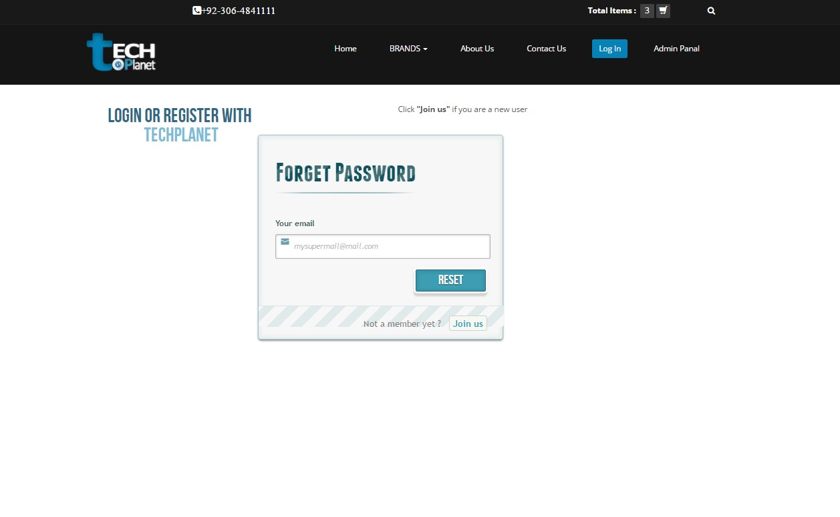

When a registered user forgets his password and is unable to log in to the website then this page helps the user to get back his lost password. Then the user will be able to perform any tasks that he is authorized to.

Login Page

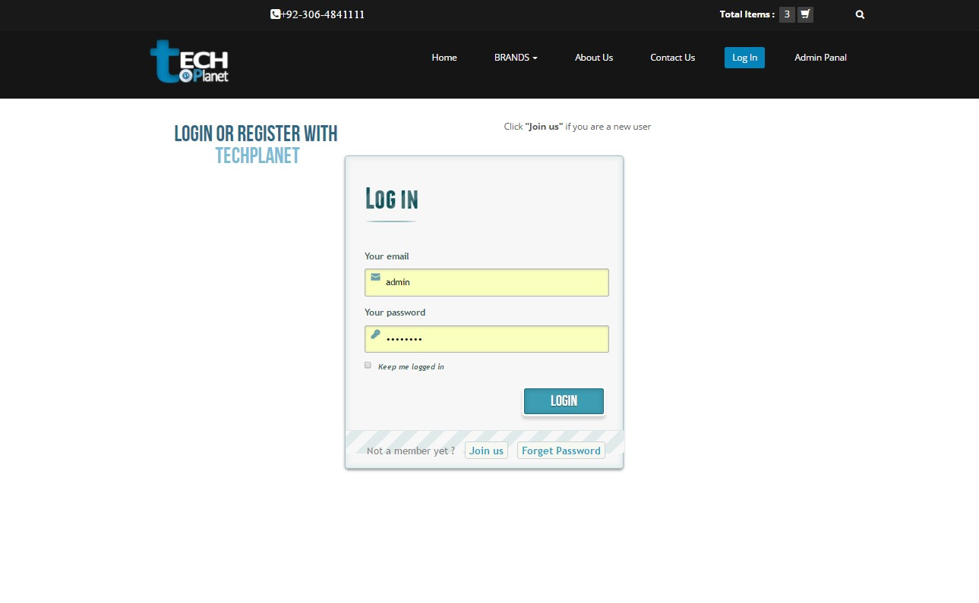

Login page is where a user will input his id (email) and password. This email and password are those which he has given while signing up to the website. This login details are necessary for a user to login to website to be authorized enough to cater his tasks he want to perform.

Checkout Page

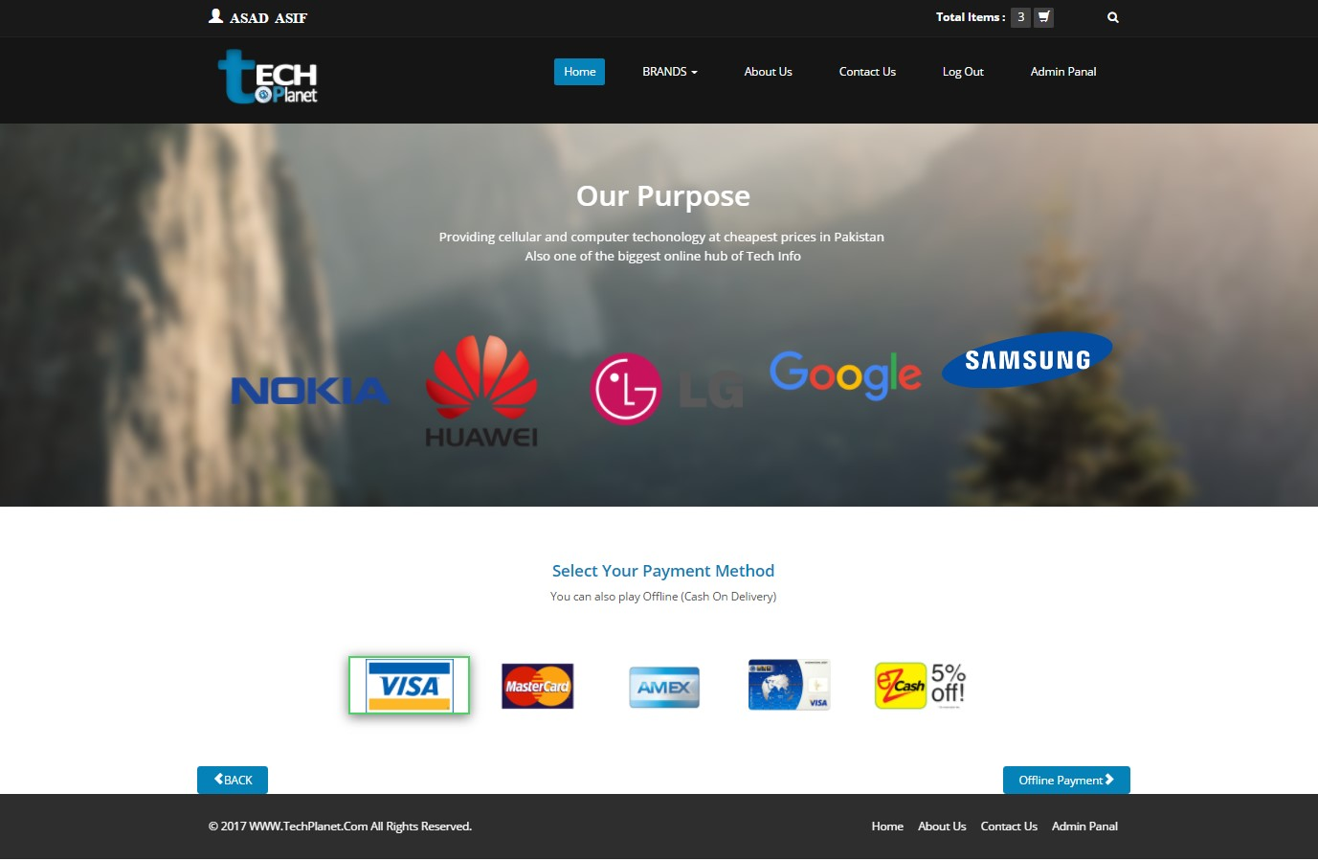

This is the checkout page shown after a customer places his order by putting his products in the cart. When a user finalizes his desired products than he click on the checkout button that redirects the user to this checkout page. This page lets the user choose the payment method which the user will use to pay for the devices that are being bought.

Shopping Cart

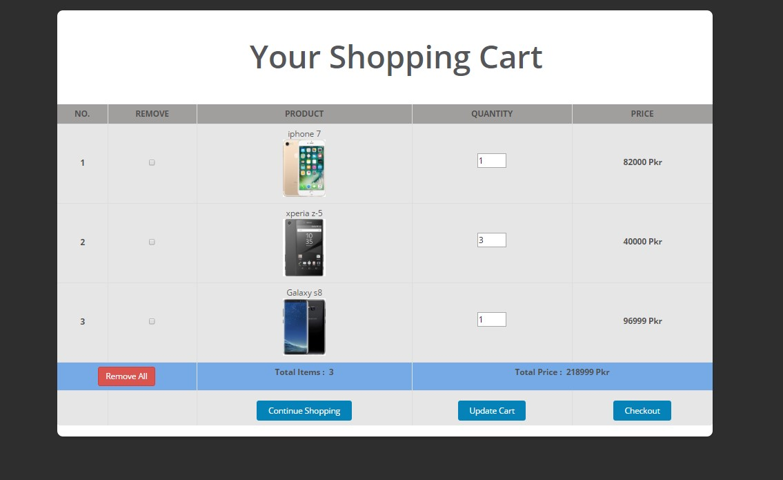

When a user wants to buy a product that user clicks on add to cart button to save that device to his cart and be ready to buy it. When he completes his cart then he goes to his shopping cart page by clicking on top of the page at a cart icon. This leads to his shopping cart page which shows the list of all the products which a user intends to buy and their quantity along with their price. It shows that a user is ready to buy.

Contact Us Page

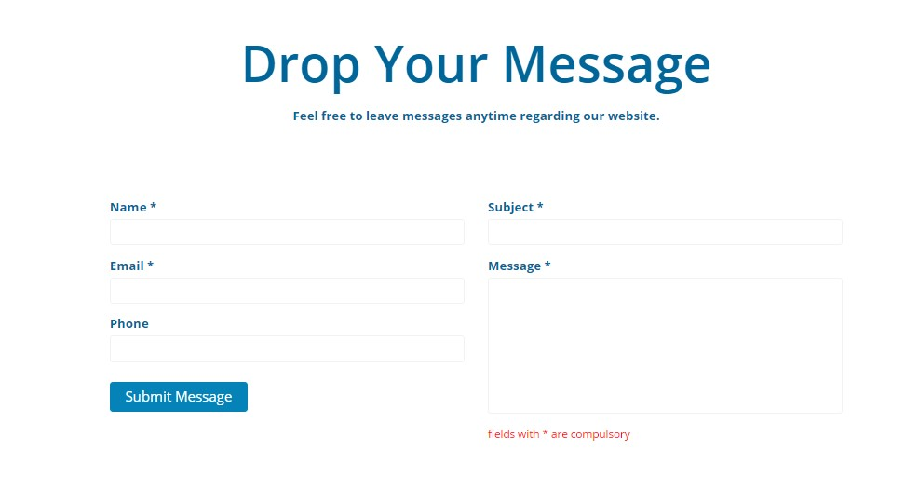

When a user needed to ask a question or that user wanted to have his queries answered against some thoughts or concerns he might have regarding the device or procedure of ecommerce. The user can contact us by fulfilling the above form and giving his proper details and the problem he needs to be solved. This query will be delivered to admin.

2. Admin Panel Pages:

Admin Panel (Brands in database Page)

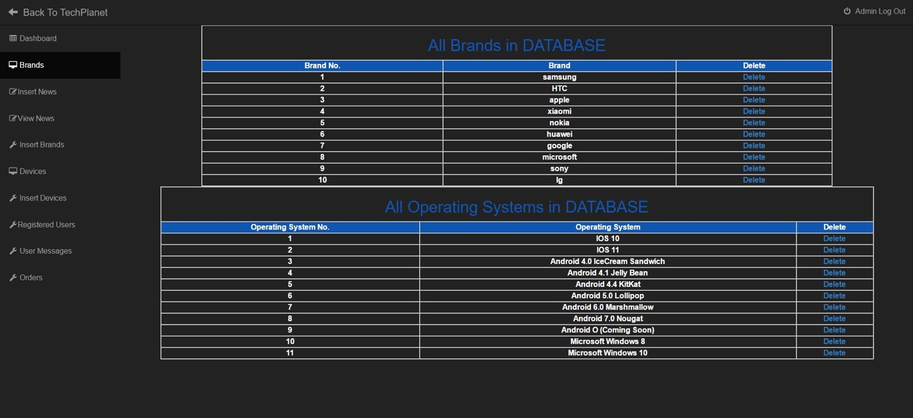

Here the admin of the website could be able to get all the brands and other details of a smartphone stored in the database. Admin can also delete these details upon his requirements. So this page helps admin customize the details regarding a smartphone.

Admin Panel (Insert Brands Page)

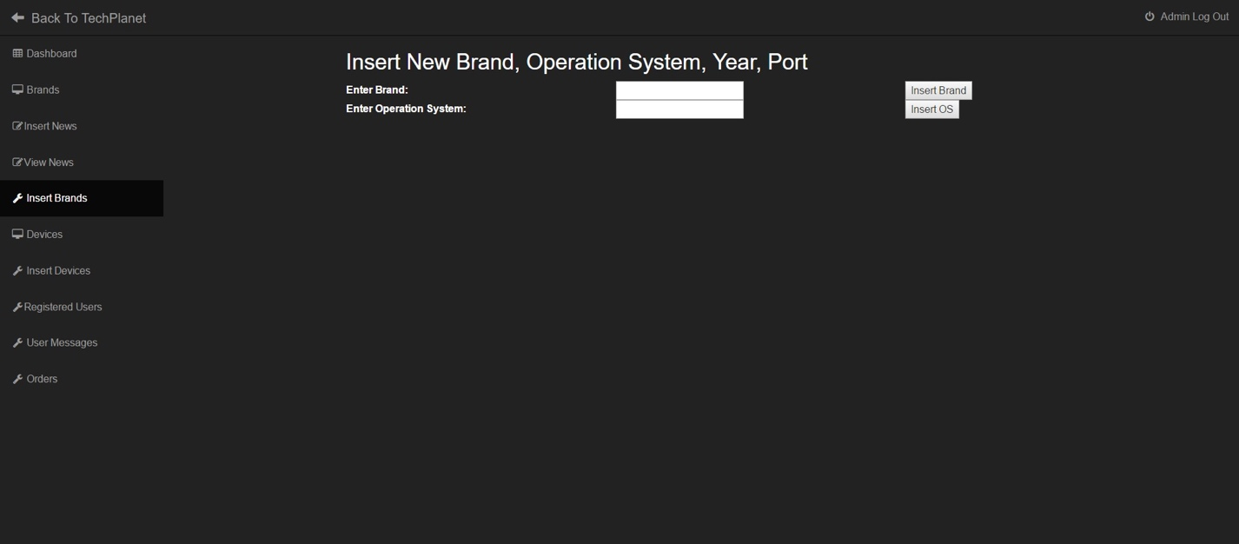

Admin can add a new brand of a newly described company and the operating system of a newly added brand or a device. This helps to identify a smartphone very easily and also helps in differentiating between different smartphones.

Admin Panel (Devices Page)

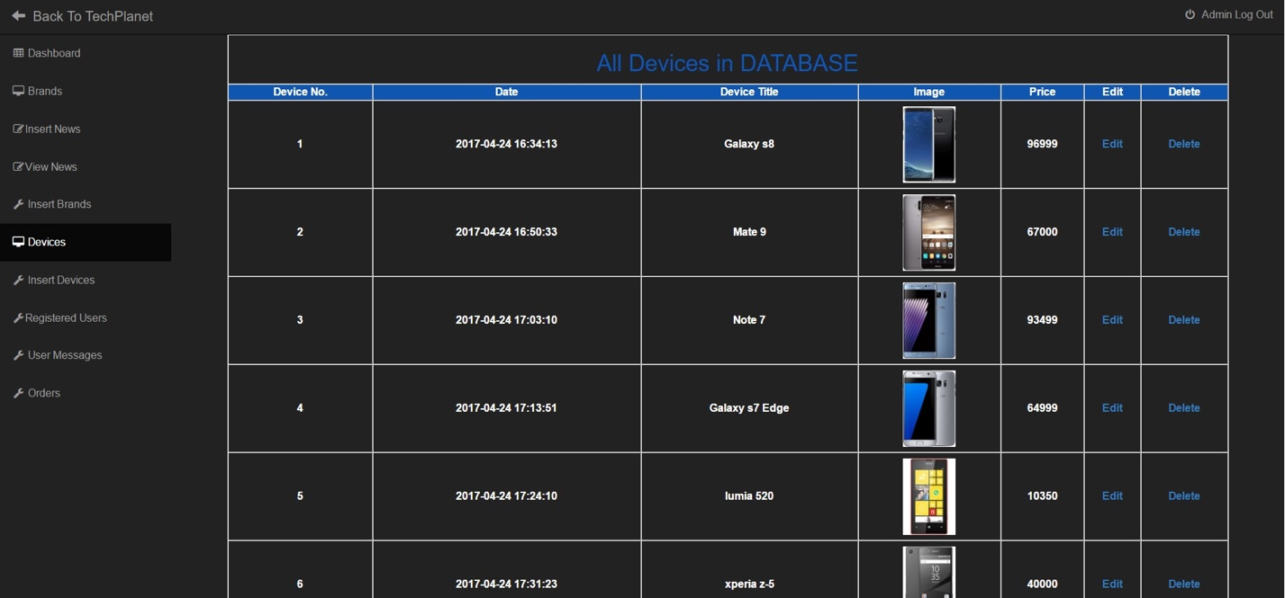

This page of admin panel displays the available or stored devices/smartphones in the database. This helps the administrator to know of all the devices that are available and which he wanted to add. Admin can edit a specific smartphone or delete a smartphone which is no longer manufactured.

Admin Panel (Insert New Device Page)

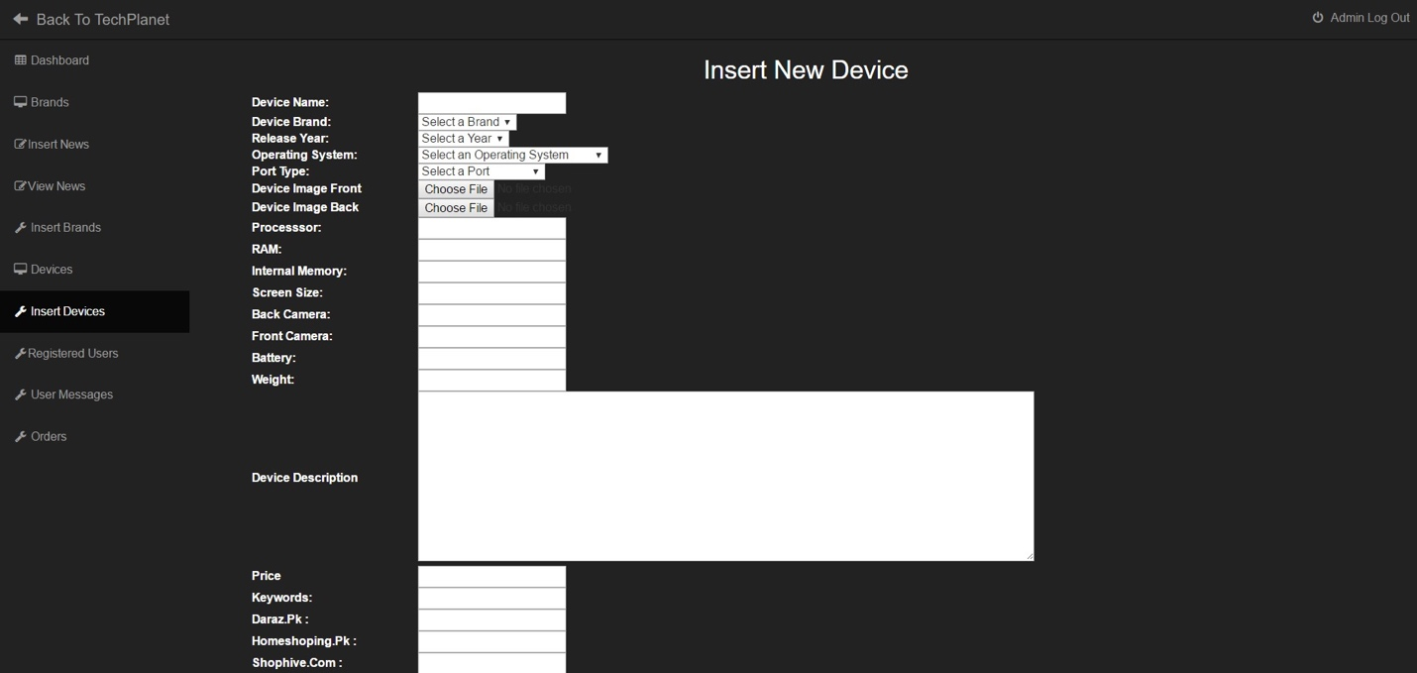

When a new brand is added into the system than it has some devices/smartphones that are to be added into the database. This page helps the admin to add the smartphone with all of its details described by a manufacturer. It also added a description about that device in the database.

Admin Panel (Registered Users Page)

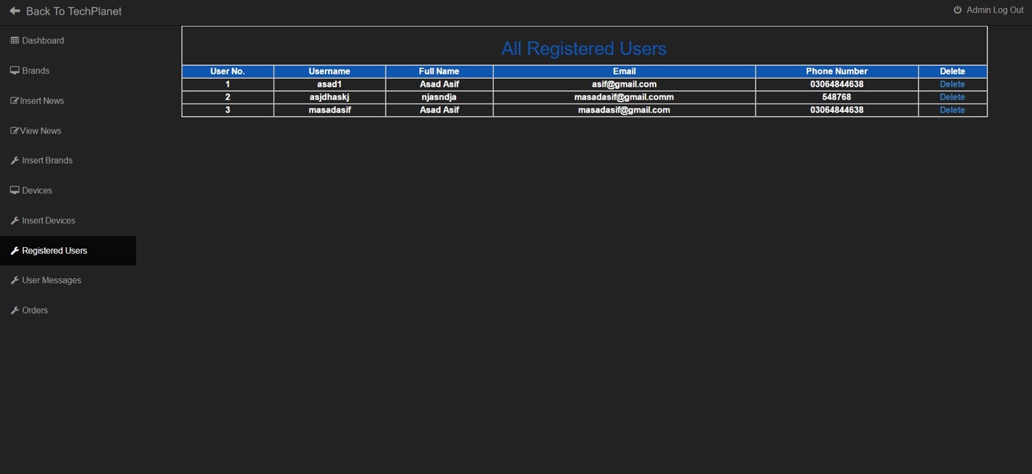

This page shows the administrator of all the available users which are registered through the website in the front end of the website. This page shows all the info of users. This page also helps an admin to fulfill the requirement of a specific user when he orders a product.

Admin Panel (Orders Page)

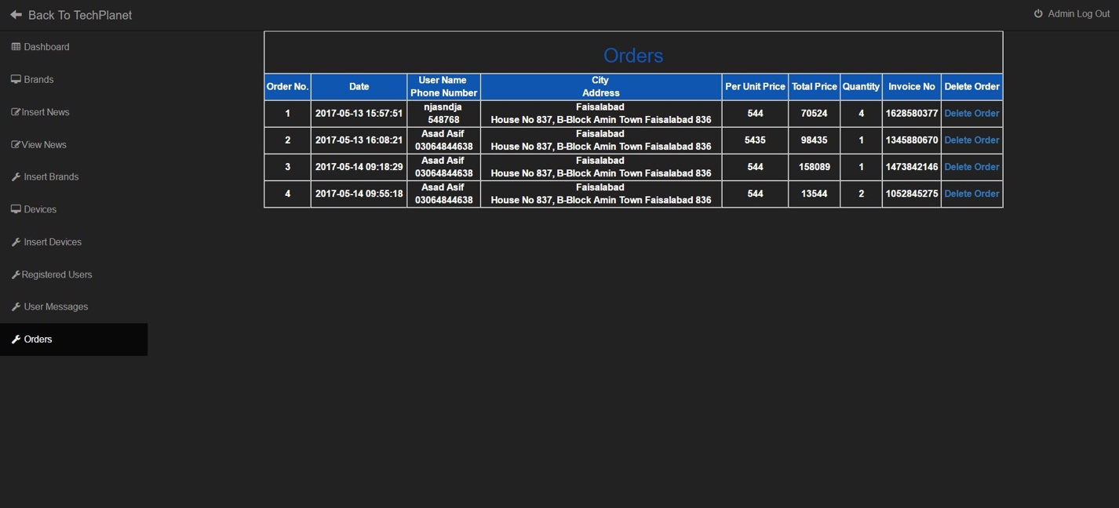

When a user/customer orders a device through techPlanet website than the order of that user is delivered to the admin by storing it in database and showing it to the user through this orders page in the admin panel. Admin will be able to see all the orders from the customers of his website along with their complete info.

Admin Panel (Edit Device Page)

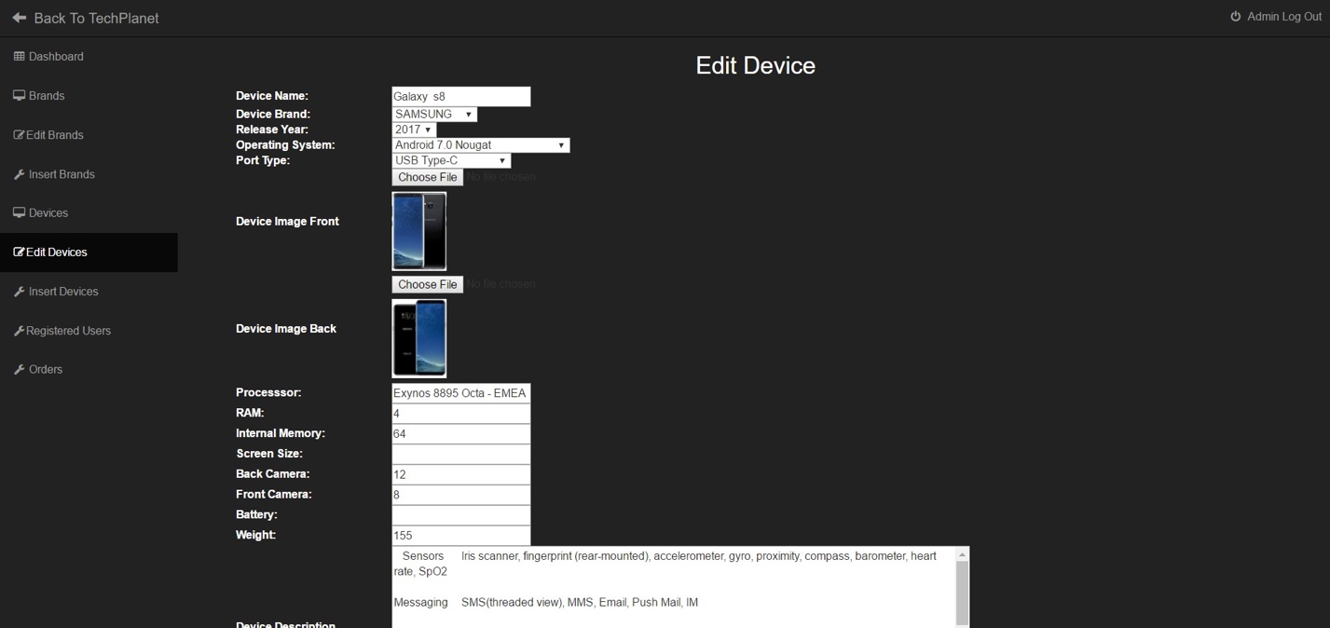

If a device has been stored in database with some faulty information regarding that device. Then it needs to be changed. This page helps the admin choose that specific device and edit its information until it is done right.