Assignment - 01
STATIC MODEL & ASSOCIATION MULTIPLICITIES

M. Asad Masood
MSS012515007

1. Introduction
The static model presents the structural side of a system. Instead of focusing on processes or changing behaviour, it concentrates on the more stable parts of the problem domain, such as classes, their attributes, operations and the relationships that exist between them. The assignment brief for Advanced Requirements Engineering explains that this view is usually less likely to change than system functions, which makes it an important foundation for analysis and design.
Among the most important elements of a static model are associations. An association shows that two classes are related in a meaningful way. For instance, an employee may work in a department, or a student may enrol in a course. At object level, an actual connection between two instances is called a link. If the association is ‘Student enrols in Course’, then the link could be ‘Ali enrols in Advanced Databases’.
A key part of association modelling is multiplicity. Multiplicity explains how many instances of one class may be connected to a single instance of another class. Clear multiplicity rules help remove ambiguity, improve requirement precision and support correct database or object-oriented design later in the project. The following sections describe five common types of associations and explain them with UML-style class diagrams.
2. One-to-One Association
A one-to-one association means that one instance of a class is related to only one instance of another class, and the reverse is also true. This type of relationship is used when both classes have a unique pairing. It is suitable when the business rule does not allow duplication on either side of the relationship.
Figure 1 shows a one-to-one association between Person and Passport. Under this rule, one person owns one passport and each passport belongs to one person. A practical object-level link would be: ‘Asad owns passport PK123456’. The relationship is straightforward because neither side can be linked with multiple objects of the other class.
This association is useful where identity, entitlement or official documentation must remain unique. It improves data integrity because it prevents the same passport from being assigned to many people and also prevents a single person from being linked to multiple active passports in the simplified model used here.
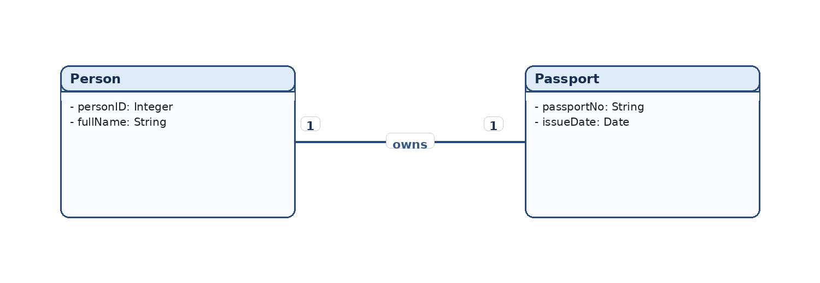
Figure 1: One-to-one association between Person and Passport. Author-created UML diagram.
3. One-to-Many Association
A one-to-many association means that one instance of the first class can be linked with many instances of the second class, while each instance of the second class belongs to only one instance of the first class. This is one of the most common relationship types in system analysis because many real-life structures are hierarchical in nature.
In Figure 2, one Department can employ many Employees, but each Employee works in one Department. A link example would be: ‘Software Engineering Department employs Sara’, while the same department may also employ Hamza, Nida and several other employees. The department therefore sits on the ‘one’ side, whereas employees appear on the ‘many’ side.
This kind of association is useful for modelling organisational structures, customer orders, hospital wards and similar cases where one parent entity controls or groups several child entities. It supports clear accountability and makes the model easier to translate into a relational database through a foreign key on the many side.
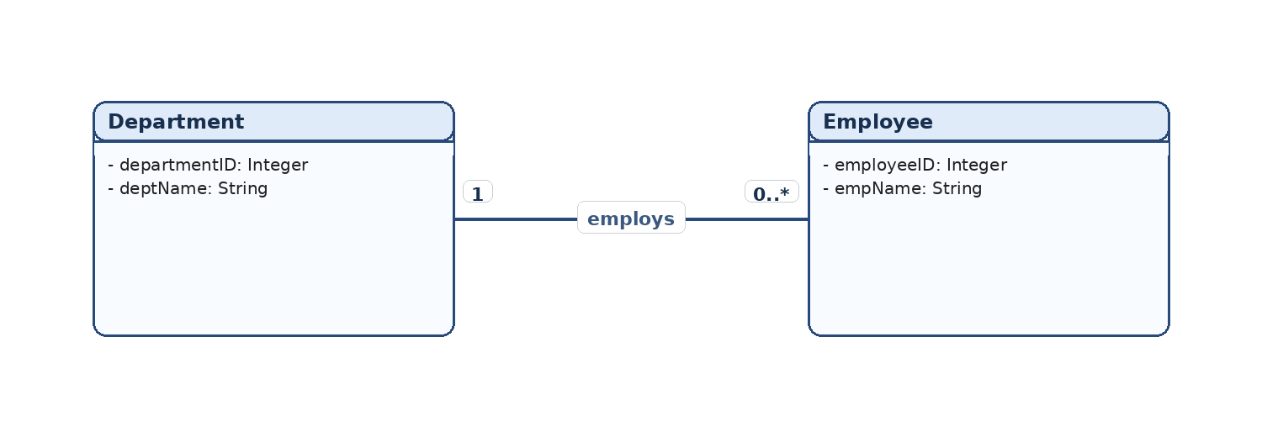
Figure 2: One-to-many association between Department and Employee.
4. Numerically Specified Association
A numerically specified association uses an exact number instead of a general many value. This tells the analyst that the relationship has a fixed business rule. Rather than writing 0..* or 1..*, the model states the exact quantity expected in the system. This is useful when the domain imposes a strict structural limit.
Figure 3 presents a Car to Wheel relationship. In the simplified example, one car contains exactly four wheels and each wheel belongs to one car. A possible link is: ‘Car ABC-123 contains wheel 1, wheel 2, wheel 3 and wheel 4’. The value ‘4’ is important because it communicates a specific design rule rather than a flexible range.
Numerical multiplicity is especially valuable in safety-critical or highly standardised environments because it reduces interpretation errors. When requirement models specify exact quantities, developers and database designers can reflect the same restrictions in implementation and validation rules.
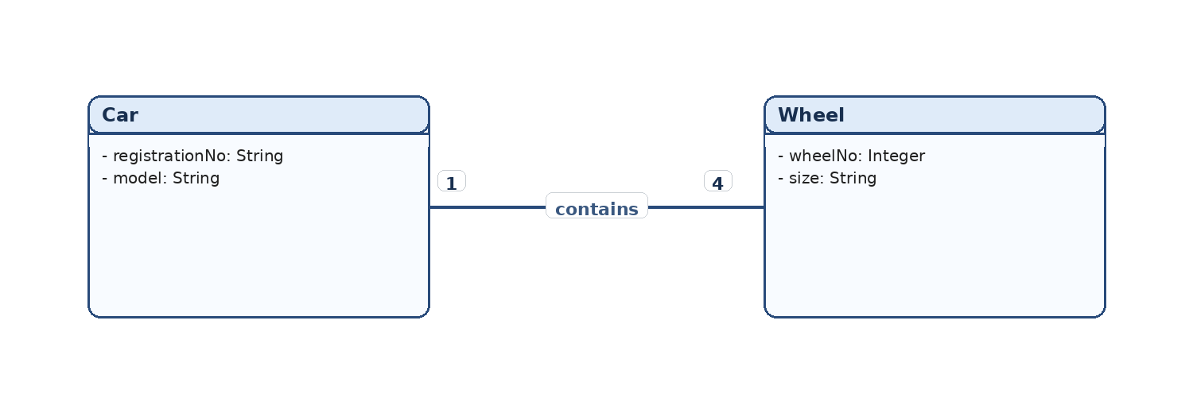
Figure 3: Numerically specified association between Car and Wheel. Author-created UML diagram.
5. Optional Association
An optional association shows that participation in the relationship is not compulsory for at least one class. In UML this is normally written using a zero lower bound, such as 0..1 or 0..*. Optionality is important because not every valid object must always be connected to another object at the same time.
Figure 4 shows a Student and Locker relationship. A student may have no locker at all or may have one locker, which is why the multiplicity on the locker side is 0..1. At the same time, a locker in this simplified model is assigned to only one student. An instance-level link could be: ‘Ayesha is assigned Locker L-12’, while another student may currently have no locker.
Optional associations are highly realistic because information systems often manage incomplete or pending states. A student can exist in the system before a locker is allocated. By modelling that option clearly, the analyst avoids forcing unnecessary data and reflects the real business process more accurately.
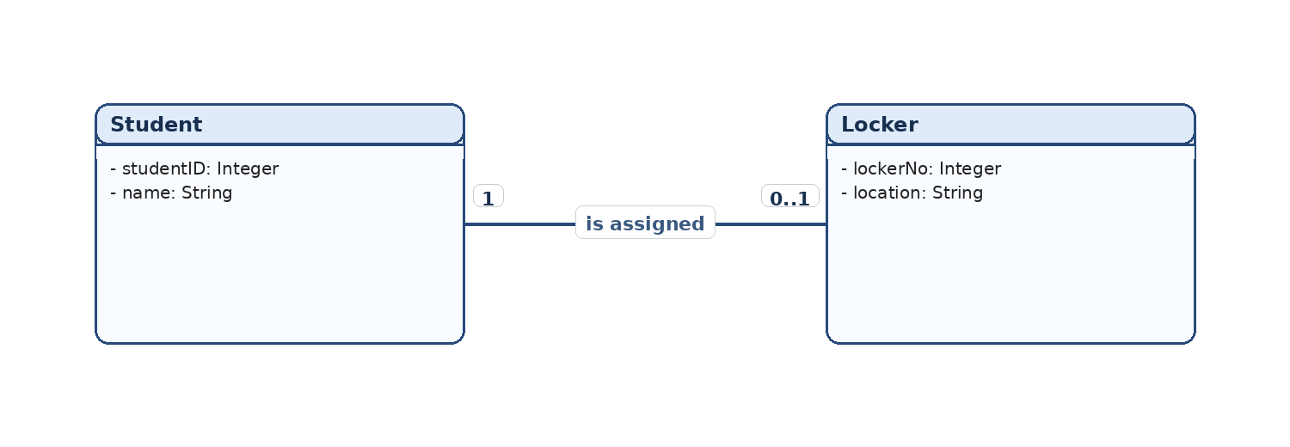
Figure 4: Optional association between Student and Locker
6. Many-to-Many Association
A many-to-many association means that multiple instances of one class may relate to multiple instances of another class at the same time. This type of relationship appears when both sides can participate repeatedly in the same business context.
In Figure 5, a Student can enrol in many Courses and a Course can include many Students. A simple link example is: ‘Bilal enrols in Software Testing’, but Bilal may also enrol in Requirements Engineering, while the Software Testing course may include Bilal, Zainab, Haris and many other students. Both sides therefore have a multiplicity of 0..*.
Many-to-many associations are conceptually simple but usually require extra design attention during implementation. In a relational database, the relationship is normally resolved through an intermediate table such as Enrolment. That extra structure stores the pairings and may also hold useful details such as enrolment date, grade or status.
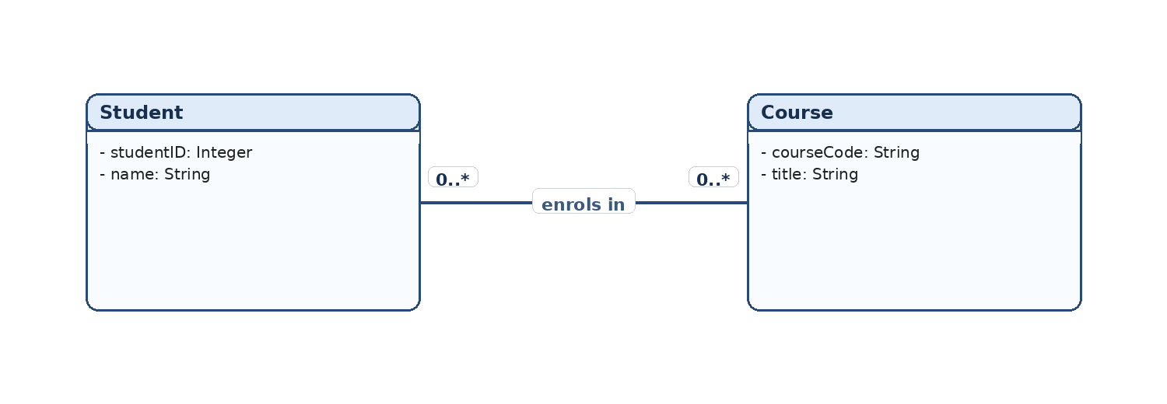
Figure 5: Many-to-many association between Student and Course.
7. Comparative Summary
The five association types described above all express different business rules. The most important distinction lies in how many related instances are allowed and whether participation is compulsory or optional. Table 1 provides a concise comparison of the associations used in this report.
Table 1: Summary of association types and examples.
Association Type | Typical Multiplicity | Meaning | Example
One-to-one | 1 — 1 | Each object has one unique partner on the other side. | Person–Passport
One-to-many | 1 — 0. * | One parent object may connect to many child objects. | Department–Employee
Numerically specified | 1 — 4 | The exact quantity of related objects is fixed. | Car–Wheel
Optional | 1 — 0.1 | Participation is allowed but not compulsory for one side. | Student–Locker
Many-to-many | 0.* 0. * | Both classes may connect with many objects. | Student–Course
8. Conclusion
In conclusion, association multiplicity is an essential part of the static model because it explains how classes relate to one another in a precise and testable way. One-to-one, one-to-many, numerically specified, optional and many-to-many associations each describe a different structural rule. When these rules are expressed clearly, the requirements model becomes easier to understand, verify and later transform into design and implementation artefacts.
The diagrams in this report show that multiplicity is not just a notation detail; it communicates the real business logic of the problem domain. A well-drawn static model therefore helps analysts reduce ambiguity, improve data consistency and support better system design decisions from the earliest stages of requirements engineering.

