Assignment - 02
Software Process

M. Asad Masood
MSSE01215007

1. What is software process improvement?
Software process improvement (SPI) is the disciplined practice of examining, measuring, and refining the way software is planned, developed, tested, delivered, and maintained. In simple words, it focuses on improving the process that produces software rather than trying to solve every problem only at the product level. The idea behind SPI is that better processes usually lead to better outcomes: fewer defects, clearer communication, better estimates, and more consistent delivery. The CMMI body of practice describes process improvement as a pathway for building capabilities that produce measurable performance results, while early SEI guidance presents SPI as a longer-term organizational response to recurring software problems rather than a short-term fix (ISACA, n.d.; Humphrey, 1992).
2. Who does SPI?
SPI is not the responsibility of one individual. It requires commitment from several layers of an organization. Senior management provides sponsorship, defines the business objectives, allocates resources, and removes organizational barriers. A dedicated process improvement structure then coordinates the work. In the IDEAL approach, this structure commonly includes a Management Steering Group (MSG) and a Software Engineering Process Group (SEPG), both of which guide and sustain improvement activity. Project managers, requirements engineers, developers, testers, quality assurance staff, and business stakeholders contribute practical evidence because they experience the existing process every day. When formal benchmarking is needed, trained appraisers may also participate to evaluate how closely the organization’s practices align with an improvement model such as CMMI (McFeeley, 1996; CMMI Institute, 2011).
3. Why is SPI important?
SPI matters because software problems are often symptoms of weak or inconsistent ways of working. When requirements are handled informally, changes are uncontrolled, reviews are irregular, or measurement is absent, teams usually experience missed deadlines, cost overruns, rework, and quality issues. A mature process does not guarantee perfect software, but it greatly improves repeatability and control. The evidence reported by the Software Engineering Institute shows that CMMI-based process improvement has been associated with better project performance, higher quality products, and gains in cost, schedule, and customer satisfaction. For a requirement engineering context, SPI is especially valuable because stable elicitation, validation, traceability, and change-management practices reduce ambiguity and help prevent expensive downstream correction (Goldenson & Gibson, 2003; ISACA, n.d.).

4. What are the main steps in SPI?
A useful way to explain the steps of SPI is through the IDEAL model, which organizes improvement into five connected phases: Initiating, Diagnosing, Establishing, Acting, and Learning. This model is practical because it treats improvement as a cycle instead of a one-time project.
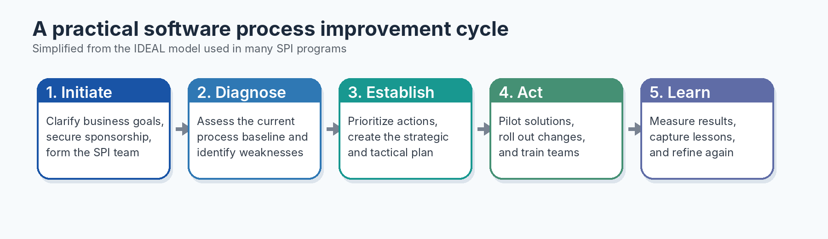
Figure 1. A simplified SPI cycle. Source: Author, based on the IDEAL model described by McFeeley (1996).
Step | IDEAL phase | Explanation
1 | Initiating | Recognize the need for improvement, connect the effort to business objectives, and create a visible sponsorship structure.
2 | Diagnosing | Establish a baseline by reviewing the current process, collecting evidence, and identifying strengths, weaknesses, and risks.
3 | Establishing | Create a strategic action plan, define priorities, assign roles, and choose the improvement approach that best fits the organization.
4 | Acting | Develop and pilot process solutions, roll out approved changes, provide training, and transition the new practices into daily work.
5 | Learning | Measure outcomes, review whether the changes worked, document lessons learned, and use the results to begin the next cycle.
Table 1. Summary of SPI steps adapted from the IDEAL framework (McFeeley, 1996).
5. What is the work product of SPI?
The work product of SPI is not only a higher maturity level or a successful appraisal score. In practice, SPI produces a set of concrete management and engineering outputs that guide future work. Typical outputs include a baseline assessment report, a findings and recommendations report, an SPI strategic action plan, defined roles and responsibilities, updated process descriptions, templates, checklists, training material, pilot results, measurement data, and lessons learned. Where formal appraisals are used, the appraisal findings and ratings also become important work products because they provide a structured view of strengths, weaknesses, and improvement priorities (McFeeley, 1996; CMMI Institute, 2011).
Work product | Purpose | Typical owner
Baseline assessment report | Explains the current state of the process and identifies major gaps. | SEPG / appraisal team
Findings and recommendations report | Translates assessment evidence into actionable improvement priorities. | SPI team
SPI strategic action plan | Defines goals, sequence, resources, responsibilities, and timing. | MSG and SEPG
Updated process assets | Provides standard procedures, templates, checklists, and role descriptions. | Process owners
Training and rollout package | Helps teams adopt the revised practices consistently. | SEPG / trainers
Metrics dashboard and lessons learned | Shows whether performance improved and captures knowledge for the next cycle. | Project leads and QA
Table 2. Common SPI work products synthesized from SEI IDEAL guidance and CMMI appraisal material (McFeeley, 1996; CMMI Institute, 2011).
6. How do I ensure that SPI has been done correctly?
SPI can be considered successful only when improvement is visible in actual project performance, not merely in documentation. The first safeguard is alignment with business objectives. CMMI guidance repeatedly emphasizes that improvement goals should be based on business needs; if the effort chases maturity levels alone, it often becomes ceremonial rather than useful. The second safeguard is evidence. An organization should define baseline measures before change is introduced, then compare those measures after rollout. Relevant indicators may include defect density, rework effort, requirements volatility, review effectiveness, change-request turnaround time, test escape rate, or schedule predictability. The third safeguard is controlled verification through audits, peer reviews, pilot evaluations, and, where required, formal appraisals such as SCAMPI B or SCAMPI A. These methods help determine whether the new process is understood, followed, institutionalized, and producing the intended result (CMMI Institute, 2011; ISACA, n.d.).
Practical criteria for deciding whether SPI is working
• The improvement goals are explicitly linked to organizational objectives such as quality, cost, cycle time, or customer satisfaction.
• The current process was baselined before changes were introduced.
• Roles, responsibilities, and process assets are documented and actually used by projects.
• Teams received training and the revised practices were piloted before organization-wide deployment.
• Performance data shows measurable improvement, not just increased documentation.
• Lessons learned are captured so the next SPI cycle begins from evidence rather than assumptions.
7. Conclusion
Software process improvement is best understood as a managed and evidence-based effort to make software work more reliable. It is carried out by leadership, process groups, project teams, and quality professionals working together around shared business goals. Its importance lies in its ability to reduce recurring failure patterns and replace ad hoc practice with controlled, repeatable, and measurable methods. A sound SPI initiative follows a cycle of initiation, diagnosis, planning, action, and learning; it produces tangible work products such as assessment reports, action plans, updated process assets, and metrics; and it is judged successful when the organization can demonstrate real gains in quality and performance. For advanced requirements engineering, SPI is particularly significant because improved requirements practices strengthen the foundation on which the rest of the software lifecycle depends.
References
CMMI Institute. (2011). Introduction to CMMI appraisals (excerpt from SCAMPI A, Version 1.3a). Carnegie Mellon University / CMMI Institute. https://cmmiinstitute.com/getattachment/6cf09de7-8756-4b72-a1b3-f82c52c8861e/Introduction-to-CMMI-Appraisals.pdf
Goldenson, D. R., & Gibson, D. L. (2003). Demonstrating the impact and benefits of CMMI®: An update and preliminary results (CMU/SEI-2003-SR-009). Software Engineering Institute, Carnegie Mellon University. https://www.sei.cmu.edu/documents/1832/2003_003_001_14117.pdf
Humphrey, W. S. (1992). Introduction to software process improvement (CMU/SEI-92-TR-7). Software Engineering Institute, Carnegie Mellon University. https://www.sei.cmu.edu/documents/1048/1992_005_001_16049.pdf
ISACA. (n.d.). CMMI® Performance Solutions. https://www.isaca.org/enterprise/cmmi-performance-solutions
McFeeley, B. (1996). IDEAL: A user’s guide for software process improvement (CMU/SEI-96-HB-001). Software Engineering Institute, Carnegie Mellon University. https://www.sei.cmu.edu/documents/1622/1996_002_001_16433.pdf

