Project Documentation

Table of Contents
Table of Contents 1
Executive Summary 2
Background 2
What is Sisca AI? 2
Introduction 3
Problem Statement 3
Objectives 3
key Highlights 4
Chatbots vs Sisca AI 4
System Features 5
System Workflow 6
System Architecture 7
Module Descriptions 8
Technology Stack 9
Stack Overview 9
Current MVP Capabilities 9
Future Scope 10
Roadmap Timeline 11
Conclusion 12

Executive Summary

Background
Artificial intelligence has rapidly evolved from static, rule-based systems into dynamic models capable of natural conversation. However, most AI tools available today remain fundamentally reactive. They answer questions but do not act. Sisca AI was conceived to bridge that gap by introducing autonomous, goal-driven behavior into everyday digital workflows.

What is Sisca AI?

Sisca AI is an autonomous AI assistant that helps users to complete tasks more efficiently. It can research information, analyze data, create visual reports, and automatically send them by email. Unlike traditional AI chatbots that only answer questions, Sisca AI can perform complete tasks helping users save time and improve productivity.

The project has been developed as a Minimum Viable Product (MVP) with the primary objective of validating the concept of Agentic AI and gathering user feedback for future improvements.

Sisca AI demonstrates how autonomous agents can simplify knowledge work by combining large language models with tool usage, browser automation, data analysis, and automated communication.

Introduction

Problem Statement
Even with major advances in conversational AI, most existing tools remain fundamentally limited when applied to real-world productivity tasks:
- Manual research is time-consuming, requiring users to search, filter, and synthesize information themselves.
- Completing an end-to-end task (research → analysis → report → delivery) is time consuming when done manually across tools.
- Lack of transparency — users often cannot see how an AI arrived at an answer or what steps it took.

Solution:
To build a reliable and extensible Agentic AI platform capable of understanding user goals, conducting autonomous research, analyzing data, and executing intelligent tasks through a unified system.

Objectives
Sisca AI is designed around the following core objectives:
- Enable autonomous task execution from a single natural-language goal
- Automate research so users no longer need to manually search multiple sources
- Generate polished, ready-to-share reports automatically
- Automate email drafting and delivery as part of task completion
- Support real-time monitoring of ongoing agent tasks
- Improve overall productivity by reducing manual, repetitive work
- Validate the platform through a functional MVP before scaling further

Key Highlights
- Autonomous multi-step task execution driven by natural-language goals
- Integrated AI chat, voice, and vision understanding in one interface
- End-to-end workflow: chat → analysis → visualization → report → delivery
- Built on a modular, scalable architecture using Flask, Groq and Google Gemini
- Functional MVP validated with core autonomous capabilities

Chatbots vs Sisca AI
Aspect | Traditional Chatbot | Sisca AI
Behavior | Reactive - responds to prompts | Proactive - pursues a defined goal
Scope | Single-turn answers | Multi-step task execution
Output | Text response only | Research, reports, analysis, emails
Autonomy | Requires constant human input manually | Operates independently once tasked

System Features
Sisca AI brings together the following core capabilities into a single, unified Agent:

💬 AI Chat
Natural, context-aware conversational interface for issuing goals and receiving updates.

🎙️ Voice Interaction
Hands-free interaction through speech-to-text and text-to-speech capabilities.

🖼️ Image Understanding
Ability to interpret and reason over uploaded images as part of a task.

🔎 Autonomous Research
searches, gathers, and synthesizes information relevant to the assigned goal.

🖥️ Virtual Computer
A sandboxed execution environment allowing the agent to browse, navigate, and interact with digital tools.

📡 Real-Time Monitoring
Provides live visibility into the agent's current step, progress, and decisions.

📊 Data Analysis
Interprets processed data to extract insights and generate reports.

✉️ Automated Email Delivery
Can send generated reports on user’s email.

System Workflow
Sisca AI follows a structured, end-to-end workflow that carries a task from initial request through to final delivery:

User
The user provides a natural-language goal or request to the system.
↓

Understand Goal
The AI interprets intent, context, and desired outcome.
↓

Tool Selection
Appropriate APIs, tools, or modules are chosen for each step.
↓

Research
The agent autonomously gathers relevant information from available sources.
↓

Report Generation
A structured, polished report is compiled automatically.
↓

Email Delivery
The final report or output can be delivered via email.
↓

Completion
The task is marked complete and the user is notified of the outcome.

System Architecture
Sisca AI is built on a modular, layered architecture that separates the user interface, backend logic, decision-making, and integrations, allowing each layer to scale and evolve independently.

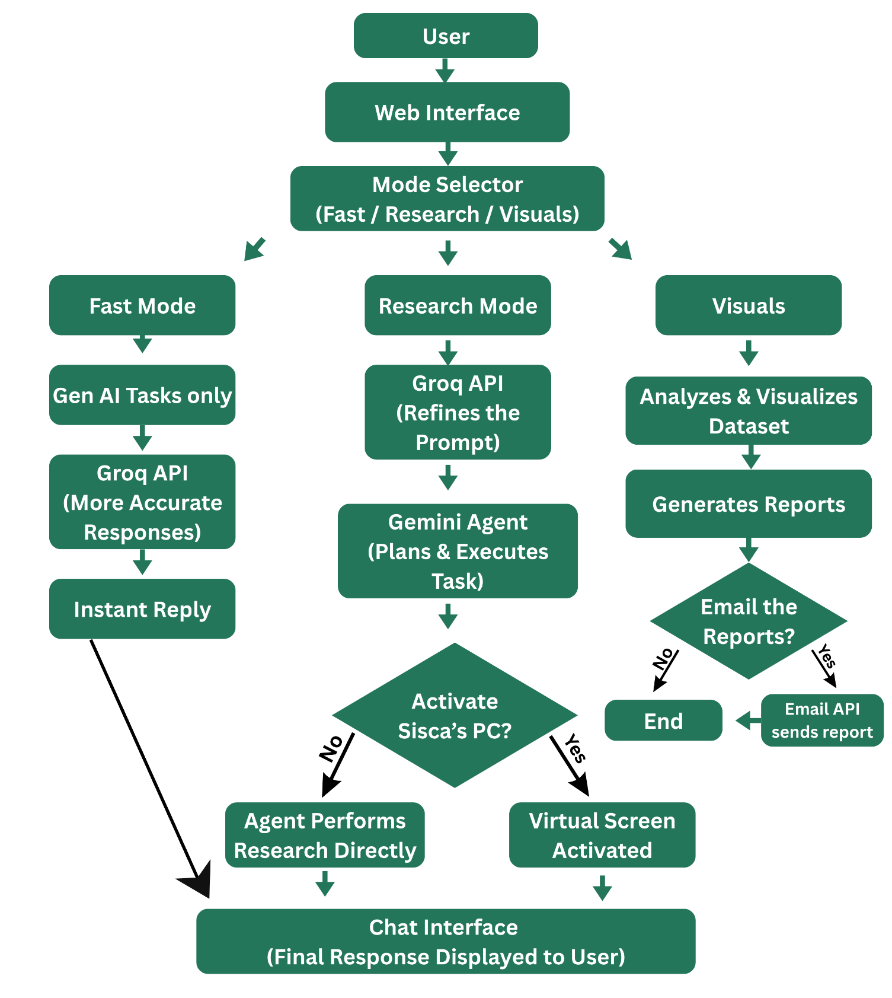

Module Descriptions

Web Interface
The front-facing layer where users submit goals, monitor task progress, and view results in real time.

Flask Backend API
A lightweight Python-based backend that handles requests, routes tasks, and coordinates communication between modules.

Gemini API
Provides the underlying language understanding, reasoning, and generation capabilities that power the agent's intelligence.

Browser (Virtual Computer)
A sandboxed browsing module that allows the agent to navigate the web and interact with online resources autonomously.

Email API
Handles drafting and sending of emails as part of completed tasks, via SMTP or Gmail integration.

Analysis Module
Processes gathered data, performs computations, and prepares insights for visualization and reporting.

Supabase
Stores task history, user data, and system state, providing persistence across sessions.

Technology Stack

Stack Overview
Layer | Technology
Frontend | HTML, CSS, JavaScript
Backend | Flask (Python)
AI Model | Google Gemini, Groq
Database | PostgreSQL
Email | SMTP / Gmail
Visualization | Matplotlib, Seaborn
Reports | PDF
Deployment | Locally

Current MVP Capabilities
✓ AI Chat
✓ Voice Interaction
✓ Vision (Image Understanding)
✓ Autonomous Research
✓ Report Generation
✓ Email Automation
✓ Live Execution / Real-Time Monitoring

Future Scope

Multi-Agent Collaboration
Future versions will support multiple specialized agents working together — for example, a research agent, an analysis agent, and a delivery agent coordinating on a single complex task.

Long-Term Memory
Introducing persistent memory will allow the agent to recall past tasks, preferences, and context across sessions, enabling more personalized and efficient assistance over time.

Mobile Application
A dedicated mobile app will extend Sisca AI's capabilities beyond the desktop, enabling task creation and monitoring on the go.

API Integrations
- Calendar — automatic scheduling and reminders based on task outcomes
- GitHub — autonomous code-related research, issue tracking, and reporting
- Google Drive — automatic storage and organization of generated reports

Security
Robust security controls will be introduced to protect user data and task integrity, including:
- Role-Based Access Control (RBAC) for managing permissions across users and teams

Cloud Deployment
Migrating from a local MVP to a scalable cloud deployment will enable higher availability, concurrent multi-user access, and improved performance.

Roadmap Timeline
Phase | Milestone | Focus
Phase 1 | MVP Validation | Core chat, research, reporting, and email automation
Phase 2 | Memory & Multi-Agent | Long-term memory and collaborative multi-agent workflows
Phase 3 | Integrations | Calendar, GitHub and Google Drive connectivity
Phase 4 | Security | RBAC, and access controls
Phase 5 | Cloud & Mobile | Cloud deployment and dedicated mobile application

Conclusion

Achievements
Sisca AI has successfully demonstrated that an autonomous, goal-driven AI agent can move beyond simple conversation to deliver complete, actionable outcomes unifying research, analysis, reporting, and communication within a single system.

Current MVP
The current MVP validates the platform's core value proposition, with functional AI chat, voice interaction, vision understanding, autonomous research, report generation, email automation, and real-time execution monitoring.

Benefits
- Significant reduction in manual research and reporting effort
- A single unified platform replacing multiple disconnected tools
- Increased transparency through real-time monitoring of agent actions
- A scalable foundation ready for enterprise and multi-agent expansion

Future Vision
As Sisca AI evolves, it aims to become a fully collaborative, multi-agent enterprise platform equipped with long-term memory, deep API integrations, robust security, and cloud-scale deployment establishing itself as an indispensable autonomous co-worker for individuals and organizations alike.

THANKYOU

