My passion for this business

# Share my passion:

My strategy is simple. Buy low and sell a little bit below the market price. Create a quality home and provide it with affordable prices. Quality means reliable, energy-efficient, and beautiful, which makes people want to be there and appreciate it.

***Put the life back in:***  
This is a fact; the mobile home depreciates over time. Usually, the life of a mobile home has only 30 years. My approach, called **“*put the life back in,*”** will make the old mobile home valuable again.

I have two ways to do this:

1. Upgrade the home by changing the furnace, plumbing, electrical, insulation, and windows. This is not visually appealing, but the most important part is to make a reliable, long-lasting home for the future homeowner This step will be the first and the most important part to **“put the life back in”** to the home.
2. Quality workmanship and creativity will make the home unique and original. Please do not misunderstand this part because the most important thing is what the public wants, not what I want. I will make an accent by using my skill to make people attractive. I will **“*put the life back in*”** with my work. I will show you an example of what I can do:

* Scrap material from the construction site furnished to make window casing pieces.

Wood finish makes the home feel warm, and featuring someplace with the wood finish is a great way to add value.

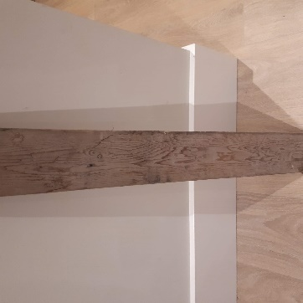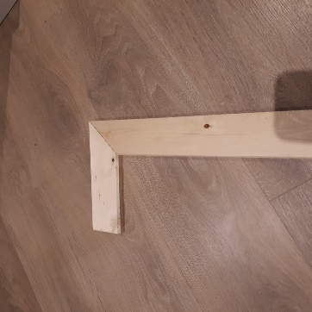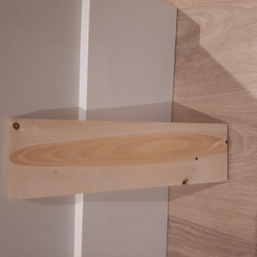

Pine ceiling.   
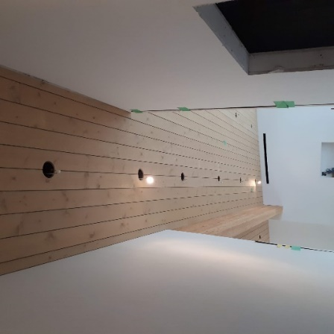

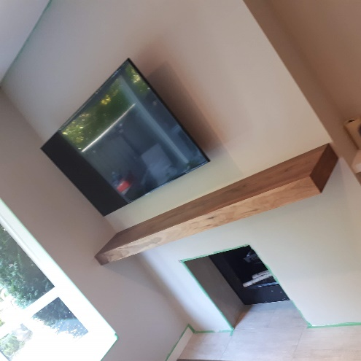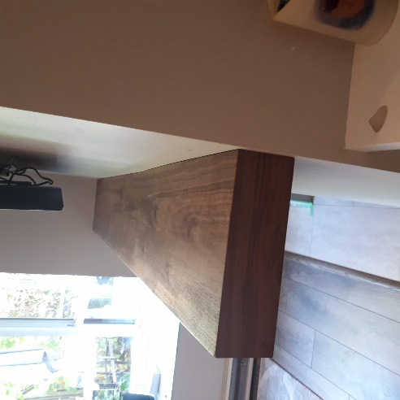

Fireplace mount I built with walnut, and the window and door casing with white oak.

