DeepACF – High-resolution weather forecast based on deep learning
What is simulated in detail, what is the societal and scientific relevance?
Weather forecasts have an enormous social and economic value, think of catastrophe prevention, aviation or agriculture. Therefore, traditional numerical weather prediction models are among the earliest and most demanding applications for supercomputers. Despite the rapid development of computing capacity and prediction quality, there is still a demand for increased resolution. Global weather models today typically reach a resolution of around 10 kilometers, while high-resolution regional models are operated with mesh sizes of about 2 kilometers. Due to topographic, landcover and other geographic differences the weather conditions may vary considerably on a local scale, which is much smaller than the model resolution. This holds especially for extreme weather events such as thunderstorms and heavy rainfall.
However, the necessary improvement of the resolution cannot be achieved simply by extending computing power and refining the measurement network. Innovative solutions are therefore needed to increase the efficiency of traditional models. Therefore, DeepACF explores the utilization of state-of-the-art deep learning techniques to create weather predictions. These techniques potentially offer several benefits and may ultimately lead to improved weather forecasts with benefits for civil safety, agriculture, logistical planning, and many other application areas.
The project is designed as a pilot study with the aim to predict the near surface temperature over a period of 10 hours. The initial dataset provided by the European Centre for Medium-Range Weather Forecasts is used to train various deep learning architectures which are derived from video prediction applications. In addition to the temperature, other atmospheric variables are incorporated as input variables in order to increase the ability to capture the complex atmospheric processes which drive the diurnal cycle of near-surface temperature.
How can this application profit from the special features of the JUWELS supercomputer?
Traditional numerical weather prediction models solve numerical equations derived from physical laws –for example the conservation of energy, momentum, and mass –to forecast the future atmospheric state. In contrast, deep learning methods offer a data-driven approach, which may be computationally cheaper in an operational setting. However, training of the several million parameters of a deep learning model requires huge data and computation resources. This is best accomplished on scalable, high-performance computing systems based on top of the line graphic processing units (GPU). The JUWELS booster provides such cutting edge GPU computing power. Essentially, the new features of the JUWELS booster, especially the tensor cores which enable the mixed-precision computing, can significantly improve the deep learning training performances without losing accuracy.
Another important feature of the JUWELS booster is the high-speed linkage to the hierarchical storage system at JSC. The meteorological deep learning networks require a huge amount of data in order to achieve reliable results. The high data throughput of JUWELS booster enables the processing of hundreds of terabytes of weather and climate data within a few hours. Such data volumes correspond to the storage capacity of hundreds of conventional hard disks.
Principal Investigators:
PD Dr. Martin Schultz, Jülich Supercomputing Centre, Forschungszentrum Jülich
Amirpasha Mozaffari , Jülich Supercomputing Centre, Forschungszentrum Jülich
Michael Langguth, Jülich Supercomputing Centre, Forschungszentrum Jülich
Dr. Bing Gong, Jülich Supercomputing Centre, Forschungszentrum Jülich
Dr.Scarlet Stadtler, Jülich Supercomputing Centre, Forschungszentrum Jülich

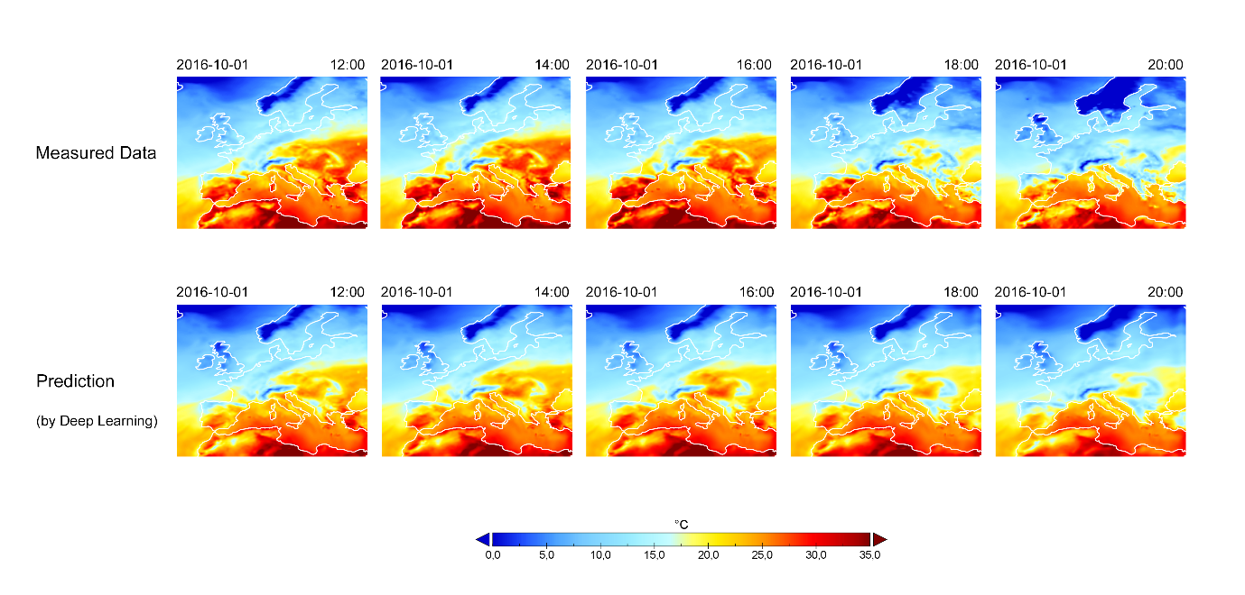
Measured temperatures (top) vs. temperatures predicted by deep learning (bottom)
Copyright: Forschungszentrum Jülich / M. Schultz, A. Mozaffari, M. Langguth, B. Gong, S.Stadtler

