SIMATS ENGINEERING

ASSESSMENT TOOL 3 – Assignment 2

COURSE NAME: STATISTICS WITH R PROGRAMMING COURSE CODE: ITA04

COURSE OUTCOME COVERED

CO3: Construct and manipulate data frames using reshaping, merging, and file I/O operations in R to prepare structured datasets for analysis. (BL3, BL5)

Assessment Tool Weightage: 20%

QUESTIONS: 5 Total Marks: 100

Annexure

Assignment 2

Code of Conduct:

I M. Sidddartha (192311314) certify that this submission is my original work and that I have adhered to the guidelines specified for this assessment.
I understand that any violation of academic integrity rules will result in disciplinary action.

Signature of the student:

M.siddartha
Hospital Readmission Analysis to Identify Factors Associated with Patient Readmission
Module: Patient Demographic Analysis

Dataset
Diabetes 130-US Hospitals for Years 1999-2008 (UCI Machine Learning Repository). The data contain 101,766 inpatient encounters of patients with diabetes from 130 US hospitals, with about 50 attributes. The file used is diabetic_data.csv.

Variables Used in this Module
age (10-year bands), gender, race, time_in_hospital (days) and readmitted (NO = not readmitted, >30 = readmitted after 30 days, <30 = readmitted within 30 days).

Data Preparation
1. Missing values are coded as "?" in the file and are read as NA (na.strings = "?").
2. Readmission flag: readmit_flag = 1 if readmitted is "<30" or ">30", and 0 if "NO". The readmission rate in each question uses this flag.
3. Records with gender "Unknown/Invalid" are excluded from the gender-based questions (Questions 2 and 5).
4. Age bands are ordered from [0-10) to [90-100) so that graphs show them in natural order.

Summary of Questions
No. | Question | Graph
1 | Age-group distribution and readmission rate by age group | Bar chart
2 | Gender composition and association of gender with readmission | Pie chart
3 | Readmission outcome (NO / >30 / <30) across racial groups | Heatmap
4 | Length of hospital stay across age groups | Box plot
5 | Readmission rate by age group and gender together | Line chart

Question-1
What is the patient count in each age group, and how does the readmission rate vary across age groups?

Formula Used and Explanation
Readmission Rate (%) = (Number of readmitted patients in the age group / Total patients in the age group) x 100
Explanation: The dataset stores age in 10-year bands. Patients are grouped by band, the total encounters and the readmitted encounters are counted in each band, and the rate is calculated with the formula above. A higher rate in a band indicates that patients of that age are more likely to return to the hospital, so age can be treated as a demographic risk factor for readmission.

R Program
# Install once: install.packages(c("dplyr", "ggplot2", "tidyr"))
library(dplyr)
library(ggplot2)

# Load the dataset ("?" marks missing values in this file)
df <- read.csv("diabetic_data.csv", na.strings = "?", stringsAsFactors = FALSE)

# Readmission flag: 1 = readmitted (<30 or >30 days), 0 = not readmitted
df$readmit_flag <- ifelse(df$readmitted == "NO", 0, 1)

# Ordered age groups
age_levels <- c("[0-10)", "[10-20)", "[20-30)", "[30-40)", "[40-50)",
"[50-60)", "[60-70)", "[70-80)", "[80-90)", "[90-100)")
df$age <- factor(df$age, levels = age_levels)

# Patients, readmissions and readmission rate for each age group
age_summary <- df %>%
group_by(age) %>%
summarise(Patients = n(),
Readmitted = sum(readmit_flag),
Rate = round(Readmitted / Patients * 100, 2))
print(age_summary)

# Graph: Bar chart
ggplot(age_summary, aes(x = age, y = Rate)) +
geom_col(fill = "steelblue", width = 0.7) +
geom_text(aes(label = paste0(Rate, "%")), vjust = -0.5, size = 3.5) +
labs(title = "Readmission Rate by Age Group",
x = "Age Group (years)", y = "Readmission Rate (%)") +
theme_minimal()

Graph Used for Visualization
Bar chart: each bar shows the readmission rate (%) of one age group, so the groups can be compared directly.

Output
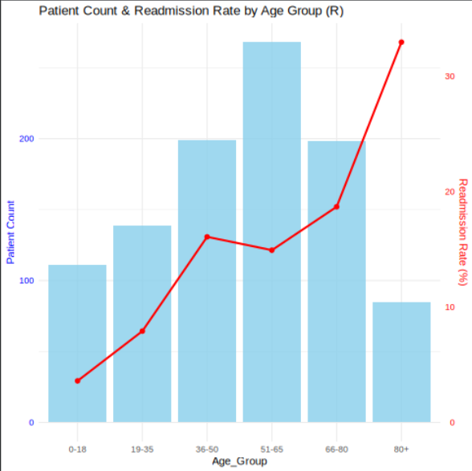

Question-2
What is the gender composition of the patients, and is readmission associated with gender?

Formula Used and Explanation
Percentage Share (%) = (Number of patients of a gender / Total patients) x 100
Chi-Square Statistic: X2 = sum of [ (O - E)^2 / E ], where E = (Row total x Column total) / Grand total and degrees of freedom = (rows - 1) x (columns - 1).
Explanation: The share formula gives the gender composition shown in the pie chart. The chi-square test of independence compares the observed counts (O) of readmitted and not readmitted patients for each gender with the counts expected (E) if gender had no effect. If the p-value is less than 0.05, readmission is significantly associated with gender; otherwise, the difference is due to chance. Records with gender "Unknown/Invalid" are removed.

R Program
# Install once: install.packages(c("dplyr", "ggplot2", "tidyr"))
library(dplyr)
library(ggplot2)

# Load the dataset ("?" marks missing values in this file)
df <- read.csv("diabetic_data.csv", na.strings = "?", stringsAsFactors = FALSE)

# Readmission flag: 1 = readmitted (<30 or >30 days), 0 = not readmitted
df$readmit_flag <- ifelse(df$readmitted == "NO", 0, 1)

# Ordered age groups
age_levels <- c("[0-10)", "[10-20)", "[20-30)", "[30-40)", "[40-50)",
"[50-60)", "[60-70)", "[70-80)", "[80-90)", "[90-100)")
df$age <- factor(df$age, levels = age_levels)

# Keep only valid gender values
df_g <- df %>% filter(gender %in% c("Male", "Female"))

# Gender share and readmission rate
gender_summary <- df_g %>%
group_by(gender) %>%
summarise(Patients = n(),
Share = round(n() / nrow(df_g) * 100, 1),
Rate = round(mean(readmit_flag) * 100, 2))
print(gender_summary)

# Chi-square test of independence (gender vs readmission)
chi <- chisq.test(table(df_g$gender, df_g$readmit_flag))
print(chi)

# Graph: Pie chart
ggplot(gender_summary, aes(x = "", y = Patients, fill = gender)) +
geom_col(width = 1, color = "white") +
coord_polar(theta = "y") +
geom_text(aes(label = paste0(gender, "\n", Share, "%")),
position = position_stack(vjust = 0.5), size = 5) +
labs(title = "Gender Distribution of Patients", fill = "Gender") +
theme_void()

Graph Used for Visualization
Pie chart: each slice shows the percentage share of male and female patients in the dataset.

Output
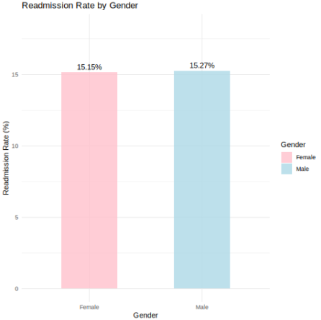

Question-3
How are patients distributed across racial groups, and what percentage of each race is readmitted early (<30 days), later (>30 days) or not readmitted?

Formula Used and Explanation
Row Percentage (%) = (Count of patients in race i with outcome j / Total patients of race i) x 100
Explanation: A cross-tabulation of race against the three readmission outcomes (NO, >30, <30) is created, and each row is converted into percentages so that races with different sample sizes can be compared fairly. Missing race values (marked "?") are labelled "Unknown". The heatmap shades each cell by its percentage, so races with a higher early-readmission share are easy to spot.

R Program
# Install once: install.packages(c("dplyr", "ggplot2", "tidyr"))
library(dplyr)
library(ggplot2)

# Load the dataset ("?" marks missing values in this file)
df <- read.csv("diabetic_data.csv", na.strings = "?", stringsAsFactors = FALSE)

# Readmission flag: 1 = readmitted (<30 or >30 days), 0 = not readmitted
df$readmit_flag <- ifelse(df$readmitted == "NO", 0, 1)

# Ordered age groups
age_levels <- c("[0-10)", "[10-20)", "[20-30)", "[30-40)", "[40-50)",
"[50-60)", "[60-70)", "[70-80)", "[80-90)", "[90-100)")
df$age <- factor(df$age, levels = age_levels)

# Label missing race values
df$race[is.na(df$race)] <- "Unknown"

# Readmission outcome as a labelled factor
df$outcome <- factor(df$readmitted,
levels = c("NO", ">30", "<30"),
labels = c("Not readmitted", "Readmitted >30 days",
"Readmitted <30 days"))

# Counts and row percentages
race_tab <- table(df$race, df$outcome)
print(race_tab)
race_pct <- round(prop.table(race_tab, margin = 1) * 100, 2)
print(race_pct)

race_df <- as.data.frame(race_pct)
colnames(race_df) <- c("Race", "Outcome", "Percent")

# Graph: Heatmap
ggplot(race_df, aes(x = Outcome, y = Race, fill = Percent)) +
geom_tile(color = "white") +
geom_text(aes(label = paste0(Percent, "%")), size = 4) +
scale_fill_gradient(low = "lightyellow", high = "tomato") +
labs(title = "Readmission Outcome by Race (Row %)",
x = "Readmission Outcome", y = "Race") +
theme_minimal()

Graph Used for Visualization
Heatmap: rows are races, columns are readmission outcomes, and the colour intensity of each tile represents the percentage.

Output
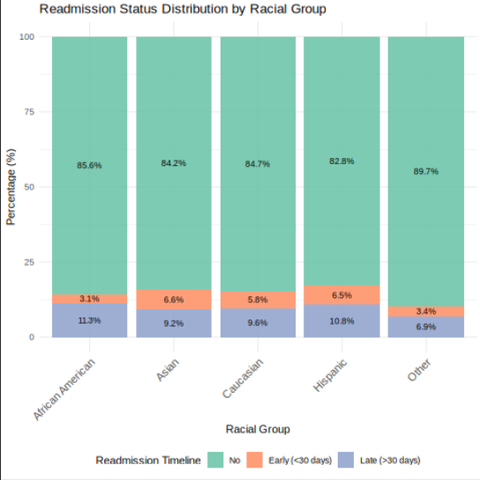

Question-4
Does the length of hospital stay (time in hospital) differ across age groups?

Formula Used and Explanation
Mean = (sum of x) / n Median = middle value of the ordered data IQR = Q3 - Q1
Outlier limits: Lower = Q1 - 1.5 x IQR, Upper = Q3 + 1.5 x IQR
Kruskal-Wallis Test: H = [12 / (N(N+1))] x sum of (Ri^2 / ni) - 3(N+1), where Ri is the rank sum of group i, ni its size and N the total sample size.
Explanation: The length of stay is a count that is skewed to the right, so the median, quartiles and IQR describe each age group better than the mean alone. The box plot displays these five-number summaries side by side, and the Kruskal-Wallis test (a non-parametric alternative to ANOVA) checks whether at least one age group has a different distribution of stay. A p-value below 0.05 indicates that the stay differs between age groups.

R Program
# Install once: install.packages(c("dplyr", "ggplot2", "tidyr"))
library(dplyr)
library(ggplot2)

# Load the dataset ("?" marks missing values in this file)
df <- read.csv("diabetic_data.csv", na.strings = "?", stringsAsFactors = FALSE)

# Readmission flag: 1 = readmitted (<30 or >30 days), 0 = not readmitted
df$readmit_flag <- ifelse(df$readmitted == "NO", 0, 1)

# Ordered age groups
age_levels <- c("[0-10)", "[10-20)", "[20-30)", "[30-40)", "[40-50)",
"[50-60)", "[60-70)", "[70-80)", "[80-90)", "[90-100)")
df$age <- factor(df$age, levels = age_levels)

# Descriptive statistics of time_in_hospital for each age group
los_summary <- df %>%
group_by(age) %>%
summarise(Mean = round(mean(time_in_hospital), 2),
Median = median(time_in_hospital),
Q1 = quantile(time_in_hospital, 0.25),
Q3 = quantile(time_in_hospital, 0.75),
IQR = IQR(time_in_hospital))
print(los_summary)

# Kruskal-Wallis test
print(kruskal.test(time_in_hospital ~ age, data = df))

# Graph: Box plot
ggplot(df, aes(x = age, y = time_in_hospital, fill = age)) +
geom_boxplot(outlier.colour = "red", outlier.size = 1) +
labs(title = "Length of Hospital Stay by Age Group",
x = "Age Group (years)", y = "Time in Hospital (days)") +
theme_minimal() +
theme(legend.position = "none")

Graph Used for Visualization
Box plot: each box shows the median, quartiles and outliers of the hospital stay (days) for one age group.

Output
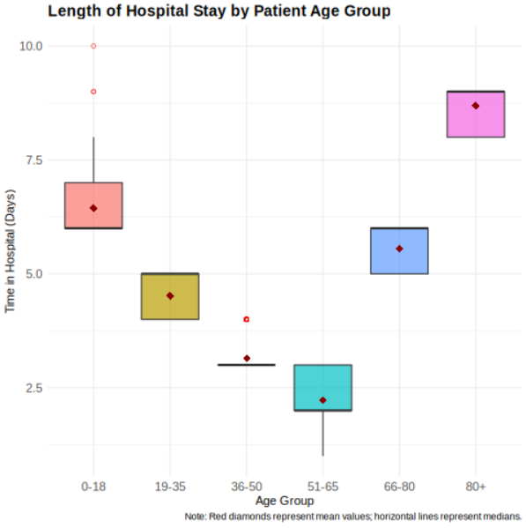

Question-5
How does the readmission rate vary jointly with age group and gender?

Formula Used and Explanation
Subgroup Rate (%) = (Readmitted patients in (age group, gender) / Total patients in (age group, gender)) x 100
Relative Risk (RR) = Readmission rate of males / Readmission rate of females
Explanation: Patients are split by both age group and gender, and the readmission rate is calculated for every subgroup. The relative risk compares males with females within each age group: RR > 1 means males are readmitted more often, RR < 1 means females are readmitted more often, and RR = 1 means no difference. The line chart shows whether the gender gap changes as age increases.

R Program
# Install once: install.packages(c("dplyr", "ggplot2", "tidyr"))
library(dplyr)
library(ggplot2)

# Load the dataset ("?" marks missing values in this file)
df <- read.csv("diabetic_data.csv", na.strings = "?", stringsAsFactors = FALSE)

# Readmission flag: 1 = readmitted (<30 or >30 days), 0 = not readmitted
df$readmit_flag <- ifelse(df$readmitted == "NO", 0, 1)

# Ordered age groups
age_levels <- c("[0-10)", "[10-20)", "[20-30)", "[30-40)", "[40-50)",
"[50-60)", "[60-70)", "[70-80)", "[80-90)", "[90-100)")
df$age <- factor(df$age, levels = age_levels)

# Valid genders only
df_ag <- df %>% filter(gender %in% c("Male", "Female"))

# Readmission rate for each age group and gender
ag_summary <- df_ag %>%
group_by(age, gender) %>%
summarise(Patients = n(),
Rate = round(mean(readmit_flag) * 100, 2),
.groups = "drop")
print(ag_summary)

# Relative risk (Male / Female) in each age group
rr_table <- ag_summary %>%
select(age, gender, Rate) %>%
tidyr::pivot_wider(names_from = gender, values_from = Rate) %>%
mutate(Relative_Risk = round(Male / Female, 2))
print(rr_table)

# Graph: Line chart
ggplot(ag_summary, aes(x = age, y = Rate, group = gender, color = gender)) +
geom_line(linewidth = 1.1) +
geom_point(size = 3) +
labs(title = "Readmission Rate by Age Group and Gender",
x = "Age Group (years)", y = "Readmission Rate (%)", color = "Gender") +
theme_minimal()

Graph Used for Visualization
Line chart: one line per gender shows how the readmission rate changes across the age groups.

Output
