

**Arab American University of Palestine**

**Faculty of Information Technology**

**Computer System Engineering**

**Introduction to Database – Course**

**Database Insurance Company Management System**

**" viollete "**



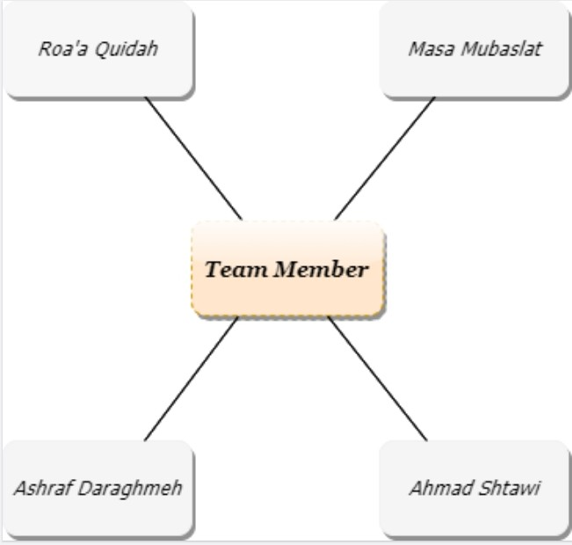

**INDEX :**

* Introduction ……………………… 5
* REQUIREMENTS ...……………...5
* ER/EER Diagram ..………………..7
* Final relational schema …………….8
* SQL Statement ……………………..9
* Constraint …………………………13
* Insertion ………………………..… 14
* Functional analysis and Query …….17
* Normalization ……………..………22

**Introduction**

This company provides compensation to customers for some of the dangers they are exposed to, such as burning their homes, exposing them to theft, or in cases of illness, infirmity, and others .

A customer tend to insure his Properties like car , home , stores he also can add his family with him , or his employees if he has workshop .

**Requerments**

1. This company has different policies .Policies have policy number and term date . They are categorized based on their types .There are four types: Home_policy , car_policy , public_policy and Helth Policy .
2. Home_policy has Area, year build, type, number of room, price, home_num and coverage.
3. car policy has engine size , engine number , car number , lic number , passenger number , model , use , weight , chassis , price , coverage , color and type .
4. The type for car policy may be vip or Comprehensive
5. public policy has job , price place_num and coverage .
6. Health policy has age , price, ill_type and coverage .
7. illness , may be the customer has more than one disease
8. our company have many section in different places each of them have agent , may be one or more .
9. agent has agent_id ,first name , last name and phone .
10. Customers take policies through policy agent , each of them can take more than one policy .
11. A customer has customer number , first name , last name , phone , Birth of date , customer id and gender .
12. The customer can add his family to the insurance as sub insured .
13. sub insured has name , gender , birth of date and relationship .
14. The customer can pay the total cost or divided it, but an initial amount must be paid , With recording time of payment .
15. Payment has payment id , amount and date .
16. A customer may faced many problem (damage).
17. Damage has report number , date , damage amount and type .
18. The customer may faced more than one damage in the same time , so we need to make the type multi value .
19. We need to take the address for accident to send the nearest agent to collect information about it, and it necessary to take the address for the insured homes and stores .
20. Section has section number , zip and city .

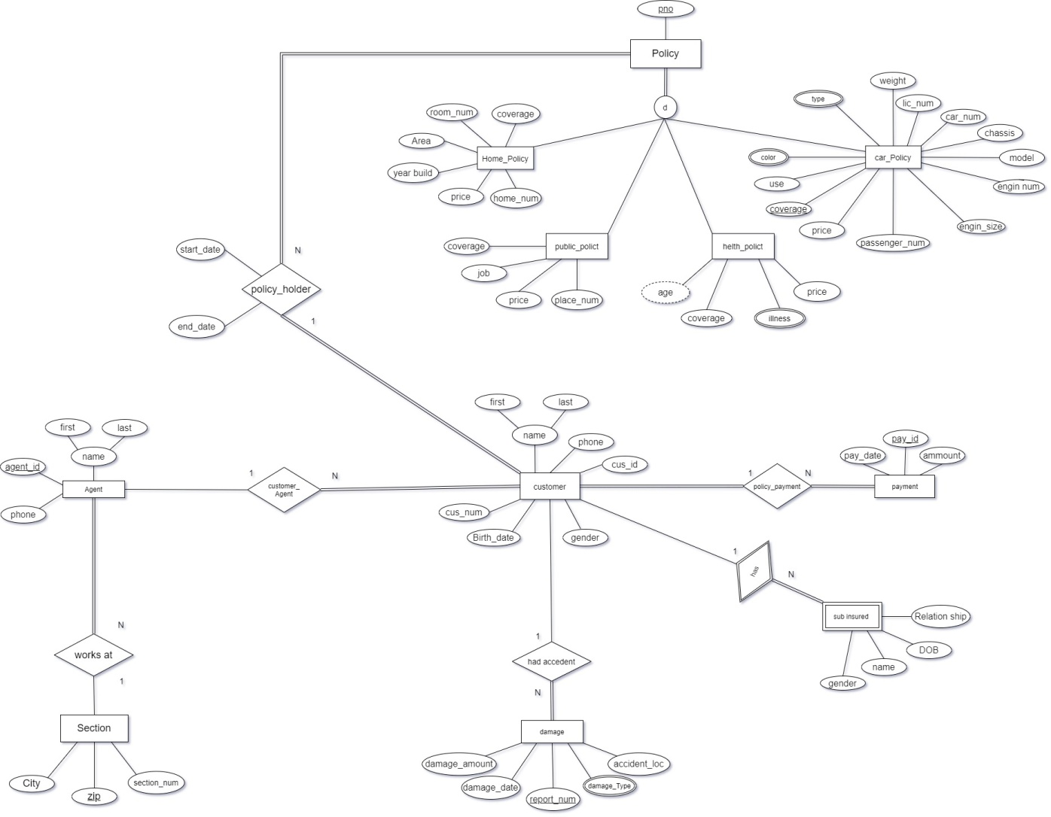

**Final relational schema**

**Policy**

|  |  |  |  |
| --- | --- | --- | --- |
| pno | C_num | Start_date | End_date |

**Home Policy**

|  |  |  |  |  |  |  |
| --- | --- | --- | --- | --- | --- | --- |
| pno | Area | Room_num | Year_build | coverage | price | Home_num |

**Public Policy**

|  |  |  |  |  |
| --- | --- | --- | --- | --- |
| pno | job | Coverage | price | Place_num |

**Health Policy illness**

|  |  |  |
| --- | --- | --- |
| Pno | price | Coverage |

|  |  |
| --- | --- |
| pno | name |

**Car Policy**

|  |  |  |  |  |  |  |  |  |  |  |  |
| --- | --- | --- | --- | --- | --- | --- | --- | --- | --- | --- | --- |
| pno | price | coverage | model | Lic_num | Car_num | Pass_num | chassis | use | Engine_num | Engine size | weight |

**Color Type**

|  |  |
| --- | --- |
| pno | type |

|  |  |
| --- | --- |
| Pno | color |

**Customer**

|  |  |  |  |  |  |  |  |
| --- | --- | --- | --- | --- | --- | --- | --- |
| C_num | First_name | Last_name | Phone | C_id | gender | Birth_date | Agent_id |

**Payment**

|  |  |  |  |
| --- | --- | --- | --- |
| Pay_id | amount | Pay_date | C_num |

**Agent**

|  |  |  |  |  |
| --- | --- | --- | --- | --- |
| Agent_id | First_name | Last_name | phone | Section_num |

**Damage**

|  |  |  |  |  |
| --- | --- | --- | --- | --- |
| Report_num | Damage_date | C_num | Damage_ amount | accident_loc |

**Damage_Type**

|  |  |
| --- | --- |
| Report_num | type |

**Sub_insured**

|  |  |  |  |  |
| --- | --- | --- | --- | --- |
| C_num | Name | Gender | BOD | Relation_Ship |

**Section**

|  |  |  |
| --- | --- | --- |
| Section_num | zip | City |

**SQL Statement**

create table policy (

2 pno int not null ,

3 cus_num number,

4 start_date date,

5 end_date date,

6 primary key (pno));

create table home_policy (

2 pno int not null,

3 area int ,

4 room_num int ,

5 year_build date ,

6 coverage float not null,

7 price int ,

8 home_num char(6) not null ,

9 primary key (pno));

create table public_policy(

2 pno int not null,

3 job varchar(9) ,

4 coverage float,

5 price int ,

6 place_num char(6) not null ,

7 primary key (pno));

create table helth_policy (

2 pno int not null,

3 price int ,

4 coverage float,

5 primary key (pno));

create table illness(

2 pno int not null ,

3 name varchar2(10) ,

4 primary key(pno , name )) ;

create table car_policy(

2 pno int not null,

3 price int ,

4 coverage float,

5 model varchar(8),

6 lic_num number not null,

7 car_num varchar(8) not null,

8 pass_num int not null,

9 chassis number ,

10 use varchar(9),

11 engine_num int ,

12 engine_size int ,

13 weight int ,

14 primary key (pno));

create table color(

2 color varchar(9),

3 pno int not null,

4 primary key (color,pno));

create table type(

2 pno int not null,

3 type varchar(9),

4 primary key (type,pno));

create table customer(

2 cus_num int not null ,

3 first_name varchar2(9),

4 last_name varchar2(9),

5 phone number ,

6 cus_id int

7 gender char ,

8 Birth_date date ,

9 agent_id int ,

10primary key (cus_num));

create table payment (

2 pay_id int not null ,

3 pay_date date ,

4 amount int ,

5 primary key (payment_id));

create table agent(

2 agent_id number not null,

3 first_name varchar(9),

4 last_name varchar(9),

5 phone number ,

6 section_num int not null,

7 primary key (agent_id));

create table damage(

2 report_num number not null,

3 damage_date date ,

4 cus_num number not null,

5 damage_amount int,

6 accedent_loc varchar2(10) ,

7 primary key (report_num));

create table damage_type (

2 report_num int ,

3 type varchar2(10) ,

4 primary key (report_num , type )) ;

create table sub_insured(

2 cus_num number not null,

3 name varchar(9),

4 gender char ,

5 bod date,

6 relation_ship varchar(8),

7 primary key (cus_num,name));

create table section(

2 section_num int primary key ,

3 zip char(5) not null ,

4 city varchar2(10) );

**Constraint**

* alter table home_policy add constraint home foreign key (pno) references policy (pno);
* alter table public_policy add constraint pub foreign key (pno) references policy (pno);
* alter table car_policy add constraint car foreign key (pno) references policy (pno);
* alter table helth_policy add constraint health foreign key (pno) references policy (pno);
* alter table color add constraint color foreign key (pno) references policy (pno);
* alter table type add constraint type foreign key (pno) references policy (pno);
* alter table policy add constraint policy_c foreign key (cus_num) references customer (cus_num);
* alter table payment add constraint payment_c foreign key (cus_num) references customer (cus_num);
* alter table damage add constraint damage_c foreign key (cus_num) references customer (cus_num);
* alter table sub_insured add constraint sub_c foreign key (cus_num) references customer (cus_num);
* alter table customer add constraint customer_a foreign key (agent_id) references agent (agent_id);
* alter table agent add constraint agent_s foreign key (section_num) references section (section_num);
* alter table damage_type add constraint damage_d foreign key (report_num) references damage (report_num);

**Insertion**

insert into policy values (1 , 100,'12-may-2010','12-may-2011');

insert into policy values (2 , 100,'27-jan-2019','30-jan-2020');

insert into policy values (3 , 101,'27-jan-2019','30-jun-2019');

insert into policy values (4, 102,'10-dec-2017','11-nov-2018');

insert into policy values (5, 103,'10-dec-2017','11-nov-2018');

insert into policy values (6, 103,'2-dec-2017','3-dec-2019');

insert into policy values (7, 103,'5-feb-2018','3-dec-2019');

insert into policy values (8, 104,'6-may-2008','3-dec-2009');

insert into policy values (9, 105,'12-mar-2011','3-aug-2012');

insert into policy values (10, 106,'12-oct-2017','4-apr-2018');

insert into home_policy values (1,150, 6,'2-may-1998' ,.50 , 1500 , '156-A' ) ;

insert into home_policy values (5,220, 10,'9-dec-2005' ,.90 , 4000 , '234-c' ) ;

insert into public_policy values (2,'carpenter', 0.30,2000 ,'157-A' ) ;

insert into public_policy values (8,'Building', 0.40,1300 ,'155-D' ) ;

insert into car_policy values (3,700 , 0.60 , '2000',1745 , '1-5628-H' , 5 , 178 , 'private' , 765 , 987 , 1700 ) ;

insert into car_policy values (7,1300 , 0.20 , '2005',1643 , '5-9834-M' , 5 , 173 , 'private' , 754 , 234 , 2000 ) ;

insert into car_policy values (9 ,1700 , 0.29 , '2007',1652 , '9-5839-P' , 7 , 184 , 'public' , 836 , 342 , 2000 ) ;

insert into color values ('Red' , 3 ) ;

insert into color values ('Black' , 7 ) ;

insert into color values ('White' , 7 ) ;

insert into color values ('White' , 9 ) ;

insert into type values (3 , 'Com' ) ;

insert into type values (7 , 'VIP' ) ;

insert into type values (9 , 'Com' ) ;

insert into helth_policy values (4 , 1300 , 0.40 ) ;

insert into helth_policy values (6 , 2000 , 0.20 ) ;

insert into helth_policy values (10 , 1500 , 0.40 ) ;

insert into illness values (4 , 'Diabetes' ) ;

insert into illness values (6 , 'Diabetes' ) ;

insert into illness values (6 , 'asthma' ) ;

insert into customer values('masa','mubaslat',0597470977 , 234567,'F',100,'20-jan-2001' , 17);

insert into customer values('Roaa','Qudaih',0597897540 , 234564,'F',101,'30-dec-2000' , 17);

insert into customer values('waleed','omar',0597897000, 234561,'m',102,'30-may-2000' , 18);

insert into customer values('ameer','omar',0597111000, 234560,'m',103,'22-may-1999' , 18);

insert into customer values('ahmad','shayeb',0599111000, 234588,'m',104,'22-jan-1999' , 18);

insert into customer values('ahmad','qotob',0592798839, 234668,'m',105,'2-feb-1999' , 18);

insert into customer values('zain','daragmeh',0592798844, 234468,'F',106,'2-aug-1999' , 17);

insert into payment values (10 ,'12-may-2010' ,500 ,100);

insert into payment values (11 ,'12-dec-2010' ,700 ,100);

insert into payment values (12 ,'27-jan-2019' ,1000 ,100);

insert into payment values (13 ,'27-jan-2019' ,900 ,101);

insert into payment values (14 ,'10-dec-2019' ,900 ,102);

insert into payment values (15 ,'10-dec-2017' ,4000 ,103);

insert into payment values (16 ,'2-dec-2017' ,1500 ,103);

insert into payment values (17 ,'5-feb-2018' ,850 ,103);

insert into payment values (18 ,'6-may-2008' ,650 ,104);

insert into payment values (19 ,'12-mar-2011' ,1700 ,105);

insert into payment values (20 ,'12-oct-2011' ,420 ,106);

insert into payment values (21 ,'15-dec-2011' ,300 ,106);

insert into agent values(17,'ahmad','hamdan',0599876876, 1);

insert into agent values(18,'khaldon','barahmeh',0599111222, 1);

insert into agent values(19,'tahseen','alhmoud',0599730301, 3);

insert into damage values (10,'10-apr-2019',101,3000,'33-A');

insert into damage values (11,'10-oct-2010',100,5000,'156-A');

insert into damage values (12,'11-nov-2017',106,200 , null );

insert into damage_type values (10 , 'accident') ;

insert into damage_type values (11 , 'fire') ;

insert into damage_type values (11 , 'theft') ;

insert into damage_type values (12 , 'Asthma') ;

insert into sub_insured values (103 , 'sara' , 'm' , '12-oct-2002' , 'wife' ) ;

insert into sub_insured values (104 , 'Amer' , 'm' , '9-oct-1999' , 'worker' ) ;

insert into sub_insured values (104 , 'Rami' , 'm' , '20-feb-2000' , 'worker' ) ;

insert into section values (1 , 12334 , 'Tubass' );

insert into section values (2 , 20177 , 'Nablus' );

insert into section values (3 , 12334 , 'Jenin' );

insert into section values (4 , 98376 , 'Ramallah' );

**Functional analysis and Query**

1. determine which policy insured in 2011 ?

select pno from policy where start_date like '%11' ;

1. determine customer's name who insured in 2011 and the policy number ?

select pno , first_name , last_name from policy natural join customer where start_date like '%11' ;

1. Deermined the city which the customer insured in where customer_num = 100?

select city

from customer join agent on (customer.agent_id=agent.agent_id) join section on (section.section_num=agent.section_num)

where cus_num=100;

1. Determine which customer faced accident and the damage cost ?

select first_name,damage_amount

from customer a join damage d on (a.cus_num=d.cus_num);

1. Determine the customer who insured their home ?

select first_name,last_name

from customer c join policy p on (c.cus_num=p.cus_num) join home_policy h on (h.pno=p.pno);

1. Determine the damage type who customer with pno = 106 faced?

select type from damage g join customer r on (g.cus_num=r.cus_num) join damage_type e on (g.report_num=e.report_num)

where r.cus_num=106;

1. Determine the number of egent in each city if exist ;

select count(agent_id),city

from agent a join section s on (a.section_num=s.section_num)

group by (city);

1. Determined which customer add his wife in his insurance ?

select first_name , last_name

from customer v join sub_insured f on (v.cus_num=f.cus_num)

where relation_ship='wife';

1. Determined first name and the type of car policy where pno = 101 ?

select first_name , type

from type t join car_policy c on (t.pno = c.pno ) join policy p on (p.pno = c.pno ) join customer m on (p.cus_num = m.cus_num)

where cus_num = 101 ;

1. Determined which damage type cost more than 1500 ?

select type

from damage b join damage_type e on (b.report_num=e.report_num )

where damage_amount>1500;

1. Determined which policy need to update and the phon for customer to tell him ?

select end_date ,phone

from policy y join customer t on (y.cus_num=t.cus_num)

where end_date < sysdate

and end_date like '%20';

1. Determine the number of customer who insure in 2017

select count (distinct cus_num)

from policy

where start_date like '%17';

1. Determine the number of customer insured in agents 17 , 18 , 19 ?

select t.first_name ,

sum (decode (x.agent_id ,17,1)) "#costomer - 17 ",

sum (decode (x.agent_id ,18,1)) "#costomer - 18 ",

sum (decode (x.agent_id ,19,1)) "#costomer - 19 "

from agent t join customer x on (t.agent_id = x.agent_id )

group by t.first_name;

1. Determine the number of sub_insured for customer 103 , 104 , 105 ?

select first_name ,

sum (decode (s.cus_num ,103,1)) "# sub_insured-103 ",

sum (decode (s.cus_num ,104,1)) "# sub_insured-104 ",

sum (decode (s.cus_num ,105,1)) "# sub_insured-105 "

from customer r join sub_insured s on (r.cus_num=s.cus_num)

group by (first_name);

1. Derive the age for each customer ?

select (to_char(sysdate,'yyyy')-to_char(birth_date,'yyyy')) ,first_name from customer ;

1. Determine the number of room for customers who insured their home ?

select room_num from home_policy ;

1. Determine the average of the amount the customers have paid

select avg (amount)

from payment;

1. Calculate the number of customer accurate to gender

select count (cus_num),gender

from customer

group by (gender);

1. Select chassis number for every car was insured and the customer name ?

select first_name , chassis

from car_policy c join policy p on (c.pno = p.pno )

join customer m on (m.cus_num = p.cus_num ) ;

1. Determine the name of customer and his sub insured ?

select first_name ,name

from customer s join sub_insured n on (s.cus_num =n.cus_num);

**Normalization**

Creating tables in our database includes relationships between tables according to rules designed both to protect the data and to make the database more flexible by eliminating redundancy and inconsistent dependency.

All tables in our project are in 1st normal form because each cell in every table doesn’t contain multiple values only one, and they are in the 2nd normal form because every nonprime attribute depends on all primary and candidate keys, also they are in the 3rd normal form because they are already in 1st and 2nd NFs and there are no transitive dependencies within them .

**CONCLUSION**

While working on this project, we learnt how to create a database, the rules to construct a good ER diagram, How to come up with relational schema mapping from the ER diagram, deriving the functional dependencies and how to normalize the relational schema. We learnt how to design a system from Database perspective and how to efficiently store and manipulate data.