SC4002 Group Report

SC4002 Natural Language Processing
Group Assignment Report
Joint intent detection and slot filling on MASSIVE 1.0 (en-US)
Group ID: [Group ID]
Full name | Contribution
[Full name 1] | [contribution]
[Full name 2] | [contribution]
[Full name 3] | [contribution]
[Full name 4] | [contribution]
[Full name 5] | [contribution]
[Full name 6] | [contribution]

1. Baseline and improved systems
Both systems read only utt and output, from one joint network, an intent and a set of [slot type : span] pairs (BIO tags decoded by a CRF). Stage 1 is a joint iterated dilated CNN (ID-CNN, Strubell et al., 2017), chosen because the group's other systems are BiLSTMs and a Transformer. Stage 2 keeps the convolutional family; every change answers a weakness measured on the validation split, and its effect was measured by ablation (validation, seed 42, change in combined score when the component is removed; seed noise is about 0.3).
Part | Stage 1 | Stage 2 | Why (validation evidence)
Tokens | whitespace tokens | clitic-aware units (what's to what 's); tags read at each token's first unit | utterances with an unseen word: 77.20 / 69.43 vs 88.92 / 85.17 otherwise; removing the split: -0.50
Word input | GloVe-initialised embeddings, fine-tuned; char-CNN | frozen GloVe and fastText (600-d, shared), 100-d trainable embedding, char-CNN, hashed char n-grams | without frozen vectors -2.02; GloVe only -0.73; n-grams -0.23 (noise)
Encoder | dilations 1, 2, 4 applied twice (shared), ReLU, 384 channels | six gated (GLU) dilated convolutions 1, 2, 4, 8, 1, 2; 192 channels; dropout 0.4 | validation loss lowest at epoch 10, then rising (overfitting); wider members -0.55
Intent | mean+max pooling, MLP | + scenario head, log-probabilities added; label smoothing 0.1 | 190 of 268 intent errors cross scenarios; scenario head -0.08 (noise); label smoothing -0.73
Slots | linear emissions, free CRF | emissions see the expected intent embedding; CRF with hard BIO constraints | slot F1 84.22 vs 63.26 when intent right/wrong; 9 invalid BIO outputs; ablations -0.35, -0.40
System | one model; AdamW, plateau schedule, early stopping | 6 members (seeds 42 to 47) sharing the frozen table; warm-up + cosine; probabilities and CRF scores averaged | validation combined with 1 / 2 / 4 / 6 members: 85.24 / 85.80 / 86.22 / 86.37

2. Experimental results
Model version | Split | Total # parameters | Total # trainable parameters | Intent accuracy (%) | Slot micro-F1 (%) | Number of epochs
Stage-1 system | Validation | 3,466,218 | 3,466,218 | 86.82 | 82.12 | 45
Stage-1 system | Test | Same as above | Same as above | 85.57 | 79.31 | Same as above
Stage-2 system | Validation | 18,215,220 | 14,692,620 | 88.59 | 83.65 | 32/39/40/33/39/38
Stage-2 system | Test | Same as above | Same as above | 87.32 | 81.64 | Same as above
Selection by best validation combined score, (intent + slot F1) / 2. Stage-2 epochs are the selected epoch of each of the six members. Stage-2 total includes the 3,522,600 frozen word-vector values, counted once.
Stage 2 improves on Stage 1 by +1.75 intent accuracy and +2.33 slot F1 on test. For context within the group, Max's BiLSTM-CRF baseline scored 86.38 / 79.14 on test (4.88M parameters) and Joy's three-member BiLSTM ensemble 87.22 / 81.84 (17.92M). Our Stage 1 is level with the BiLSTM baseline with fewer parameters, and our Stage 2 is tied with the BiLSTM ensemble; both differences are within run-to-run noise.
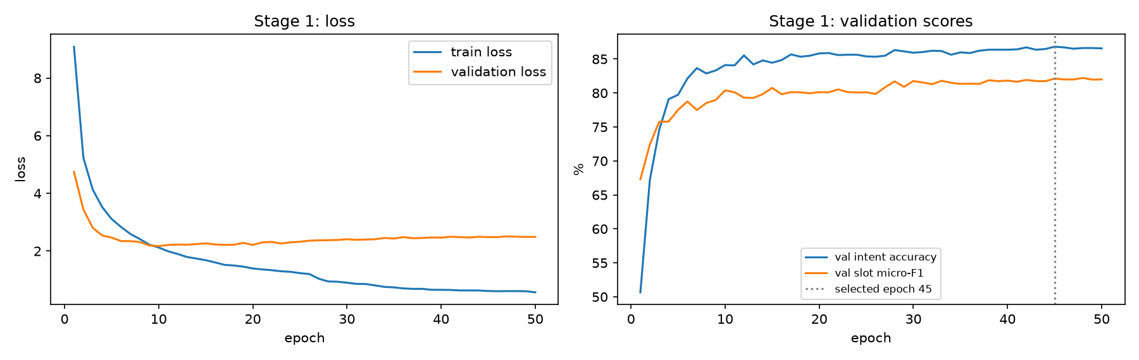 | 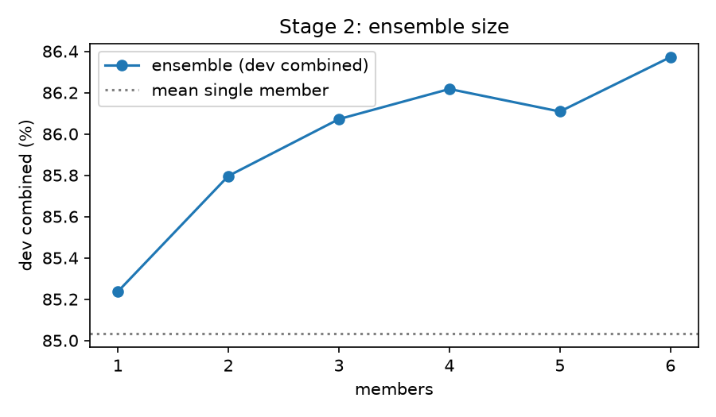
Stage 1 learning curves: validation loss bottoms out early while validation scores keep improving. | Stage 2 validation score against number of members (stage2_experiments.ipynb).

3. AI collaboration
Tool: Claude Code with Claude Opus 5.5 (Anthropic). The chat history is submitted separately as ai_collaboration.md. The AI wrote diagnosis code, proposed and implemented changes, and designed the ablations; the group directed the scope and judged the evidence.
- Weaknesses it helped identify: unseen words (the largest gap above), cross-scenario intent confusions, slot errors cascading from wrong intents, invalid BIO outputs, overfitting, and an engineering one: PyTorch's dilated convolution ran about three times slower per batch than an equivalent shifted-matrix form on our CPU.
- Accepted: frozen GloVe and fastText tables, clitic-aware tokenisation (suggested by a group member, implemented with the AI), label smoothing, BIO constraints, intent-aware emissions, seed ensembling.
- Modified: the AI's first Stage 2 design (one 256-channel model) reached only 84.68 validation combined, barely above Stage 1; after a small-member run did better, we moved to 192-channel members and spent the parameter budget on six of them.
- Rejected after measurement: a self-attention layer (-0.15), R-Drop (-0.42), fine-tuning instead of freezing vectors (-0.24), joint top-3 intent re-ranking with slot-type masks (-0.18 on the ensemble) and kNN retrieval over training vectors (best -0.02, and 13.3M extra stored values).
- Group reasoning beyond the AI output: the group asked members to avoid a third BiLSTM, which is why this work uses dilated CNNs; the group required a baseline that is not weak by design; and after the single test run showed a tie rather than a win, we chose to report it rather than re-tune and re-test.

4. Analysis and lessons learned
- How advice was verified. Every suggestion was tested on the validation split against the seed noise of the final configuration (six seeds: 84.79 to 85.24 combined). Code was checked independently: the CRF against brute-force enumeration, the scorer by gold round-trips (100.00 on every split), reloaded checkpoints by asserting identical validation counts, and a code lock kept the test split unreadable until each model was frozen.
- Lessons. Smaller, more regularised members beat larger ones on 11.5k utterances; ensembling gave the largest single gain; decoding rules that remove a specific error class (illegal slot types for an intent) did not move the aggregate metric (possibly because they also block rare but correct combinations; we did not test this). CPU thread count changes training numerically: the same six-member configuration scored 86.37 (2 threads) and 86.12 (3 threads) on validation.
- Unsuccessful experiments: listed under Rejected above; the scenario head and character n-grams were kept but are within noise, so we do not claim they help.

5. Error analysis and limitations (Stage 2, test split)
- "pink is all we need" (gold iot_hue_lightchange, predicted play_music; Stage 1 music_likeness). The slot [color_type : pink] is found correctly, yet the intent is wrong. Likely cause: indirect phrasing with no lighting word, and "pink" also names an artist; the intent-to-slot link is one-way, so a confident colour slot cannot correct the intent.
- "what is the exchange rate of us dollar to pound sterling" (gold news_query with one long news_topic span; predicted qa_currency with two currency_name slots). The labels of two scenarios overlap, and once the intent is wrong the slots follow it: one decision costs one false negative and two false positives. Overall, slot F1 is 84.06 when the intent is right and 59.34 when it is wrong.
- "play music from my rock list" (gold [playlist_name : rock list], predicted [music_genre : rock]): a boundary and type error on a genuinely ambiguous phrase; playlist, genre and song names are among the weakest slot types.
Limitations. Unseen words remain the main weakness: test utterances with one score 75.23 intent / 66.42 slot F1 against 90.01 / 85.34, and only 14.9% of unseen validation units hit a frozen vector because the table was kept small to fit six members. 288 of 377 test intent errors still cross scenarios. Ablations use one seed, and each stage was tested once. Future work: a mixed ensemble of CNN and BiLSTM members, a larger vector table in place of some members, and a two-way intent-slot interaction so that confident slots can inform the intent.

