# Project Proposal – Team MARS

## Motivation

According to general consensus (Kyoto/Paris agreements) human-made CO2 emissions has had the most significant detrimental effect toward adverse climate change. China, India and the US are three of the largest countries by population and are the largest 3 country level emitters of CO2 on the planet.

**Populations and Growth Rates:**

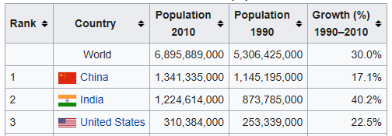

https://en.wikipedia.org/wiki/Population_growth

**CO2 emission Rates:**

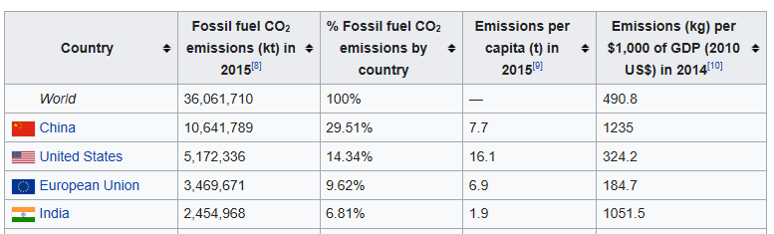

<https://en.wikipedia.org/wiki/List_of_countries_by_carbon_dioxide_emissions>

This project aims to explore whether there is quantifiable evidence of climate shift within these countries, the local region, and whether future changes can be predicted.

## Hypotheses

1. The highest emitters have seen the highest impact of climate change at a temperature level.
2. Immediate neighboring countries to the three highest emitters are more impacted than those not neighboring.

## Technical approaches to be taken

We intend to analyze the data using a number of techniques, including the following:

* KNN
* ARIMA
* SPC
* Neural network

## Data used

Kaggle dataset includes “[Climate Change: Earth Surface Temperature Data](https://www.kaggle.com/berkeleyearth/climate-change-earth-surface-temperature-data/kernels)”

Variables include

* Global Land and Ocean-and-Land Temperatures (GlobalTemperatures.csv):
  + Date: starts in 1750 for average land temperature and 1850 for max and min land temperatures and global ocean and land temperatures
  + LandAverageTemperature: global average land temperature in celsius
  + LandAverageTemperatureUncertainty: the 95% confidence interval around the average
  + LandMaxTemperature: global average maximum land temperature in celsius
  + LandMaxTemperatureUncertainty: the 95% confidence interval around the maximum land temperature
  + LandMinTemperature: global average minimum land temperature in celsius
  + LandMinTemperatureUncertainty: the 95% confidence interval around the minimum land temperature
  + LandAndOceanAverageTemperature: global average land and ocean temperature in celsius
  + LandAndOceanAverageTemperatureUncertainty: the 95% confidence interval around the global average land and ocean temperature

## Risks and mitigation strategies

|  |  |
| --- | --- |
| **Risk** | **Mitigation** |
| * Limited time to prepare proposal and review data | * Group meeting with tutor to bed down proposal |
| * Unable to complete scope in timeframe | * Seek additional resource from course pool. |
| * Data preparation proves a roadblock to progress | * Refine / adjust scope accordingly |

## Goals and deliverables

* Perform exploratory data analysis and formulate questions on change in temperature over time.
* Develop various forecasting models, evaluate the effectiveness of each models, and detect any abnormality in temperatures.