GEO3502 Economic Geography
Final paper

Michael San Pietro
12/5/2025

Word count (3357 words excluding bibliography)

An Analysis of West Virginia’s Faltering Economy through the Lens of Deindustrialization.

- Introduction: what is your concept and research question? (10 points)

Deindustrialization is a concept used to discuss the effects of a region’s disinvestment from industrial and manufacturing capital to invest in a more service-oriented economy. It is typically implemented following the decline of profitability or scale of industrial efforts. Common symptoms of deindustrialization include various types of socioeconomic turmoil, as this drastic economic change results in a radical change in the labor market, profitability by sector, and production. As post-industrial economies rely increasingly on a more educated workforce with skills that are often not transferable from previous industries, disparity develops between the upper class and working-class people due to the education gap. The state of West Virginia, a historically energy and manufacturing-based economy, now stands as one of the primary deindustrializing regions in the United States.
Rich in natural resources and comparatively cheap land, West Virginia stood out during the American industrial period as a subnational region that placed most of its economic and cultural identity into energy production and industrial manufacturing (O’Leary and Boettner, 4). However, modern macroeconomic factors have lessened if not extinguished West Virginia’s comparative advantage in these regards (Bowen et. al, 6-9). The decline of the energy production and manufacturing industries in West Virginia, referred to in this study as the industrial sector, accompanied by poor adjustment to service-oriented industries, has led to a state that, as of 2024 (Herath Bandara, 1), “ranks 50th among U.S. states in terms of growth rate”, possesses an incredibly low labor force participation rate coupled with disparity in employment between counties which were historically coal mining counties and those that were not, and has had an on average declining higher education pursual rate since 2013 (WVHEPC, College-Going At a Glance). Three critical components of deindustrialization are present in these economic struggles: socioeconomic turmoil, division between classes of labor, and disinvestment from industrial sectors. Therefore, the view of West Virginia from a deindustrialization context is one of both analysis of economic implications and strategic insights into how the state can transition into a post-industrial economy.
To describe the symptoms afflicting West Virginia through the concept of deindustrialization, this study employs quantitative and literary information to answer the following question: “How can the economy and workforce of West Virginia in the wake of the declining energy and manufacturing industry be explained by deindustrialization?” This study hypothesizes that the deindustrialization period afflicting the state has been able to persist due to education and metropolitan deficiencies, and that its effects have been detrimental to both the production and workforce of the state. This combination of attributes creates circumstances that allow the continued existence of an economically negative transitional period. This study will specifically emphasize three focal points where the effects of deindustrialization can be most aptly visualized: state industry, employment, and education.

- Empirical section: how does your concept explain recent economic changes in the geography of your region (15 points)?

2.1.
Deindustrialization is primarily evident in industry, leading to stagnation in the state’s gross domestic product (GDP) (Bandera, 1). West Virginia’s primary industry prior to deindustrialization can be characterized as a two-pronged approach between industrial manufacturing and energy mining, specifically coal. Mary Anglin’s article, Toward A New Politics of Outrage and Transformation: Placing Appalachia Within The Global Political Economy, characterizes this industry structure through the idea of an “internal colony”. In this lens, the broader Appalachian area of the United States has been viewed by the United States as an area abundant in cheap labor and natural resources, one that can be exploited in an analogous way to British colonization. Mining has faced a precipitous drop in profitability and scale, due in large part to decreased energy exports, the fall of natural gas prices, and the U.S. implementation of clean energy technologies (Bowen et al., 6-9). Similarly, the cheap land and labor that once served as a competitive advantage for West Virginia’s industrial manufacturing sector can now be underbid overseas due to globalization. In the wake of deindustrialization, West Virginia has attempted to prop up its state GDP through two, almost contradictory approaches: the first being the economic transition towards service-based sectors, the second being lowering corporate tax rates and offering cheap land and labor in an attempt to entice investors to revitalize the industrial system. Katherine Custis Gerlaugh’s work Twenty-first Century Deindustrialization and Uneven Development in Appalachia, places emphasis on the idea of transition towards retail and leisure. The value proposition for these two sectors lies in the idea that the labor force would require little retraining to enter these workforces, and the lack of suburbanization and gentrification present in rural West Virginia lends itself well to a thriving tourism industry (Hoey, 79-80). These industries have not been effective from a GDP or labor force point of view, providing neither the scale nor the wages of the previous industrial system (Gerlaugh, 108). Viable alternatives have been found in the government and finance sectors. Finance refers to finance, insurance, real estate, rental, and leasing, and government encompasses all industries under government and government enterprises. According to data from the US Department of Commerce's Bureau of Economic Analysis, the government and finance sectors experienced inflation-adjusted growth rates of approximately 154% and 190%, respectively, from 1997 to 2023. Despite the significant growth rates, these industries currently struggle with the problem of scale. Making up just roughly 2.07% of state GDP for government and 14.2% for finance. The difficulty in scaling these industries beyond this recent boom lies in the workforce and the lack of metropolitan areas. Both industries require intensive training to acquire skills that share little translatability with the skills commonly held by the workforce in previous industrial eras. Due to struggles with education, further elaborated on in the education section, it is increasingly difficult to source a workforce with the necessary skills to build up these sectors. Additionally, these industries mainly thrive in large metropolitan areas, both limited in number and geographically divorced from the historical industrial areas whose development has been most severely affected by deindustrialization. Therefore, the influx of capital into service-oriented industries, a key aspect of deindustrialization, is apparent here. However, as West Virginia transitions into a post-industrial region, there exists significant friction in the state's economic development.
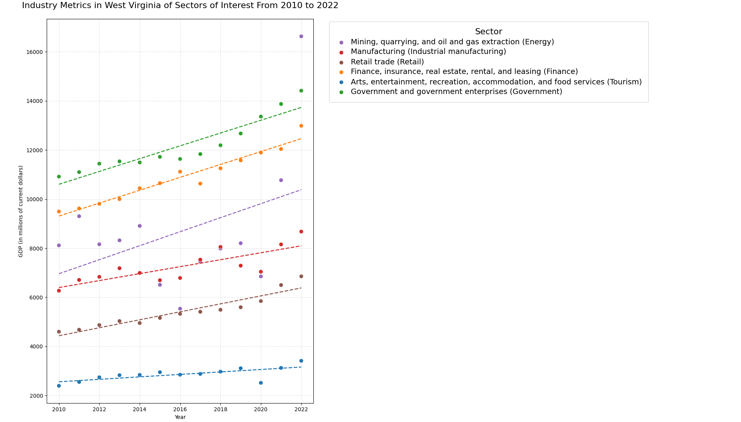
Figure 1: Comparison of the trajectory (GDP in millions of current dollars from 2010 to 2022) of 6 sectors, 4 being service-related sectors, proposed as viable replacements for previous industrial sectors, 2 being the aforementioned industrial sectors of manufacturing and energy production. Scatter plot with each group fitted with ordinary least squares regression lines. Note the larger slopes of finance and government in comparison to retail and leisure(tourism). Positive slopes of energy production and manufacturing indicate the economic phenomenon of “smokestack chasing”. Data Sourced from the US Department of Commerce Bureau of Economic Analysis. Created using the Seaborn library in Python
As such, this study can characterize West Virginia as a subnational region that, while undergoing the process of deindustrialization, does not currently possess the necessary labor and capital factors to thrive as a post-industrial economy. In line with this concept, there has been considerable effort to reinstate an industrial system in the state. Brian Hoey’s Capitalizing on Distinctiveness: Creating West Virginia For The “New Economy” illuminates a recurrent economically negative practice in the state, colloquially known as “smokestack chasing”, wherein local economies will lower both taxes and land and labor prices to draw industrial investors back in. He argues that this practice, which is minimally effective at best, commodifies the state and its inhabitants, allowing them to be bought and sold. The economic balance between investors, localities, and employees that underpinned the industrial system has been radically changed with globalization, such that any attempt to reindustrialize necessitates disclosure of complete economic control to investors. As such, without the economic tools to proceed with a post-industrial economy and the breakdown of the industrial sector, West Virginia is stuck in a supposedly transient period of deindustrialization. This is fundamentally problematic in that the process of deindustrialization sacrifices short-term production from industrial firms for long-term production from service-oriented firms; however, without the secondary component, this process serves only to economically cripple the state.
2.2.
Deindustrialization has affected employment in West Virginia through incredibly low labor participation rates and disparities in employment between former industrial regions and other regions in the state. According to Bureau of Labor Statistics data from December 2024, West Virginia reported a seasonally adjusted unemployment rate of 4.1%, which was in line with the national average for the period and has averaged a seasonally adjusted 5.74% rate of unemployment from 2000 to 2024, again in line with the national average of 5.7%. This statistic alone is not particularly concerning from an economic standpoint; however, it is misleading when evaluated on its own. This rate, like almost any other economic measure of unemployment, is based on participants in the labor force. However, in 2024, (Herath Bandara, 1) “only about 54% of West Virginia’s adult population is either employed or actively seeking employment, resulting in one of the lowest labor force participation rates in the nation”. This incredibly low labor force participation rate can be attributed to the inefficient transition of workforce skills and the strong staying power of the population. As previously iterated, the sectors that have seen the greatest growth in production recently require technical skills unlikely to be acquired through industrial work. This is revealing, as the average employment rate suggests, that those who are in the workforce are reasonably able to find employment, likely those with skills applicable to the service-oriented sectors. However, the low labor force participation rate suggests that a large portion of the adult population, likely former industrial sector workers, does not possess the newly demanded skills of a post-industrial economy. With such a stark transition in the labor market and without effective employment training programs to ease the transition, employment disparity has formed due to an education gap between the two groups. This discontinuity is reflected geographically, where historical coal mining towns possess significantly higher unemployment rates than other counties.
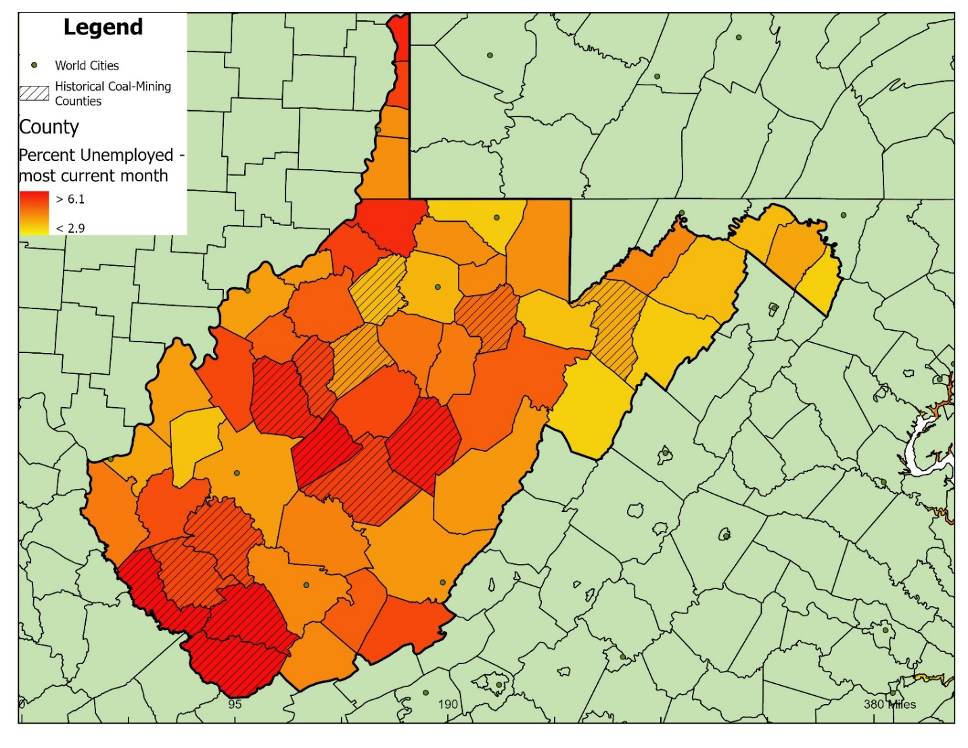
Figure 2: Disproportionate Unemployment in Historical Coal Mining Counties. Unemployment density scales from yellow to red, major cities are denoted with green dots, and mining counties are partially shaded with lines. Unemployment has been measured using non-seasonally adjusted August 2025 data. Historical coal mining counties are identified using the work of” Booms and Busts The Impact of West Virginia’s Energy Economy” by O’Leary and Boettner, in which they identify counties via the percentage of the workforce employed in coal mining jobs from 2005-2009, using data from the Bureau of Economic Analysis. Data sourced from ArcGIS World Cities map, GADM Map of county and state borders, and ESRI Demographics Team Unemployment Density Layout using data from the US Bureau of Labor Statistics. Created using ArcGIS Pro.
The population of the Appalachian region of the United States has long been noted as having tremendous staying power, especially among working-class individuals. This is due in large part to a strong sense of place amongst locals and a vehement cultural opposition towards leaving (Anglin, 52). This staying power lends itself to a disproportionate impact of deindustrialization on the subset of the population with strong staying power. Functioning as an inelastic demand curve of emigration, this subset of the population is much more affected by the calamitous shift in the job market caused by deindustrialization than similar populations of workers who are more willing to emigrate. Furthermore, there was an implicitly promised quality of work under the industrial system. Jefferson Cowie and Joseph Heathcott’s 2003 article The Meanings of Deindustrialization proposes the idea of an “industrial order” as a basis for societal foundation and not merely an economic system. The social compacts and labor unions that thrived under the industrial system have broken down in the post-industrial state. Towns like Weirton, West Virginia, have lost their primary industry and socioeconomic system in the wake of the loss of Weirton Steel Corporation, leaving the town a shell of its former self (Jennings 27-34). This is apparent in the practice of “smokestack chasing”, where reinstated industrial sector jobs are fraught with labor exploitation (Hoey, 71-72). There exists a significant detriment to not just the quantity, but the quality of work in the state. Much like the industrial sector that underpinned the state’s economic system, the labor compacts that underpinned the state’s employment system have dissipated with deindustrialization. This study characterizes the effects of deindustrialization on employment in West Virginia through a disparity in employment and labor force participation between former industrial workers and metropolitan residents of the state, a disproportionate impact on West Virginia specifically due to the strong staying power of the working-class population, and a decrease in the quality of work due to the breakdown of labor organizations.
2.3.
The difficulties regarding education in the state of West Virginia serve to firmly entrench the state in a lengthy, deindustrializing period. The production and employment sections have delved heavily into the concept of a disparity centered around education, both in furtherance of the state's economic transformation and an employment gap. Viable replacements for the industrial sector rely heavily on a workforce proficient in technical skills acquired through post-secondary education. Similarly, the disparity in employment between former industrial employees and the metropolitan population can largely be attributed to a gap in education. As such, education remains the key aspect that prevents advancement towards a post-industrial economy.
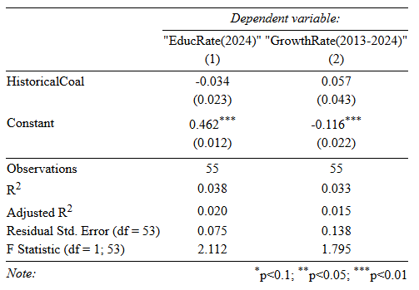
Figure 3: Two Ordinary Least Squares Regression results showing no statistically significant difference in pursuit of College from Historical Mining counties. HistoricalCoal is a Dummy Variable based on the Historical Coal Mining Towns ”Booms and Busts” by O’Leary and Boettner (see Figure 2 caption for more information on this work), EducRate(2024) is the proportion of graduates enrolled in College in the summer or fall following graduation from high school in 2024 for a specific county, and GrowthRate(2013-2024) is the rate of change expressed as a decimal in EducRate from classes that graduated in 2013 compared to 2024 graduating classes for each county. College is defined by the West Virginia Higher Education Policy Commission as” any high-quality education or training beyond high school”. Data sourced from the West Virginia Higher Education Policy Commission County College-Going Rate by High School Graduation Year table. Created using the Stargazer library in R-Studio.
Utilizing two linear regression analyses conducted to observe the effect of living in a historical coal mining county on education rate in 2024 and the growth rate of education from 2013 to 2024, analyzing the coefficients with a magnitude of coefficients approach (ignoring statistical significance due to small sample size, which is the entire population, leading to high standard error), there is evidence to suggest both an initial disparity in rate of post-secondary education between historical coal mining counties, which are representative of towns historically based around the industrial sector, and other counties in the state. This reaffirms a critical component of deindustrialization, the division around education between workers. Additionally, the coefficient on the growth rate term provides quantitative evidence that this disparity is closing. This suggests a transition towards a post-industrial education system focused on equipping workers with the necessary technical skills for a service-oriented economy.
Education in West Virginia is hindered by the cultural attitudes towards education, which are reflected in state funding. The “industrial order” concept of the culture around industrialism did not heavily value education. The reasons for this are quite practical; in a town or region whose economy is based on manufacturing or energy production, the value of post-secondary education is severely diminished. Work qualifications in these regions historically did not require any post-secondary education, as training was largely completed on the job. Cultural inputs are fixed in the short term in this regard, and this attitude is reflected in state funding. According to the State Higher Education Finance (SHEF) report, published by the State Higher Education Officers Association in 2024, West Virginia spent roughly $6,794 in appropriations per full-time equivalent student, a sharp decrease from the national average of $11,683, while receiving $315 more in tuition per student than the national average. This has led to a post-secondary education system that, according to the SHEF, has experienced a decrease in full-time enrollment of 22,808 students from 2010 to 2024, equating to a roughly 39.12% decrease. It should be noted that some macroeconomic factors, such as the COVID-19 pandemic, have influenced a decrease in enrollment during this period, but not to this magnitude (SHEF). Additionally, West Virginia has experienced a modest bump in enrollment over the past two years (SHEF). Deindustrialization and the state's education system create a situation of mutual causality. The cultural legacy and economic system of industrialism have diminished emphasis on post-secondary education, both at the individual and state levels. Consequently, the education system fails to create a workforce that can move the economy into a post-industrial system. Through low enrollment and funding, as well as the disparity between regions, education in West Virginia is both a byproduct of and an enabler of a continued period of deindustrialization.

- Conclusion: what did you find? (10 points)

In conclusion, the decline in production and profitability of the industrial sector pushed West Virginia into a period of deindustrialization. The effects can be observed both in state industries and in the quantity and quality of employment, and the deficits in education keep the state in a perpetual period of deindustrialization. West Virginia’s economy, as of 2024, had negative annualized growth and ranked 50th in terms of growth rate (Herath Bandera, 1). This can be attributed to the difficulty in scaling service-oriented industries and the negative economic effects of slashing prices of land and taxes to draw industrial investors. The state is plagued by drastically low labor force participation rates and disparities in employment between former industrial regions and metropolitan areas. Education rates share the same disparity along regional lines; the previous industrial systems' neglect of post-secondary education continues to influence both state and local attitudes. With decreasing enrollment rates and funding well below the national average (SHEF), the education systems provide little support to alleviate symptoms of deindustrialization. Therefore, West Virginia remains in a purgatory state of deindustrialization, unable to equip its workforce and economy with the prerequisites for post-industrialization and faced with the macroeconomic factors of globalization leading to competitive disadvantages in manufacturing, decreased energy exports and prices, and the rise of clean energy alternatives (Bowen et. al, 6-9), which prevent the reinstallation of the industrial system. Therefore, policy implementation would be most effective by preparing the state and its workforce for a post-industrial system. Firstly, it is economically advantageous for the practice of “smokestack chasing” to be heavily disincentivized and regulated; the factors that brought about the end of the industrial system in the state are not addressable at a microeconomic level and therefore cannot be reversed by any state or local policy action. Any attempt to do so has historically led to economically negative consequences. Secondly, this study conjectures that for West Virginia to become a thriving post-industrial economy, it must invest heavily in and ensure equitable access to education. This provides the workforce with the necessary skills to scale service-based sectors such as government and finance. Finally, economic stimulus efforts would be most efficient when focused on the previous industrial regions, both to mend the disparity between these regions and the rest of the state and to incorporate the existing workforce to improve the employment issues afflicting these regions. It should be noted that this study is limited in its scope, observing just West Virginia in the context of deindustrialization. Additionally, there exists very limited information on targeted employment and education initiatives and their effects on the state. Finally, quantitative studies on deindustrialization are limited. Further research should seek to build a more complex economic model of the state through various lenses, observe the effects of education and employment programs to gauge their effectiveness, and provide more quantitative data for some of the economic phenomena discussed in this study.

- Bibliography: what did you read? (5 points)

This section must include at least 3-5 recent peer-reviewed publications
Works Cited

“Administrative Boundaries Layer.” GADM Maps, GADM, 2018, gadm.org/maps.html#google_vignette.
“ArcGIS Pro.” 3.5.0, ESRI, 13 May 2025, https://www.esri.com/en-us/home. Accessed 15 Oct. 2025.
Bowen, Eric, et al. West Virginia University, Morgantown, West Virginia, 2018, pp. 4–41, An Overview of the Coal Economy in Appalachia.
“County College-Going Rate by High School Graduation Year.” West Virginia Higher Education Policy Commission, West Virginia Higher Education Policy Commission, 6 Apr. 2022, www.wvhepc.edu/resources/data-and-publication-center/cgr/.
Cowie, Jefferson, and Joseph Heathcott. "The Meanings of Deindustrialization.", Cornell University, United States – New York, 2003. Accessed 14 Nov. 2025.
ESRI Demographics Team. “Bureau of Labor Statistics Monthly Unemployment (Latest 14 Months) Layer.” ArcGIS, ESRI, 15 Oct. 2025, www.arcgis.com/home/item.html?id=993b8c64a67a4c6faa44a91846547786.
Gerlaugh, Katherine Custis. "Twenty-‐first Century Deindustrialization and Uneven Development in Appalachia.", University of Tennessee, United States –Tennessee, 2017, Accessed 14 Nov. 2025.
Herath Bandara, Saman Janaranjana. “Regional Workforce Dynamics in West Virginia: Insights from shift-share and location quotient analysis.” Economies, vol. 12, no. 11, 28 Oct. 2024, p. 290, https://doi.org/10.3390/economies12110290.
Hlavac, Marek. “Stargazer: Well-Formatted Regression and Summary Statistics Tables.” R package version 5.2.3, 4 Mar. 2022, https://CRAN.R-project.org/package=stargazer. Accessed 15 Oct. 2025.
Hoey, Brian. “Capitalizing on Distinctiveness: Creating West Virginia for a ‘New Economy.’” Journal of Appalachian Studies, vol. 21, no. 1, 2015, pp. 64–85. JSTOR, https://doi.org/10.5406/jappastud.21.1.0064. Accessed 14 Nov. 2025.
Jennings, Ella. Stories of Deindustrialization: Exploring Narratives in Weirton, West Virginia, West Virginia University, United States -- West Virginia, 2019. ProQuest, https://login.lp.hscl.ufl.edu/login?url=https://www.proquest.com/dissertations-theses/stories-deindustrialization-exploring-narratives/docview/2303231362/se-2. Accessed 14 Nov. 2025.
Mary Anglin. “Toward a New Politics of Outrage and Transformation: Placing Appalachia within the Global Political Economy.” Journal of Appalachian Studies, vol. 22, no. 1, 2016, pp. 51–56. JSTOR, https://doi.org/10.5406/jappastud.22.1.0051. Accessed 14 Nov. 2025
O’Leary, Sean, and Ted Boettner. West Virginia Center on Budget and Policy, Charleston, West Virginia, 2011, pp. 1–21, Booms and Busts The Impact of West Virginia’s Energy Economy.
The pandas development team. “Pandas: Data Structures for Statistical Computing in Python.” 2.2.2, Zenodo, Feb. 2020, https://doi.org/10.5281/zenodo.3509134. Accessed 14 Oct. 2025.
Posit Team. “RStudio: Integrated Development Environment for R.” 2024.4.2.764, Posit Software, PBC, 2024, http://www.posit.co/. Accessed 15 Oct. 2025.
“SAGDP2 Gross Domestic Product (GDP) by State 1.” Bureau of Economic Analysis, Bureau of Economic Analysis of the U.S. Department of Commerce, 28 Mar. 2025, www.bea.gov/.

“State Higher Education Finance: FY 2024.” State Higher Education Officers Association, State Higher Education Officers Association, 2025, https://shef.sheeo.org/
Waskom, Michael L. “Seaborn; Statistical Data Visualization.” 0.13.2, Journal of Open Source Software, 6 Apr. 2021, https://joss.theoj.org/papers/10.21105/joss.03021. Accessed 14 Oct. 2025.
“West Virginia, Unemployment, Seasonally Adjusted.” Bureau of Labor Statistics, Bureau of Labor Statistics, Dec. 2024, www.bls.gov/.
“World Cities Layer.” ArcGIS Hub, ARCGIS, 27 Mar. 2023, hub.arcgis.com/datasets/6996f03a1b364dbab4008d99380370ed_0/explore.

