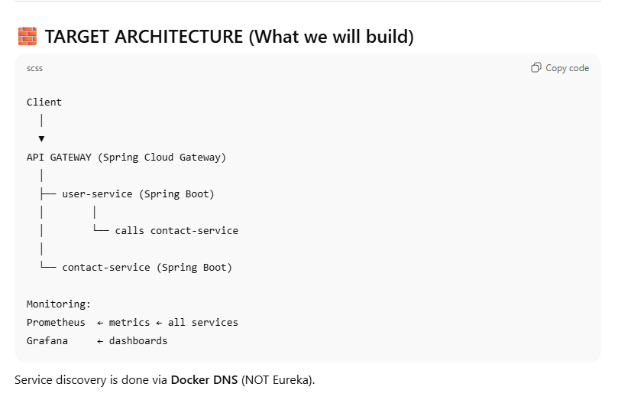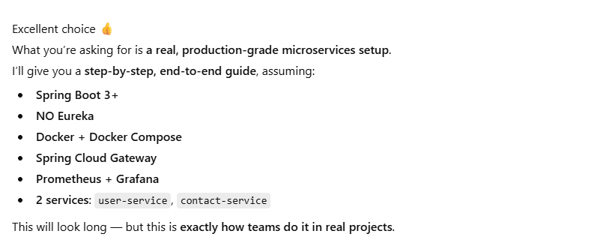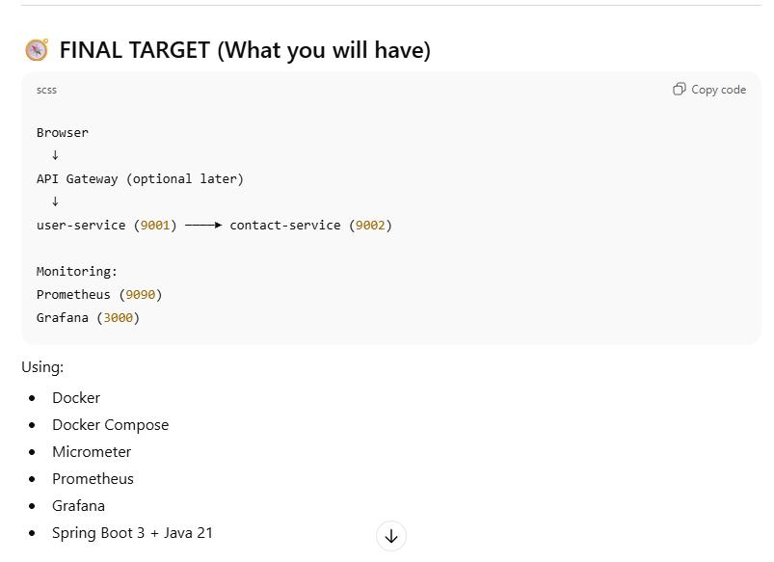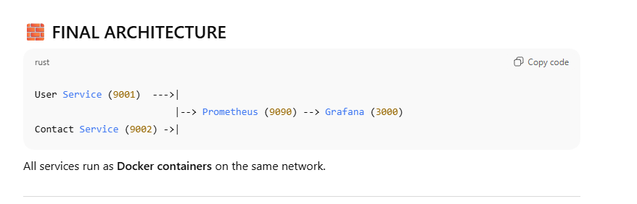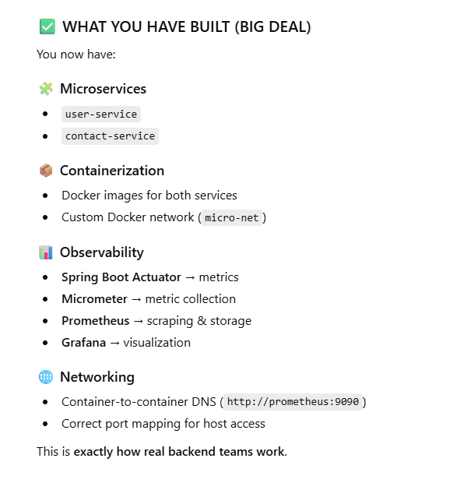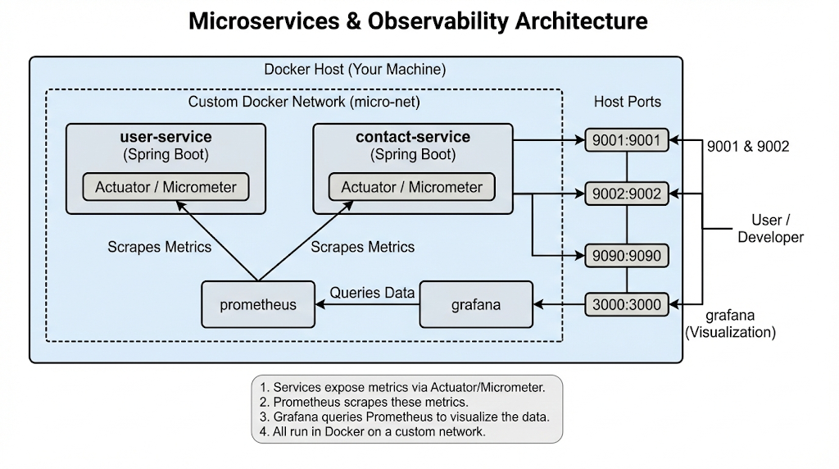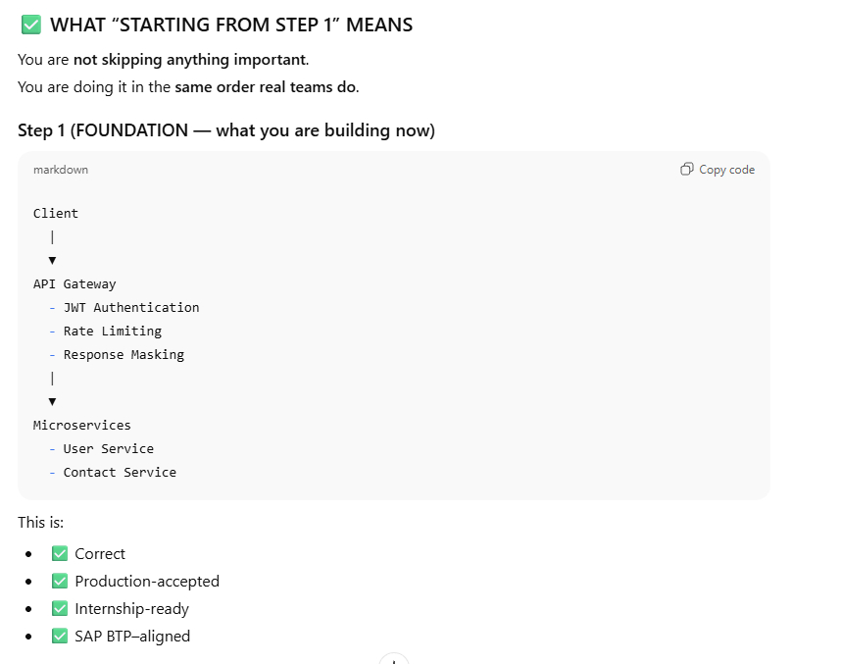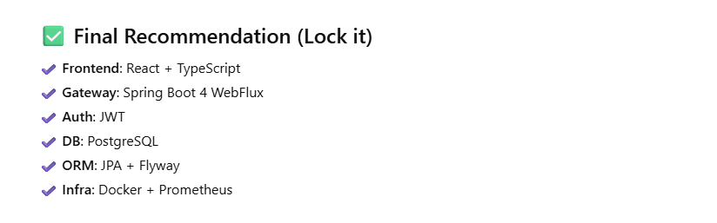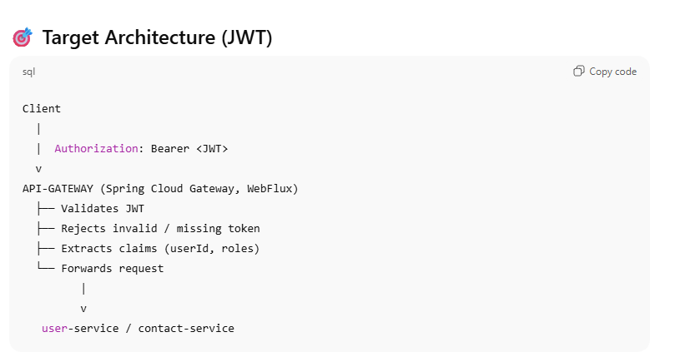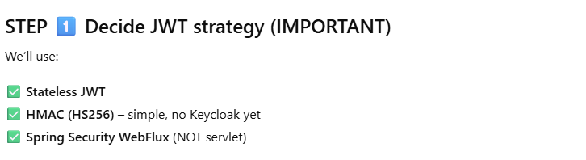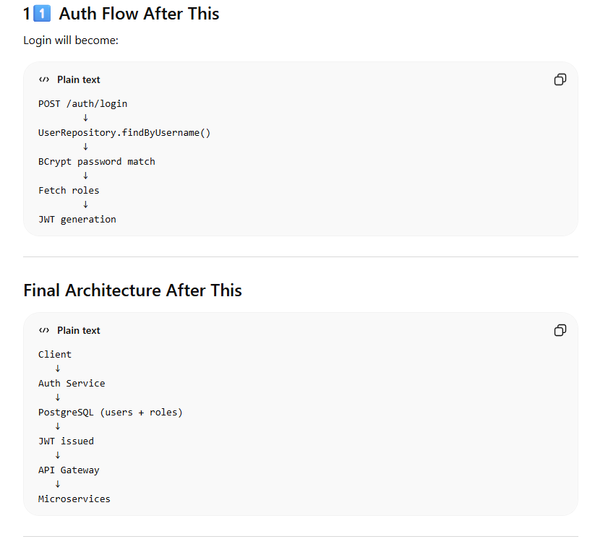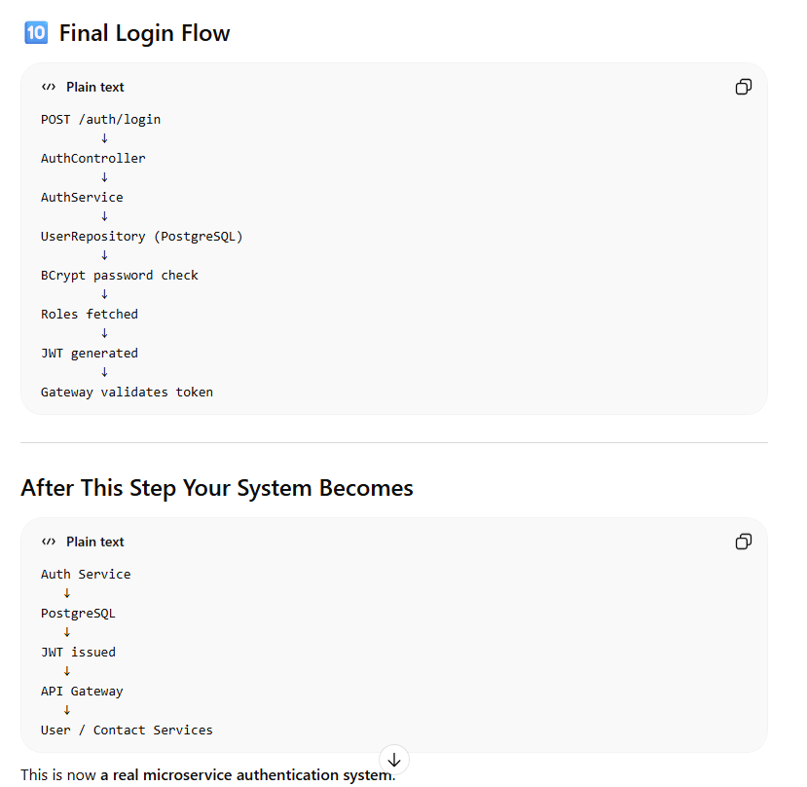

==================================================================================
Below is a clear architectural summary of your entire system so far, structured the way you would explain it in a technical interview. I’ll divide it into:
1️⃣ System Architecture Overview
2️⃣ What You Have Implemented (step-by-step)
3️⃣ Security Architecture
4️⃣ Infrastructure Setup
5️⃣ Monitoring Setup
6️⃣ What Redis Rate Limiting Adds
7️⃣ Remaining Steps (Core + Advanced)
8️⃣ How to Explain This Project in Interviews

1️⃣ System Architecture Overview
Your project is a Dockerized microservices architecture secured by JWT and controlled through an API Gateway.
High-level architecture:
Client
│
▼
API Gateway (Spring Cloud Gateway)
│
├── JWT Authentication Filter
├── Rate Limiting (Redis) ← currently implementing
│
├── Auth Service
│ ├── Login
│ ├── Admin Create User
│ └── PostgreSQL
│
├── User Service
│
└── Contact Service
Infrastructure layer:
Docker Compose
│
├── Redis (rate limiting)
├── PostgreSQL (Auth DB)
├── Prometheus (metrics)
└── Grafana (visualization)
This resembles a real production microservice platform.

2️⃣ What You Have Implemented So Far
1. Microservices Architecture
You created independent services:
auth-service
user-service
contact-service
api-gateway
Each service:
- Runs independently
- Has its own REST APIs
- Communicates via HTTP through the gateway
Example:
Client → Gateway → User Service

2. API Gateway
Implemented using:
Spring Cloud Gateway (Reactive WebFlux)
Responsibilities:
Routing
Authentication
Authorization
Central security
Future rate limiting
Routes configured:
/auth/** → auth-service
/admin/** → auth-service
/users/** → user-service
/contacts/** → contact-service
Gateway acts as the single entry point for the system.

3. JWT Authentication
Authentication implemented using:
JSON Web Tokens
Login flow:
Client → /auth/login
↓
Auth Service verifies credentials
↓
JWT token generated
↓
Token returned to client
Example token payload:
{
"sub": "1001",
"roles": ["ROLE_ADMIN"],
"exp": ...
}

4. Gateway JWT Filter
A GlobalFilter validates every request.
Steps:
1 Request arrives at gateway
2 Authorization header checked
3 JWT validated
4 Roles extracted
5 UserId forwarded to downstream services
Headers forwarded:
X-User-Id
X-Roles
Example request flow:
Client
│
▼
API Gateway
│
▼
User Service
This prevents services from needing their own authentication logic.

5. Role-Based Authorization
Implemented RBAC.
Roles:
ROLE_ADMIN
ROLE_USER
Rules enforced in gateway:
/admin/** → ADMIN only
/users/** → USER or ADMIN
/contacts/**→ USER or ADMIN
Example:
Admin → create users
User → cannot create users

6. Admin User Management
Admin endpoints created in Auth Service.
Admin can:
Create users
Assign roles
Example endpoint:
POST /admin/register
Example request:
{
"username": "john",
"password": "password"
}
Admin workflow:
Admin login
↓
Create user
↓
User logs in

7. Database Integration
Auth service connected to PostgreSQL.
Tables:
users
roles
user_roles
Password storage:
BCrypt hashing
Example flow:
Register → password hashed
Login → BCrypt verification
No plain-text passwords stored.

8. Dockerized Infrastructure
Everything runs inside Docker containers.
Services defined in:
docker-compose.yml
Containers running:
api-gateway
auth-service
user-service
contact-service
postgres-auth
redis
prometheus
grafana
All services communicate through:
micro-net docker network
Example service communication:
api-gateway → auth-service:9000
api-gateway → user-service:9001

9. Monitoring Setup
You integrated:
Prometheus
Grafana
Metrics collected from:
Spring Boot Actuator
Flow:
Services → Prometheus → Grafana Dashboard
Metrics monitored:
API requests
Response times
Gateway traffic

3️⃣ Security Architecture
Security layers implemented:
Layer 1 — Gateway Authentication
JWT validation
Layer 2 — Role Authorization
ROLE_ADMIN
ROLE_USER
Layer 3 — Password Security
BCrypt hashing
Layer 4 — Token Expiration
JWT expiration configured.

4️⃣ Redis Infrastructure
Redis container added for:
Rate limiting
Gateway protection
Running inside docker:
redis:6379
Gateway connects using:
redis:6379
This prevents abuse like:
Brute-force login
API flooding
DDoS attempts

5️⃣ Rate Limiting (Current Task)
Gateway will enforce limits using:
Spring Cloud Gateway RequestRateLimiter
RedisRateLimiter
Example configuration:
5 requests per second
10 burst capacity
Example behavior:
Client sends 20 login requests
Gateway allows 10
Remaining requests → 429 Too Many Requests

6️⃣ Current Architecture (Complete)
Client
│
▼
API Gateway
│
├── JWT Authentication
├── RBAC Authorization
├── Redis Rate Limiting
│
├── Auth Service
│ └── PostgreSQL
│
├── User Service
│
└── Contact Service
Monitoring layer:
Prometheus
Grafana
Infrastructure:
Docker Compose

7️⃣ Remaining Core Steps
These are the mandatory tasks still left.
1. Finish Redis Rate Limiting
Implement:
RequestRateLimiter
KeyResolver
Test:
429 Too Many Requests

2. Clean API Error Handling
Return proper responses:
401 Unauthorized
403 Forbidden
404 Not Found
429 Too Many Requests

3. Database Migration Tool
Replace auto table creation with:
Flyway
This allows:
Versioned database schema

8️⃣ Advanced Improvements (Later)
These are enterprise-level improvements.
Not mandatory but excellent for interviews.
Security
Refresh Tokens
Token Revocation
OAuth2 / Keycloak
Reliability
Circuit Breaker (Resilience4j)
Retries
Timeouts
Observability
Distributed tracing (Zipkin)
Central logging (ELK)
Scalability
Service Discovery (Eureka)
Load balancing

9️⃣ How to Explain This Project in Interviews
Good answer:
I built a Docker-based microservice architecture with a centralized API Gateway using Spring Cloud Gateway. Authentication is implemented using JWT tokens issued by an Auth Service backed by PostgreSQL. The gateway validates tokens and enforces role-based authorization before routing requests to downstream services like User and Contact services. Infrastructure components such as Redis are used for rate limiting, while Prometheus and Grafana provide observability and monitoring of system metrics.
This shows knowledge of:
Microservices
Security
Infrastructure
Observability
Scalability
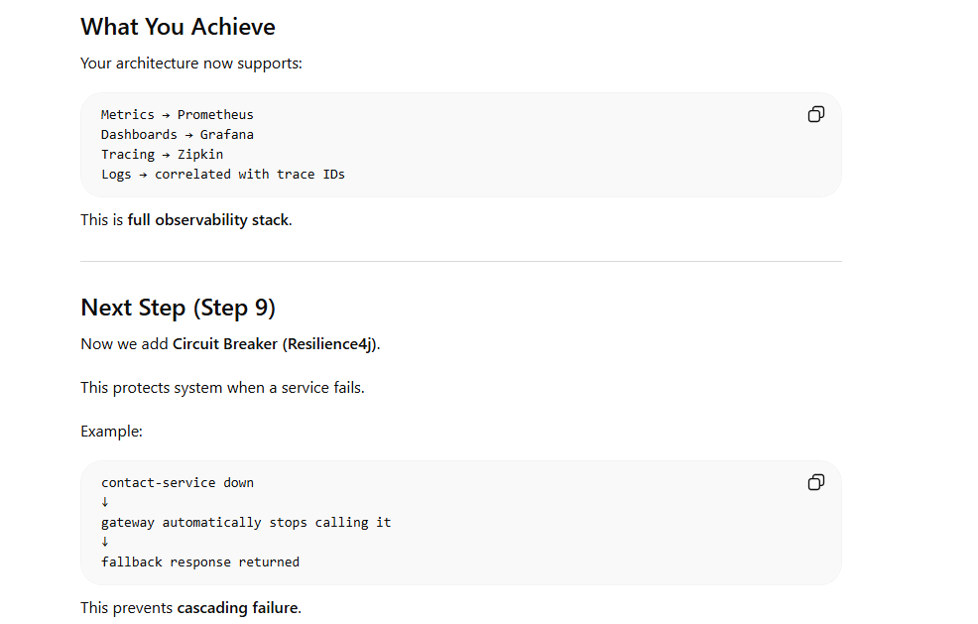
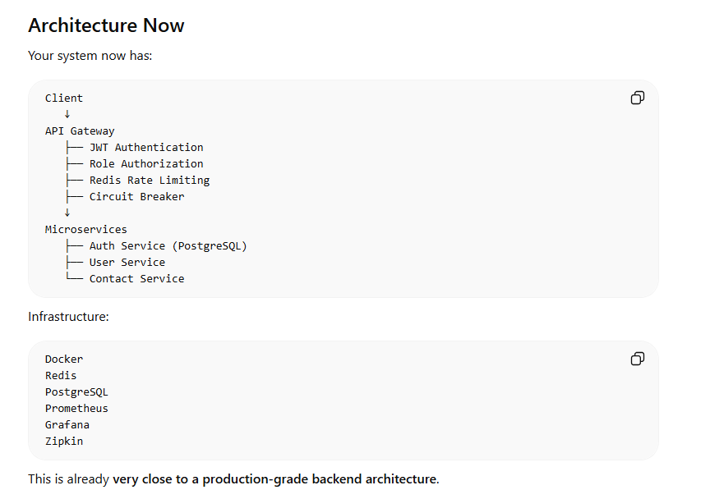
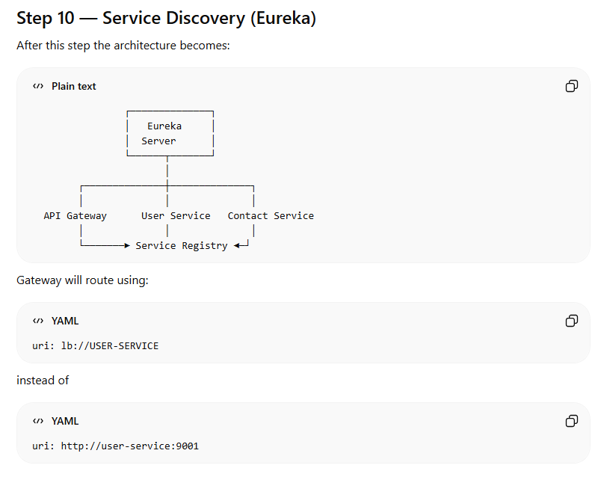
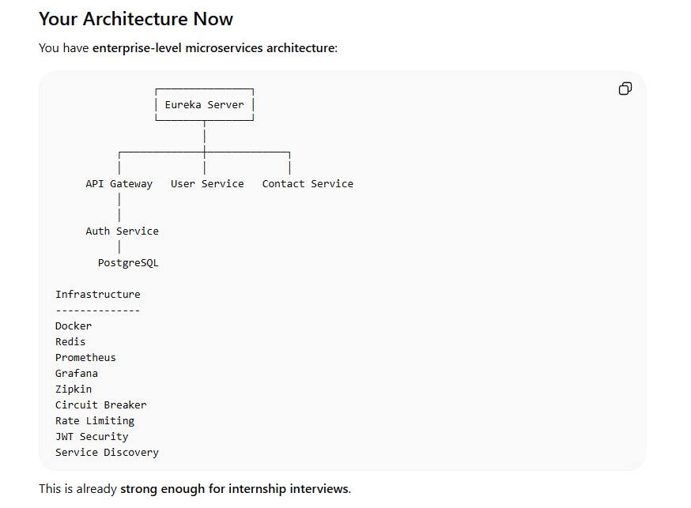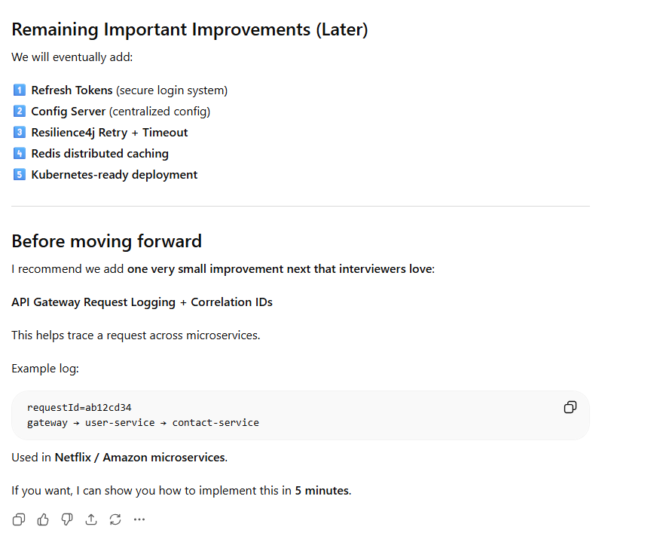
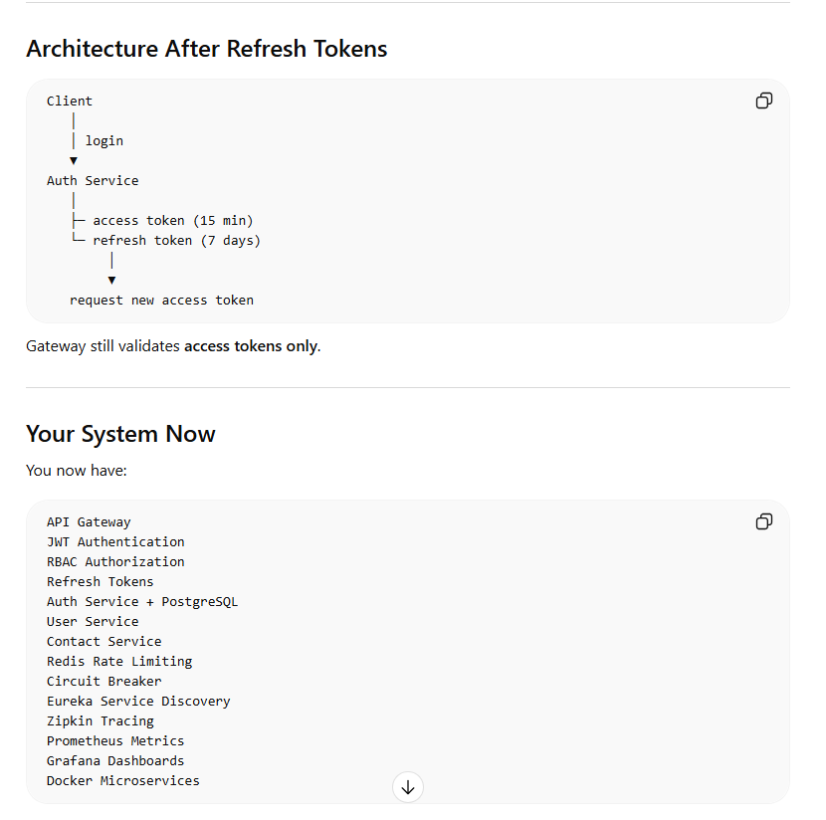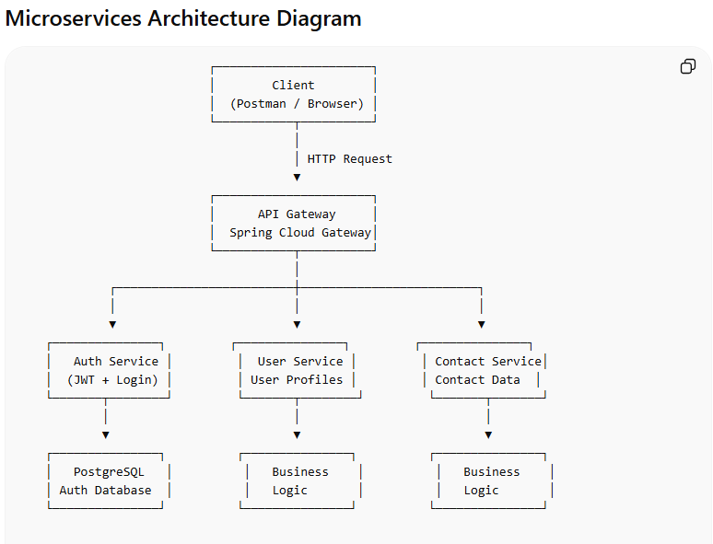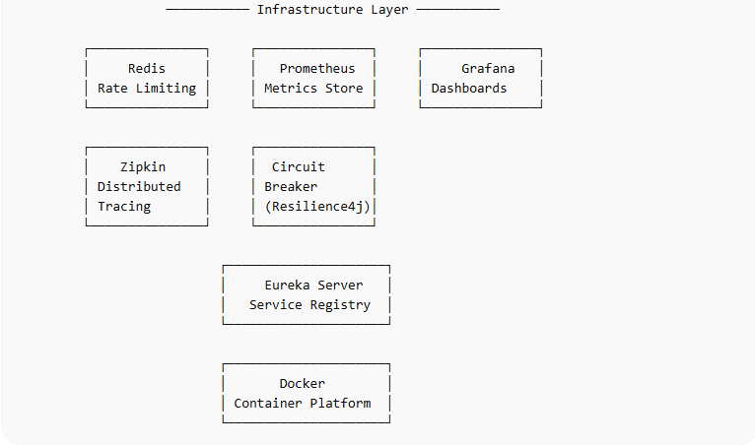

Component Explanation (Interview Friendly)
1. Client
The client represents any external consumer of the system.
Examples:
- Postman
- Frontend application
- Mobile application
The client sends requests to the API Gateway, not directly to services.

2. API Gateway
Technology:
Spring Cloud Gateway
Purpose:
- Single entry point for all APIs
- Handles cross-cutting concerns
Responsibilities:
- JWT authentication
- Role-based authorization
- Routing requests to services
- Rate limiting using Redis
- Circuit breaker
- Metrics and tracing
Example routing:
/auth/** → auth-service
/users/** → user-service
/contacts/** → contact-service
/admin/** → user-service admin controller

3. Auth Service
Purpose:
Handles authentication and token generation.
Functions:
- User login
- User registration
- Generate JWT access tokens
- Generate refresh tokens
- Validate credentials
Database:
PostgreSQL
Endpoints:
POST /auth/login
POST /auth/register
POST /auth/refresh

4. User Service
Purpose:
Manages user profile data.
Example endpoints:
GET /users/{id}
GET /admin/dashboard
Responsibilities:
- User profile retrieval
- Admin operations
- Business logic for user entities

5. Contact Service
Purpose:
Stores user contact details.
Example endpoints:
GET /contacts/user/{userId}
Responsibilities:
- Retrieve contacts
- Manage contact records

6. PostgreSQL Database
Used by:
Auth Service
Stores:
- Users
- Password hashes
- Roles
- Refresh tokens
Why PostgreSQL:
- ACID compliance
- strong relational support
- widely used in production systems

7. Redis
Purpose:
Rate limiting.
Flow:
Client → Gateway → Redis counter
Example rule:
max 10 requests / second
Prevents:
- API abuse
- brute force attacks
- DoS spikes

8. Circuit Breaker (Resilience4j)
Purpose:
Protects system when services fail.
Example scenario:
Contact Service crashes
Without circuit breaker:
Gateway keeps retrying → system slowdown
With circuit breaker:
Gateway stops calling service temporarily
returns fallback response

9. Prometheus
Purpose:
Collects system metrics.
Examples:
HTTP request count
request latency
error rate
CPU usage
Prometheus scrapes metrics from:
/actuator/prometheus

10. Grafana
Purpose:
Visualization tool for metrics.
Grafana dashboards show:
API traffic
Error rate
Latency
Service performance
This helps with observability.

11. Zipkin
Purpose:
Distributed tracing.
Tracks request flow across microservices.
Example trace:
Client
↓
Gateway
↓
User Service
↓
Contact Service
Helps debug latency and failures.

12. Eureka Server
Purpose:
Service discovery.
Without Eureka:
Gateway → http://user-service:9001
With Eureka:
Gateway → lb://USER-SERVICE
Benefits:
- Dynamic service registration
- Load balancing
- Scalability

13. Docker
Purpose:
Container platform.
Each service runs as a container:
api-gateway
auth-service
user-service
contact-service
redis
postgres
prometheus
grafana
zipkin
eureka
Benefits:
- consistent environment
- easy deployment
- portability

Complete Request Flow
Example request:
GET /users/1001
Flow:
Client
↓
API Gateway
↓ JWT Validation
↓ Rate Limiting
↓ Circuit Breaker
↓
Eureka Discovery
↓
User Service
↓
Response returned

Security Flow
Login:
POST /auth/login
Response:
access_token
refresh_token
Usage:
Authorization: Bearer <access_token>
Gateway validates the token before forwarding requests.

