SOFTWARE REQUIREMENTS SPECIFICATION (SRS)
An Intelligent Career Guidance System for IT Students
Course: 61FIT3SS2 – Spring 2026
Group: 08
No. | Full Name | Student ID
1 | Nguyễn Tiến Anh | 2301040009
2 | Đào Quang Thái Anh | 2301040002
3
4
5

TABLE OF CONTENTS
TABLE OF CONTENTS 2
1. INTRODUCTION 2
1.1 Purpose 3
1.2 Scope 3
1.3 Overview 3
1.4 Definitions, Acronyms, and Abbreviations 3
1.5 References 4
2. GENERAL DESCRIPTION 4
2.1 Product Perspective 4
2.2 Product Functions 4
2.3 User Characteristics 4
2.4 General Constraints 4
2.5 Assumptions and Dependencies 4
3. REQUIREMENTS 4
3.1 External Interface Requirements 4
3.1.1 User Interfaces 5
3.1.2 Hardware Interfaces 5
3.1.3 Software Interfaces 5
3.1.4 Communications Interfaces 5
3.3 Performance Requirements 7
3.4 Design Constraints 7
3.5 Attributes (Non-Functional Requirements) 7
3.6 Other Requirements 8
3.6.1 Operations 8
3.6.2 Site Adaptation 8
APPENDIX A: Sample Input/Output Formats 8
APPENDIX B: API Handshake Pack (Draft Contract) 8
APPENDIX C: Error Schema (Client-Visible) 8
APPENDIX D: Traceability Matrix (Baseline) 9
APPENDIX E: Requirements Ownership (Team Allocation) 9
APPENDIX F: Course Topic Coverage (Draft) 9

1. INTRODUCTION

1.1 Purpose
This Software Requirements Specification (SRS) provides a comprehensive, detailed blueprint for the TechPath AI system. The explicit purpose of this document is to explicitly outline and detail every functional feature, system interface, and non-functional constraint of the application based closely on the internal source code (main.py, models.py). This document is intended to serve as the ultimate baseline for system design, implementation grading, and final evaluation, providing a common understanding for the instructor and development team.

Scope
TechPath AI is an intelligent, full-stack career guidance platform tailored specifically to navigate the complexities of the IT industry. The system guarantees guidance for users by conducting an intuitive assessment and subsequently generating an interactive, customized learning roadmap.
In-scope functionalities:
- Account Generation & Lifecycle: Local credential Registration alongside Google OAuth 2.0 integrations, heavily secured by bcrypt hashing and OTP email workflows.
- Dynamic Assessment Engine: A multi-step asynchronous form evaluating explicit career path targeting vs. open-ended interest matching without reloading whole web pages.
- Roadmap Dashboard & Progress Evaluation: Directing unstructured AI insights into highly tracked local database entities (Phases, Checkpoints, Resources). The system captures user checkmarks to formulate numeric completion percentages dynamically.
Out-of-scope:
- Plagiarism detection and assignment grading.
- Live instructor-led mentoring or text-based instant messaging between peers.

Overview
This document consists of three main chapters. Section 1 outlines the general context. Section 2 describes the macroscopic environment, product perspectives, and core constraints where TechPath AI lives. Section 3 exhaustively details internal capabilities, grouping functional requirements directly under their actor roles (User, Admin), mapping strictly to system performance standards and exterior interfaces (Database/SMTP).

1.4 Definitions, Acronyms, and Abbreviations
Table 1: Terms and definitions
Term/Acronym | Definition
HTMX | High Power Tools for HTML. Empowers partial DOM replacements via AJAX natively from HTML tags, avoiding client-side state complexities.
SQLModel | A library leveraging Pydantic and SQLAlchemy designed to seamlessly bind python objects directly to SQL table definitions.
Jinja2 | The templating engine utilized by FastAPI to construct and render dynamic data onto HTML documents before delivery.
OTP | One-Time Password. Used for securing forgotten account lifecycles.
MIME | Multipurpose Internet Mail Extensions, a standard that extends the format of email to support text/HTML and attachments.

1.5 References
NA.

2. GENERAL DESCRIPTION

2.1 Product Perspective
TechPath AI functions as an entirely independent web-based Software as a Service (SaaS). It operates in a standard Client-Server architectural pattern.
- The Client (Browser): Parses and displays standard HTML5/CSS3. Interactivity is supplemented heavily with HTMX replacing traditional single-page application complexities.
- The Server Layer: A Python FastAPI routing instance validating HTTP forms and session configurations.
- The Data Layer: System records are governed strictly by a normalized, local SQLite database (techpath.db).

2.2 Product Functions
- Sign up / Sign in Operations: Users seamlessly provision database user objects manually or authenticate through a third-party Google provider.
- Restoring Access Operations: User requests an OTP via email, enters the OTP into an HTMX-rendered view, and secures a new password token.
- Executing Assessments: Users provide current capability metrics (Weekly hours, Skills). The backend intercepts these answers to construct parameters.
- Roadmap Visualization: Detailed rendering of learning paths mapping phases and resource links directly within a unified tracking hierarchy.
- Milestone Management: Toggle checkpoints dynamically and visualize the global roadmap completion math directly without screen flashes.

2.3 User Characteristics
The system targets diverse individuals needing structured IT learning paths:
- “The Confused Fresher”: A university student overwhelmed by IT definitions. Requires the system's "Not yet known" capability to measure general traits across 10 areas (like Interest in abstract math vs. UI prototyping).
- “The Focused Transitioner”: An existing professional focusing precisely on "Artificial Intelligence (AI) Engineer". Needs direct parsing of specific competency layers (e.g., Python math basics) without generic testing.

2.4 General Constraints
- Asynchronous Execution Constraint: Generative AI logic dictates heavy waiting periods; therefore, backend algorithms (async def) must avoid blocking thread limits to allow multiple clients concurrent dashboard access.
- Database Modularity constraint: The system strictly utilizes relational SQLite syntax, converting unmappable parameters into JSON-serialized strings inside individual column cells.

2.5 Assumptions and Dependencies
- The system unconditionally assumes the availability of an SMTP relay (smtp.gmail.com initialized over SSL Port 465) properly configured with application-specific passwords.
- Google Client IDs strictly match authorized redirect origins established within the Google Cloud Console. Failure restricts integration signups.

3. REQUIREMENTS

3.1 External Interface Requirements

3.1.1 User Interfaces
- The web app heavily utilizes a responsive, academic aesthetic based on modern navy-blue (#0d3b66) and gold elements (#f5c842).
- Account Forms: Utilize Bootstrap floating inputs. Form errors invoke alert banners rendered conditionally above submissions.
- Roadmap Board: Uses an intuitive vertical timeline. Phases collapse gracefully (Bootstrap Accordions), containing bulleted interactive HTML checkpoints mapped carefully to backend logic.

3.1.2 Hardware Interfaces
The application executes on servers fulfilling minimum memory requirements necessary to persist SQLite .db read/write blocks. Client devices strictly require modern browsers capable of establishing continuous HTTP traffic pipelines without unique hardware requirements.

3.1.3 Software Interfaces
- Local Relational Boundaries: Connects continuously to SQLite storing exact entity models ensuring structural consistencies. User retains configuration elements (hours_per_week, primary_skills). Assessment stores serialized strings. Roadmap hosts dynamic math outputs connected structurally to multiple Phase and Checkpoint definitions tracking the booleans (is_complete).
- OAuth Providers: Interfaces externally to https://accounts.google.com receiving verified payload configurations capturing explicit user context via Bearer tokens.

3.1.4 Communications Interfaces
- Uses standardized HTTP protocol via TCP/IP routing boundaries.
- Customly replaces strict JSON API consumption through pure HTML HTMX injections where asynchronous component modification is optimal.
· 3.2 Functional Requirements
3.2.1 User
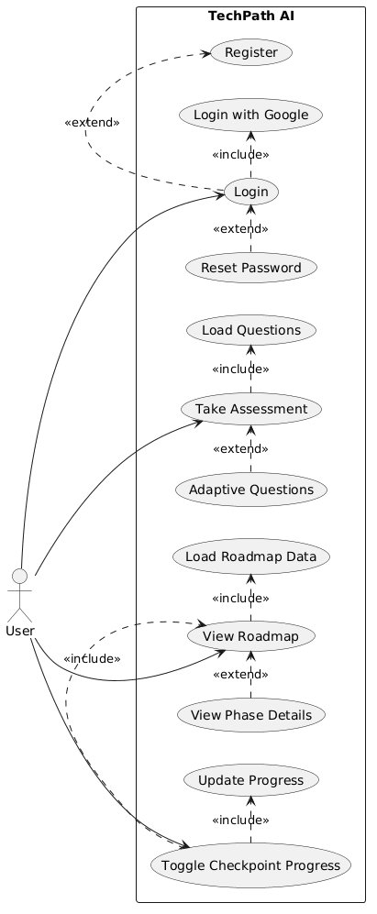
3.2.1.1 Login
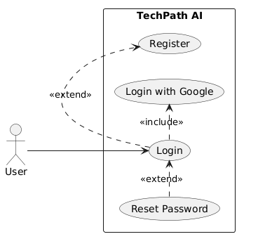
ID & Name: | UC-1: Login
Primary Actor: | User
Description: | User authenticates into the system using email/password or a Google account to access personalized features
Trigger: | User selects the "Login" option on the system interface.
Pre-conditions: | User is not logged in.
Post-conditions: | User is successfully authenticated and redirected to the dashboard with a valid session.
Normal Flow: | - User enters Email and Password.  - User clicks "Login".  - System validates input format.  - System verifies credentials with the database.  - System creates a session token.  - System redirects the user to the dashboard.
Alternative Flows: | AF1: At step 1, the user selects "Login with Google".  → System redirects to Google OAuth authentication.  → On success, the flow continues at step 5.  AF2: At step 1, the user selects "Sign Up".  → System redirects to the Register use case.
Exceptions: | E1: At step 4, if credentials are invalid → System displays "Invalid email or password".  E2: At step 4, if a system error occurs → System displays an authentication error message.
Priority: | High

3.2.1.2 Take Assesment
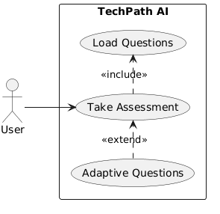
ID & Name: | UC-2: Take Assessment
Primary Actor: | User
Description: | User completes an assessment survey to evaluate logical abilities and technical skills in order to generate a personalized learning profile.
Trigger: | User clicks "Start Assessment".
Pre-conditions: | User is logged in.
Post-conditions: | System generates and stores the user’s aptitude configuration.
Normal Flow: | - User selects basic preferences (e.g., hours per week) in Step 1.  - System dynamically loads sequential questions using HTMX.  - User answers all remaining questions.  - User clicks "Submit".  - System processes and evaluates responses via backend API.  - System calculates user traits and aptitude configuration.
Alternative Flows: | AF1: At step 2, the user selects "Software Engineer" as the target path.  → System dynamically loads technical-focused questions.  → Flow continues at step 3.
Exceptions: | E1: At step 2, if the system fails to load questions → System displays "Unable to load assessment questions".  E2: At step 5, if evaluation fails → System displays "Error processing assessment results".
Priority: | High

3.2.1.3 View Roadmap
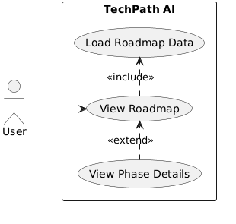
ID & Name: | UC-3: View Roadmap
Primary Actor: | User
Description: | User views their personalized learning roadmap, organized into phases and checkpoints in a structured timeline interface.
Trigger: | User navigates to the Roadmap Dashboard.
Pre-conditions: | User is logged in.
Post-conditions: | The system displays the roadmap with phases and checkpoints in an interactive UI.
Normal Flow: | - System retrieves the user’s roadmap from the database.  - System iterates through Phases and their corresponding Checkpoints.  - System renders the roadmap using collapsible UI elements (accordions).  - User expands a Phase to view its Checkpoints.
Alternative Flows: | AF1: At step 4, user selects a different Phase → System updates UI to display selected Phase details.
Exceptions: | E1: At step 1, if no roadmap is found → System redirects user to the Assessment page and displays message "Please complete the assessment first".  E2: At step 1, if system fails to retrieve roadmap data → System displays "Error loading roadmap".
Priority: | High

3.2.1.4 Toggle Checkpoint Progress
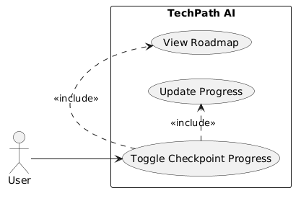
ID & Name: | UC-4: Toggle Checkpoint Progress
Primary Actor: | User
Description: | User marks a learning checkpoint as completed or not completed, allowing the system to update overall roadmap progress.
Trigger: | User toggles the is_complete checkbox of a checkpoint.
Pre-conditions: | User is logged in and viewing an active roadmap.
Post-conditions: | Checkpoint status is updated in the database and overall roadmap completion percentage is recalculated and reflected in the UI.
Normal Flow: | - User clicks on a checkpoint toggle (checkbox).  - System sends an asynchronous request to the backend (via HTMX).  - System updates the is_complete status of the selected checkpoint.  - System recalculates the overall completion percentage of the roadmap.  - System updates the UI to reflect the new progress.
Alternative Flows: | AF1: At step 1, user toggles multiple checkpoints rapidly → System queues and processes requests sequentially to ensure data consistency.
Exceptions: | E1: At step 2, if network connection is lost → System fails to send request and reverts the checkbox state in the UI.  E2: At step 3, if backend API fails → System displays "Unable to update progress" and restores previous state.
Priority: | High

3.3 Performance Requirements
The system shall satisfy the following performance targets (baseline):
ID | Requirement | Target | Verification
PERF-01 | UI page load for base interfaces and Roadmap dashboard | < 1.5 seconds locally | Browser performance test on local environment.
PERF-02 | Initial AI-generated Roadmap load and evaluation | < 15.0 seconds locally | Network profiling of generative API latencies.
PERF-03 | Background processing response for localized HTMX assessment elements | < 300 ms | Manual test + network profiling.
PERF-04 | Secure email dispatch pipeline execution (OTP delivery) | < 4.0 seconds timeframe | Test: verify wait times; manual verification of delivery.
PERF-05 | Checkpoint status computations and database persistence | < 250 ms round-trip window | Demo benchmark: toggle checkpoint and record round-trip time.

3.4 Design Constraints
- All processes execute inside strict ASGI boundaries (Uvicorn servers) utilizing Python's async/await syntax ensuring scalable capabilities natively.
- UI manipulation enforces Server-Side Rendering behaviors manipulating DOM trees via HTML over the wire instead of pure Single-Page variations ensuring smaller client-download thresholds.

3.5 Attributes (Non-Functional Requirements)
Each NFR includes a rationale (why we implement it) and a verification approach.

REQ# | PRIORITY | DESCRIPTION | RATIONALE | USE CASE
NFR001 | Critical | Passwords must be securely hashed using a non-reversible algorithm such as bcrypt before being stored in the database. | To protect user credentials and prevent unauthorized access in case of data breaches. | UC-1: Login
NFR002 | Critical | The system must generate session tokens using secure random identifiers (e.g., UUID4) and prevent predictable session patterns. | To prevent session hijacking and unauthorized access via token guessing. | UC-1: Login
NFR003 | High | The system must require users to re-authenticate before performing sensitive operations such as changing passwords. | To ensure that only verified users can modify critical account information. | UC-1: Login
NFR004 | High | System responses for user actions must be returned within 2 seconds under normal load. | To ensure smooth user experience and avoid frustration. | All User Use Cases
NFR005 | Medium | The system must provide a clear and intuitive UI, including step-by-step guidance during assessment and roadmap navigation. | To improve user engagement and reduce confusion. | UC-2: Take Assessment, UC-3: View Roadmap
NFR006 | High | The system must handle failures gracefully and recover from errors without data loss. | To ensure system stability and prevent loss of user progress. | UC-4: Toggle Progress, UC-3: View Roadmap

3.6 Other Requirements

3.6.1 Operations
Deployment commands and debugging protocols consistently depend intrinsically upon simple startup executables natively mapping module applications uvicorn main:app --reload.

3.6.2 Site Adaptation
User interface must continuously conform mathematically against Bootstrap viewport width changes scaling text components perfectly matching mobile constraints.

APPENDIX A: Sample Input/Output Formats

APPENDIX B: API Handshake Pack

APPENDIX C: Error Schema
All API errors returned to the client shall follow a consistent schema:
Field | Description
errorCode | Stable machine-readable code (e.g., UPLOAD_INVALID_FORMAT, AUTH_INVALID).
message | Human-readable message for UI display.
details | Optional list of field errors or additional context.
Example:
{ "errorCode": "UPLOAD_INVALID_FORMAT", "message": "Submission ZIP is missing /src folder.", "details": [{"field":"file","issue":"missing src"}] }

APPENDIX D: Traceability Matrix

APPENDIX E: Requirements Ownership
This table allocates responsibility for drafting and verifying requirements to ensure coverage by all members. Final allocation can be adjusted during planning.
Member | FRs | NFRs
Nguyễn Mai Trang | FR-01, FR-02 | NFR-01
Nguyễn Thu Thủy | FR-05, FR-06 | NFR-03
Nguyễn Quán Quế | FR-03, FR-04 | NFR-02
Nguyễn Chí Tuấn | FR-09, FR-10 | NFR-02
Nguyễn Thị Hạ Vy | FR-07, FR-08 | NFR-04

APPENDIX F: Course Topic Coverage
This matrix demonstrates how the project requirements map to key course topics. It helps justify feasibility and course relevance.
Course Topic | Project Coverage | Evidence / Deliverable
END OF DOCUMENT./.

