**＜画面レイアウト＞**

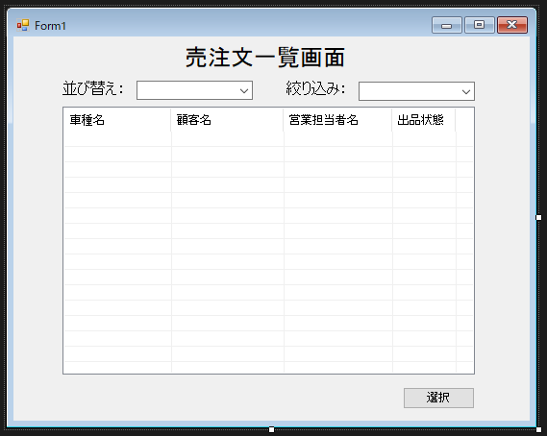

**＜機能説明＞**

・

・

・

・

・

・

・

| **項番** | **項目名** | **オブジェクト名** | **桁数** |
| --- | --- | --- | --- |
| １ | 顧客番号 | Tx_Kokyaku | 5 |
| ２ |  |  |  |
| ３ |  |  |  |
| ４ |  |  |  |
| ５ |  |  |  |
| ６ |  |  |  |
| ７ |  |  |  |
| ８ |  |  |  |
| ９ |  |  |  |
| １００ |  |  |  |
| １１ |  |  |  |
| １２ |  |  |  |
| １３ |  |  |  |
| １４ |  |  |  |
| １５ |  |  |  |
| １６ |  |  |  |
| １７ |  |  |  |
| １８ |  |  |  |
| １９ |  |  |  |
| ２０ |  |  |  |
| ２１ |  |  |  |
| ２２ |  |  |  |
| ２３ |  |  |  |
| ２４ |  |  |  |
| ２５ |  |  |  |
| ２６ |  |  |  |
| ２７ |  |  |  |