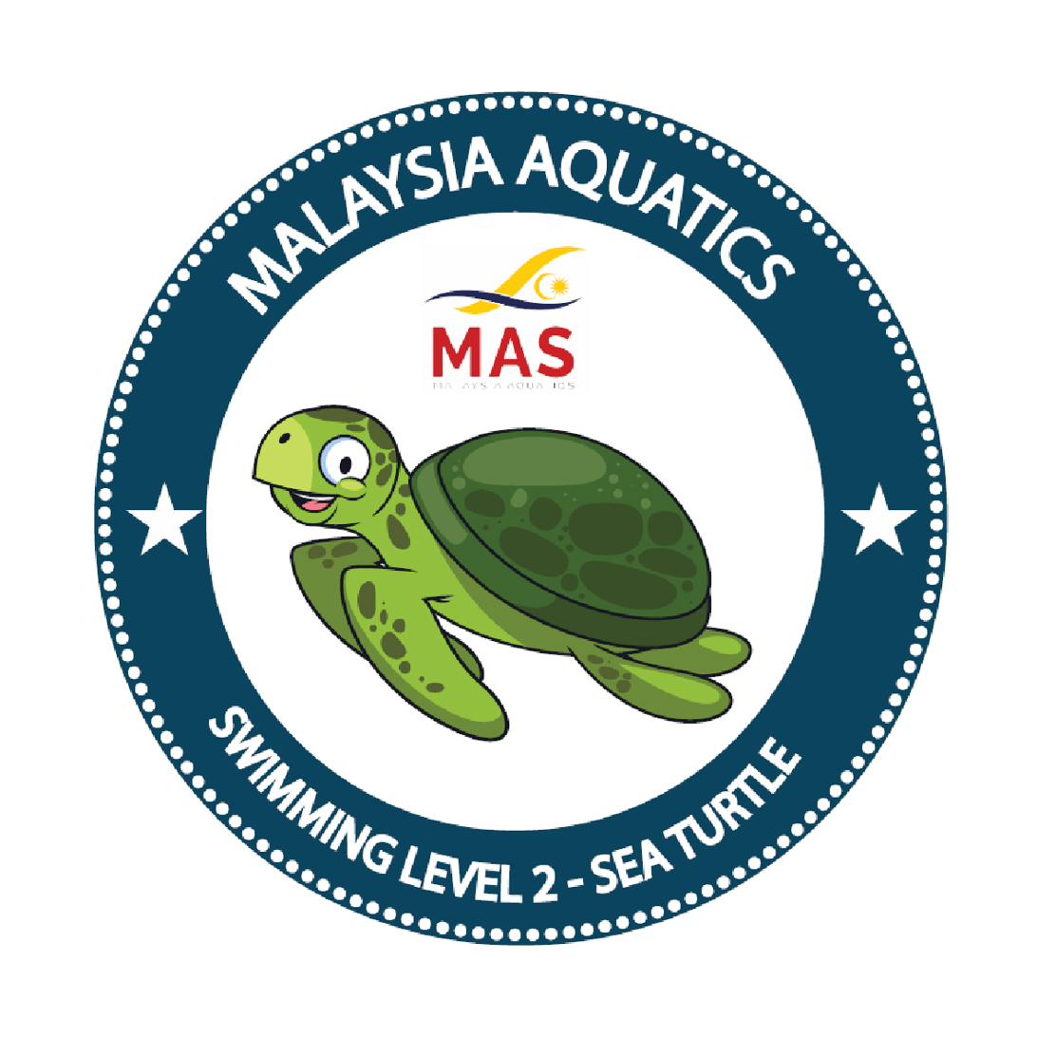

MALAYSIA AQUATICS · AKUATIK MALAYSIA
MAS BADGES
EXAMINER CERTIFICATION COURSE

Notes Booklet
A participant workbook for the BADGES Examiner Certification Course

— down at the water, and judged to the criteria —

BADGES · NATIONAL LEARN-TO-SWIM SYSTEM www.masbadges.org

How to use these notes
These notes follow the examiner course module by module. Each module page gives you the outcome (what you'll be able to do), the key points, and space for your own notes. Write in them freely — a good examiner keeps a working notebook.
The notes mirror the Assessment System Handbook (the standard) and the Examiner Certification Course Guide (the course). Where the two go deeper, this workbook points you there.
The course at a glance
Day | Focus | Modules
Day 1 | Standards | M1 Programme & Governance · M2 Levels 1–3 · M3 Levels 4–5 · M4 Levels 6–7
Day 2 | Conduct & system | M5 Swimming on Video · M6 Conduct of Assessment · M7 Code of Conduct · M8 Portal for Examiners
Day 3 | Independent practical | M9 Practical Independent Assessment · feedback · approval recommendations

To be certified: attend every module, pass the theory quiz (Manual Appendix F), demonstrate Portal competency, reach Competent on the practical, sign the Code, and be ratified by the Coaching Panel.
Two reference sections you'll come back to often
The Seven Levels — Judging Guide sits between M4 and M6. One page per level: assessment criteria, what Competent versus Struggling looks like, and observation pitfalls.
Quick reference (1–3) at the back: session-day protocol, session limits & staffing, and a Code-of-Conduct one-pager.

The three ideas everything rests on
Impartial, competent, safe — you belong to no swimmer, only to the criteria.
Judge only what the criterion asks — the standard is never lowered for an under-prepared candidate.
Independence keeps the badge credible — never assess your own students, never announce results at the pool.

BADGES essentials — the examiner's view
The pathway you assess against
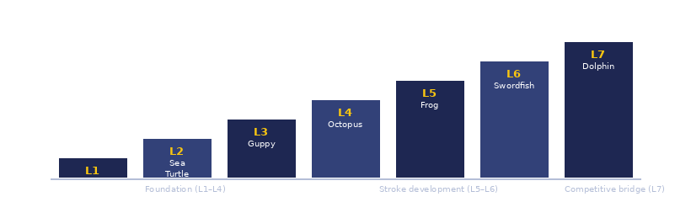
Poolside calibration
Your judgement, checked against the Chief Examiner and the Master Trainer. All three of you watch the same swimmer against the same criterion; a Pass/Refer call is calibrated when the three of you agree. This is what the practical (Module 9) tests, and what keeps the standard consistent across every examiner in the country.
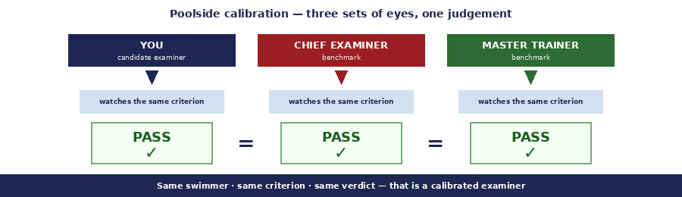
Pass or Refer — no partial pass
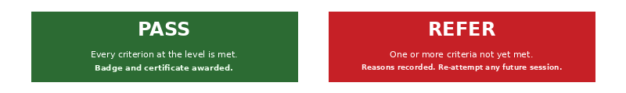

One rule you cannot break — conflict of interest.
You may not assess any swimmer you have personally taught, coached, or instructed. If you are the only examiner available, another is arranged. The Portal enforces this in data.

M1 | Programme & Governance | CLASSROOM

You will be able to: explain the MAS structure, the 7-level pathway, and where an examiner sits within it.

Key points
• MAS runs BADGES: the Board, the Coaching & Technical Board, the Chairperson, the Chief Examiner, and the Master Trainer.
• The six governing documents: Manual, 7-Level Syllabus, Teaching System Handbook, Assessment System Handbook, and the two Course Guides.
• You certify the swimmer, never the coach — every certificate carries MAS's authority, not a school's.
• The Chief Examiner owns the examiner roster; the Chairperson holds standing oversight; the Master Trainer certifies you.

MY NOTES

M2 | Levels 1–3 Standards | CLASSROOM + POOL

You will be able to: distinguish Competent from Struggling performance at Starfish, Sea Turtle, and Guppy.

Key points
• L1 Starfish (shallow): water confidence, breath control, floats, streamline, flutter, rotation.
• L2 Sea Turtle (shallow): fall-in-turn-grab, basic front crawl and backstroke arms, back flutter, reach-and-pull.
• L3 Guppy (shallow/deep intro): FC with unilateral breathing, backstroke, underwater push-and-glide, treading 30 s.
• See the Judging Guide (later in this workbook) for the Competent vs Struggling calibration per criterion.

MY NOTES

M3 | Levels 4–5 Standards | CLASSROOM + POOL

You will be able to: distinguish Competent from Struggling performance at Octopus and Frog, including dive and stroke biomechanics.

Key points
• L4 Octopus: FC bilateral 15 m, BK 15 m, breaststroke whip kick 10 m, sit dive + 3 m underwater glide, survival BK 10 m.
• L5 Frog: FC/BK/BR 25 m each, dolphin kick 10 m, sculling+flutter+breath 15 m, flip turns both ways, squat dive + 5 m dolphin underwater.
• The screw kick is the classic breaststroke fault — observe from behind, both heels must turn out symmetrically.
• Dive judgement is about the entry line and streamline underwater, not the height of the entry.

MY NOTES

M4 | Levels 6–7 Standards | CLASSROOM + POOL

You will be able to: distinguish Competent from Struggling at Swordfish and Dolphin, and apply timing at L7.

Key points
• L6 Swordfish (deep water): 50 m each FC/BK/BR-with-pullout; 10 m butterfly; tumble and open turns in/out; stand dive + 5 m dolphin; sidestroke 15 m.
• L7 Dolphin (deep only): 100 m each FC/BK/BR; 50 m fly; all turns; stand dive; back dive; IM 100 m — with FC ≤ 2:30 and IM ≤ 3:00 (hard criteria).
• L7 is the only level with a time gate — bring a stopwatch. A stroke or a time missing is a Refer.

MY NOTES

The Seven Levels — Judging Guide
This section is your level-by-level companion. For each of the seven levels you'll find the assessment criteria verbatim, a Competent-versus-Struggling calibration for each criterion, the common observation pitfalls at that level, and any level-specific procedural notes.
Use these pages before, during, and after a session: before, to remind yourself what the level demands and where struggling candidates tend to lose it; during, on deck, to sharpen your Pass/Refer call; after, to note whatever calibration adjustments the Chief Examiner suggests.

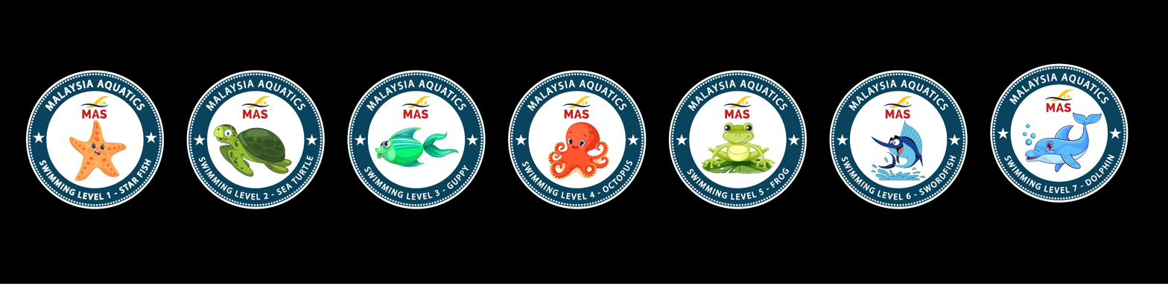

Session limits & water at each level
Level | Water | Max/session
L1 Starfish | Shallow | 16
L2 Sea Turtle | Shallow | 14
L3 Guppy | Shallow / deep | 12
L4 Octopus | Shallow / deep | 10
L5 Frog | Shallow / deep | 8
L6 Swordfish | Shallow / deep | 8
L7 Dolphin | Deep only | 6

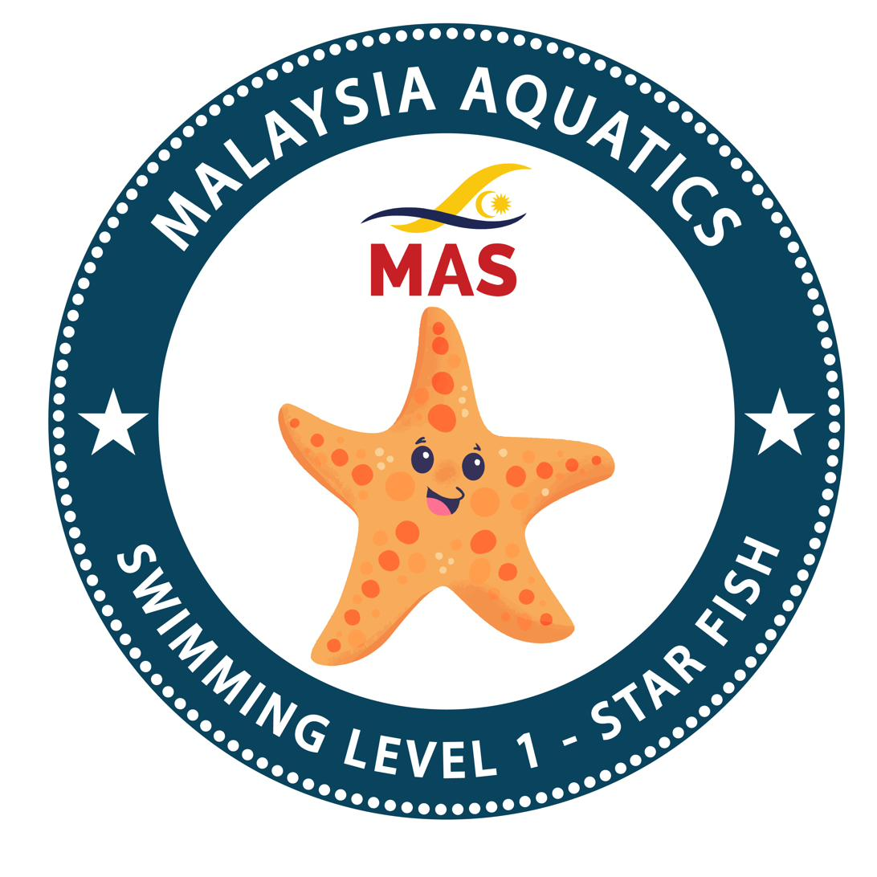 | Level 1  Starfish | FOUNDATION

Shallow water · Max 16 per session

CRITERION | COMPETENT ✓ (Pass) | STRUGGLING (Refer)
1 Enter and exit the pool safely. | Controlled entry (steps, seated, or supported); calm, purposeful; safe exit using edge / ladder. | Jumps/runs in; visible fear; needs lifting out; no awareness of pool rules.
2 Bobbing — 10 reps, full submersion, exhale + inhale cycle. | Rhythmic, calm; head fully submerged each time; clean exhale then inhale; 10 clean reps in sequence. | Gasps at surface; incomplete submersion (nose/mouth stay out); breaks before 10; holds breath rather than exhales.
3 Front float — 10 seconds. | Horizontal, face-down, arms out, relaxed body; unassisted; stable for the full 10 s. | Hips sink below 45°; lifts head early; needs support; unable to stay 10 s.
4 Back float — 10 seconds. | Hips up, ears in, calm face; unassisted; stable for the full 10 s. | Piked position (hips low); hands grabbing air; head tucked forward; sits rather than floats.
5 Streamlined front flutter kick — 3 metres. | Streamline hold; small fast kick from the hips; ankles loose; clear forward travel; 3 m reached. | Big knee-bend bicycling; feet flexed / dorsiflexed; no forward travel; stops repeatedly.
6 Back push and glide — 2 metres. | Locked streamline; clean push off wall; 2 m reached before recovery. | Arms not locked; sinks immediately; no push off wall; less than 2 m.
7 Lateral rotation — both directions. | Controlled roll front→back and back→front, unassisted, both directions. | Flails; only one direction; needs support; loses horizontal position.

Observation pitfalls at this level
⚠ Buoyant children can appear to float — check for real body control, not just being held up by fat/lung volume.
⚠ Kids trained to bob may hold breath rather than exhale — watch for bubbles at the surface.
⚠ Count 10 seconds silently to yourself — don't judge by feel.
Procedural notes
Assess in shallow water. All skills done independently. Order of the day is: enter → bobs → front float (roll) → back float (roll) → flutter → back glide → exit.
MY NOTES

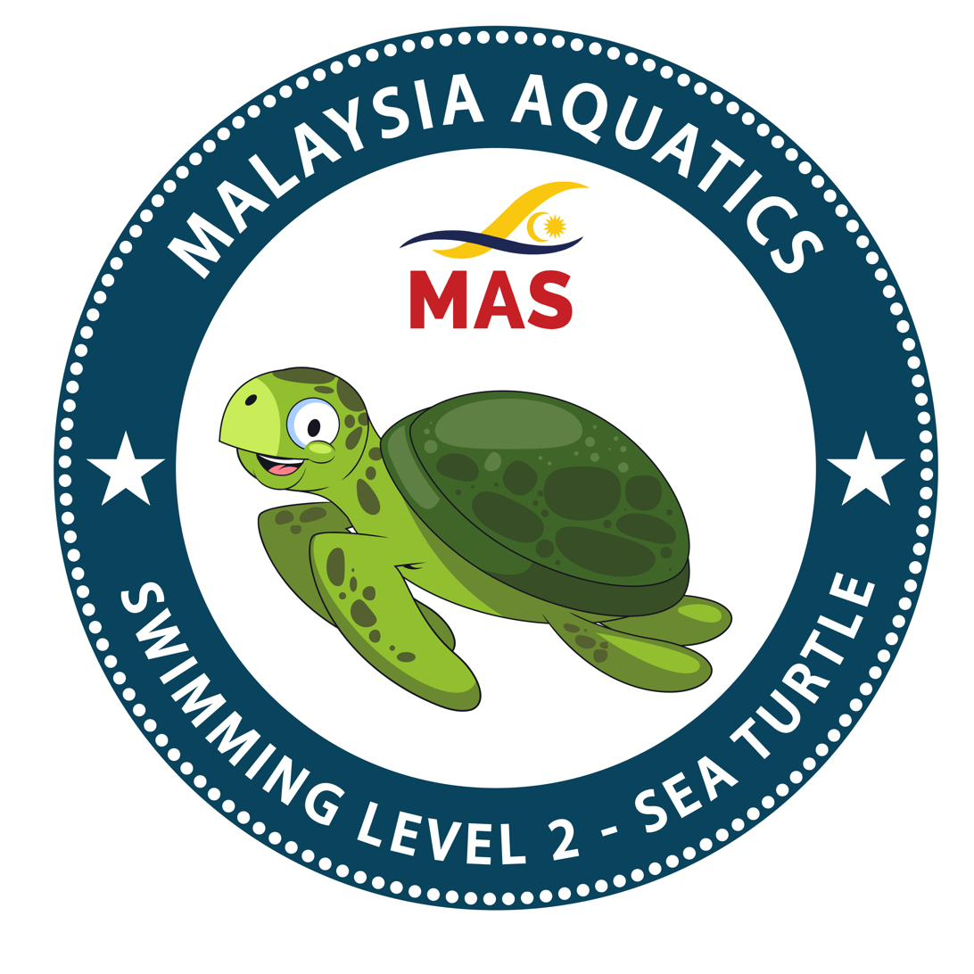 | Level 2  Sea Turtle | FOUNDATION

Shallow water · Max 14 per session

CRITERION | COMPETENT ✓ (Pass) | STRUGGLING (Refer)
1 Fall in, turn, grab wall. | Intentional entry (loss of balance-style); controlled rotation in the water; purposeful grab of wall/ledge. | Deliberate confident dive rather than 'fall'; no rotation; misses the wall; needs prompt.
2 Basic front crawl arm movement with flutter kick — 5 metres. | Recognisable alternating arm action; some head control; clear forward progress; 5 m reached. | Arms slap water without pull; head submerged whole time or head fully up; no forward travel; halts before 5 m.
3 Back flutter kick — 5 metres. | Body flat; hips up; kick from the hips; sustained forward progress; 5 m clear. | Sitting position; kick from the knee; no distance; head tucked forward.
4 Basic backstroke arm movement with flutter kick — 5 metres. | Recognisable alternating arm action; back position held; 5 m reached. | Head in water; sitting/piked position; arms flapping without pull; no distance.
5 Reach and pull with comfortable breath — 5 metres. | Sculling / reach motion visible; breath maintained throughout; forward progress; 5 m clear. | Panic breath; drowning-style movements; no forward progress; hands stiff.

Observation pitfalls at this level
⚠ 'Fall in' is not a dive — needs to feel like a controlled loss of position. A confident dive is a Refer on this criterion.
⚠ Arm-mechanics are basic at this level — do not judge to a full-stroke standard; look for the pattern.
⚠ Watch that the swimmer is breathing throughout reach-and-pull, not holding breath the whole 5 m.
Procedural notes
Assess in shallow water. All skills done independently. Fall-in-turn-grab is the survival criterion — non-negotiable for L2.
MY NOTES

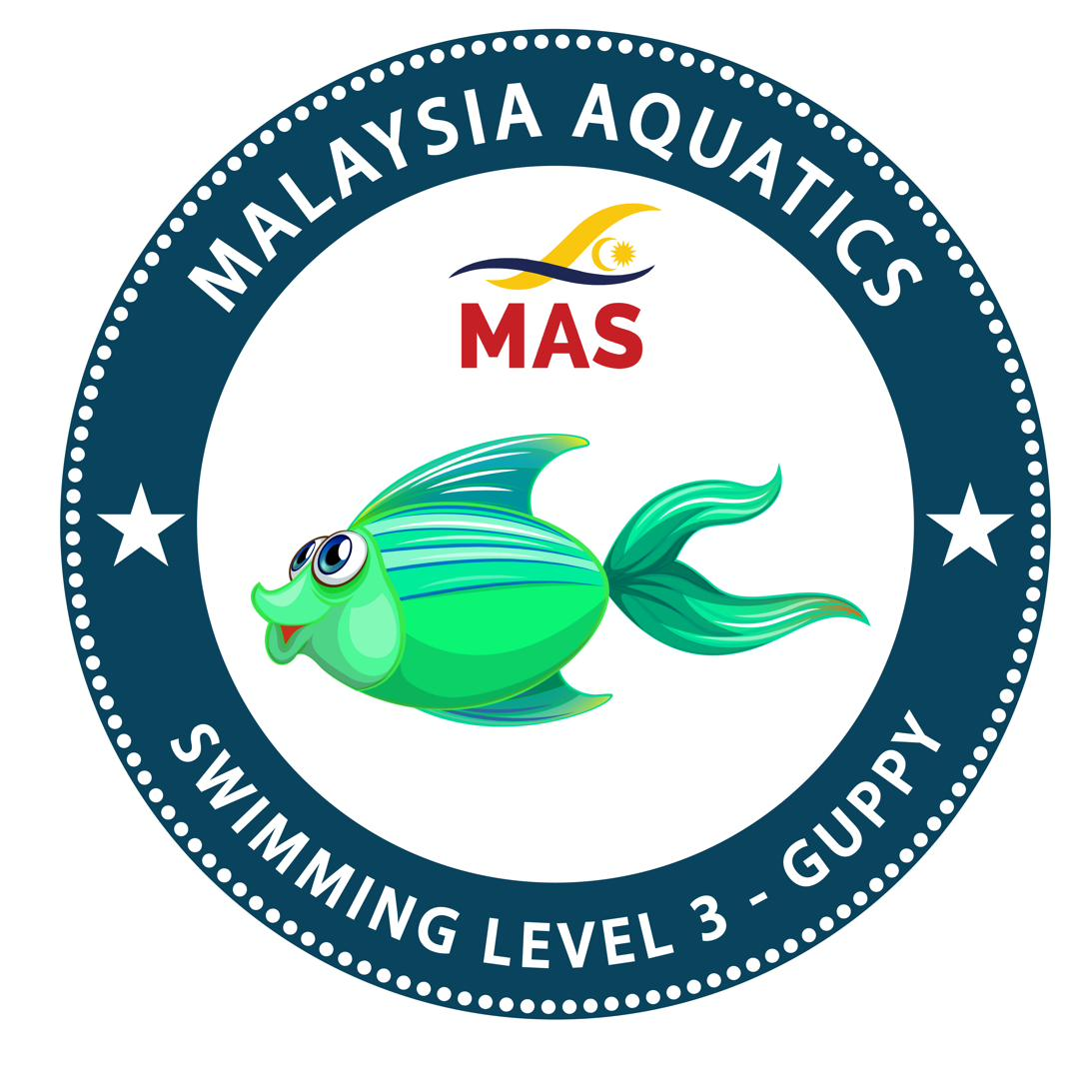 | Level 3  Guppy | FOUNDATION

Shallow or deep water · Max 12 per session

CRITERION | COMPETENT ✓ (Pass) | STRUGGLING (Refer)
1 Front crawl with unilateral breathing — 10 metres. | Rhythmic breathing to one consistent side; head turns (not lifts); stroke stays connected; 10 m clear. | Head-up breathing (lifts rather than turns); loses rhythm at breath; head-down and holds breath for 10 m; halts.
2 Backstroke — 10 metres. | Hips up; ears in the water; alternating pull; 10 m clear. | Sits or pikes; veers into lane line; halts; head lifted.
3 Streamlined underwater push and glide — 3 metres. | Clean push off wall; body streamlined and submerged; 3 m reached before surfacing. | Surfaces early; streamline unlocked (arms apart); no clean push; travels less than 3 m.
4 Water treading — 30 seconds. | Head consistently above water; controlled sculling/kick; relaxed; 30 s clear. | Dips below the surface; uses wall/lane rope; gasps; unable to sustain 30 s.

Observation pitfalls at this level
⚠ Unilateral breathing is often taught as a head-lift — a lift is a Refer. Insist on the turn.
⚠ Underwater push-and-glide is a passive glide from a push — not a swum underwater length. Watch that the swimmer is not kicking or pulling.
⚠ Deep water may be the candidate's first experience — reassure between skills; observe from a safe position.
Procedural notes
Assess in shallow or deep water. Treading is best done in deep water. All skills independent.
MY NOTES

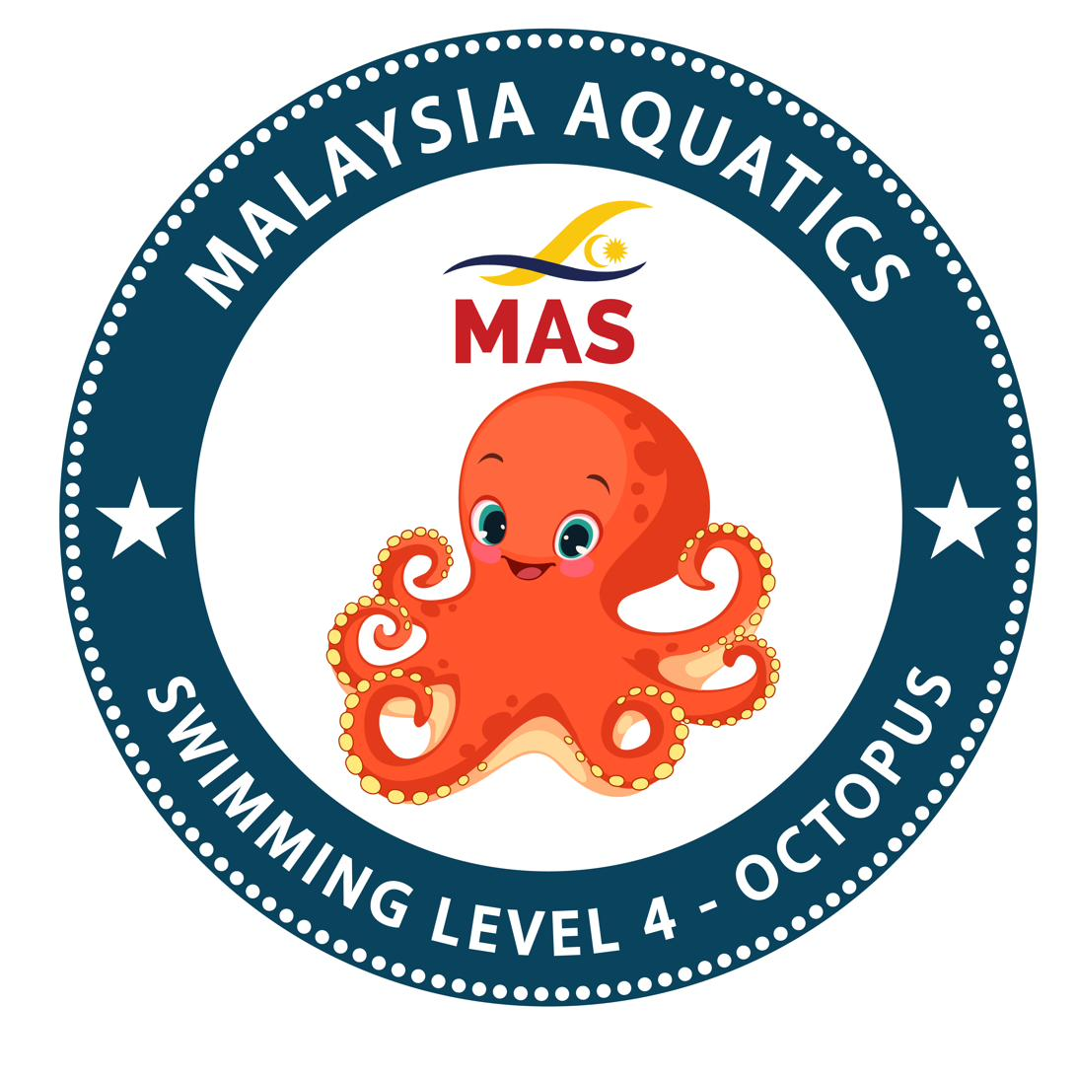 | Level 4  Octopus | FOUNDATION

Shallow or deep water · Max 10 per session

CRITERION | COMPETENT ✓ (Pass) | STRUGGLING (Refer)
1 Front crawl with bilateral breathing — 15 metres. | Alternates breathing sides consistently; rhythm held over the full 15 m; head rotates cleanly. | One-side dominant with token attempts at the other side; loses rhythm; chokes at the weaker-side breath; halts.
2 Backstroke — 15 metres. | Efficient stroke; hips up; consistent alternating pull; 15 m clear. | Sitting position; inconsistent arm cycle; halts; veers.
3 Breaststroke whip kick — 10 metres. | Symmetric: heels to bottom → turn out → whip and squeeze together; visible forward progress; 10 m clear. | Screw kick (one heel higher than the other, asymmetric turn-out); no forward travel; frog-kick without whip.
4 Sit dive + underwater streamline glide — 3 metres. | Controlled entry (no belly flop); chin tucked; streamlined body underwater; 3 m reached before surface. | Belly flop; feet-first entry; surfaces immediately; less than 3 m.
5 Survival backstroke — 10 metres. | Hips up; minimum arm/leg action; breath in control; sustained 10 m. | Head high; over-active arms (wasting energy); panicked pace; no distance.

Observation pitfalls at this level
⚠ Screw kick is masked by forward momentum from the pull — observe from behind, or from directly overhead.
⚠ Bilateral breathing sometimes shows as 3-stroke-one-side then a token 3-stroke-other-side — insist on true alternating over the 15 m.
⚠ Sit dive: chin tuck and arm lock matter more than height off the deck.
Procedural notes
Assess in shallow or deep water. Sit dive is from the wet deck, not from blocks.
MY NOTES

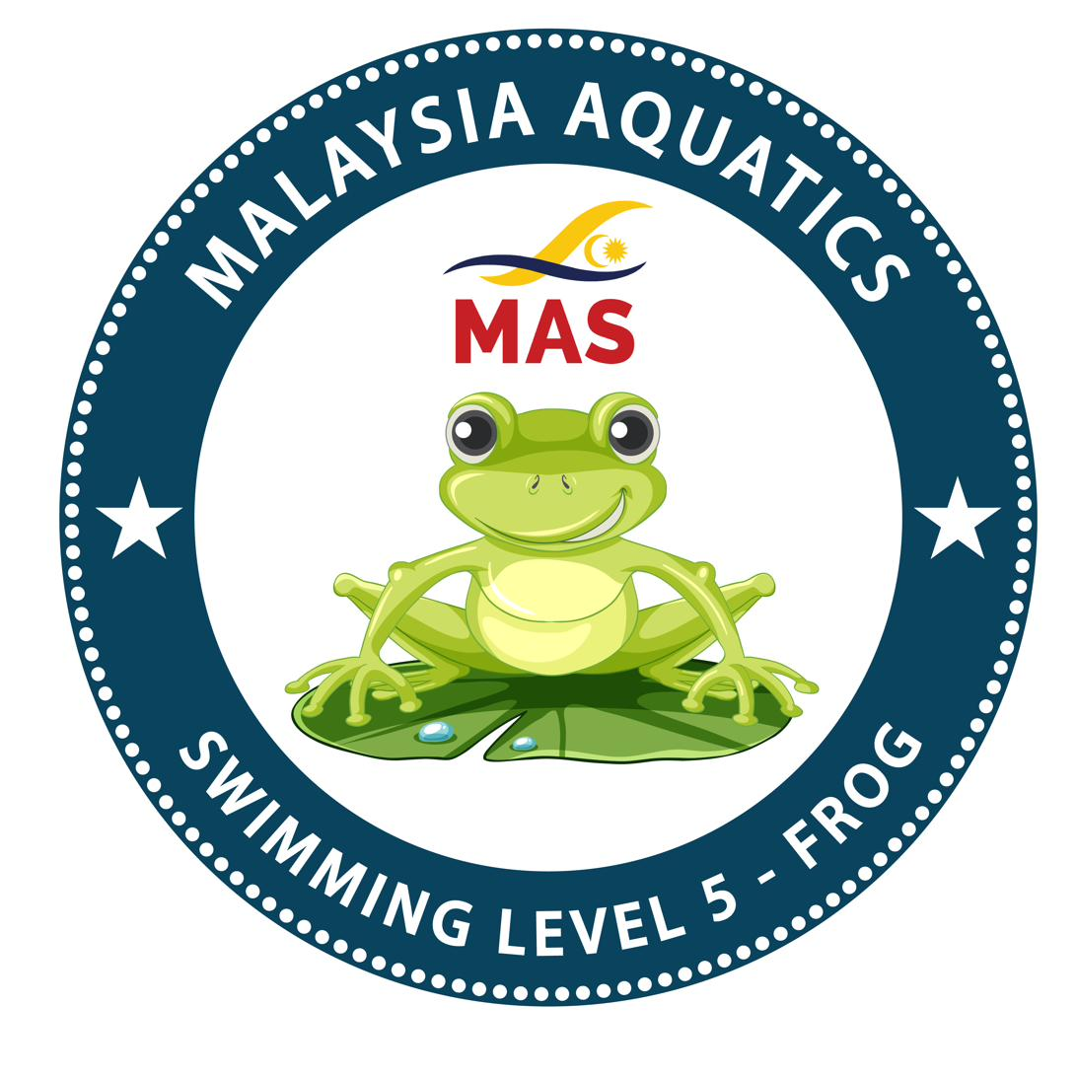 | Level 5  Frog | STROKE DEVELOPMENT

Shallow or deep water · Max 8 per session

CRITERION | COMPETENT ✓ (Pass) | STRUGGLING (Refer)
1 Front crawl with bilateral breathing — 25 metres. | Sustained rhythm and bilateral breathing across the full 25 m; no walking between reps; stroke stays connected. | Walks / touches down mid-length; loses bilateral in the last 5 m; chokes; stops for breath.
2 Backstroke — 25 metres. | Hips-up position held; no head lift; consistent alternating pull; 25 m clear. | Sitting position; head lifts; veers.
3 Breaststroke — 25 metres. | Pull-breathe-kick-glide timing intact; symmetric whip kick; visible glide phase between strokes. | No glide phase; rushed timing; screw kick; asymmetric heel action.
4 Dolphin kick — 10 metres. | Hip-led undulation; both legs move together; clear forward travel; 10 m reached. | Flutter-with-dolphin-attempt (single-leg lead); knee-only movement; no undulation.
5 Sculling with flutter kick and breathing — 15 metres. | Figure-8 scull with wrists tilted; flutter kick underneath; breath every few strokes; 15 m clear. | Stiff wrists (no sculling motion); flutter fails; breath lost; halts.
6 Flip turn — forwards and backwards separately. | Clear rotation off the wall; streamlined push-off with underwater kicks; both directions independently. | No rotation (walks off wall); no push-off; no streamline; fails one direction.
7 Squat dive + underwater dolphin — 5 metres. | Entry angle correct (fingertip lead); streamlined; dolphin kick sustained underwater to 5 m. | Belly flop; surfaces early; no dolphin kick; less than 5 m.

Observation pitfalls at this level
⚠ 'Attempted' flip turn is not competent — look for the streamlined push-off distance, not just the tumble.
⚠ 25 m distances tax stroke integrity — signs of struggle appear in the last 5 m; observe the finish especially.
⚠ Dolphin kick is often single-plane and knee-driven — insist on true hip lead. Two-body-wave should be visible.
Procedural notes
Assess in shallow or deep water. Squat dive is from the wet deck. Flip turns forwards AND backwards — both required.
MY NOTES

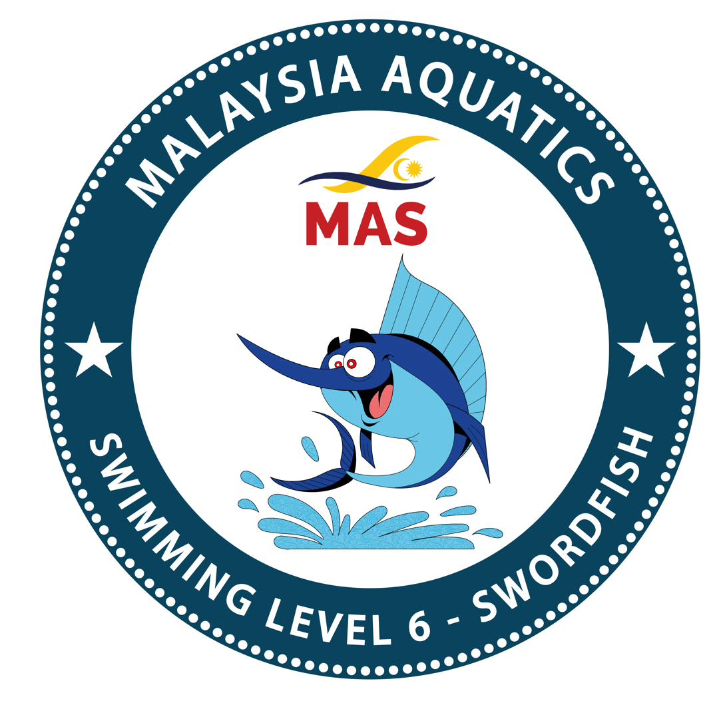 | Level 6  Swordfish | STROKE DEVELOPMENT

Shallow or deep water · Max 8 per session

CRITERION | COMPETENT ✓ (Pass) | STRUGGLING (Refer)
1 Front crawl — 50 metres with tumble turns. | Sustained stroke across all four lengths; tumble turn at each wall; pace does not collapse. | Wall-touch turn rather than tumble; pace degrades badly on later lengths; walks touchdown at a wall.
2 Backstroke — 50 metres. | Hips up; competitive-style turn at each wall; 50 m clear. | Sits; wall-grab-only at turn; halts; veers.
3 Breaststroke with underwater pullout — 50 metres (open turns). | Legal pull-out off each wall (one full pull, glide); symmetric whip kick; open turn correctly executed. | Pull-out skipped or half-done (breath at surface immediately); screw kick; incorrect open turn (both hands not touching).
4 Butterfly — 10 metres. | Hip-led undulation; two kicks per pull; arm recovery clear of the water; sustained for 10 m. | Arms drag / don't clear the water; single-plane knee-driven kick; stalls before 10 m; degrades to survival stroke.
5 Tumble turn in and out with underwater kicks. | Rotation on approach; streamlined push-off; underwater kicks visible before surface. | No rotation; touch-turn instead; no streamline hold; straight kick immediately at surface.
6 Open turn in and out with underwater kicks. | Legal open turn (both hands to wall simultaneously); push with kicks; streamline held. | Wall-grab without push; only one hand touches; no streamline; no underwater kicks.
7 Stand dive + underwater dolphin — 5 metres. | Controlled competition-style entry; streamlined; 5 m of dolphin kick before surface. | Belly flop; surfaces before 5 m; no dolphin kicks.
8 Sidestroke — 15 metres. | Recognisable stroke: top-arm/bottom-arm coordination; scissor kick; 15 m clear. | No recognisable form; no scissor kick; halts.

Observation pitfalls at this level
⚠ The breaststroke pullout is often skipped or half-done — must be a full pull under water. If breath surfaces immediately, that's a Refer.
⚠ 10 m butterfly is often 'attempted' — insist on legal butterfly for the full 10 m. Arms drag = Refer.
⚠ Tumble turn (for FC) vs. open turn (for BR/fly) — know which criterion applies to which stroke.
⚠ Stand dive at L6 is safe-and-streamlined; at L7 it becomes competitive-style off blocks.
Procedural notes
Assess in shallow or deep water.
MY NOTES

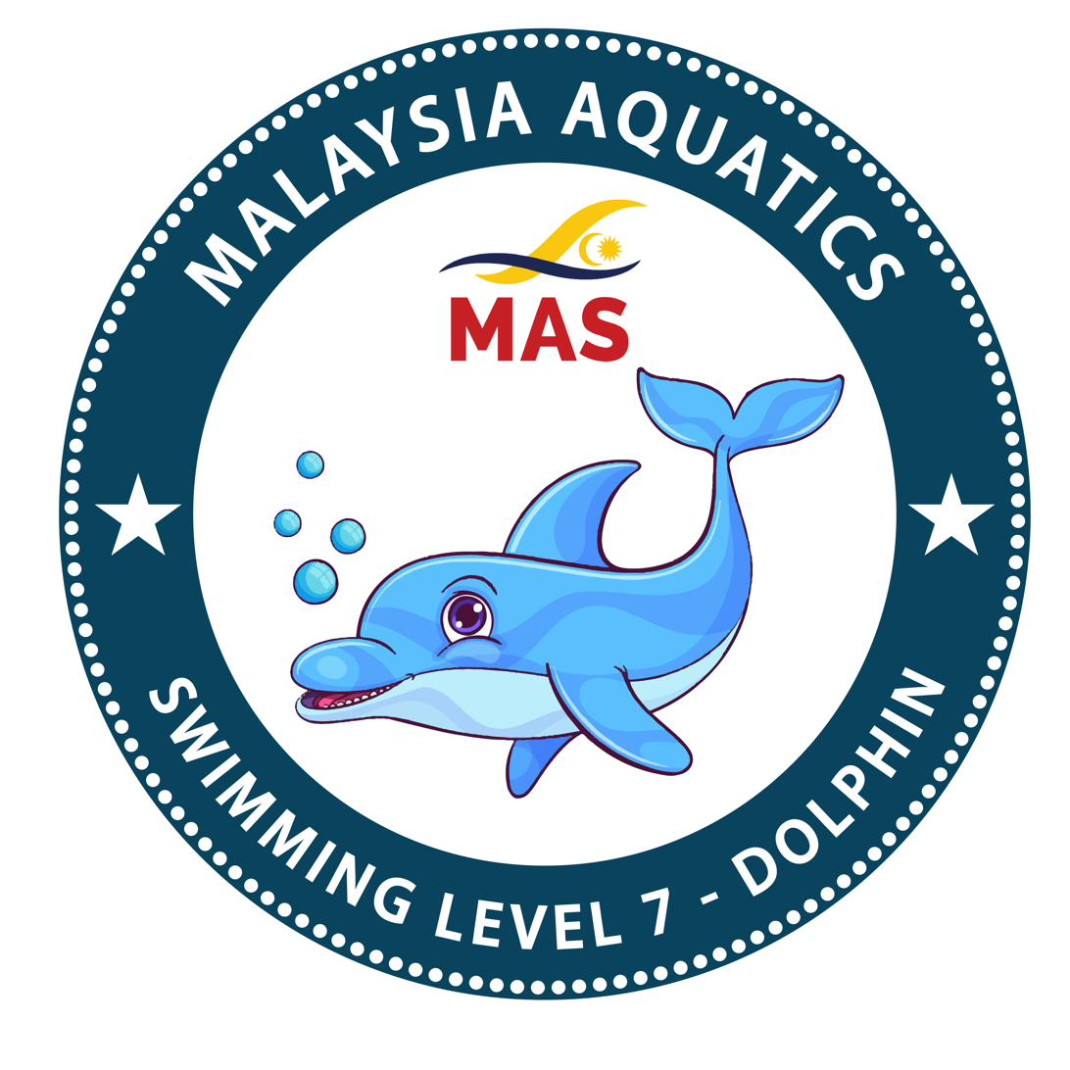 | Level 7  Dolphin | COMPETITIVE BRIDGE

Deep water only · Max 6 per session

CRITERION | COMPETENT ✓ (Pass) | STRUGGLING (Refer)
1 Front crawl 100 m within 2:30. | Pace maintained across all four lengths; high elbow visible; time is met. | Pace decays after 50 m; time missed; high-elbow catch lost; form collapses.
2 Backstroke 100 m with competitive pull. | Bent-arm pull under water; hip roll visible; sustained across 100 m. | Straight-arm through the whole 100 m; no hip roll; head lift.
3 Breaststroke with underwater pullout — 100 m. | Legal pullout at every wall; symmetric whip kick; timing intact across 100 m. | Pullout skipped or half-done on any wall; screw kick; rushed timing.
4 Butterfly — 50 metres. | Two kicks per pull; hip-led; sustained; arms clear water; 50 m held. | Degrades to survival stroke by 25 m; arms drag; single-plane kick.
5 Tumble turn in and out with underwater kicks. | Legal tumble; streamlined push-off; underwater kicks visible. | Not legal (wall-touch); no streamline; straight kick.
6 Open turn in and out with underwater kicks. | Legal open turn (both hands touch); pushed streamline; underwater kicks. | Not legal; only one hand touches; no push; no kicks.
7 Stand dive off blocks / wet deck with underwater skills. | Competitive-form entry; streamlined; skill (dolphin or flutter) into stroke. | Safe but not competitive; belly-flop; no streamline; no underwater skills.
8 Backstroke dive off blocks / wet deck with underwater skills. | Legal backstroke start; arch and streamline; underwater dolphin kicks; correct emergence to stroke. | Slips at start; no arch; no dolphin kicks; illegal recovery.
9 Individual Medley — 100 m within 3:00. | Correct order (fly → BK → BR → FC); legal transitions at each wall; within 3:00. | Wrong stroke order; illegal transition; misses time; one stroke fails.

Observation pitfalls at this level
⚠ L7 is time-critical — bring a stopwatch. Time is a hard criterion, not a guideline.
⚠ Do not accept 'attempted' for any stroke at this level. If one stroke fails, the level is Referred.
⚠ IM transitions have specific legal requirements — observe each wall carefully.
⚠ Backstroke dive off blocks is a specialised entry — check the arch and streamline separately from the kicks.
Procedural notes
Deep water only. L7 is a competitive-bridge level: judge to World Aquatics standards for legal strokes and turns. Two hard timings: FC 100 m ≤ 2:30 and IM 100 m ≤ 3:00.
MY NOTES

M5 | Conduct of Assessment | CLASSROOM + ROLE-PLAY

You will be able to: watch real swimmers at each level and calibrate your eye to the competent-vs-struggling line before you judge live.

Key points
• The same video library used in the instructor course, viewed through the examiner’s lens: your job is to judge, not teach.
• Watch competent performance and common faults at each level; discuss what tips a criterion from Pass to Refer.
• Calibrate your eye against the Chief Examiner’s benchmark — the standard is the Syllabus, not personal preference.
• Bridges the level-standards modules (M2–M4) and the assessment-conduct module (M7): you see the standard before you learn to run the day.

MY NOTES

You will be able to: run a safe, impartial assessment day from pre-check through record submission.

Key points
• Arrive 15 minutes early. Inspect the pool. Confirm your Water-Safety Supervisor and Assistant Facilitators are present (staffing table, Annex B).
• Registration & consent gate: no consent, no assessment. Late arrivals after the safety briefing cannot join.
• Keep parents/coaches in the separate holding area — no contact during the assessment.
• Level by level; a pass reveals the next level; you never announce results at the poolside.
• Submit records on the Portal within 48 hours (7 working days max).

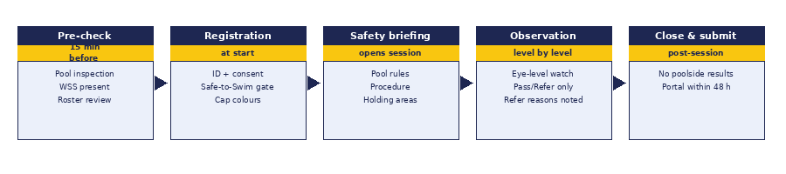

MY NOTES

M6 | Code of Conduct | CLASSROOM

You will be able to: uphold the Examiner Code of Conduct, with the conflict-of-interest rule at its core.

Key points
• Conflict of interest — never assess a candidate you have personally taught or coached. If you are the only option, a different examiner is arranged.
• No gifts. No payments beyond the official MAS fee. Ever.
• Standards discipline: an award is never lowered to grant an unearned success. A shortfall is a Refer with a brief written reason.
• Confidentiality: candidate records are for MAS certification purposes only, never published, never repurposed.
• Safeguarding: parental consent verified; a child is never isolated one-to-one out of sight; concerns escalate immediately to the Designated Safeguarding Lead (interim: the Chairperson).

MY NOTES

M7 | BADGES Portal for Examiners | HANDS-ON

You will be able to: operate the Portal end to end for the examiner role.

Key points
• Onboarding is gated: pass the quiz, accept the Code, then the Chief Examiner activates you. Your Examiner ID is auto-generated (e.g. EXM-2026-0001).
• You see sessions in your state's pool after the instructor's payment clears. You claim a session; the roster becomes yours.
• The Portal blocks you from grading candidates you have taught — the conflict-of-interest rule is enforced in data.
• Record Pass/Refer per candidate per level. Refers require a brief reason. Submission triggers pass-gated certificate issuance.
• You never see the amounts charged to instructors, and you never announce results at the pool — release is central.

MY NOTES

M8 | Practical Independent Assessment | POOL

You will be able to: run a real mock assessment to the Competent standard under Master Trainer observation.

Key points
• You run a mock assessment on real swimmers. The Master Trainer observes on deck.
• Rated on five domains: safety & procedure, observation & positioning, judgement (Pass/Refer accuracy), record & conduct, and impartiality.
• Poolside calibration — you, the Master Trainer, and the Chief Examiner must arrive at the same Pass/Refer on each candidate.
• Safety & procedure is a hard gate: a shortfall there is an automatic non-pass, whatever else you do well.



MY NOTES

The Rubric
How you will be assessed in Module 9 — the practical independent assessment.
Every domain must reach Competent or above. Domain 1 (Safety & Procedure) is a hard gate — a non-pass there is an automatic non-pass, regardless of everything else. A non-pass is called a Refer; the assessor names the domain to develop before the candidate re-attempts.
Domain | Not Yet | Developing | Competent ✓ | Strong
1 Safety & Procedure  ⚠ HARD GATE | Skips pre-check; poor briefing; procedure not followed. | Follows most steps but with lapses. | All pre-check items done; safe briefing; procedure followed correctly. | Anticipates and pre-empts issues; team runs like clockwork.
2 Observation & Positioning | Watches from the deck at height; misses details. | Position sometimes correct; observation intermittent. | Positioned on deck to see the criterion clearly; watches every candidate. | Anticipates the fault; position adapts to the criterion.
3 Judgement (Pass/Refer accuracy) | Passes clearly-Refer performances; misses obvious criteria failures. | Correct on easy calls; struggles at the borderline. | Agrees with Chief Examiner and Master Trainer on every call, including borderline. | Reasons articulated to the criterion; borderline calls calibrated.
4 Record & Conduct | Announces results at pool; incomplete record; sloppy. | Record complete but slow; occasional slip in conduct. | Record complete; no poolside results; conduct professional throughout. | Submits within hours; record clean; conduct exemplary.
5 Impartiality & Independence | Assesses own students; accepts favours; standards drift under pressure. | COI rule respected but not modelled to peers. | COI declared and acted on; no favours; standards held under pressure. | Actively upholds independence; educates peers on the COI rule.

Pass = Competent or Strong on every domain.
Refer = not yet Competent on any domain — state which. Domain 1 non-pass = Refer regardless of other scores.
MY NOTES

Quick reference (1 of 3) — The session day
A single page reminding you what happens, in order, on assessment day.


Pre-assessment — ≥ 30 days before
• Booking confirmed on the Portal; you accepted the session (COI-clean).
• Date, venue, and roster acknowledged; equipment list sent to the requesting instructor.
• Water-Safety Supervisor and Assistant Facilitators arranged per staffing table.
• Parental consent and Safe-to-Swim Declaration collected for every candidate.
On the day
• Arrive 15 minutes early. Inspect the pool. Confirm water-safety team is present.
• Registration: identity check, consent gate.
• Late arrivals after the safety briefing may not join — no exceptions.
• Parents and coaches to the parents' holding area; no contact during assessment.
• Deliver the safety briefing. State pool rules, procedure, and holding areas.
• Assess level by level, in ordered sequence. A pass reveals the next level, up to a Refer — no skipping.
• No poolside results. Ever. Record per candidate per level on the Portal.
Post-assessment
• Submit records within 48 hours (7 working days maximum).
• Notify MAS the same day of any rain-off, incident, or safeguarding concern.
• Bonus level Passes (levels attempted beyond the booked one) trigger stage-2 invoices to the instructor; those certificates release on payment.

Quick reference (2 of 3) — Limits, staffing & weather
The numbers that govern how a safe, standards-holding session is built.
Session limits per level (one examiner)
Level | Max | Water
L1 Starfish | 16 | Shallow
L2 Sea Turtle | 14 | Shallow
L3 Guppy | 12 | Shallow / deep
L4 Octopus | 10 | Shallow / deep
L5 Frog | 8 | Shallow / deep
L6 Swordfish | 8 | Shallow / deep
L7 Dolphin | 6 | Deep only

Up to three adjacent levels may be assessed in one session. One examiner assesses up to 30 candidates; above 30 a second examiner runs parallel, to a maximum of 60.
Staffing team (Annex B)
Candidates | Examiners | Water-Safety Supervisors | Assistant Facilitators | Min. team
1–12 | 1 | 1 | — | 2
13–20 | 1 | 1 | 1 | 3
21–30 | 1 | 2 | 1* | 4
31–45 | 2 | 2 | 2* | 6
46–60 | 2 | 3 | 2* | 7

* For 21+, one Assistant Facilitator is the named Session Coordinator. Deep water (any L4–L7 in deep water): ≥ 2 WSS regardless of band. Never double: examiner never the safety person; WSS never the marshal.
Inclement weather — Annex A
Scenario | L1 | L2 | L3 | L4 | L5 | L6 | L7
Alert lifted 15 min after start (~60 min effective) | ≤12 | ≤10 | ≤8 | ≤6 | ≤5 | ≤4 | ≤4
Alert lifted 30 min after start (~45 min) | ≤8 | ≤6 | ≤6 | ≤4 | off | off | off
Beyond 30 min after start (<45 min) | off | off | off | off | off | off | off

"off" = rain-off for that level. Rain-off candidates re-book at no additional fee. Your safety judgement always prevails; pool is cleared at first lightning or thunder.

Quick reference (3 of 3) — Code of Conduct
The signed operating instrument. Every examiner signs this on appointment and re-affirms at renewal.
Conflict of interest — the one rule you cannot break
You may not assess any candidate you have personally taught, coached, or instructed in the relevant skills.
If the candidate's own instructor is the only examiner available, a different examiner is arranged — from within the centre, from another centre, or by cross-state deployment. The Portal enforces this rule in data.

Standards discipline | An award is never lowered to grant an unearned success. A shortfall is a Refer with a brief written reason. You judge against the published criteria, not personal preference.
No gifts, no payments | No gift, payment, or benefit beyond the official MAS fee may be accepted from a candidate's family. Under any circumstance.
Confidentiality & data | Candidate records are confidential, used only for MAS certification purposes, never published or repurposed without MAS approval.
Safeguarding throughout | Parental consent verified before any child takes part. A child is never isolated one-to-one out of sight. A child's result and identity are never disclosed poolside or publicly. Concerns escalate immediately to the Designated Safeguarding Lead (interim: the Chairperson).
Recusal (MT/CE) | A Master Trainer or Chief Examiner may hold a centre affiliation. They recuse from any decision involving their own centre — venue approval, scheduling, complaints, or certifying their own staff.
No poolside results | Outcomes are never read out, displayed, or discussed at the pool. Release is central via the Portal, protecting examiner independence and the child's privacy.

Breach tiers — Annex D
Tier | Examples | Typical action
Minor | Late arrival · late record submission · minor administrative lapse. | Verbal warning; written warning on repeat.
Major | Compromising safety in the conduct of an assessment · circumventing procedure · failing to declare a conflict of interest. | Written warning; suspension on repeat.
Serious | Major safety lapse · fraudulent results · safeguarding breach · behaviour causing a child discomfort. | Suspension or removal (Board ratifies removal).

MAS BADGES

Keep this workbook.
Your notes here become the start of your calibrated eye —
the Chief Examiner's, the Master Trainer's, and yours in agreement.

BADGES · NATIONAL LEARN-TO-SWIM SYSTEM www.masbadges.org

