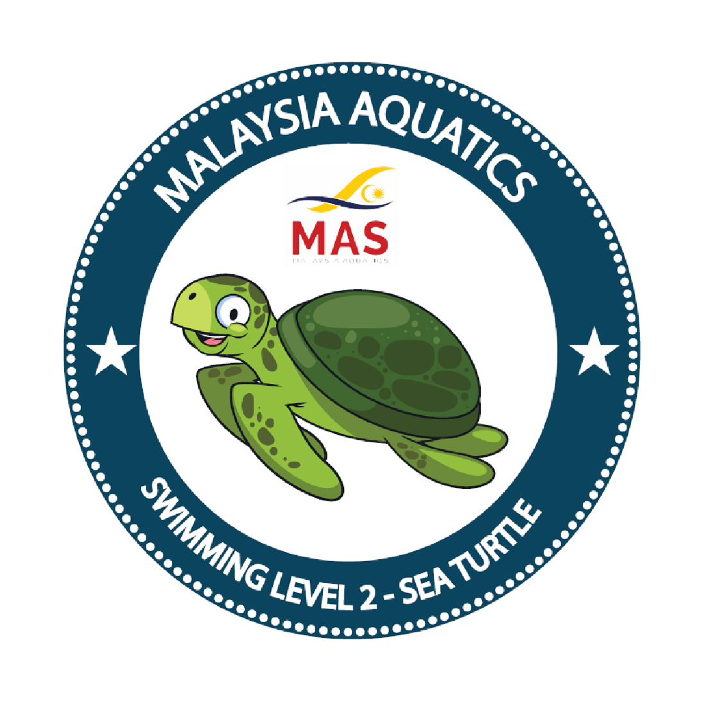

MALAYSIA AQUATICS · AKUATIK MALAYSIA
MAS BADGES
INSTRUCTOR CERTIFICATION COURSE

Notes Booklet
A participant workbook for the BADGES Instructor Certification Course

— follow along, and make it your own —

BADGES · NATIONAL LEARN-TO-SWIM SYSTEM www.masbadges.org

How to use these notes
These notes follow the course module by module. Each module page gives you the outcome (what you'll be able to do), the key points to remember, a diagram or space for a photo, and room for your own notes. Write in them freely — the best instructors keep a working notebook.
The notes mirror the Teaching System Handbook (the standard) and the Instructor Certification Course Guide (the course). Where the two go deeper, this workbook points you there.
The course at a glance
Day | Focus | Modules
Day 1 | Foundations | M1 Programme & Governance · M2 The Syllabus Taught · M3 Swimming on Video · M8 Water Safety & Safeguarding · M10 Conduct
Day 2 | Method & safety | M4 IRD · M5 Lesson Delivery · M6 Safe Teaching & Position · M7 Safety Responsibilities · M9 Engagement
Day 3 | System & assessment | M11 The Portal · M12 Preparing for Assessment · M13 Practical Teaching Assessment

To be certified: attend every module, pass the theory quiz (Manual Appendix F), demonstrate Portal competency, and reach Competent on the practical teaching assessment.
Two reference sections you'll come back to often
The Seven Levels — Teaching Guide sits between M2–M3 and M4. One page per level: teaching objectives, assessment criteria, and correction cues you can use on deck.
Quick reference (1–3) at the back: teaching position, ratios, checklists, rubric, assessment sequences, and a full fault-and-correction table.

The three ideas everything rests on
Safe, competent, confident — in that order.
Teach to the skill, not to the test — real competence, and the pass follows.
You prepare; an independent examiner judges — that separation is what makes the badge mean something.

BADGES essentials
The pathway — seven levels, one continuous journey
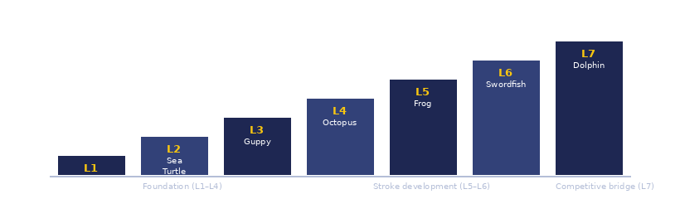

The IRD teaching cycle
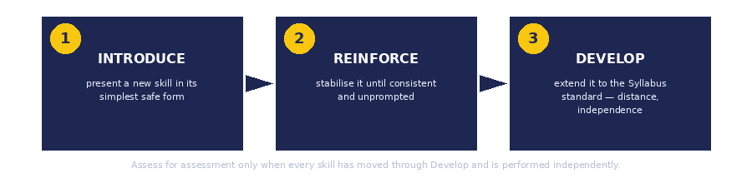

Independence
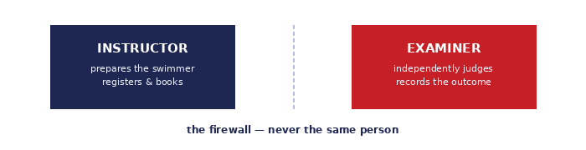

M1 | Programme & Governance | CLASSROOM

You will be able to: explain where you fit in the BADGES system and why the separation of instructing and examining exists.

Key points
• MAS runs BADGES: the Board, the Coaching & Technical Board, the Chairperson, the Chief Examiner, and the Master Trainer.
• Six governing documents: the Manual, the 7-Level Syllabus, the Teaching System Handbook, the Assessment System Handbook, and the two Course Guides.
• The certificate certifies the swimmer, never the coach.
• The one rule: every assessment is booked by a certified instructor, and whoever assesses a swimmer is never that swimmer's own teacher.



MY NOTES

M2 | The 7-Level Syllabus, Taught | CLASSROOM + POOL

You will be able to: recognise what “ready” looks like at each of the seven levels.

Key points
• Seven levels, Starfish → Dolphin, earned in order — no skipping.
• Each level has Teaching Objectives (Introduce/Reinforce/Develop) and Assessment Criteria — you teach toward the criteria.
• Foundation L1–L4 · stroke development L5–L6 · competitive bridge L7.
• The Syllabus owns what is assessed; you never restate or drill the exact test.



MY NOTES

The Seven Levels — Teaching Guide
This section is your level-by-level companion. For each of the seven levels you'll find the teaching objectives (what to Introduce, Reinforce, and Develop), the full assessment criteria your swimmers must meet, and the key correction cues for the faults most common at that stage.
Use these pages in lessons: before a session, remind yourself what the level demands; during, look up the cue for whatever you're seeing; after, note what's progressing and what still needs work.
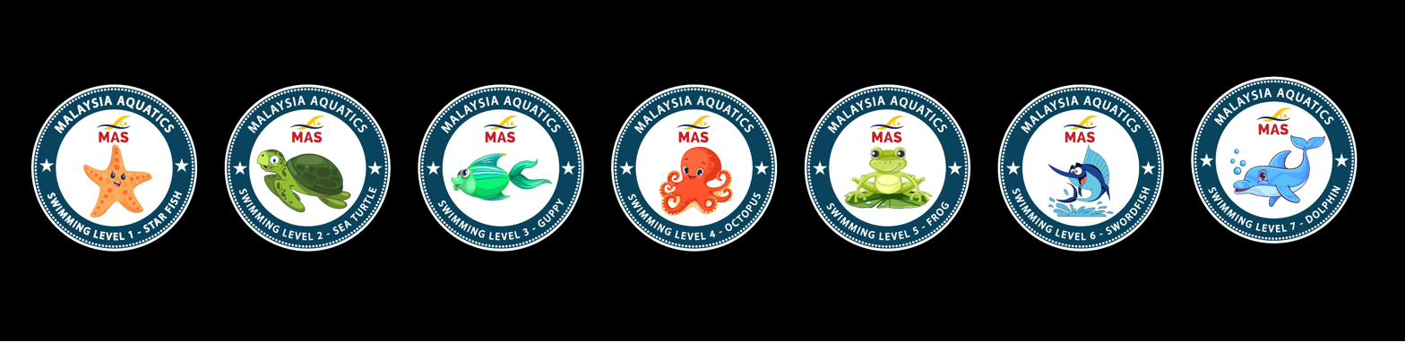

Pathway overview
Phase | Levels | Focus
Foundation | L1–L4 · Starfish to Octopus | Water confidence, safe entry/exit, basic strokes (FC, BK), survival skills, body position, kicking foundations, bilateral breathing, basic diving.
Stroke Development | L5–L6 · Frog & Swordfish | All four competitive strokes, sculling, flip and open turns, stand dive, distance and efficiency.
Competitive Bridge | L7 · Dolphin | High-elbow FC, competitive BK pull, IM 100m, time qualifications — competition foundation.

Remember: the Syllabus owns the criteria; you own the method.
Never drill the exact assessment task. Build the skill — meeting the criterion becomes natural.

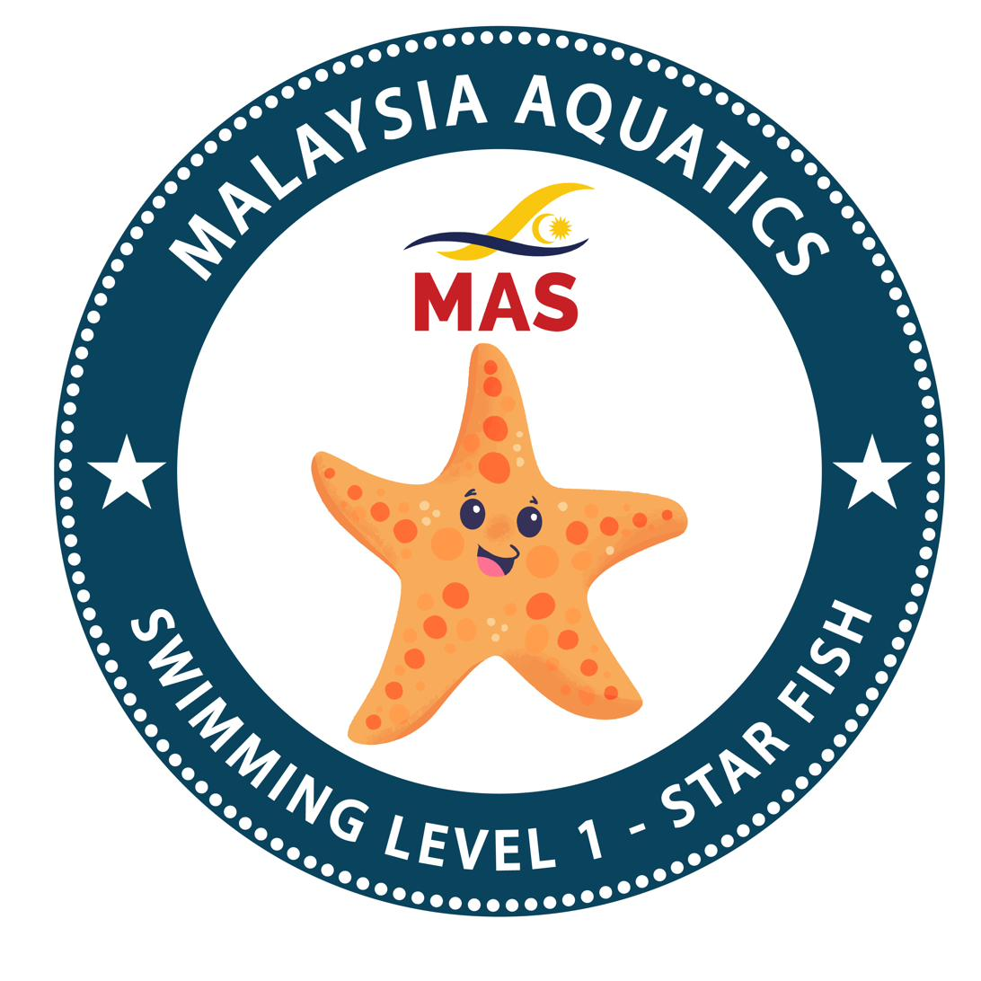 | Level 1  Starfish | FOUNDATION

TEACHING OBJECTIVES  INTRODUCE  › Rules & regulations at the pool  › Safe entries & exits  › Comfortable breath (exhale & inhale) in water  › Basic flotation & water familiarisation  › Basic mobility in water  › Basic stationary survival skill  DEVELOP  › Confidence in the water environment  › Basic mobility in the water environment  › Survival skill |  | ASSESSMENT CRITERIA  Demonstrate ability to:  1 Enter and exit the pool safely.  2 Exhale (blow bubbles) with the head fully submerged, then inhale after resurfacing — 10 repetitions (bobbing).  3 Perform a front float comfortably for 10 seconds.  4 Perform a back float comfortably for 10 seconds.  5 Perform a streamlined front flutter kick for 3 metres.  6 Perform a back push and glide for 2 metres.  7 Perform a lateral rotation from a horizontal float — back-to-front and front-to-back.  Condition: All skills performed in shallow water. Skills done independently.

Key correction cues for this level
FAULT | LIKELY CAUSE | CUES YOU CAN USE
Front/back float — hips sink | Head lifted · empty lungs · tension | "Look down, belly to the sky, big lungs; ears in on your back."
Streamline — arms apart, quick sink | No lock position | "Squeeze your ears, hide your chin, point like an arrow."
Flutter kick — big knee bend, no travel | Kicking from the knee, stiff ankles | "Long legs, floppy feet, kick from the hips — small and fast."

MY NOTES

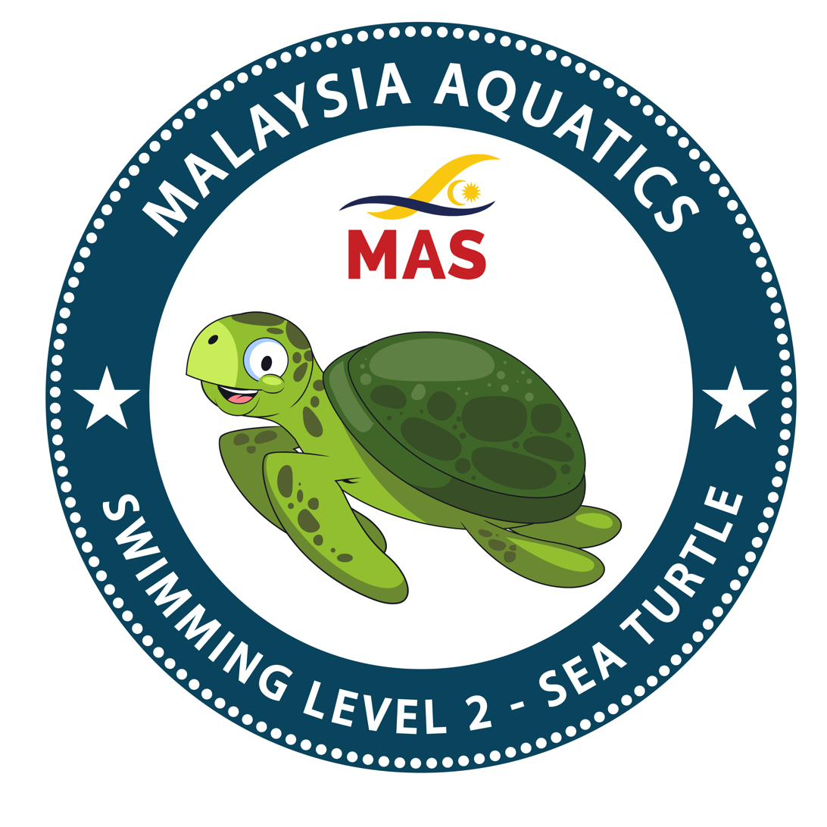 | Level 2  Sea Turtle | FOUNDATION

TEACHING OBJECTIVES  INTRODUCE  › Self-survival (grab onto wall)  › Basic front mobility  › Basic back mobility  › Basic mobility survival skills  REINFORCE  › Safe entry & exit  › Body position — prone & supine awareness  › Streamlined front flutter kick  › Lateral rotation (front and back)  DEVELOP  › Fall in, turn and grab wall  › Basic front crawl arm movement  › Back flutter kick  › Basic backstroke arm movement  › Reach and pull with breath as a survival skill |  | ASSESSMENT CRITERIA  Demonstrate ability to:  1 Fall in, perform a turn in the water and grab onto a wall or ledge.  2 Perform basic front crawl arm movement with flutter kick for 5 metres.  3 Perform back flutter kick for 5 metres.  4 Perform basic backstroke arm movement with flutter kick for 5 metres.  5 Perform reach and pull with comfortable breath for 5 metres.  Condition: All skills performed in shallow water. Skills done independently.

Key correction cues for this level
FAULT | LIKELY CAUSE | CUES YOU CAN USE
Front crawl — hand crosses the centre-line | Reaching across the body | "Reach past your shoulder — swim on train-tracks."
Backstroke — sits / pikes | Head & hips low | "Head still, ears in, hips up, tummy to the sky."
Backstroke — bent-arm entry | No straight recovery | "Thumb out, little-finger in, brush your ear."

MY NOTES

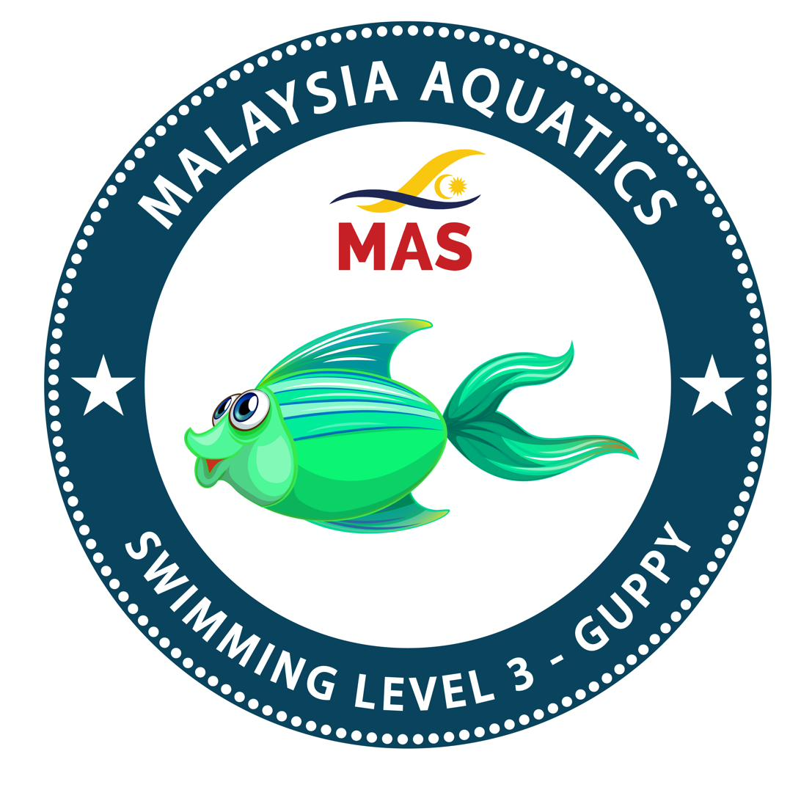 | Level 3  Guppy | FOUNDATION

TEACHING OBJECTIVES  INTRODUCE  › Basic front crawl swim with breathing  › Underwater mobility skill  › Deep-water stationary survival skill  REINFORCE  › Consistent basic front crawl swim  › Consistent basic backstroke swim  › Efficient survival skills  DEVELOP  › Basic front crawl with unilateral breathing  › Efficient backstroke swim  › Underwater push-off skill  › Mobility in survival skills |  | ASSESSMENT CRITERIA  Demonstrate ability to:  1 Perform basic front crawl swim with unilateral breathing for 10 metres.  2 Perform backstroke swim for 10 metres.  3 Perform a streamlined underwater push and glide for 3 metres.  4 Perform water treading for 30 seconds.  Condition: All skills performed in shallow or deep water. Skills done independently.

Key correction cues for this level
FAULT | LIKELY CAUSE | CUES YOU CAN USE
Front crawl — lifts head to breathe | Head up not rotating | "Turn, don't lift — keep one goggle in."
Backstroke — sits / pikes | Head & hips low | "Head still, ears in, hips up, tummy to the sky."
Streamline — arms apart | No lock | "Squeeze your ears, hide your chin, point like an arrow."

MY NOTES

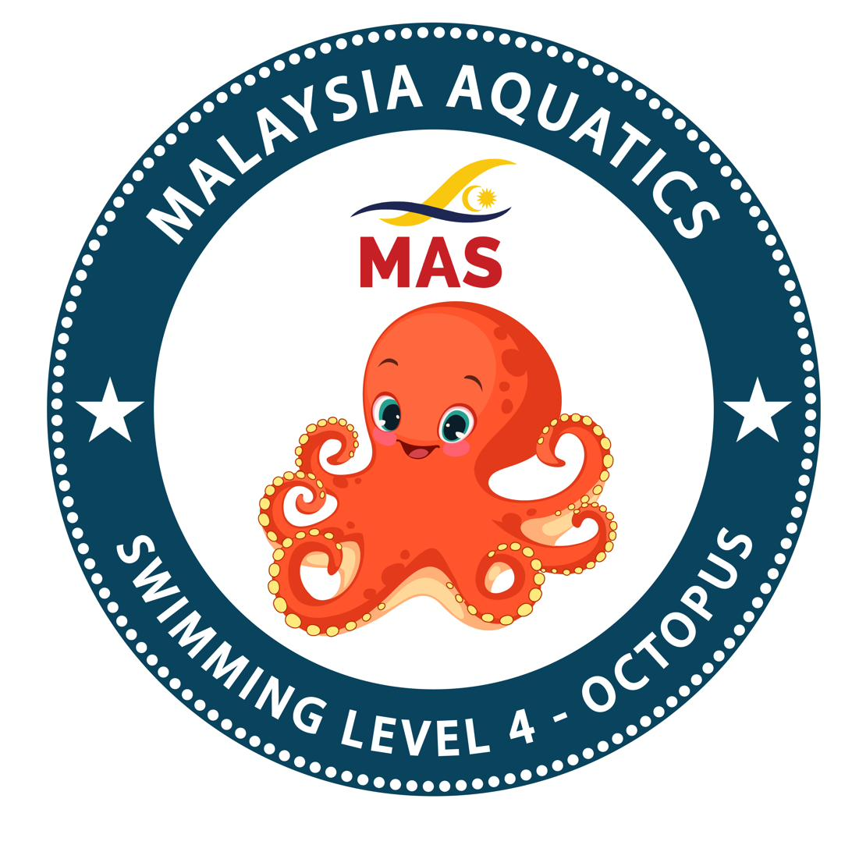 | Level 4  Octopus | FOUNDATION

TEACHING OBJECTIVES  INTRODUCE  › Front crawl swim with bilateral breathing  › Breaststroke whip kick  › Basic sit dive with underwater skill  › Intermediate mobility survival skills  REINFORCE  › Efficient front crawl swim  › Efficient backstroke swim  › Streamlined underwater skills  › Survival skills  DEVELOP  › Front crawl swim with breathing and distance  › Efficient backstroke swim with distance  › Sit dive into underwater skill progression  › Mobility in survival skills |  | ASSESSMENT CRITERIA  Demonstrate ability to:  1 Perform front crawl with bilateral breathing for 15 metres.  2 Perform backstroke swim for 15 metres.  3 Perform breaststroke whip kick for 10 metres.  4 Perform a sit dive off the wet deck with underwater streamline glide for 3 metres.  5 Perform survival backstroke swim for 10 metres.  Condition: All skills performed in shallow or deep water. Skills done independently.

Key correction cues for this level
FAULT | LIKELY CAUSE | CUES YOU CAN USE
Front crawl — dropped elbow, short pull | No catch | "High elbow, fingertips down, pull past your hip."
Breaststroke — screw kick | Asymmetric turn-out | "Heels to your bottom, feet turned out, whip and squeeze evenly."
Dive — belly flop | Chin up, no aim | "Hide your chin, squeeze your ears, aim your fingers at a spot."

MY NOTES

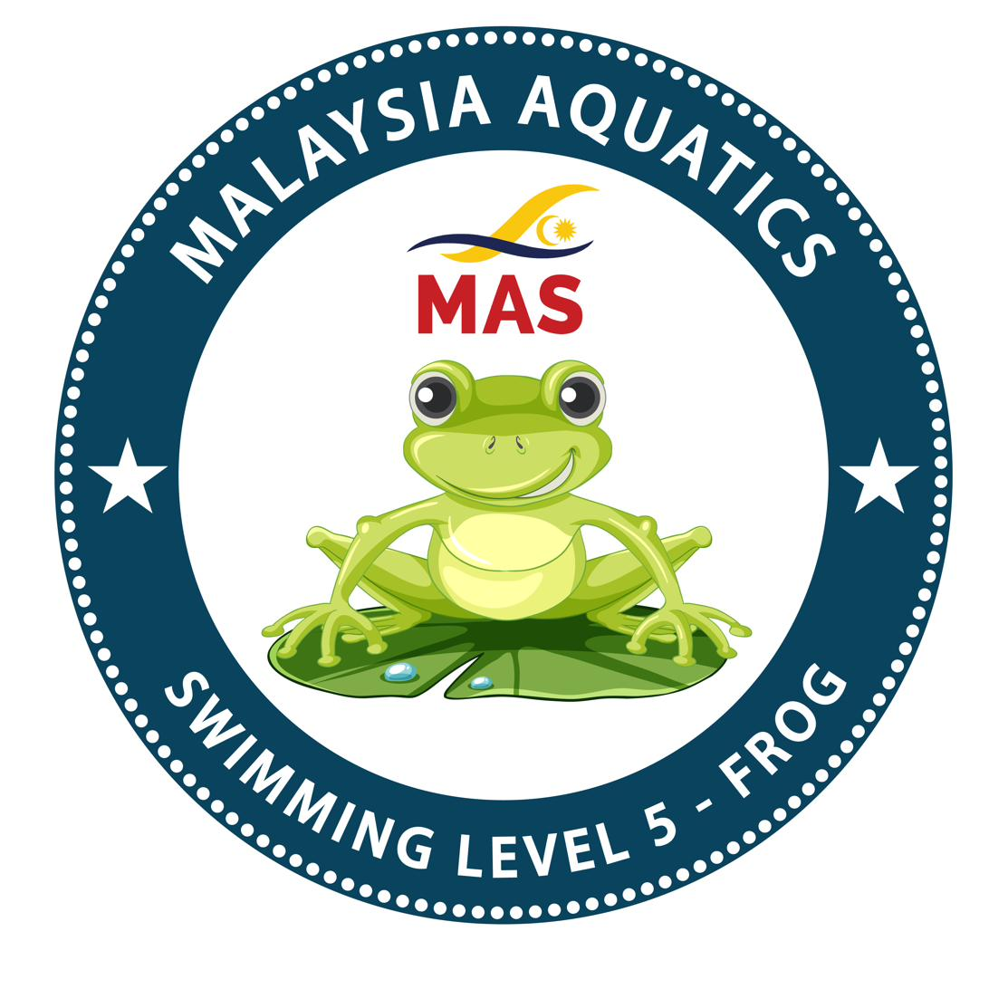 | Level 5  Frog | STROKE DEVELOPMENT

TEACHING OBJECTIVES  INTRODUCE  › Breaststroke swim  › Dolphin kick  › Basic sculling motion  › Basic flip turn  › Squat dive with underwater skill  REINFORCE  › Efficient front crawl & backstroke swim  › Dive skill  › Streamlined underwater skills  › Survival skills  DEVELOP  › Front crawl & backstroke distance  › Breaststroke full stroke  › Efficient dive and underwater skills  › Mobility in survival skills |  | ASSESSMENT CRITERIA  Demonstrate ability to:  1 Perform front crawl with bilateral breathing for 25 metres.  2 Perform backstroke swim for 25 metres.  3 Perform breaststroke swim for 25 metres.  4 Perform dolphin kick for 10 metres.  5 Perform sculling with flutter kick and breathing for 15 metres.  6 Perform a 360° flip turn forwards and backwards separately.  7 Perform a squat dive off the wet deck with underwater dolphin kick for 5 metres.  Condition: All skills performed in shallow or deep water. Skills done independently.

Key correction cues for this level
FAULT | LIKELY CAUSE | CUES YOU CAN USE
Breaststroke — no glide, timing collapsed | Rushing the cycle | "Pull — breathe — kick — glide; be a torpedo between strokes."
Butterfly — arms-only, stalls | No hip drive | "Hips lead — two kicks, one pull; kick your hands in and out."
Tumble turn — mistimed | Judging late | "Pick your marker, last stroke in, tuck and flip; feet plant, arrow, push."

MY NOTES

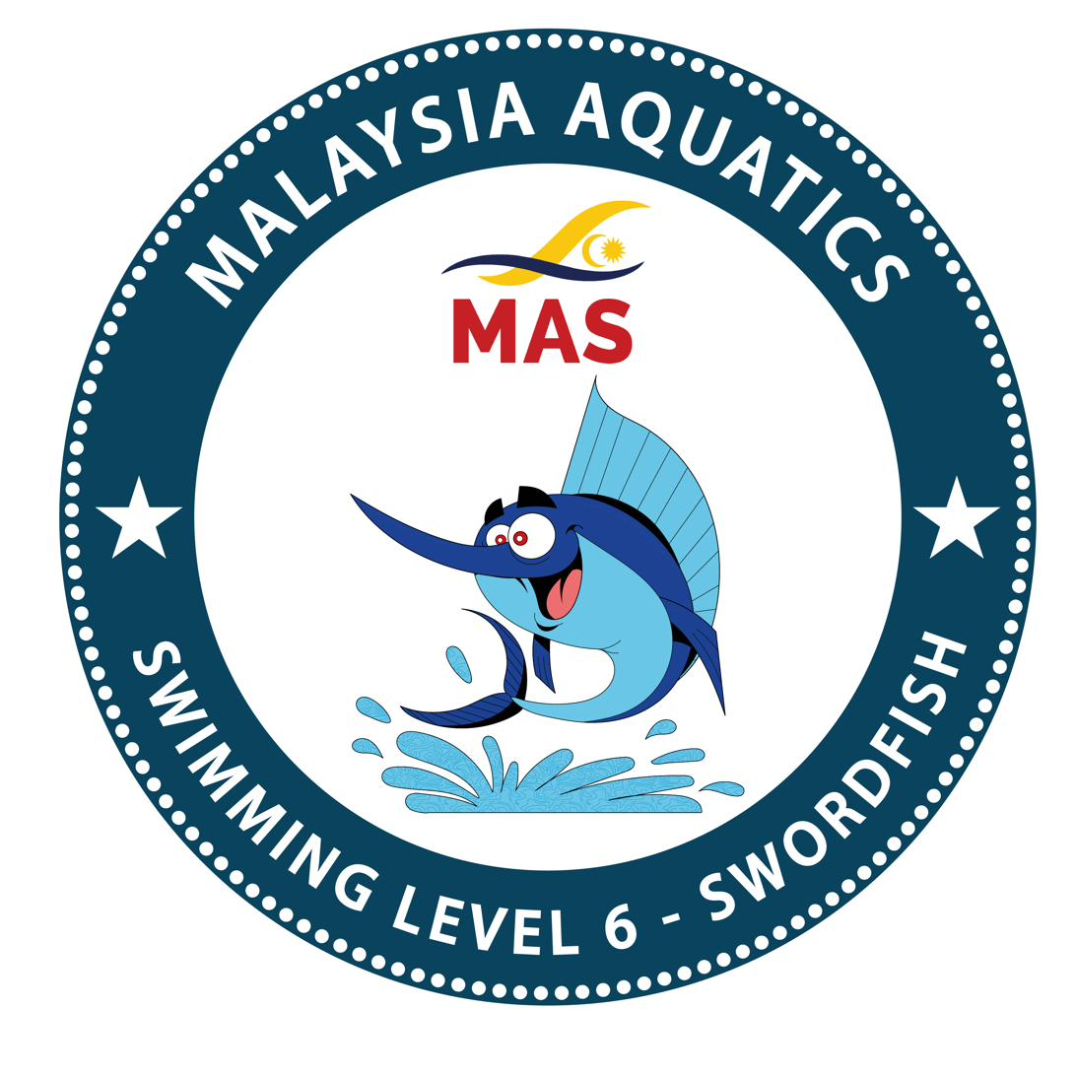 | Level 6  Swordfish | STROKE DEVELOPMENT

TEACHING OBJECTIVES  INTRODUCE  › Breaststroke pullout  › Butterfly swim  › Tumble turn with wall  › Open turn with wall  › Stand dive and underwater skills  › Sidestroke  REINFORCE  › Efficient front crawl, backstroke & breaststroke  › Flip turn  › Dive skill  › Sculling skills  › Underwater skills  DEVELOP  › Front crawl, backstroke & breaststroke swim distance  › Butterfly full stroke  › Tumble turn and open turn out of wall  › Dive and underwater skills |  | ASSESSMENT CRITERIA  Demonstrate ability to:  1 Perform front crawl swim for 50 metres.  2 Perform backstroke swim for 50 metres.  3 Perform breaststroke with underwater pullout swim for 50 metres.  4 Perform butterfly for 10 metres.  5 Swim into the wall, tumble turn, and out of the wall with underwater kicks.  6 Swim into the wall, open turn, and out of the wall with underwater kicks.  7 Perform a stand dive off the wet deck with underwater dolphin kick for 5 metres.  8 Perform sidestroke for 15 metres.  Condition: All skills performed in shallow or deep water. Skills done independently.

Key correction cues for this level
FAULT | LIKELY CAUSE | CUES YOU CAN USE
Butterfly — arms-only, stalls | No hip drive | "Hips lead — two kicks, one pull; kick your hands in and out."
Breaststroke — no glide | Timing collapsed | "Pull — breathe — kick — glide; be a torpedo between strokes."
Tumble turn — mistimed | Judging late | "Pick your marker, last stroke in, tuck and flip; feet plant, arrow, push."

MY NOTES

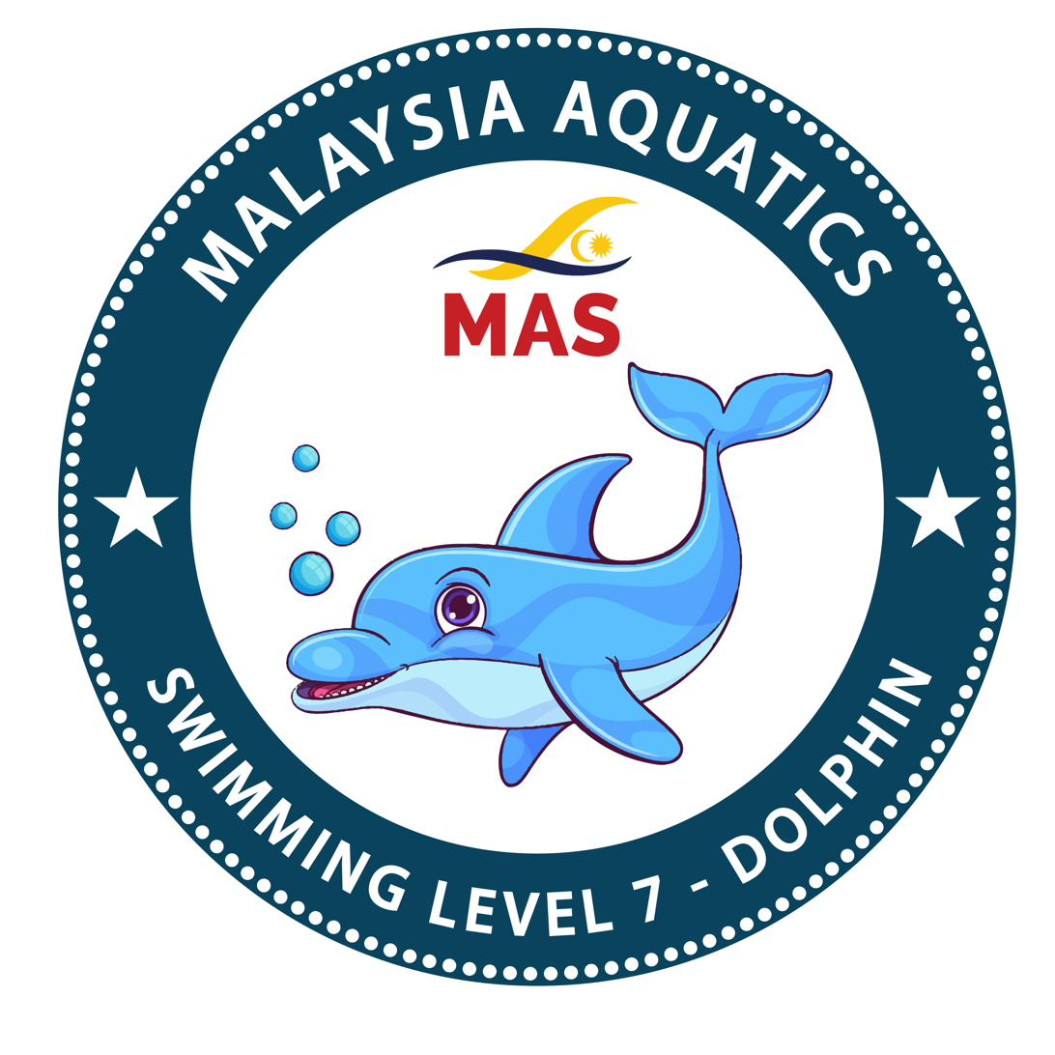 | Level 7  Dolphin | COMPETITIVE BRIDGE

TEACHING OBJECTIVES  INTRODUCE  › Front crawl high elbow / open armpit  › Backstroke competitive pull  › Backstroke dive  › Individual Medley swim  REINFORCE  › Front crawl & IM swim time qualification  › Efficient all four strokes  › Tumble and open turns  › Dive skills  › Underwater skills  DEVELOP  › All four strokes swim distance  › Individual Medley swim sequence  › Dive and underwater skills |  | ASSESSMENT CRITERIA  Demonstrate ability to:  1 Perform front crawl swim with high elbow for 100 metres within 2:30.00.  2 Perform backstroke swim with competitive pull for 100 metres.  3 Perform breaststroke swim with underwater pullout for 100 metres.  4 Perform butterfly for 50 metres.  5 Swim into wall, tumble turn, and out with underwater kicks.  6 Swim into wall, open turn, and out with underwater kicks.  7 Perform stand dive off the blocks / wet deck with underwater skills into swim.  8 Perform a backstroke dive off the blocks / wet deck with underwater skills into swim.  9 Perform Individual Medley for 100 metres within 3:00.00.  Condition: All skills performed in deep water. Skills done independently.

Key correction cues for this level
FAULT | LIKELY CAUSE | CUES YOU CAN USE
Front crawl — dropped elbow, short pull | No catch | "High elbow, fingertips down, pull past your hip."
Sculling — stiff wrists | No feel | "Paint figure-8s, tilt your palms — feel the water push back."
Butterfly — arms-only, stalls | No hip drive | "Hips lead — two kicks, one pull; kick your hands in and out."

MY NOTES

M4 | The IRD Teaching Method | CLASSROOM + POOL

You will be able to: watch real swimmers at each level and calibrate your eye to what "ready" looks like — competent performance and common faults.

Key points
• A filmed walkthrough of each level's standard in the water — see the assessment criteria performed by real swimmers.
• Watch for competent performance and common faults; discuss what tips a criterion from Pass to Refer.
• Bridges knowing the criteria (M2) and learning the teaching method (M5): you see what "ready" looks like before you learn how to build it.
• Use these videos as a reference after the course — revisit them before your first booking to refresh your eye.

MY NOTES

You will be able to: move a swimmer through Introduce → Reinforce → Develop for each skill.

Key points
• Introduce a skill simply; Reinforce to consistency; Develop to the Syllabus standard.
• Build technique, not the test. Consolidate body position and kick before the full stroke.
• Diagnose: what you see → the likely cause → a simple correction cue (Annex B2).
• Only put a swimmer forward once every skill is through Develop and performed independently.



PLACEHOLDER — INSERT PHOTO
instructor giving a poolside correction cue to a young swimmer

MY NOTES

M5 | Lesson Delivery & Class Management | CLASSROOM + POOL

You will be able to: run a safe, well-managed, progressive lesson.

Key points
• The lesson shape: entry & safety check → warm-up & review → skill focus → application → cool-down & exit.
• Keep everyone moving — small sets, short quality repeats; limit waiting.
• Ratios: maximum 1:6, reduced for depth, age, ability, and venue.
• Plan every session on paper, with a purpose for each activity (Annex B4).

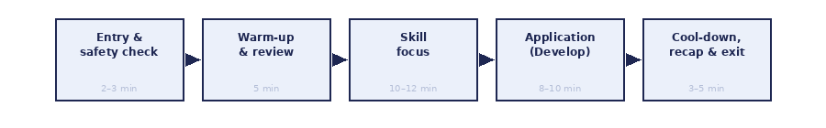

MY NOTES

M6 | Safe Teaching Methods & Teaching Position | CLASSROOM + POOL

You will be able to: choose the safest effective position and keep every swimmer in view.

Key points
• Teach from the poolside first; enter the water only by risk-assessed decision, to mid-chest depth.
• Stand tall and open, hands visible; don't demonstrate strokes yourself — use a capable swimmer while you watch.
• Hands-on support only with consent and by an approved hold; never under the tummy, never grab.
• Never turn your back to the water. A competent observer is always on the deck.

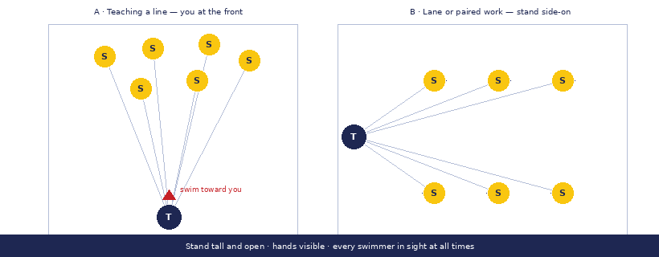

MY NOTES

M7 | Instructor Safety Responsibilities & Emergency Readiness | CLASSROOM

You will be able to: foresee risk before swimmers enter the water, and be ready to act.

Key points
• You own the safety of the teaching environment — control hazards before the lesson.
• Know each venue's rules and Emergency Action Plan, and the location of the phone, AED, first-aid kit, and rescue equipment.
• Supervise to a safe ratio; know each swimmer's stage and any declared condition.
• Hold current First Aid/CPR, Bronze Medallion, or equivalent. Run the pre-class check every time (Appendix E).

PLACEHOLDER — INSERT PHOTO
pool safety equipment: rescue tube, reaching pole, first-aid kit, AED sign

MY NOTES

M8 | Water Safety & Safeguarding | CLASSROOM

You will be able to: uphold child protection and water safety in every lesson.

Key points
• Water safety is taught from Level 1 and revisited at every level — it is the foundation, not a topic.
• Parental consent before participation; a child is never isolated one-to-one out of sight.
• A child's information is never disclosed publicly.
• Escalate any concern immediately to the Designated Safeguarding Lead (interim: the Chairperson).

PLACEHOLDER — INSERT PHOTO
safe, supervised entry and exit at the poolside

MY NOTES

M9 | Effective Teaching & Engagement | CLASSROOM + POOL

You will be able to: make a lesson safe, busy, and genuinely enjoyable.

Key points
• Confidence: get to eye level, use names, stay calm, praise small wins.
• Motivation & movement: start and finish well; small sets keep everyone active.
• Basics & communication: know your progressions; be clear, concise, consistent; sandwich a correction between two positives.
• Reward effort as well as success — immediate and meaningful.

MY NOTES

M10 | Conduct & Professionalism | CLASSROOM

You will be able to: act with integrity and protect the credibility of the badge.

Key points
• Honest readiness — put a swimmer forward only when genuinely ready; a Refer is normal and useful.
• Respect examiner independence and never pressure an outcome.
• Be transparent with families; use MAS marks correctly.
• Uphold the Code of Conduct and safeguarding at all times.

MY NOTES

M11 | BADGES Portal for Instructors | HANDS-ON

You will be able to: operate the Portal end to end for your role.

Key points
• Onboarding is gated: pass the quiz (Manual Appendix F), accept the Code of Conduct, then the Master Trainer activates you.
• Register candidates (single or bulk) and hand each family a claim slip in person.
• Book at least 30 days ahead; the roster locks at create and payment opens the session to examiners.
• You never grade your own swimmers, and never see the amounts shown to examiners.

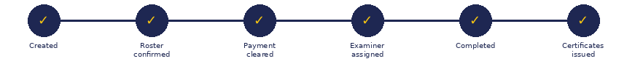

MY NOTES

M12 | Preparing Swimmers for Assessment | CLASSROOM + POOL

You will be able to: walk a swimmer through the assessment sequence for their level.

Key points
• Each level has an ordered run-through of its criteria — teach the flow once the skills are owned.
• On the day, the examiner runs levels in waves: a pass reveals the next level, up to a Refer — no skipping.
• Extra levels cleared are 'bonus' passes — real awards, billed and certified separately.
• Prepare the swimmer for the shape of the day, never by drilling the test.

PLACEHOLDER — INSERT PHOTO
a small group lined up for assessment, examiner observing on deck

MY NOTES

M13 | Practical Teaching Assessment | POOL

You will be able to: deliver a teaching segment to the Competent standard.

Key points
• You teach a real segment under the Master Trainer's observation.
• Rated on six domains: Planning, Safety, IRD, Communication, Feedback, Professionalism.
• Scale: Not Yet · Developing · Competent · Strong. Competent is the pass bar.
• Safety is a hard gate — a shortfall there is an automatic non-pass, whatever else you do well.

MY NOTES

The Rubric
How you will be assessed in Module 13 — the practical teaching assessment.
Every domain must reach Competent or above. Domain 2 (Safety) is a hard gate — a non-pass there is an automatic overall non-pass, regardless of all other domains. A non-pass outcome is called a Refer; the assessor names the domain(s) to develop before the candidate re-attempts.
Domain | Not Yet | Developing | Competent ✓ | Strong
1 Planning & Preparation | Aimless; no usable plan. | Vague or poorly sequenced; unclear objectives. | Clear, written, progressive plan matched to the level and IRD phase. | Contingencies too; every activity earns its place.
2 Safety, Supervision & Positioning  ⚠ HARD GATE | Loses sight of swimmers; unsafe position or ratio. | Supervises, but with lapses. | Continuous line of sight, safe position, correct ratio, consented support, checks done. | Anticipates and removes risk; coverage is effortless.
3 Skill Development (IRD) | Teaches to the test; random activity. | Progression blurs; IRD phases unclear. | Clear IRD building genuine technique at a sound pace. | Adapts live; corrects the cause, not the symptom.
4 Communication & Engagement | Unclear instructions; group disengaged. | Inconsistent; some idle swimmers. | Clear, age-appropriate; effective demonstration; group moving. | Warm, motivating; class busy, safe, and enjoying it.
5 Observation, Correction & Feedback | Misses obvious faults. | Vague feedback; addresses symptom not cause. | Identifies the key fault and cause; gives a usable cue; feedback is balanced. | Prioritises what matters most; specific, owned, positive.
6 Professionalism & Conduct | Unprofessional; unaware of the separation of roles. | Inconsistent; doesn't always model the standard. | Professional; honest readiness; respects independence; correct marks; safeguarding upheld. | Models the standard for peers.

Pass = Competent or Strong on every domain.
Refer = not yet Competent on any domain — state which domain(s) to develop. Domain 2 non-pass = Refer regardless of other scores.

MY NOTES

Quick reference (1 of 2)
Teaching position & line of sight


Ratios
Maximum 1:6 when teaching in the water — reduced for depth, age, ability, and venue (1:4 for very young or nervous). A competent responder is always on the poolside.

Safe-teaching checklist
• Poolside first; in-water only by decision, to mid-chest.
• Stand tall, hands visible; don't demo strokes yourself.
• Support only with consent, by an approved hold.
• Never turn your back to the water; observer on deck.

Quick reference (2 of 2)
Good practice — the seven
Confidence · Motivation · Movement · Basics · Communicate · Plan · Reward

What you're assessed on (the rubric)
Six domains: Planning · Safety (hard gate) · IRD · Communication · Feedback · Professionalism
Scale: Not Yet / Developing / Competent (pass) / Strong

Your Portal steps
Register candidate → issue claim slip → book (≥ 30 days, roster locks, pay to open) → prepare → after assessment, results release & certificates issue.

Assessment sequences by level
Level | Ordered run-through
L1 Starfish | enter → 10 bobs → front float 10 s → roll → back float 10 s → roll → front flutter 3 m → back glide 2 m → exit
L2 Sea Turtle | fall in, turn, grab → front crawl 5 m → back flutter 5 m → backstroke 5 m → reach-and-pull 5 m
L3 Guppy | underwater glide 3 m → front crawl 10 m → backstroke 10 m → tread 30 s
L4 Octopus | sit dive + glide 3 m → front crawl 15 m → backstroke 15 m → breaststroke kick 10 m → survival backstroke 10 m
L5 Frog | squat dive + dolphin 5 m → FC 25 m → BK 25 m → BR 25 m → dolphin kick 10 m → scull 15 m → flip turns
L6 Swordfish | stand dive → FC 50 m (tumble) → BK 50 m → BR + pullout 50 m (open) → fly 10 m → sidestroke 15 m
L7 Dolphin | stand dive → FC 100 m ≤ 2:30 → back dive → BK 100 m → BR 100 m → fly 50 m → IM 100 m ≤ 3:00

Quick reference (3 of 3) — Fault, Cause & Correction
Use this as your poolside reference. Correct the cause, not the symptom — the cues target the root of each fault. Cues are child-facing language you can use in the moment.
STROKE/SKILL | FAULT SEEN | LIKELY CAUSE | CUE TO TRY
Front/back float | Hips sink | Head lifted · empty lungs · tension | "Look down (or up), belly to the sky, big lungs; ears in on your back."
Streamline | Arms apart, quick sink | No lock position | "Squeeze your ears, hide your chin, point like an arrow."
Flutter kick | Big knee bend, no travel | Kicking from the knee, stiff ankles | "Long legs, floppy feet, kick from the hips — small and fast."
Front crawl | Hand crosses centre-line | Reaching across the body | "Reach past your shoulder — swim on train-tracks."
Front crawl | Dropped elbow, short pull | No catch | "High elbow, fingertips down, pull past your hip."
Front crawl | Lifts head to breathe | Head up not rotating | "Turn, don't lift — keep one goggle in."
Backstroke | Sits / pikes | Head & hips low | "Head still, ears in, hips up, tummy to the sky."
Backstroke | Bent-arm entry | No straight recovery | "Thumb out, little-finger in, brush your ear."
Breaststroke | Screw kick | Asymmetric turn-out | "Heels to your bottom, feet turned out, whip and squeeze evenly."
Breaststroke | No glide, timing collapsed | Rushing the cycle | "Pull — breathe — kick — glide; be a torpedo between strokes."
Butterfly | Arms-only, stalls | No hip drive | "Hips lead — two kicks, one pull; kick your hands in and out."
Sculling | Stiff wrists | No feel for the water | "Paint figure-8s, tilt your palms — feel the water push back."
Dive | Belly flop | Chin up, no aim | "Hide your chin, squeeze your ears, aim your fingers at a spot."
Tumble turn | Mistimed | Judging late | "Pick your marker, last stroke in, tuck and flip; feet plant, arrow, push."

MAS BADGES

Keep this workbook.
Your notes here become the start of your own teaching notebook —
a good instructor never stops refining the craft.

BADGES · NATIONAL LEARN-TO-SWIM SYSTEM www.masbadges.org

