**How similar are Indonesian Embassies based on their location**

boy.setiawan

April 4th, 2021

1. **Introduction**
   1. **Problem Description**

**An Embassy** is a representative of a country in other countries, their existence helps to indicate a relation among countries and serve as a way to communicate or strengthen the ties. Their location follows a strict and complex requirements both from the country it comes from and the country it resides, usually in a special diplomatic compound or district. Despite all of the careful planning and requirements, the decision to establish an embassy could have come from other necessities such as certain neighborhood/district/area, near to and close from certain amneties, places that could support the embassy mission etc.

The knowledge of how a certain embassies are similar or different could **help give a bigger view to Indonesian Foreign Affairs Officials** to understand the general environment their embassies are located. Should a certain embassies need to be treated differently, do embassies with certain criteria experience the same or different stress level of working for their staffs, do certain embassies experience certain disturbance etc.

The task to find and group embassies into their own similar group could be a daunting task. From forming the basic data, to gathering and analyzing the data must be done without bias and subjectivity. The end result must be able to give an insight of what the embassies really are so they can be interpreted and understand as a whole new information or to strengthen the already known facts.

* 1. **Data Description**

In order to accomplish the analysis, we will need data on Indonesian Embassies abroad and their latitude and longitude so we can combine it with data about venues surrounding the embassies which we intend to explore from FourSquare API to give a better understanding about the embassy's neighborhood, venues and places.

* 1. **Solution**

Our solution is to cluster the embassies and see the differences and similarities between them based on the data gathered about venues surrounding the embassies.

* 1. **Methodology**

1. **Data Gathering**
2. List of Indonesian Embassies Abroad

Apparently to get data about the list of Indonesian Embassies abroad is going to be a bit difficult, this is because the Ministry of Foreign Affairs website doesn't display the data to be easily analyzable. But with the help of google and wikipedia we find a page that we could extract the data that we need as a starting point.

<https://id.wikipedia.org/wiki/Kedutaan_besar_Republik_Indonesia>

after scraping the page with BeautifulSoup we manage to import the data in a Data Frame as so.

There are 98 Indonesian Embassies according to our data. As we can see the data needs to be cleaned since the scrapping process leave us with some characters we need to eliminate.

After we clean the Data Frame we need to change some values and drop some rows from the Data Frame. This is because some of the data used pronunciation of capitals in Indonesian language, others not so common name and data that does not interest us such as Indonesian representatives for the United Nations.

The final tally is 93 Indonesian Embassies abroad.

1. The Embassies Address

It would be nice if everything was served on a plate but in this task, we need to have some wits up our sleeves. What we need are longitudes and latitudes of the embassies, as with the problem above it is not readily available to us. But there is hope since the address is available for us to extract from the Ministry of Foreign Affairs website for they have a common URL that we can explore.

<https://kemlu.go.id/CAPITAL>

with this information we need to iterate this URL with our Data Frame and do another scrapping to get the all the addresses.

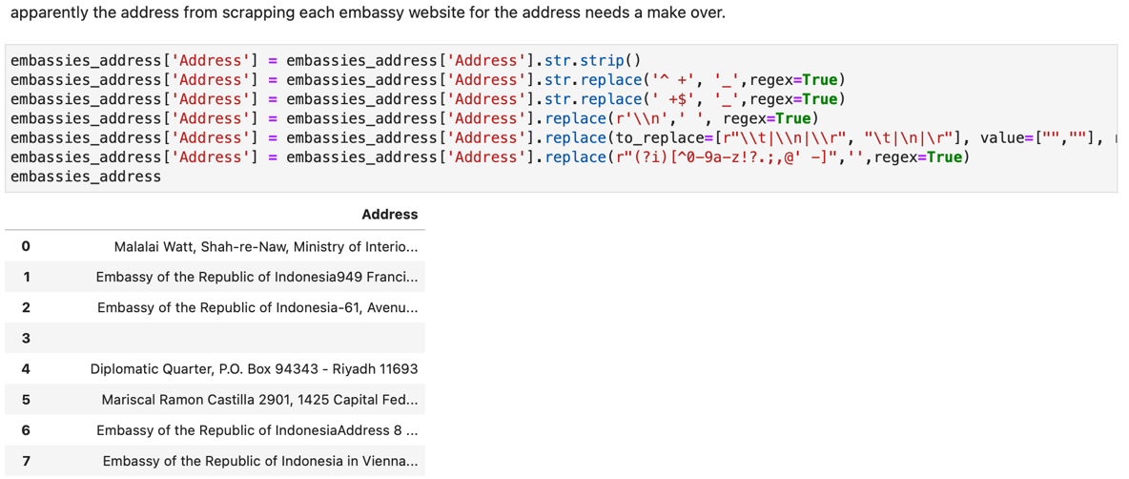

After looking at the result we need to take a decision to save the data frame and edit the address manually since the format is not unison. Not a very satisfying task but something we need to take since creating regex rules does not look like a viable solution for this problem. After that we integrate it with our Data Frame and voila a list of Indonesian Embassies abroad with their address.

1. The Embassies Geo Location

As our initial data requirement is to have a list of embassies with their geolocation, we need to translate the address into latitude and longitude coordinate. To do that we use a common library in python called geocoder and loop through the address.

And then format the result in a Data Frame and combine with our embassies Data Frame.

Unfortunately, there are some embassies without geolocation information.

In this case, 40 embassies are still without geolocation information.

To overcome this obstacle and after googling about free forward geocoding, we stumble open positionstack.com which offer a diverse and rich API in their service. After following the instruction and documentation, we translate the remaining address to get their latitude and longitude.

And do the process all over again and see if there is any embassy without geolocation information, which there are and decide to do it manually since the number is quite small.

Let’s see if we get our geolocation data right with displaying a sample.

1. The Embassies Venues

Now let’s get venues data surrounding the embassies from FourSquare.

Which resulted in an astonishing 2.232 venues which we can work on.

1. **Data Exploration**

To get a better understanding of the data, we need to explore our data. Let’s see what kind of data we have exactly.

We can see that each embassy has venues and their categories. The one we will be using is the value in the Venue Category, because this value will be available across embassies. Let’s see how many categories there are in our Data Frame.

We can see that that the biggest venues are in Manila, Mexico City and Washington. And the least venues are in Ottawa, Addis Ababa and Abu Dhabi.

Let’s see how many categories we have in the Data Frame.

There are 323 categories and if we see some are generally the same. A Restaurant might have specialty but basically it is a restaurant, so we have to gather identical categories into a more general category so we can have a better model as a result.



We do this repeatedly for the categories until we are satisfied that there no more ambiguous in the Data Frame.



In this case from 323 we managed to shrink it to 139 categories. For the last exploration let’s find out if there is any embassy with no venues at all.

Apparently, there are 4 embassies with no venues data. So, we will disregard these embassies in the final result.

The next step is to make the categories into their own column in the Data Frame.

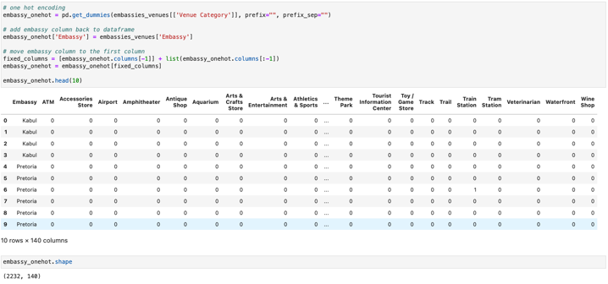

Which resulted in 2.232 rows and 140 columns. In the current state our Data Frame can be used make a cluster. If we looked back, our first data consist of 93 embassies and after exploring FourSquare we end up with 4 embassies with no venues data. So, if our calculation is correct, we need to sum up 2.232 rows into 89 rows. We do that by grouping the Data Frame by the embassy column and count the mean of each column in the group.

* 1. **Discussion**
  2. **Conclusion**