# Decisions

Extra attribute of the competitor class.

* I choose 4 level for competitor as numbers from 1 to 4 they represent Novice, Standard, Veteran and Expert respectively.
* An array of integer scores of sizes 5 with values between 0 and 5
* An age as integer
* A country as string

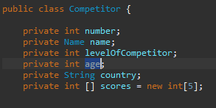

Overall score calculated by an average of top n scores where n is the level number.

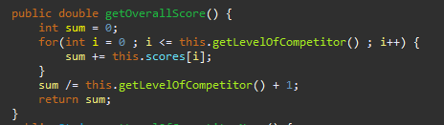

# Status report

**Testing Competitor class Main Functions**

Create an object by passing an argument with a parameterized constructor.

Picture 3

|  |  |  |  |
| --- | --- | --- | --- |
| Test Item | Test Data | Expected Result | Actual Result |
| getFullDetails() | Calling getFullDetails() Function | Competitor number 100, name Keith John, country Uk.  Keith is a Novice aged 20 and received these scores: 5,4,5,4,3  This gives him an overall score of 4.0. | √ |
| getShortDetails() | Calling getShortDetails() Function | CN 100 (KJ) has overall score 4.0 | √ |
| getLevelofCompetitorName() | Calling getLevelofCompetotorName() Function | Novice | √ |
| getOverallScore() | Calling getOverallScore() Function | 4.0 | √ |

**Testing CompetitorList class Main Functions**

Create an object by default constructor.

Picture 4

Within default constructor reading data from the CompetitorList.txt File.

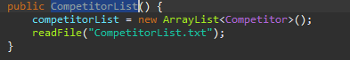

CompetitorList.txt File Content.

|  |  |  |  |
| --- | --- | --- | --- |
| Test Item | Test Data | Expected Result | Actual Result |
| reportToFile(String FileName) | Calling reportToFile(“report.txt”)  Function | Report.txt content | √ |
| checkIsValidCompetitorNo (int number) | Calling checkIsValidCompetitorNo(101) Function | CN 101 (JM) has overall score 3.0 | √ |
| Calling checkIsValidCompetitorNo(10001) Function | competitor number is not valid. | √ |

# Diagrams

**Class Diagram**

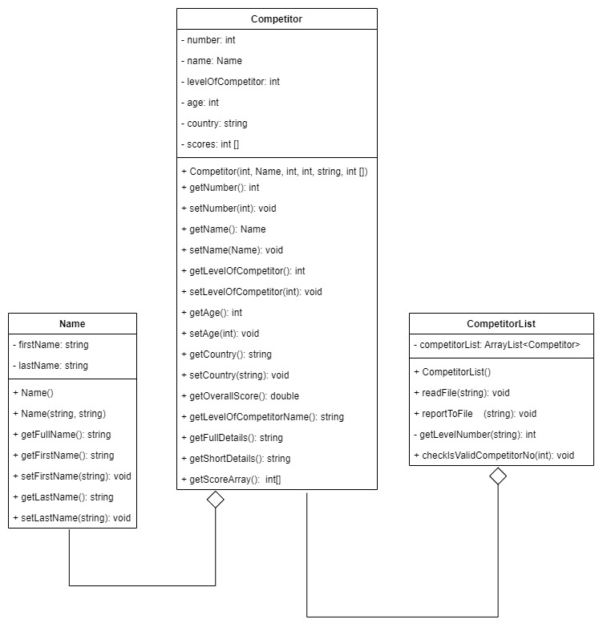

**Sequence diagram**

While reading competitor records from the input file.

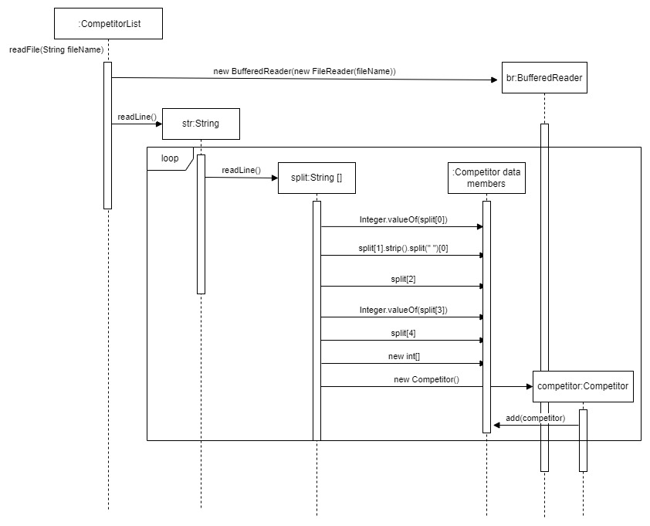

Activity Digram,

use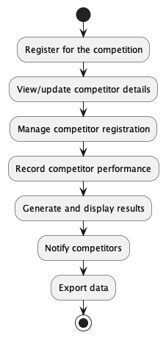 case-diagram

