第二题：提高题（28分）
第 1 小题：代理访问（12 分）
1.1 试验平台及拓扑图
用在第一小题中搭建好的平台进行试验。
平台：Ubuntu14.04 + POX + mininet
PC主机上运行Ubuntu14.04操作系统，安装POX作为SDN Openflow环境的控制器。
PC机器上安装VMBox，其中运行带有Mininet的虚拟机，用来模拟OpenFlow中的交换机以及实现简单的自定义拓扑结构。
该题拓扑结构如图所示：
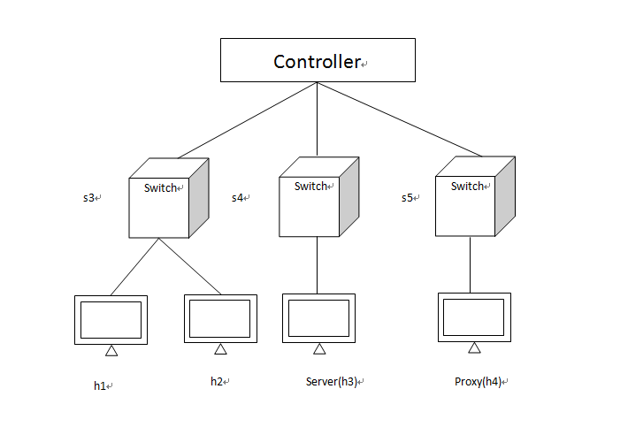
1.2 实现思路
其实Server和ProxyServer实现相同功能，只需要限制对于Proxy的用户访问，即设置对应的流表项，对于来自h1的请求予以转发给Proxy，而对于来自h2的请求丢弃即可实现该功能。本题利用POX控制器提供的openflow.webservice和web.webcore组件，以实现对localhost:8008/OF/这个url以POST形式传送并且接受json格式的数据，从而利用其API可以实现对于流表的查询删除增加等操作，在最后一小题中也是使用这个思想来完成的。
1.3 操作步骤
1.3.1 启动mininet
首先，在mininet/custom下编写my_topo.py实现上图的拓扑结构图：
from mininet.topo import Topo

class MyTopo( Topo ):
"Simple topology example."

def __init__( self ):
"Create custom topo."

# Initialize topology
Topo.__init__( self )

# Add hosts and switches
leftHost1 = self.addHost( 'h1' )
leftHost2 = self.addHost( 'h2' )
middleHost = self.addHost( 'h3' )
rightHost = self.addHost( 'h4' )
leftSwitch = self.addSwitch( 's3' )
middleSwitch = self.addSwitch( 's4' )
rightSwitch = self.addSwitch( 's5' )

# Add links
self.addLink( leftHost2, leftSwitch )
self.addLink( leftHost1, leftSwitch )
self.addLink( leftSwitch, middleSwitch )
self.addLink( middleSwitch, rightSwitch )
self.addLink( rightHost, rightSwitch )
self.addLink( middleHost, middleSwitch )

topos = { 'mytopo': ( lambda: MyTopo() ) }
在mininet中启动该拓扑结构：
mn --custom mininet/custom/my_topo.py --topo mytopo --controller=remote,ip=192.168.56.1,port=6633
并设置h3和h4分别为Server和ProxyServer：
h3 -m SimpleHTTPServer 80 &
h4 -m SimpleHttpServer 80 &
1.3.2 编写代码以实现功能
创建Q3.py，并且写入如下代码以实现对三个控制器流表的设置：
import os
import json
import urllib
import urllib2

query = {"method":"get_switches","id":1}
url='http://127.0.0.1:8000/OF/'
h1 = "82:7e:57:ae:74:1a"
h2 = "1a:80:a0:63:cc:65"
h3 = "76:e4:4e:ef:05:73"
h4 = "ee:e5:ab:66:0d:82"

def get_switch():
jdata = json.dumps(query)
req = urllib2.Request(url, jdata)
response = urllib2.urlopen(req)
return response.read()

def get_switch_desc(dpid):
query = {}
params = {}
params["dpid"] = dpid
query["params"] = params
query["method"] = "get_switch_desc"
query["id"] = "1"
print query
jdata = json.dumps(query)
req = urllib2.Request(url, jdata)
response = urllib2.urlopen(req)
return response.read()

def get_flow_stats(dpid):
query = {}
params = {}
params["dpid"] = dpid
query["params"] = params
query["method"] = "get_flow_stats"
query["id"] = "1"
print query
jdata = json.dumps(query)
req = urllib2.Request(url, jdata)
response = urllib2.urlopen(req)
return response.read()

def decode_switch(response):
def acquire_switch(result):
for element in result["result"]:
print element["dpid"]

def acquire_ports(result):
for element in result["result"]:
for device in element["ports"]:
print device
result = json.loads(response)
print response
acquire_ports(result)
acquire_switch(result)

def decode_switch_desc(response):
print response

def decode_switch_flow_stats(response):
print response

def set_table(dpid , flows):
query = {}
params = {}
params["flows"] = flows
params["dpid"] = dpid
query["method"] = "set_table"
query["id"] = "1"
query["params"] = params
print query
jdata = json.dumps(query)
req = urllib2.Request(url, jdata)
response = urllib2.urlopen(req)
return response.read()
def config_s3 ():
flows = []
flow_item = {}
match = {}
actions = []
action_item = {}
action_item["type"] = "OFPAT_OUTPUT"
action_item["port"] = 1
actions.append(action_item)
match["dl_dst"] = h2
flow_item["actions"] = actions
flow_item["match"] = match
flow_item["idle_timeout"] = 0
flow_item["hard_timeout"] = 0
flows.append(flow_item)

flow_item = {}
match = {}
actions = []
action_item = {}
action_item["type"] = "OFPAT_OUTPUT"
action_item["port"] = 2
actions.append(action_item)
match["dl_dst"] = h1
flow_item["actions"] = actions
flow_item["match"] = match
flow_item["idle_timeout"] = 0
flow_item["hard_timeout"] = 0
flows.insert(1,flow_item)

flow_item = {}
match = {}
actions = []
action_item = {}
action_item["type"] = "OFPAT_OUTPUT"
action_item["port"] = 3
actions.append(action_item)
match["dl_dst"] = h3
flow_item["actions"] = actions
flow_item["match"] = match
flow_item["idle_timeout"] = 0
flow_item["hard_timeout"] = 0
flows.insert(1,flow_item)

flow_item = {}
match = {}
actions = []
action_item = {}
action_item["type"] = "OFPAT_OUTPUT"
action_item["port"] = 3
actions.append(action_item)
match["dl_dst"] = h4
flow_item["actions"] = actions
flow_item["match"] = match
flow_item["idle_timeout"] = 0
flow_item["hard_timeout"] = 0
flows.insert(1,flow_item)

flow_item = {}
match = {}
actions = []
action_item = {}
action_item["type"] = "OFPAT_OUTPUT"
action_item["port"] = 1
actions.append(action_item)
match["dl_dst"] = h4
match["dl_src"] = h2
flow_item["actions"] = actions
flow_item["match"] = match
flow_item["idle_timeout"] = 0
flow_item["hard_timeout"] = 0
flows.insert(1,flow_item)

flow_item = {}
match = {}
actions = []
action_item = {}
action_item["type"] = "OFPAT_OUTPUT"
action_item["port"] = "OFPP_ALL"
actions.append(action_item)
match["dl_dst"] = "ff:ff:ff:ff:ff:ff"
flow_item["actions"] = actions
flow_item["match"] = match
flow_item["idle_timeout"] = 0
flow_item["hard_timeout"] = 0
flows.insert(1,flow_item)

print flows
set_table("00-00-00-00-00-03",flows)

def config_s4 ():
flows = []
flow_item = {}
match = {}
actions = []
action_item = {}
action_item["type"] = "OFPAT_OUTPUT"
action_item["port"] = 1
actions.append(action_item)
match["dl_dst"] = h2
flow_item["actions"] = actions
flow_item["match"] = match
flow_item["idle_timeout"] = 0
flow_item["hard_timeout"] = 0
flows.append(flow_item)

flow_item = {}
match = {}
actions = []
action_item = {}
action_item["type"] = "OFPAT_OUTPUT"
action_item["port"] = 1
actions.append(action_item)
match["dl_dst"] = h1
flow_item["actions"] = actions
flow_item["match"] = match
flow_item["idle_timeout"] = 0
flow_item["hard_timeout"] = 0
flows.insert(1,flow_item)

flow_item = {}
match = {}
actions = []
action_item = {}
action_item["type"] = "OFPAT_OUTPUT"
action_item["port"] = 2
actions.append(action_item)
match["dl_dst"] = h4
flow_item["actions"] = actions
flow_item["match"] = match
flow_item["idle_timeout"] = 0
flow_item["hard_timeout"] = 0
flows.insert(1,flow_item)

flow_item = {}
match = {}
actions = []
action_item = {}
action_item["type"] = "OFPAT_OUTPUT"
action_item["port"] = 3
actions.append(action_item)
match["dl_dst"] = h3
flow_item["actions"] = actions
flow_item["match"] = match
flow_item["idle_timeout"] = 0
flow_item["hard_timeout"] = 0
flows.insert(1,flow_item)

flow_item = {}
match = {}
actions = []
action_item = {}
action_item["type"] = "OFPAT_OUTPUT"
action_item["port"] = "OFPP_ALL"
actions.append(action_item)
match["dl_dst"] = "ff:ff:ff:ff:ff:ff"
flow_item["actions"] = actions
flow_item["match"] = match
flow_item["idle_timeout"] = 0
flow_item["hard_timeout"] = 0
flows.insert(1,flow_item)
print flows
set_table("00-00-00-00-00-04",flows)

def config_s5 ():
flows = []
flow_item = {}
match = {}
actions = []
action_item = {}
action_item["type"] = "OFPAT_OUTPUT"
action_item["port"] = 1
actions.append(action_item)
match["dl_dst"] = h2
flow_item["actions"] = actions
flow_item["match"] = match
flow_item["idle_timeout"] = 0
flow_item["hard_timeout"] = 0
flows.append(flow_item)

flow_item = {}
match = {}
actions = []
action_item = {}
action_item["type"] = "OFPAT_OUTPUT"
action_item["port"] = 1
actions.append(action_item)
match["dl_dst"] = h1
flow_item["actions"] = actions
flow_item["match"] = match
flow_item["idle_timeout"] = 0
flow_item["hard_timeout"] = 0
flows.insert(1,flow_item)

flow_item = {}
match = {}
actions = []
action_item = {}
action_item["type"] = "OFPAT_OUTPUT"
action_item["port"] = 2
actions.append(action_item)
match["dl_dst"] = h4
match["dl_src"] = h1
flow_item["actions"] = actions
flow_item["match"] = match
flow_item["idle_timeout"] = 0
flow_item["hard_timeout"] = 0
flows.insert(1,flow_item)

flow_item = {}
match = {}
actions = []
action_item = {}
action_item["type"] = "OFPAT_OUTPUT"
action_item["port"] = 1
actions.append(action_item)
match["dl_dst"] = h4
match["dl_src"] = h2
flow_item["actions"] = actions
flow_item["match"] = match
flow_item["idle_timeout"] = 0
flow_item["hard_timeout"] = 0
flows.insert(1,flow_item)

flow_item = {}
match = {}
actions = []
action_item = {}
action_item["type"] = "OFPAT_OUTPUT"
action_item["port"] = "OFPP_ALL"
actions.append(action_item)
match["dl_dst"] = "ff:ff:ff:ff:ff:ff"
flow_item["actions"] = actions
flow_item["match"] = match
flow_item["idle_timeout"] = 0
flow_item["hard_timeout"] = 0
flows.insert(1,flow_item)
print flows
set_table("00-00-00-00-00-05",flows)

flows = []
flow_item = {}
match = {}
actions = []
action_item = {}
action_item["type"] = "OFPAT_OUTPUT"
action_item["port"] = "OFPP_ALL"
actions.append(action_item)
flow_item["actions"] = actions
flow_item["match"] = match
flow_item["idle_timeout"] = 10
flows.append(flow_item)

config_s3()
config_s4()
config_s5()
#response = set_table("00-00-00-00-00-04" , flows)
#print response
#response = get_switch_desc("00-00-00-00-00-04")
#decode_switch_desc(response)
response = get_flow_stats("00-00-00-00-00-03")
decode_switch_flow_stats(response)
#response = get_switch()
#decode_switch(response)

1.3.3 启动POX
因为在本题中使用了POX的两个组件，因此启动时要将这两个组件添加进去：
./pox.py openflow.webservice web.webcore
进入刚才创建Q3.py的目录中执行：
python Q3.py
即可看到现在的各个控制器中的流表项均已成功添加：
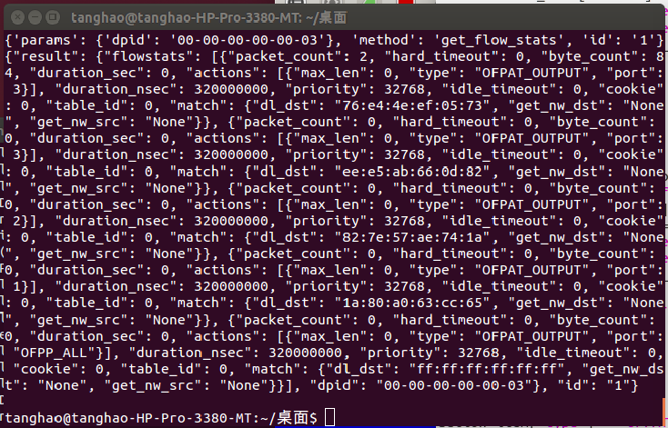

1.4 试验结果
在本题试验的设置中，代理服务器为h1可以访问，h2不能够访问。在mininet中从h1中分别请求服务器和代理服务器的信息：
h1 wget h3
h1 wget h4
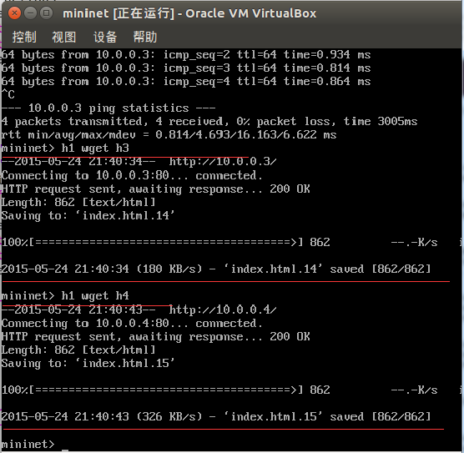
h1对于两台服务器的访问均可完成。
h2分别请求服务器和代理服务器：
h2 wget h3
h2 wget h4
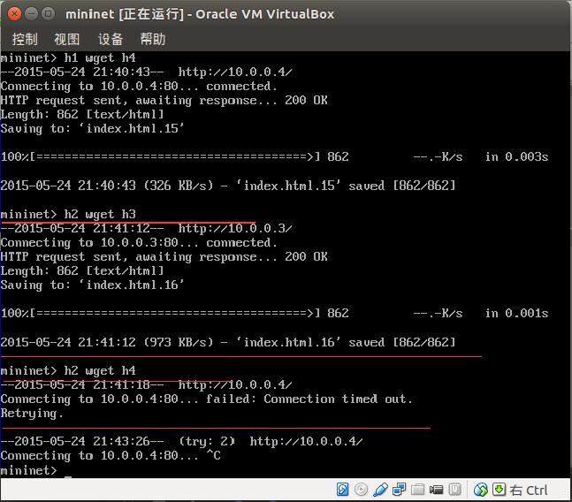
可以看到，h2对于Server的访问可以正常执行，而对于ProxyServer的访问超时而不能够完成，因为代理服务器只对h1开放了服务。
至此，本题要求完成的内容全部实现。

