**Data commentary - Extension task**

1. Before writing a data commentary, the discuss these questions in groups:
2. Which of these apps are you familiar with? Which are new to you?
3. Why do you think these apps are popular at this time?
4. How might you categorise the apps? What categories can you come up with?
5. Which might you describe as *video conferencing apps*, and which are *entertainment apps*?
6. What aspect(s) of the data might you highlight?
7. What commentary might you provide?

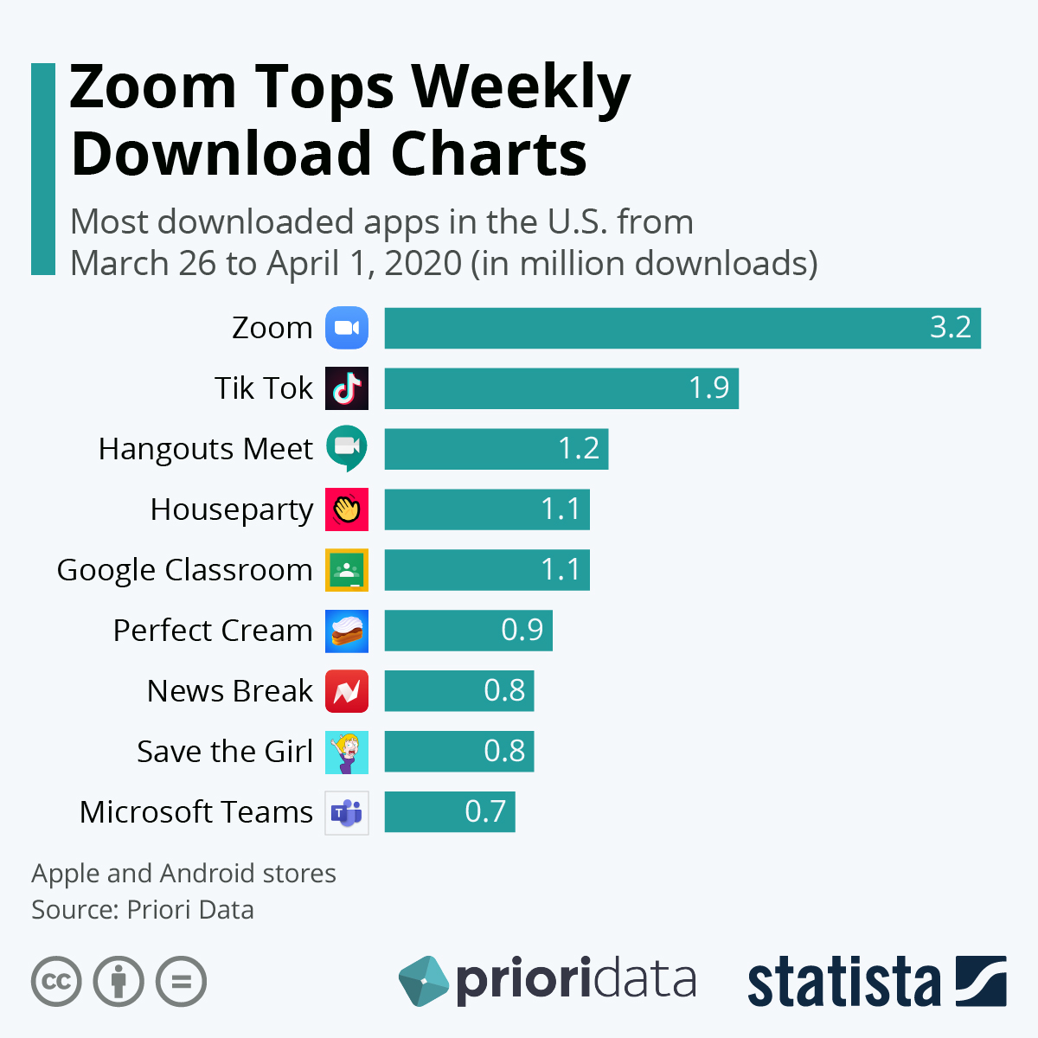

**Figure 1:** Most downloaded apps in the US from March 26th to April 1st 2020 (in million downloads)

1. Now write a data commentary for ‘**Figure 1:** Most downloaded apps in the US from March 26th to April 1st 2020.’ Remember that you don’t need to describe everything in the data.

**Don’t look at the model on the following page!**

**Model answer**

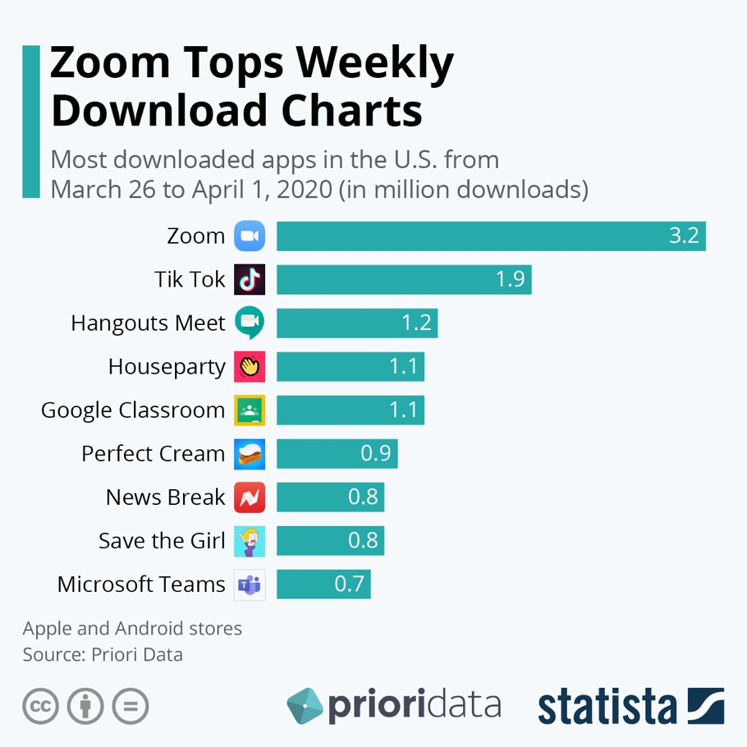

**Figure 1:** Most downloaded apps in the US from March 26th to April 1st 2020 (in million downloads)

|  |
| --- |
| **[1]** Figure 1 shows the top ten downloaded apps in the US from March 26th to April 1st 2020. **[2]** As can be seen, video conferencing apps, such as *Zoom*, *Houseparty* and *Microsoft Teams*, dominate the list. **[3]** By far, the most popular app was Zoom with 3.2 million downloads. **[4]** These apps have allowed users to work remotely and stay in touch with friends and family at a time of lockdown due to Covid 19. **[5]** It is interesting to note that *Teams* is far less popular than *Zoom* with only 0.7 million downloads during this period. **[6]** This may be because *Zoom* can be used for free and has been widely adopted by schools while *Teams*, which is a paid for service, is mainly aimed at professional use. **[7]** Entertainment apps also featured prominently on the list. **[8]** The video sharing app, *Tik T*ok, was downloaded 1.9 million times, making it the second most popular app, while the online games *Perfect Cream* and *Save the* *Girl* also made the top ten. **[9]** If Covid restrictions continue, we might expect that such forms of online entertainment will increase in popularity. |

1. Overall, how is the text structured? Identify the (1) location statement, (2) highlighting statements (i.e. trends in the data), (3) data used to illustrate the trend, and (4) commentary/discussion.
2. Notice how the writer doesn’t just repeat the numbers in the Figure. How does he try ‘put them in perspective’ and make them easier to understand?
3. Does the writer try and cover all the information in the Figure? Is this appropriate?
4. How is cohesion achieved?
5. Find examples of hedged language.
6. What do you like / dislike about this data commentary