<https://maschafer.github.io/FirstDropbox/Lab4/index.html>[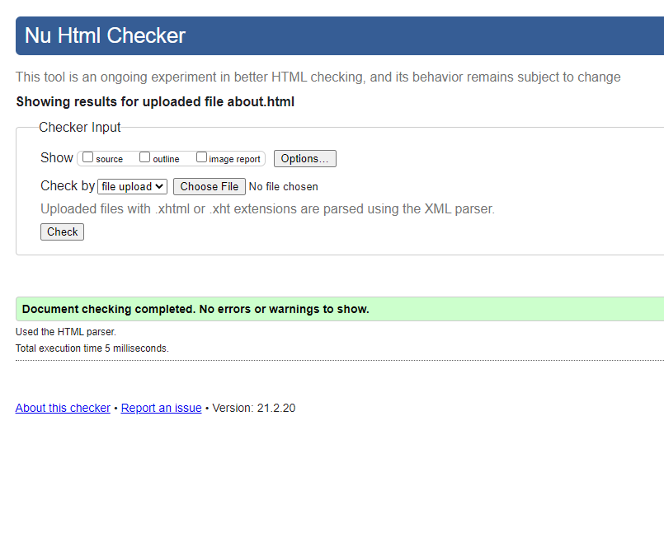](https://maschafer.github.io/FirstDropbox/Lab4/index.html)