Supporting Human Relationship-Building in a Daily Life Community
Koya Iwase, Kota Gushima, Tatsuo Nakajima
Department of Computer Science and Engineering
Waseda University, Tokyo
{chocochan_i, gushi, tatsuo}@dcl.cs.waseda.ac.jp
Abstract. A wide friendship network helps us in our daily lives, and there are merits to expanding personal connections. Newly developed communication services have been developed as a means to expand the network of connections, and they enable the building of new relationships on the Internet without meeting people directly. While these tools are spreading, currently in Japan, various warnings and instructions are communicated regarding Internet encounters, and due to interactions of young people via the Internet, many people recognize that it is dangerous to have relationships with unknown partners. We want to alleviate the distrust users have for unknown partners and contribute to relationship-building on the Internet. This paper proposes ComFriends, a communication tool that reduces the resistance of an initial conversation and helps expand friendships more easily and safely. ComFriends provides users with conversations between people who belong to the same community and are in a state of mutual interest, and it supports relationship-building. We first present a ComFriends design approach and then describe its evaluation via a user study.
Keywords: Civic computing; Personal informatics; SNS
- Introduction
A wide friendship network helps us in our daily lives, and there are merits to expanding personal connections [1] [2]. Newly developed communication services can expand the network of people, and we can build new relationships on the Internet without meeting directly. Therefore, expanding personal connections has become much easier. While these tools are spreading, communication among young people on the Internet in Japan is facing various warnings and education about Internet communication concerns; many people recognize that it is dangerous to have relationships with unknown partners on the Internet [3]. However, in the current information society, SNS interaction is convenient and frequently used and also will be a major way to build relationships in the future [4]. We want to alleviate distrust of unknown partners and contribute to relationship-building on the net.
This paper proposes ComFriends, a communication tool that reduces the resistance of an initial conversation and helps us expand our friendships more easily and safely. ComFriends provides conversations between mutually interested people in the same community and supports relationship-building. We thought that if the users and partners belong to the same community, distrust of the unknown would be slightly relieved, and we could focus on applications that expand relationships within the community. In this research, we want to confirm how sharing communities influences the affinity and usefulness of relation building. In addition, we would like to investigate other obstacles in SNS exchanges in order to promote smooth relationship building.
We first introduce the current approach to assisting initial relationship building and then our ComFriends approach. This research provides clues for better SNS development and contributes to its future development.
- Related Work
Various systems have been developed to assist relationship building or utilize relationships according to purpose. We will introduce some of them and consider which elements are necessary for relation building.
  - Support for directly facing communication
Several approaches for people directly face each other when communicating for the first time. For example, conversation contents (what you talk about when you first meet someone) are important [5]. To eliminate this obstacle, various content conversation systems were developed to help users talk more easily. However, the problem was that these systems proposed topics that speakers did not want to discuss with a first-time partner. It also seems that many people were resistant to directly face a first-time partner, except when they had to face each other directly and talk.
  - Virtual relationship expansion
There are also studies on virtually broad connection via other means [6]. In this system, an individual’s personal network can be shared via a database, allowing each individual to connect to another. If you face a problem at work and you need human resource support, you can find suitable people through your acquaintances.
  - People proposal based on common elements
We are unconsciously looking for commonality with our partner when interacting with them for the first time, and it is said that this sense of familiarity will remove psychological barriers [7]. Researchers grasp elements such as hobbies where people need help and support for artificially matching similar people in order to make the sharing process smoother. In fact, results show that pairs with many commonalities have many conversation topics and tend to get along. In particular, hobby commonalities seem to have a large positive impact on familiarity. However, since a third party’s evaluation carried out the artificial matching, it is an uncertain means for relation building, and the administrator presents a significant burden. We believe that it is good to find common points with the partner depending on the user’s will.
- Design Implementation
To explore the problems of existing relationship building and chat applications, before creating ComFriends we created a concise, similar design, and asked for user evaluation. The first design implementation procedures are shown below.
  - Questionnaire
To produce the initial ComFriends design, we surveyed eighteen people ages 20 to 57, and addressed five issues: 1) Do you feel resistance to conversation in the first meeting? 2) Do you feel resistance to talking on the SNS with someone you have never met before? 3) Have you experienced easy conversation with the person you were within the first meeting? 4) Do you think that interaction within the community is necessary? 5) Do you want to expand the network of people in the community?
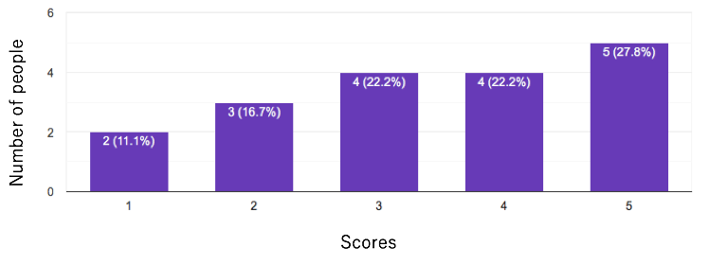
Fig. 1. Result of the first question - Do you feel resistance in the first meeting? (The higher the score, the stronger the sense of resistance.)
Figure 1 shows the result of the first question. More participants felt resistance in the first-time conversation and their main reasons were “I don’t know what to talk about.”, “I don’t know what kind of person this is.”, “I don’t know the speed of partner’s reply.”, etc.
Figure 2 has results of the next question and, contrary to the previous question, the number of people who feel resistance is very low in an SNS conversation. Reasons for decreasing resistance were “I can’t see the other’s expression, so I don’t have to worry about it.”, “I can get the information necessary for conversation through the users’ profile.”, etc. In addition, participants felt it was easy to talk with each other for the first time under the following situations: when the content is decided, when they have a common hobby, and when they can clearly see a reaction.
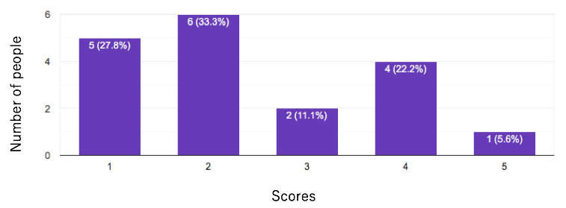
Fig. 2. Result of the second question - Do you feel resistance to talking on the SNS with someone you have never met?
(The higher the score, the stronger the sense of resistance.)
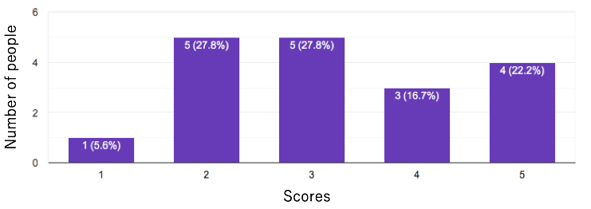
Fig. 3. Result of the fourth question - Do you think that interaction within the community is necessary?
(The higher the score, the more they feel it is necessary.)
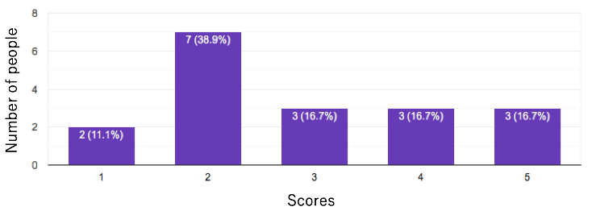
Fig. 4. Result of the fifth question – Do you want to expand the network of people in the community?
(The higher the score, the more they have motivation to build new relationships.)
Next, are the results of an exchange within the community. As shown in Figure 3, half of the participants felt that an exchange within the community was necessary, and half did not. While the former argued that it is necessary in the event of emergency, the latter argued that it would be difficult to complain about group living there when they know each other. We believe that these merits and demerits apply to “residential communities” such as residential areas and apartment houses, not “affiliation communities” such as schools and workplaces. As shown in Figure 4, fewer people want to expand the network within the community, and some mentioned that this is mainly due to the difficulty of building a new relationship regardless of whether it is a community interaction or not.
  - Approach
Given the questionnaire results, we decided to create an application with the following approach: 1) Provide a concise profile required for conversation, 2) Prepare on the premise that there is mutually favorable reaction.
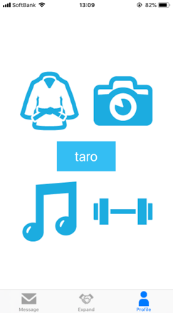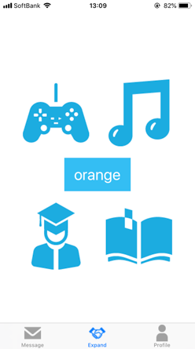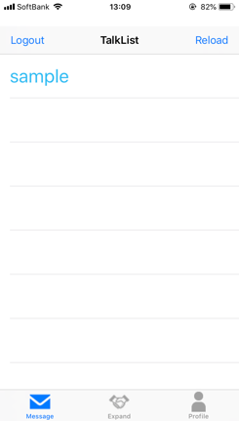
Fig. 5. Initial Design - Profile Scene, Expand Scene, Message Scene
This design has three main scenes. The first is “Profile Scene” where you can check your brief profile. Next is “Expand Scene” which proposes users in the same community, one after the other. The application users will indicate whether or not they are interested in the proposed profile by dragging the image. If they are not interested in the opponent, they move the image up, and if they are interested, they pull it in front to accept. The last is “Message Scene”, which uses the “Expand Scene” to create a talk room between users who are mutually interested. The talk room allows them to talk like an existing chat and check the partner’s profile.
  - User Study
We conducted a user study for five participants ages 20 to 25 using the initial ComFriends design. In a prior questionnaire, we asked if they would like to expand their network in the community, their hobbies, and what kind of partner information they need when building an SNS relationship. We thought that it was necessary to treat the “school and workplace” and “region and apartment house” communities separately, so we checked each one’s motivation for personal network expansion. All the participants are students and results show that they do not want to expand the network in the region and apartment house, but many strongly desire it in schools and workplaces; therefore, we decided to conduct experiments only with their university community. Next, regarding the hobby from the preliminary questionnaire and the information participants needed to build relationships, we prepared several profiles and asked for their reaction. We then asked participants to talk to a fictitious user whom he/she was interested in via chats, and the conversation was simulated. Conversely, another user whom participants were interested in, talked to them via chat and simulated the conversation.
  - Interview
After the study, we asked participants to evaluate the design and we interviewed them.
Theme 1: Usability
Figure 6 shows the initial design evaluation in term of usability. Results show that several functions had to be extended and some participants did not give the initial design a high score. We will explain these issues in other themes in detail.
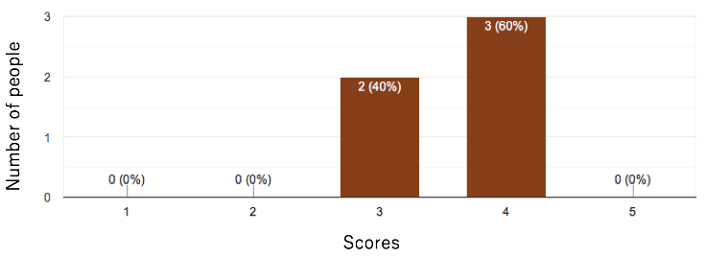
Fig. 6. Usability of the initial design.
(The higher the scores, the higher the usability.)
Theme 2: Ease of Talking
Regarding ease of talking, evaluation scores were divided as shown in Figure 7. People who often talk with someone they have never met on SNS and who are motivated to expand relationships said that they were able to talk easily based on the displayed partner’s characteristics. Others who are not good at conversation and have low motivation for relationship building said that it was difficult to speak because they didn’t know the conversation tempo with a new person or how to write the opponent’s chat. To solve the problem of not knowing the conversation tempo, they suggested displaying whether or not each other is entering the sentence.
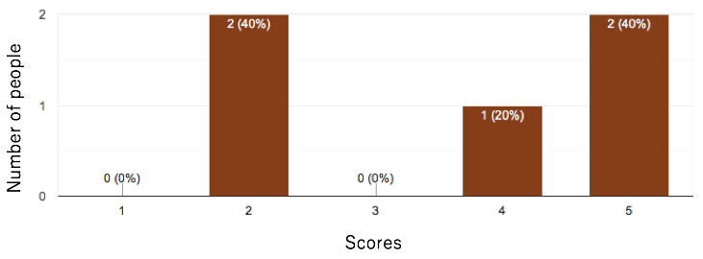
Fig. 7. Ease of Talking in the initial design.
(The higher the scores, the easier it was to talk.)
Theme 3: Sufficiency of Information
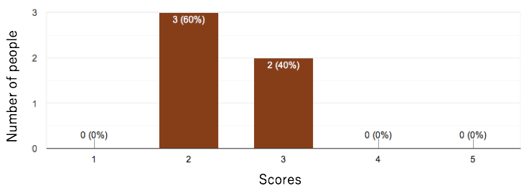
Fig. 8. Sufficiency of Information in the initial design
(The higher the scores, the more they feel the information is sufficient.)
As shown in Figure 8, information provided in the initial design is inadequate. The first common result was that gender information is necessary, but in this design, the only way to get gender information was to guess from the partner’s name, which was an uncertain method. Participants mentioned that building relationships or changing behavior in conversation depended on the partner’s gender. In addition, related to the above theme, one of the participants stated that brief introductory text was needed in order to write the other party’s chat. She stated that she would estimate the other’s writing style and the sense of distance, even if she could not get detailed characteristics from the sentence. Finally, the strongest opinion was that the profile characteristics were too brief. For example, even if the user and opponent have music and reading in common, because these comprise several genres and pieces of work, they insisted that they do not necessarily get along well with each other. We used a brief profile, even with the chance that users will be selective and not interested in anyone, because it allows for the possibility of a wide community. But, this actually may not be a problem even if detailed information is used. They also wanted to change how much detailed information can be disclosed depending on the partner; some participants did not want to show their detailed information if they could not get along with the other person.
Theme 4: Relationships Building
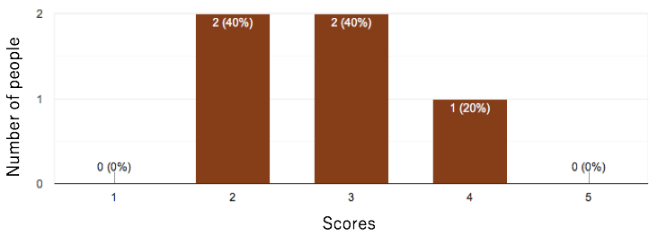
Fig. 9. Whether they feel that they could build a relationship with the opponent.
(The higher the scores, the more they feel they build new relationships.)
Figure 9 shows the results of investigating whether this design could help participants build relationships with the conversation partner. Participants’ awareness towards friendships from usual means was a significant influence. Participants with some SNS relationships recognized the other person as an acquaintance only by this chat conversation, but those who did not, said that if they do not meet directly, they could not recognize them as an acquaintance. Since we think this application is the first step to building relationships, it is good if a relationship can be made with only chat, otherwise, this is a good path to direct exchange. Additionally, current information is insufficient to recognize the other as an acquaintance. This experiment showed that a conversation about the community greatly changed the participants’ impression. If they cannot recognize that the partners are close to them, they will become unrelated, so we felt that we should present more information related to the community.
  - Results
As a result of the initial study, the following main elements are necessary for ComFriends.
- Enhancement of chat
- Refinement of proposed profile
- Addition of community elements
The next chapter has details for each element. We also could roughly identify three participant patterns:
- People with a wide range to recognize partners as acquaintances in short SNS conversations and who have high relationship building motivation.
- People who have high relationship building motivation but do not recognize opponents as acquaintances in short SNS conversations.
- People with low motivation for relationship building.
Since we want to utilize the premise of community chat to assist relationship-building, we narrowed down the target to the second group of people after that.
- Improvement
  - Enhancement of chat
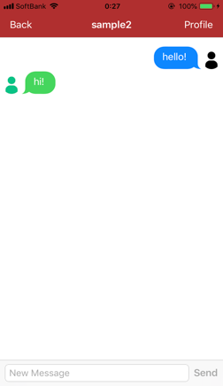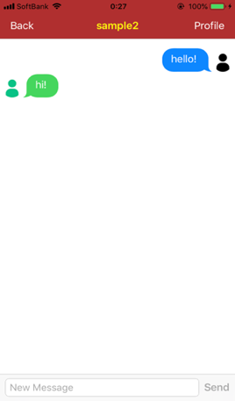
Fig. 10. Improved Talking Scene.
The first improvement is the expansion of the chat function. One of the initial design evaluations was the lack of clarity around the partner’s conversation speed. This is considered a major obstacle in the first meeting, so to eliminate this, we fixed the chat design so the user can get visual information about whether or not the other party is entering text. If the conversation partner inputs text, the displayed partner name in the talk room changes to yellow as shown on the right in Figure 10; otherwise, it turns white as shown on the left.
  - Refinement of proposed profile
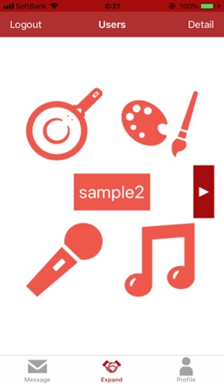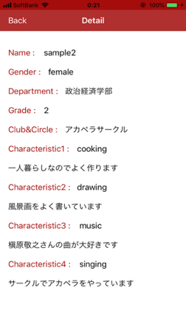
Fig. 11. Improved Expand Scene and Detail.
The next improvement is refinement of the proposed profile. In the initial design, due to the many genres of displayed characteristics, the user would not necessarily know if the conversation would be successful with a simple characteristic. Therefore, in order for the user to know the partner’s characteristics in more detail, we added a one-word comment field for each characteristic to be displayed as shown in Figure 11. Users can check this information by pressing the “detail” button on the upper right of the screen. This also gives users a clue about how to write their partner’s chat. Based on findings that gender information is important for selecting partners, we modified the proposed profile to grasp partner gender by color difference. A male partner profile is displayed in gray and a female partner profile is displayed in light orange. Finally, in the initial design, we learned that participants remember their partner by associating with their icon in conventional SNS, so we made it possible to display the user’s icon in the talk room.
  - Addition of community elements
The last improvement is the addition of community elements. The initial design does not contain community information in the proposed profile and the user had to propose that topic in the conversation. We thought that users felt close to each other when the partner belonged to the same community, so we added profile information on the grade, department, and club activities of the participants’ university. In addition, because some participants did not want to disclose community information to people they did not know, we allow users to arbitrarily set the community information disclosure range to three types: 1) Public to all, 2) Public only to partners who are interested in each other, and 3) Not public to anyone.
- User Study and Evaluation
We conducted a user study on six college students ages 21 to 25, who were highly motivated to build new relationships with an improved ComFriends. Half of the participants used the first design and the other half used ComFriends for the first time. We first asked participants to set up their profile and prepare five fictitious profiles that they would be interested in getting referred to them. Profiles include name, gender, characteristics that indicate hobbies, community information such as grade and department, and icons used for talking. They reacted to whether or not they were interested in the proposed fictitious users and, similar to the initial user study, they simulated conversation for approximately 10 minutes in one of the talk rooms generated by mutual interest. Then, we asked them to evaluate the app and we briefly interviewed them.
The application evaluation criteria are as follows: 1) Usability, 2) Ease of Talking, 3) Affinity for conversation partner, and 4) Motivation to build relationships with this application. Figure 12 shows a comparison of the initial design and improved design evaluation results. The score is the average of all participants between 1 to 5 points, with higher scores representing higher ease of use, less resistance to conversation, greater affinity, and higher motivation for the app.

Fig. 12. The evaluation of the initial design and the improved design
As shown in Figure 12, the improved design got a better evaluation than did the initial design. From the usability point of view, the initial design gained 3.6 points and the improved design gained 4.7 points, which was a significant improvement. Participants seemed to be able to use the app naturally, like a conventional talk application. Next, for ease of talking, the initial design gained 3.6 points and the improved design gained 4.5 points. Participants seemed to have a good impression of the new design because they were able to grasp the speed of the partner’s conversation and avoid conflict by checking the partner’s display name color. Regarding partner affinity, the initial design gained 2.8 points and the improved design gained 3.5 points. Many participants could recognize that their partners are located in familiar places because they got partner information about community. In particular, participants with community related topics in the conversation simulation give high points to the improved design. Participants who did not give high points said the reasons were insufficiency of conversation time and lack of community-related topics. In terms of motivation to use this app, the improved design got 4 points. We did not compare this result to the initial design since we did not get this evaluation then. Participants said they would like to actively use this app when enter a new community.
- Discussion
  - Obstacle in the first meeting
In this section, we will discuss whether ComFriends could assist first-time conversations. According to the survey of 18 users, we found that the obstacles in the first meeting were the unclear conversation content and the ambiguity of the partner’s conversation speed.
To solve the problem of conversation content, ComFriends gave the user information on the characteristics of their partner's hobby and their status in the community, and at the time of profile selection, made it possible for users to freely choose people they wanted to talk to. If a talk room is created, there is a presumption that they want to talk with each other, so users can be highly motivated for conversation. In the user study, participants seemed to have a smooth conversation proposal with reference to characteristics. Participants said that due to the four simple profiles, they could easily sort out those who are not interested at all versus interested parties, which avoided the need to confirm details; we thought that this visually easy-to-understand design was useful in selecting multiple partners. We added these details in the new design, which reduced the mismatch of hobbies. As shown in Figure 12, this made it easier for users to select the partner and propose the conversation topic.
To solve the conversation speed problem, ComFriends made it possible for the user to check whether the conversation partner is entering a chat. This function reduced conversation conflict so it got a good evaluation, but users found it difficult to see the design. Several participants said that since a chat is added at the bottom of the conversation, the design should confirm whether or not the conversation partner has entered the chat in at the lower side of the screen (from the user's perspective).
Throughout the experiment, some participants were less familiar with their opponents due to lack of conversation time, but all participants said they were not resistant to conversation with the other party.
  - Usefulness of community sharing
This section discusses the usefulness of personal expansion within the community. Our first hypothesis was that expanding the community network would increase the user’s sense of security and affinity compared to using SNS. In the interview, participants mentioned that they were able to recognize the partner as a familiar presence through topics and information related to their community, which were displayed in detail.
As shown in Figure 12, partner affinity was greatly enhanced by adding community information. They also felt that they could provide more information to people in the same community than to other partners on the Internet who they do not know at all. We believe that sharing a lot of information brings partners closer and it seems that maintaining the community helped relieve user anxiety about unknown parties and helped build relationships. Participants' interest in expanding relations within the community via this application was also high.
- Conclusion and Future Work
In this work, we investigated obstacles to interacting in a first meeting, proposed an application design for expanding the community network, and got evaluation results. The main design concepts are the display of the characteristic as conversation seed, the conversation by mutual interest, and preparing the assumption that users belong to the same community. A study of six users showed that a concise design with characteristics that promote conversation and belonging to a community, gave users a sense of intimacy.
In the future, it is necessary to confirm actual interaction among users in the community. Since this was a simulation experiment using fictional users, results from a more natural environment will be required. For the community, we need to try this concept at different scales. This time it was a big community, such as a university, but we have to confirm how this application works in a smaller community or a resident community such as an apartment house.

References
- Tom Rath. (2006) “Vital Friends: The People You Can’t Afford to Live Without”, The Gallup Press.
- Nicole B. Ellison, Charles Steinfield, Cliff Lampe. (2007) “The Benefits of Facebook “Friends:” Social Capital and College Student’s Use of Online Social Network Sites”, Journal of Computer-Mediated Communication, Vol.12, issue 4, p1143-1168.
- Murata, I., Suzuki, N. (2009) “A Newspaper-Based Analysis of Minors’ Legal Responsibility for Mobile Phone-Induced Crimes: With Special Reference to Articles of Online Dating Sites Related Crimes”, Japan journal of educational technology, Vol.32, No.4, p435-442.
- Ishii, Y., Aburai, T., Takeyasu, K. (2013) “An Analysis of User Attitudes to SNS”, OIU journal of international studies, Vol.26, No.2, p1-21.
- Nguyen, T. T., Nguyen, D. T., Iqbal, S. T. and Ofek, E. “The known stranger: Supporting conversations between strangers with personalized topic suggestions”, In Proc. of CHI, 555-564, 2015.
- Ogata, H., Yano, Y., Furugori, N., Jin, Q. (1995) “PeCo-Mediator: Development and Modelling of a Supporting System for Sharing and Handling Personal Connections”, Transaction of Information Processing Society of Japan, Vol.36, No. 6.
- Iwasaki, H., Yano, E., Sinohara, I., Kato, T. (2009) “Modeling of Personal Sense of Intimacy using Common Points of Contents”, Kansei Engineering International, Vol.8, No. 3.
- Matsuo, Y., Yasuda, Y. (2007) “How Relations are Built within a SNS World -Social Network Analysis on Mixi-”, Transactions of the Japanese Society for Artificial Intelligence: AI, Vol.22, issue 5, p531-541.
- Hamasaki, M., Takeda, H., Ohmukai, I., Ichise, R. (2004) “Proposal and Analysis of a Community System using Personal Networks”, Transactions of the Japanese Society for Artificial Intelligence: AI, Vol.19, issue 5, p389-398.
- Uehigashi, N., Sakabe, S., Yamazaki, H. (2016) “Relationship between Communication on Social Network Service and Empathy”, Papers on Environmental information science, Vol.30, p273-278.

