**Supporting Human Relationship Building**

**in a Daily Life Community**

Koya Iwase, Kota Gushima,Tatsuo Nakajima

Waseda University, Tokyo

1. **Introduction**

In our daily lives, a wide friendship helps us, and there are some merits to expanding your personal connections [1]. In general, Japanese tend to feel resistance in their first-face-to-face exchanges [2], and it is difficult to meet directly and expand friendship, but recently various communication services have been developed as means to expand the network of people, and we can build new relationships relatively easily with people all over the world. However, even these developed communication tools still contain the risk of crime through exchanges with unknown partners and the sense of resistance of conversation with them [3], so some people feel uneasy about expanding friendships on the Internet.

This paper proposes ComFriends, a communication tool that reduce the resistance feeling of the conversation between the first meeting and help us expand our friendship more easily and more safely. ComFriends provides users with conversations between people who belong to the same community in a state of mutual interest, and support users building relationships. We first present some existing approaches for assisting relationship building for the first time, next we will show the approach of ComFriends.

In this work, we investigate the factors that people feel resistance in the first conversation and the information that they need to build relationships, and we will show the clues for facilitating interaction in the first meeting and future SNS development.

1. **Related Work**

Today, various systems have been developed to assist relationship building or utilize the relationships according to purpose. Here we will introduce some of them and consider the elements that are necessary for relation building from them.

・Communication support facing directly

There are several approaches directly facing each other for the first time. For example, it is a suggestion of conversation contents [4]. What you talk about in the conversation with the person you meet for the first time is an important issue for the speakers. In order to eliminate this obstacle, various systems to propose the content of conversation were developed, which helped users to talk smoothly. However, as a problem, these systems proposed topics which speakers didn’t want to talk to their first-time opponent. Also, it seems that many people felt a sense of resistance to face directly with the first-time opponent, except for situations where you had to face each other directly and talk.

・Virtual relationship expansion

There are also studies for us to have a virtually broad connection via others [5]. In this system, individual’s personal networks can be shared in a database, and each individual can connect to various people via that personal network. If you face a problem at work and you need human resources who can solve the problem, you can find people suitable for the problem resolution smoothly through your acquaintance.

・People proposal based on common elements

We are unconsciously looking for something in common with our opponent when interacting with the person for the first meeting, and it is said that the psychological barriers to the partner will be removed if we feel a sense of familiarity due to this commonality [6]. In a project, researchers grasp elements such as hobbies of people who need help and supporters, and artificially match people with similarities in order to conduct volunteers more smoothly. Actually, the result that pairs with many common points have many topics of conversation, they tend to get along is appeared. Especially, among the several elements, the hobby common seems to have a great positive impact on familiarity. However, since these artificial matching is carried out by the third party’s evaluation, it is an uncertain means for relation building, and the administrator burdens a lot. We thought that it is good for our application to find common points with the partner depending on the user’s will.

1. **Design Implementation**

Before creating ComFriends, in order to explore the problems of existing relationships building application and chat application, we created a concise design close to those and asked for users’ evaluation. Procedures of the first design implementation are shown below.

・Questionnaire

In order to produce the initial design of ComFriends, we first asked 18 people aged 20 to 57 years old. In the questionnaire, we confirmed the following five items: 1) Do you feel resistance to conversation for the first meeting, 2) Do you feel resistance to talking on the SNS with someone you have never met before, 3) Have you experienced easy talking with the person you were in first meeting, 4) Do you think that interaction within the community is necessary, 5) Do you want to expand the network of people in the community.

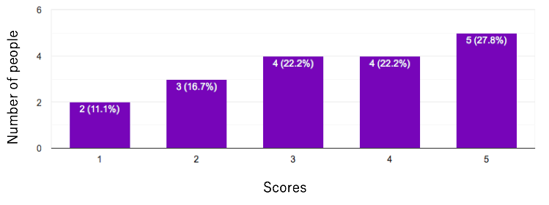

**Fig. 1.** Result of the first question - Do you feel resistance for the first meeting?

The higher the score, the stronger the sense of resistance.

First, the result of the first question is as shown in Figure 1. As a result, participants who felt resistance in the first-time conversation were more than participants who did not, their main reasons are “I don’t know what to talk about”, “I don’t know what kind of person is”, “I don’t know the speed of partner’s reply”, etc.

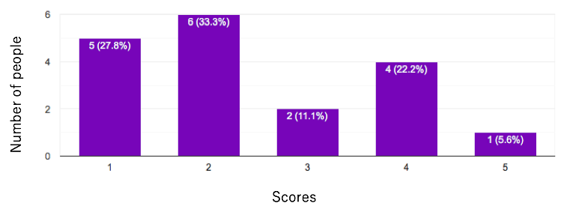

**Fig. 2.** Result of the second question -

Do you feel resistance to talking on the SNS for with someone you have never met?

The higher the score, the stronger the sense of resistance.

In contrast to previous question, the result of the next question is as shown in Figure 2, and the number of people who feel resistance is very low in the case of a conversation on SNS. As reasons for decreasing resistance, they said “I can’t see the other’s expression, so I don’t have to worry about it”, “I can get the information necessary for conversation through the users’ profile”, etc. In addition, as a situation that participants felt easy to talk with each other for the first meeting, they gave cases when the content to talk about is decided, when each other has common hobby, and when the reaction shows clearly from the other.

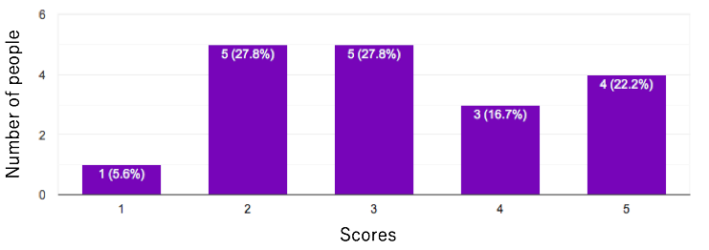

**Fig. 3.** Result of the fourth question -

Do you think that interaction within the community is necessary?

The higher the score, the more they feel it is necessary.

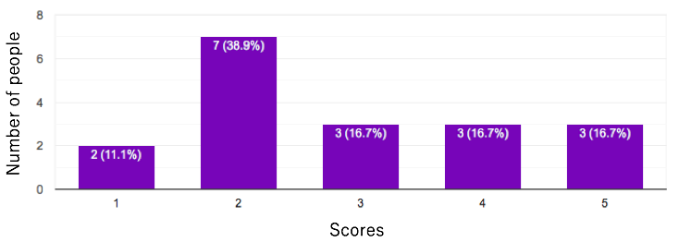

**Fig. 4.** Result of the fifth question – Do you want to expand the network of people in the community?

The higher the score, the more they have motivation to build new relationships.

Next, I will show the results of questionnaire about exchange within the community. As shown in the figure 3, half of participants felt an exchange within the community was necessary, and half felt it was not. While the former argued that it is necessary for cooperation in the event of emergency, the latter argued it would be difficult to complain about group living by getting to know each other. We think that these merits and demerits that apply to “residential community” such as residential areas and apartment houses, not “affiliation community” like schools and workplaces. Also, as shown in the figure 4, there are fewer people who want to expand the network within the community, some people mentioned that the main cause is the difficulty of building a new relationship regardless of whether it is an interaction within the community or not.

・Approach

Considering the results of the questionnaire, basically we decided to create an application with the following approach: 1) Provide a concise profile required for conversation, 2) Preparation on the premise that they show mutually favorable reaction.

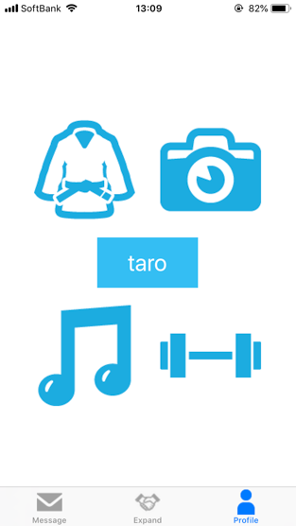 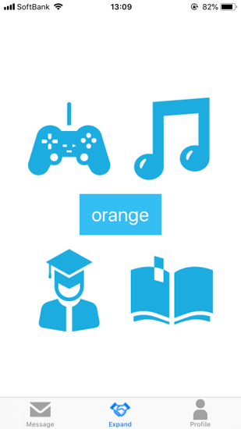 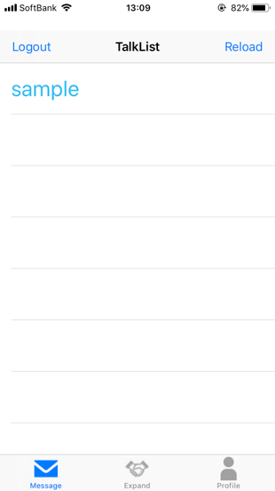

**Fig. 5.** Initial Design - Profile Scene, Expand Scene, Message Scene

This design consists of three main scenes. The first scene is “Profile Scene”. On this screen, you can check your brief profile. The next scene is “Expand Scene”. In this scene, users belonging to the same community are proposed one after another. The users of the application will indicate whether or not they are interested in the profile proposed on this screen by dragging the image. If they are not interested in the opponent, they move the image up, and if they are interested, they pull it in front to accept. The last scene is “Message Scene”. In this scene, a talk room between users who are interested in each other through the “Expand Scene” is created. They can talk like an existing chat through this talk room and check opponent’s profile.

・User Study

We conducted a user study using the initial design of ComFriends for 5 participants aged 20 to 25. First of all, in a prior questionnaire, we asked whether they would like to expand their network of people in the community, what their hobbies are, what kind of information they need for the partner when building a relationship through SNS. We thought that it was necessary to treat the community as “school and workplace” and “region and apartment house” separately, so we checked the motivation for personal network expansion for each of them. As a result, all the participants are students and they do not want to expand the network of people in the region and apartment house, but there are many people who strongly desire it in schools and workplaces, so we decided to conduct experiments only with the university community they belong to. Next, with reference to the hobby confirmed in the preliminary questionnaire and the information required by participants to build relationships, we prepared several profiles that they would be interested in and asked them to react those. After that, we asked participants to talk to fictitious users whom they were interested in through chat and simulated the conversation. Then, contrary to that, another user whom participants were interested in talked to them through chat and simulated the conversation.

・Interview

After the user study, we asked participants to evaluate the design and interviewed them.

Theme 1: Usability

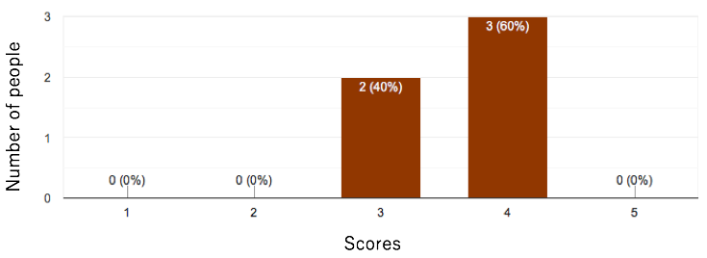

**Fig. 6.** Usability of the initial design

The higher the scores, the higher the usability.

The initial design got the evaluation as shown in the figure 6 in term of usability. As a result, there were several functions to be extended, some participants did not give a high evaluation to the initial design. We will explain these issues in other themes in detail.

Theme 2: Ease of Talking

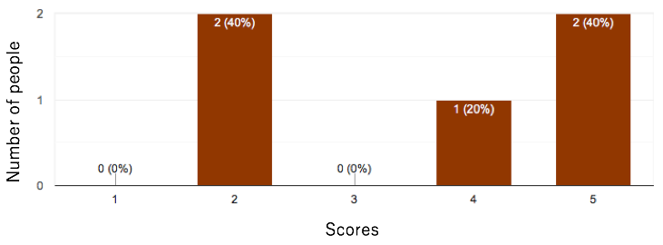

**Fig. 7.** Ease of Talking in the initial design

The higher the scores, the easier to talk.

In term of ease of talking, evaluation was divided among the participants as shown in figure 7. While people who often talk with someone they have never met on SNS and who are motivated to expand relationships said that they were able to talk easily based on the displayed opponent’s characteristics, others who feel that they are not good at conversation itself and who have low motivation for relationships building said that they felt it was difficult speak because they didn’t know the tempo of conversation with person for the first talking and how to write the chat of opponent. And in order to solve the problem of not knowing the tempo of conversation, they suggested to display whether each other is entering the sentence or not.

Theme 3: Sufficiency of Information

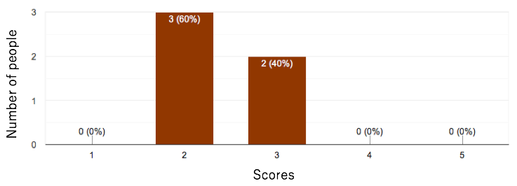

**Fig. 8.** Sufficiency of Information in the initial design

The higher the scores, the more they feel the information is sufficient.

As shown in figure 8, the information provided in the initial design is inadequate. First of all, they stated that gender information is necessary in common. In this design, the only way to get gender information was to guess from opponent’s name, and it was uncertain way. Participants mentioned that whether to build relationships or the behavior in conversation changes depending on gender information of the opponent. In addition, in connection with the theme mentioned above, one of the participants stated that a brief introductory text is needed to know how to write the other party’s chat. She stated that she would estimate the way the other writes the sentence and the sense of distance in the chat, even if she can not get the information about the characteristics from that sentence. Finally, the strongest opinion was that the characteristics of the profile were too brief. For example, even if the user’s opponent has characteristics of music and reading in common with the user, because there are several genres and pieces of work among them, they insisted that they do not necessarily get along well each other. We used a brief profile in fear of users being selective about the proposed profile and not interested in anyone, but in the case of a wide community like this time, there may be no problem even if detailed information is proposed. They also said they wanted to change the extent of disclosure of detailed information depending on the partner. There were participants who felt that they did not want to show their detailed information if they could not get along with the other.

Theme 4: Relationships Building

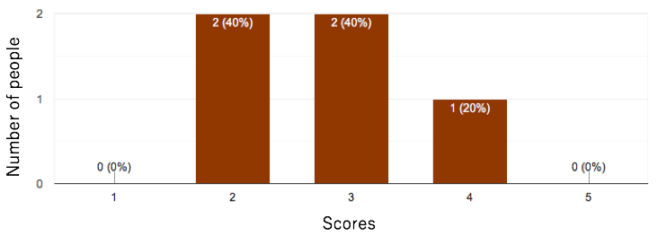

**Fig. 9.** Whether they feel that they could build a relationship with the opponent

The higher the scores, the more they feel they build new relationships.

Finally, figure 9 shows the results of investigating whether they felt that they could build relationships with the conversation partner in this design. Regarding this results, the participants’ awareness towards friendships from usual times greatly influenced them. Participants who have some relationships that were made on SNS recognized the other as acquaintance only by this chat conversation, but those who do not said that as long as they do not meet directly, they could not recognize them as acquaintance. As we are thinking that this application is the first step to building relationships, it is good if it is possible to make a relationship with only chat, otherwise it is better to become a foot to direct exchange. Also, information is insufficient this time to recognize the other as acquaintance. In this experiment, whether there was a conversation about the community greatly changed the impression of the participants. They said that if they cannot recognize that the partners are close to them, they will become unrelated to them. We felt that we should present more information related to the community.

・Results

As a result of the initial study, we thought that the following main elements are necessary for ComFriends.

1. Enhancement of chat
2. Refinement of proposed profile
3. Addition of community elements

We show the details about these elements in the next chapter. Also, we could roughly identify three patterns of participants.

1. People with a wide range to recognize opponents as acquaintances as they are in short conversation on SNS and who have a high relationship building motivation.
2. People who have a high relationship building motivation but who do not recognize opponents as acquaintances in short conversation on SNS.
3. People with low motivation for relationship building.

Since we want to utilize the premise of chat in the community to assist relationship building, we decided to narrow down the target to the second people after that.

1. **Improvement**

・Enhancement of chat

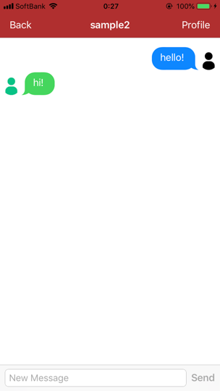 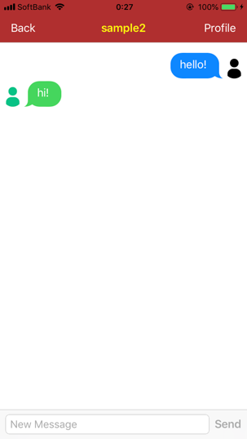

**Fig. 10.** Improved Talking Scene

The first improvement is the expansion of the chat function. One of the evaluations obtained in the initial design was the unclearness of the conversation speed of the partner. This is considered to be a major obstacle in the first meeting, so in order to eliminate this, we fixed the chat design so that the user can visually get the information whether or not the other party is entering the text. If the conversation partner inputs text, the name of the partner displayed in the talk room changes to yellow as shown on the right of the figure 10, otherwise it turns white as shown on the left of the figure 10.

・Refinement of proposed profile

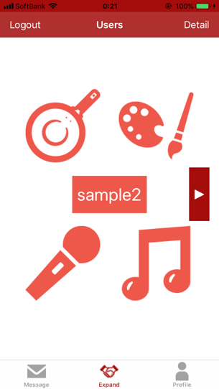 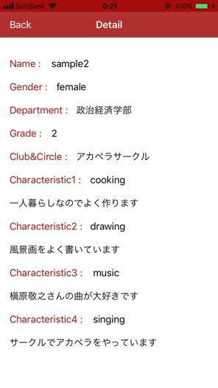

**Fig. 11.** Improved Expand Scene & Detail

The next improvement is refinement of the profile of the proposed user. In the initial design, due to the large number of genres in the displayed characteristics, there was a problem that the user could not necessarily find whether the conversation with the partner would be successful with a simple characteristic. Therefore, in order for the user to know the characteristics of the partner in more detail, we added a field for showing a one-word comment on each characteristic to be displayed as shown in figure 11. Users can check this detailed information by pressing the “detail” button located at the upper right of the screen. This will also give the users a clue as to how to write their partner’s chat. Also, based on the evaluation that gender is important information for selecting the partners, we modified the proposed profile to be able to grasp the gender of partners by color difference. If partner is male, his profile is displayed in gray, and if partner is female, her profile is displayed in light orange. Finally, in the initial design, we got an opinion that participants remember their partner by associating with the opponent’s icon in conventional SNS, so we made it possible to display the icon set by users in the talk room.

・Addition of community elements

The last improvement is the addition of community elements. In the initial design, the proposed profile does not contain community information, and either user had to proposed that topic in the conversation. We thought that users feel close to each other by recognizing strongly that partner belong to the same community as theirs, so in this time, we added information on the grade, department, and club activities at the university to which participants belong to profile. In addition, because there were some participants who do not want to disclose information on community to people whom they do not know, we made it possible for users to arbitrarily set the disclosure range of community information to 3 types in this design: 1) Public to all, 2) Public only to partners who are interested in each other, 3) Not public to anyone.

1. **User Study & Evaluation**

We conducted a user study on six college students aged 21 to 25 who were highly motivated to build new relationship in advance questionnaire with improved ComFriends. Half of the participants participated in the experiment using the first design, and the other half used ComFriends for the first time. First of all, we asked participants to set up their own profile and prepared 5 fictitious profiles that they would be interested in referring to them. Profiles include names, gender, characteristics that indicate hobbies, information on community such as grade and department, and icons used for talking. They showed reactions of whether they are interested in or not to the proposed fictitious users and, as well as the initial user study, simulated conversation for about 10 minutes in one of the talk rooms generated by mutual interest. After that, we asked them to evaluate the app and had a brief interview with them.

The evaluation criteria of the application are as follows: 1) Usability, 2) Ease of Talking, 3) Affinity with conversation partner, 4) Motivation to build relationships with this application. A comparison result of the evaluation of the initial design and the improved design is shown in figure 12.

The score is the average of the evaluations of all participants between 1 to 5 points, higher the scores represent higher ease of use, less resistance to conversation, greater affinity, higher motivation for app.

**Fig. 12.** The evaluation of the initial design and the improved design

As shown in figure 12, the improved design obtained a better evaluation than the initial design. From the usability point of view, the initial design gained 3.6 points and the improved design gained 4.7 points, so great improvement was seen. Participants seemed to be able to use the app naturally like the conventional talk application. Next, from the viewpoint of ease of talking, the initial design gained 3.6 points and the improved design gained 4.5 points. The participants seemed to have a good impression on the talk with a new design because they were able to grasp the speed of the partner’s conversation and avoid the conflict of the conversation by checking the color of the partner’s displayed name. Regarding affinity with partner, the initial design gained 2.8 points and the improved design gained 3.5 point. Many participants could recognize that their partners are located in familiar places because they got partner’s information about community, and especially participant who had topics related to the community in the conversation simulation give a high point to the improved design. Participants who did not give a high point raised the insufficiency of conversation time and that there was nothing related to the community in topic as a cause. Finally, in terms of motivation to use this app, the improved design got 4 points. Since we did not get the evaluation on motivation in the initial design, we did not compare it. Participants said they would like to actively use this app if they had just entered a new community.

1. **Discussion**

・Obstacle in the first meeting

In this section, we will discuss whether ComFriends could assist the conversation for the first time. By the questionnaire we did for 18 users, we defined that the obstacle to be removed in the first meeting was the unclear of the content of the conversation and the ambiguity of the conversation speed of the partner.

First, in order to solve the problem of conversation contents, ComFriends provided the user with information on the characteristics of their partner's hobby and the status in the community, and at the time of selecting a profile, and made it possible for users to freely choose people who they want to talk to. If a talk room is created, there is a mutual interest premise that they want to talk with each other, so users can get a high motivation for conversation. In the user study, participants seemed to have made a conversation proposal smoothly with reference to characteristics. Regarding these characteristics, participants said that due to the four simple profiles, they could easily sort out those who are not interested at all and interested parties, and saved the action of confirming the details, so we thought that this visually easy-to-understand design was useful in selecting multiple partners. In addition, as an improvement from the initial design, we added details in the new design. This reduced the mismatch of hobbies unintended by the user, and as shown in Figure 12, made it easier for users to select the partner and propose the topic of the conversation.

Next, in order to solve the problem of conversation speed, ComFriends made it possible for the user to check whether the conversation partner is entering a chat. This function reduced conflict of conversation with the other party, so this got a good evaluation from the user, but there was an opinion that it is difficult to see the design. Several participants said that a chat is added down in the conversation, so it is desirable to design that it is possible to confirm whether or not the conversation partner has entering chat in at the lower side of the screen where the user's point of view gathers.

Throughout the experiment, some participants were a bit less familiar with their opponents due to lack of conversation time, but all participants said they did not feel resistance to conversation with the other party.

・Usefulness of community sharing

In this section we will discuss the usefulness of personal expansion limited within the community.

First of all, we had a hypothesis that expanding the network within the community would increase the sense of security and affinity for the user compared to doing on SNS. In the interview of this experiment, the participants mentioned that they were able to recognize the opponent as a familiar presence through topics related to the community and information on the community of the opponent displayed in detail.

As also shown in figure 12, we can see that the affinity for the partner was greatly enhanced by adding community information. Also, they felt that they can provide more information to the other who belong to the same community than other partners on the Internet whom the users do not know at all. We think that sharing a lot of information brings each other closer. As a result, it seems that maintaining the common community helped relieve the user's anxiety about unknown parties and helped build relationships. Participants' interest in expanding relations within the community using this application was also high.

1. **Conclusion & Future Work**

In this work, we investigated obstacle factors by interaction between people for the first meeting, proposed an application design for expanding the network within the community based on that, and gained evaluation. The main concept of the design is the display of the characteristic as conversation seed, the conversation by mutual interest and the preparation of the assumption that users belong to the same community. A user study conducted on 6 participants showed that a concise design that show users’ characteristic promotes conversation and belonging to a common community gives users a sense of intimacy.

In future work, it is necessary to confirm with actual interaction among users in the community. Since it was a simulation experiment using fictional users this time, it will be required to achieve results in a more natural environment. As for the community, we need to try this concept in communities of different scales. This time it was a big community like a university, but we have to confirm how this application works in a smaller community or in a resident community such as apartment house.

1. **Reference**
2. Searching
3. Searching
4. Searching
5. Nguyen, T. T., Nguyen, D. T., Iqbal, S. T. and Ofek, E. The known stranger: Supporting conversations between strangers with personalized topic suggestions. In Proc. of CHI, 555-564, 2015.
6. Ogata, H., Yano, Y., Furugori, N., Jin, Q. (1995) PeCo-Mediator : Development and Modelling of a Supporting System for Sharing and Handling Personal Connections. Transaction of Information Processing Society of Japan, Vol.36, No. 6.
7. Iwasaki, H., Yano, E., Sinohara, I., Kato, T. (2009) Modeling of Personal Sense of Intimacy using Common Points of Contents. Kansei Engineering International, Vol.8, No. 3.