1. Final result of variable number is?

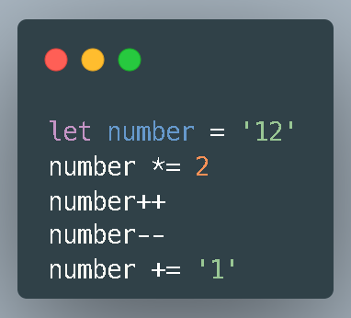

1. 251
2. 241
3. 25
4. 24
5. What is the output from console.log(String(12) === ‘12’)?
6. True
7. False
8. Undefined
9. Null
10. The following is the correct statement regarding the while loop is?
11. While command the condition will be checked after the iteration run
12. While command will only run if the given condition is false
13. While command will iterate every time if the condition is true
14. All Answer is Correct
15. The following are correct statements regarding Array in JavaScript, except?
16. Has `.length` method
17. It can accommodate more than one value
18. It can hold all data types and values in Javascript except for object
19. It can hold all data types and values in Javascript, including arrays
20. The result displayed from console.log(name) is?

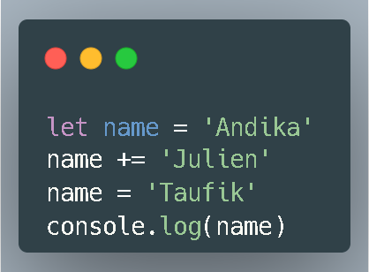

1. Taufik
2. Julien
3. Andika
4. Andika Julien
5. LIFO (Last in First Out) is a concept used in one type of data structure. The data structure that uses LIFO is:
6. Stack
7. Queue
8. Linkedlist
9. Hash Map
10. What will be displayed by console.log if the code below is executed?

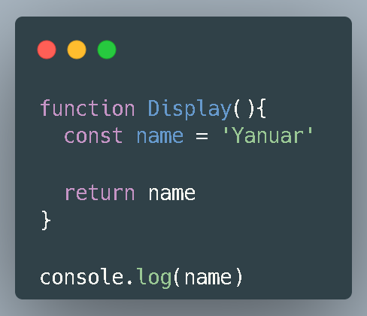

1. Undefined
2. Null
3. Yanuar
4. `ReferenceError: name is not defined`
5. What is the result of console.log(numbers)?

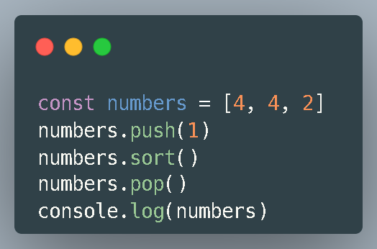

1. TypeError: Sort is not a function
2. [4, 2, 1]
3. [1, 2, 4]
4. TypeError: Assignment to constant variable
5. The last value of the variable output if the above code is executed is?

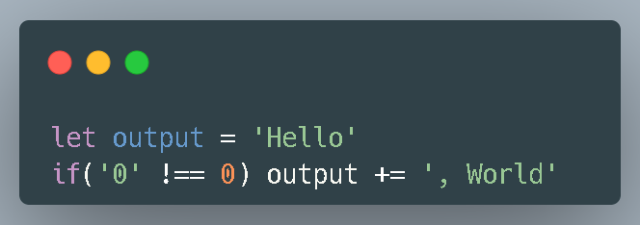

1. ‘Hello’
2. ‘, World’
3. ‘Hello, World’
4. ‘Hello, World!’
5. What is the result of the code above?

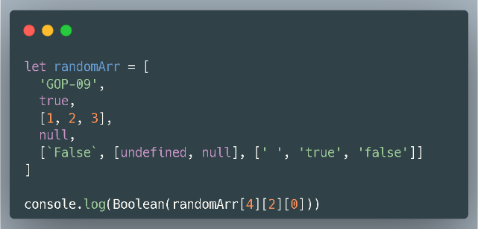

1. True
2. False
3. ‘ ‘
4. Undefined
5. The difference between .map and .forEach is?
6. forEach() can be used to loop through objects just like a for-loop
7. map() is used if you only need a loop without creating a new array
8. A forEach() loop can be stopped with break
9. forEach() does not return a new array, whereas map() return new array
10. The result of the code above when executed is?

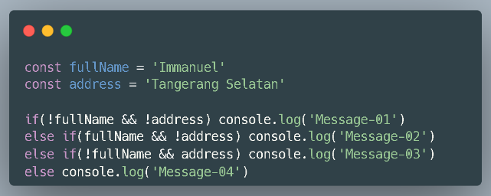

1. Message-04
2. Message-03
3. Message-02
4. Message-01
5. What the result from this code bellow?

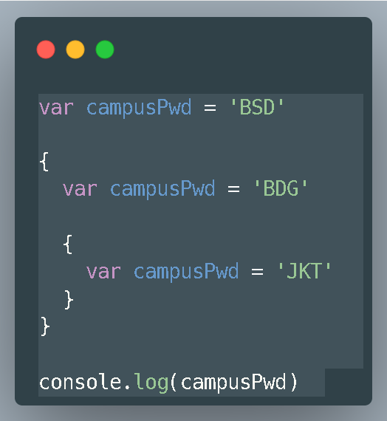

1. ‘BSD’
2. ‘BDG’
3. ‘JKT’
4. SyntaxError: Identifier 'campusPwd' has already been declared
5. What the result from this code bellow?

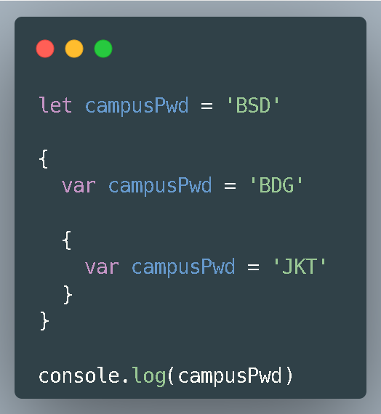

1. ‘BSD’
2. ‘BDG’
3. ‘JKT’
4. SyntaxError: Identifier 'campusPwd' has already been declared