# JavaScript Unit 2- Exercise 2

In this exercise, you will be working with a variety of built-in functions and variables. There will be 3 pages that you will be adding scripts to. As you progress from one page to another, the steps will get slightly more difficult. This is to help test that you understand what you have read. If you have not done so, download the exercise_2.zip folder and extract the files.

## Setting up your Web Server

1. Within the csci2447 folder on your web server, create a sub-folder and name it **exercise2**.

## Open the index.html within your IDE

1. Within the existing script element, declare a constant called **myFirstName**.
   1. Initialize **myFirstName** with a suitable value(Use your actual name).
2. Declare a variable called **myAge.** Make sure to utilize let.
3. Reassign myAge variable.
   1. Prompt the user to input their age and store that info within the variable.
4. Declare a variable called **myFuture.** Make sure to utilize let.
5. Reassign **myFuture** variable.
   1. You will want to calculate what the age will be in 30 years within the variable. Create a calculation that will add 30 to the myAge variable and store the result within the myFuture variable. **Hint**: You might need to parse the variable so it is considered a number and not string.
6. Use a template literal to write/insert a phrase within an alert.
   1. You will combine the myFirstName and myFuture variable into a phrase.
   2. Example phrase: **My name is Buddy and my age 30 years from now will be 60**.
   3. The alert will run once the page loads.

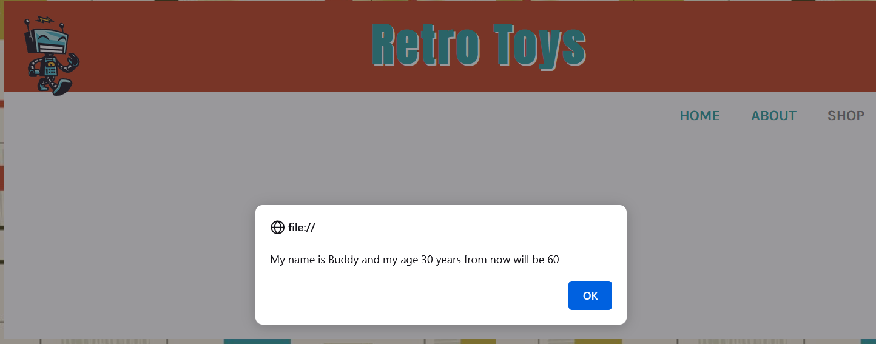

## Open the shop.html within your IDE

You will be selecting an existing element and replacing the content of that element.

1. Create a variable that stores the element with the id of cost.
   1. This is the div element on the shop page.
   2. You can use document.getElementById() to select the Element by Id.
2. Create a variable that stores the following string: **Current Sale: 30% off Regular Price**.
3. You can always replace content on the page. When you store the element as a variable, you can then use a variety of methods or properties to change the content. There are many ways to accomplish this. You could use the **textContent** or **innerHTML** property. Replace the existing div content with the new variable string content created in step 2.

## Screenshot of the web page showing the end result after the addition of the of the code.

## Open the temp.html within your IDE

You will be creating a script that will prompt the user for the temperature in Fahrenheit and you will convert that temperature to Celsius.

1. Prompt the user to input the temperature (in Fahrenheit) and store that info within a variable.
2. The formula to convert Fahrenheit to Celsius is the following: 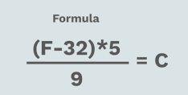
   1. Use or create any other variables or constants that are needed to complete the formula.
   2. The results from the formula will be stored within a variable.
3. Now, simply return temperature in Celsius within an alert message.
   1. Use a template literal to write out your phrase within the alert.
   2. Example of phrase: **The Temperature in Celsius is 0 degrees**.

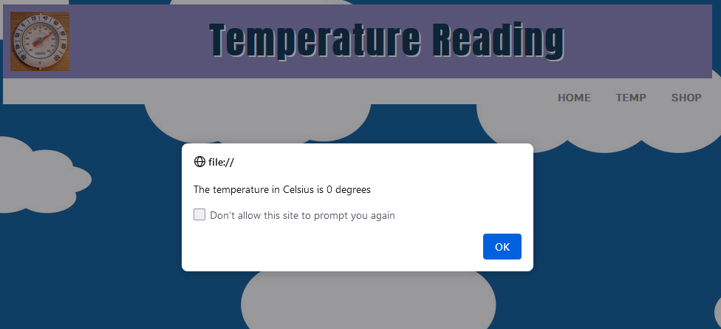

## Uploading your Page

1. Upload the three .html files plus the styles and images folder to the public_html/csci2447/exercise2 folder.
2. To check if you posted the file correctly, point your browser to: *http://citwebdev.cscc.edu/~<your_username>/****csci2447****/exercise2*
3. Submit the complete URL within the Blackboard assignment. Failure to do so will result in a zero.

### Additional Links to help you with the task

* [CitWebDev Accounts](http://citwebdev.cscc.edu/?page_id=119)
* [Alerts](https://developer.mozilla.org/en-US/docs/Web/API/Window/alert)
* [Write() method](https://developer.mozilla.org/en-US/docs/Web/API/Document/write)
* [innerHTML](https://www.w3schools.com/jsref/prop_html_innerhtml.asp)
* [textContent](https://developer.mozilla.org/en-US/docs/Web/API/Node/textContent)

### Grading Rubric

* Working URL submitted (1 pts)
* Sound Syntax Structure (5 pts)
* Project Requirements (4 pts)