

Project submission
Fundamentals of web development
Online Food Ordering Website
Student details
Student name | Maseeha.M
Registered number | 34625009035
Department | BCA
ID | E233D7949226A32890E4F026ECB4E274
College | M.M.E.S women's art and science  college
Date of submission | 27.10.2026

1.problem statement & objectives
Problem Statement:
The Online Food Ordering Website helps customers view food items,
search for dishes, add food to a shopping cart, change quantities,
and check the total price before placing an order.
Objectives:
1.Display food items with images, names, descriptions, and
prices.
2.Search for food items by name.
3.Filter food items by category.
4.Add and remove items from the shopping cart.
5.Increase or decrease item quantities.

6.Calculate the total order price automatically.
7.Display the order summary.
8.Validate customer details before ordering.
9.Save cart data using Local Storage.
10. Display messages when the cart is empty or the order is
submitted.
2. Architecture:
The architecture explains how the Online Food Ordering
Website works. Customers can view food items, search for
dishes, add items to the cart, and place an order.
2.1 Application Flow:

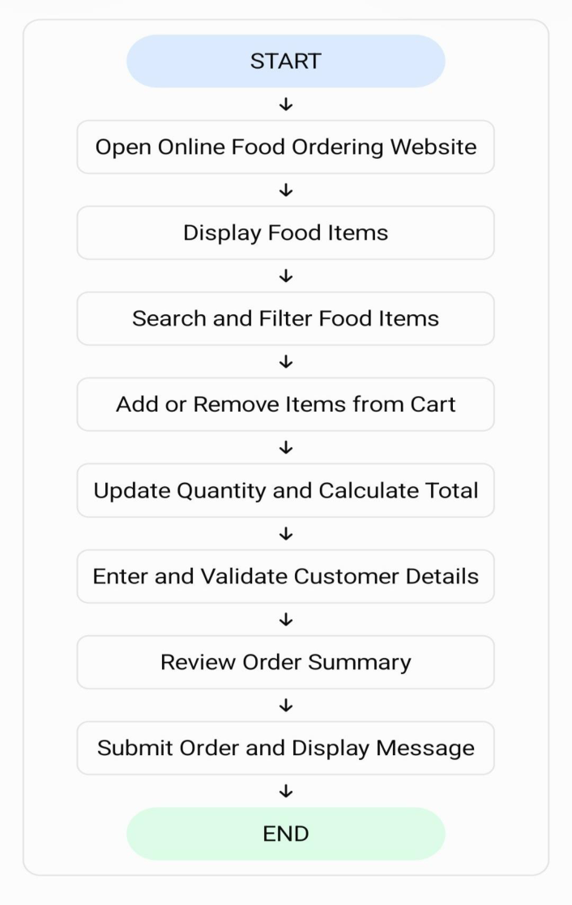

Technologies Used

HTML: Creates the structure of the website.
CSS: Designs and styles the website.
JavaScript: Adds search, filtering, cart management, and price
calculation.
3. Practical Implementation:
The Online Food Ordering Website is developed using HTML, CSS,
and JavaScript. It allows customers to view food items, search for
dishes, add items to the cart, and place orders.
3.1 Features Implemented:
Features | Description
Food Menu | Displays food items and prices.
Search | Finds food items by name.
Category Filter | Filters food by  category.
Shopping Cart | Adds and removes food items.
Quantity Control | Changes item  quantities.
Price Calculation | Calculates the total price.

3.2 Source code

The following are the important source code used in portal
HTML
<!DOCTYPE html>
<html>
<head>
<title>My Webpage</title>
</head>
<body>
<h1>Welcome to My Website</h1>
<p>This is my first HTML webpage.</p>
<h2>My Hobbies</h2>
<ul>
<li>Baking</li>
<li>Reading</li>
<li>Listening to Music</li>
</ul>

<button>Click Me</button>
</body>
</html>
CSS
<!DOCTYPE html>
<html lang=”en”>
<head>
<meta charset=”UTF-8”>
<title>CSS Example</title>
<style>
/* This is the CSS Code */
Body {
Background-color: #f0f2f5;
Font-family: Arial, sans-serif;
Display: flex;
Justify-content: center;

Align-items: center;
Height: 100vh;
Margin: 0;
}
.card {
Background-color: white;
Padding: 24px;
Border-radius: 8px;
Box-shadow: 0 4px 8px rgba(0, 0, 0, 0.1);
Text-align: center;
Max-width: 300px;
};
H1 {
Color: #1a73e8;
Margin-bottom: 8px;
}
P {
Color: #5f6368;

Font-size: 16px;
Line-height: 1.5;
}
Button {
Background-color: #1a73e8;
Color: white;
Border: none;
Padding: 10px 20px;
Border-radius: 4px;
Cursor: pointer;
Font-weight: bold;
}
Button:hover {
Background-color: #1557b0;
}
</style>
</head>
<body>

<!—This is the HTML Structure →
<div class=”card”>
<h1>Hello World!</h1>
<p>This styled card component is built using HTML and internal
CSS.</p>
<button>Click Me</button>
</div>
</body>
</html>
JavaScript
<!DOCTYPE html>
<html lang=”en”>
<head>
<meta charset=”UTF-8”>
<title>JavaScript Counter Example</title>
<style>
Body {

Font-family: Arial, sans-serif;
Display: flex;
Flex direction: column;
Align-items: center;
Justify-content: center;
Height: 100vh;
Margin: 0;
Background-color: #f7f9fa;
}
.counter-box {
Text-align: center;
Background: white;
Padding: 30px;
Border-radius: 10px;
Box-shadow: 0 4px 12px rgba(0,0,0,0.1);
}
#count-display {
Font-size: 48px;

Font-weight: bold;
Color: #333;
Margin: 20px 0;
}
Button {
Padding: 12px 24px;
Font-size: 16px;
Background-color: #007bff;
Color: white;
Border: none;
Border-radius: 5px;
Cursor: pointer;
}
Button:hover {
Background-color: #0056b3;
}
</style>
</head>

<body>
<div class=”counter-box”>
<h2>Click Counter</h2>
<div id=”count-display”>0</div>
<button id=”increment-btn”>Increase Count</button>
</div>
<!—This is the JavaScript Code →
<script>
// 1. Initialize the counter variable
Let count = 0;
// 2. Select the HTML elements using DOM selection
Const display = document.getElementById(‘count-display’);
Const button = document.getElementById(‘increment-btn’);
// 3. Add an event listener to detect clicks
Button.addEventListener(‘click’, function() {
// Increment the counter
Count = count + 1;
// Update the text inside the HTML display element

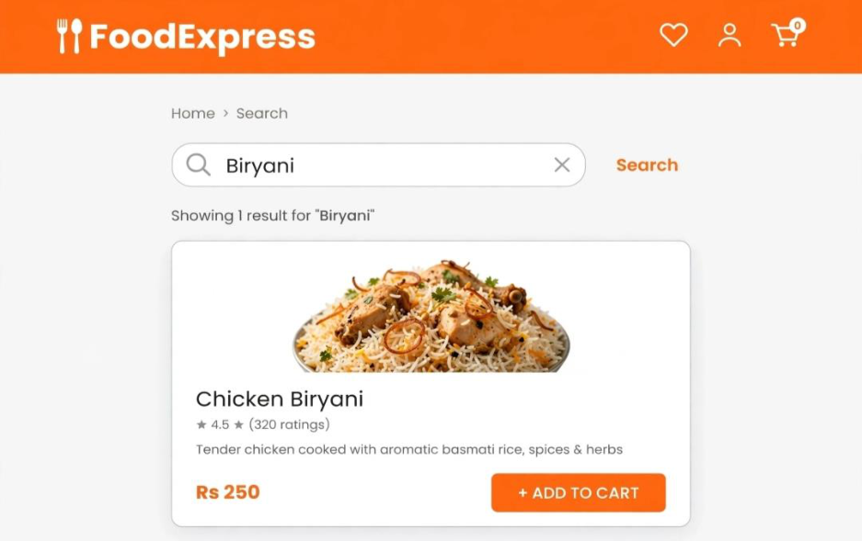

Display.textContent = count;
});
</script>
</body>
</html>
4.OUTPUT SCREENSHOT:
The following are the screenshot that represent the working portal
and its features
Screenshot 1 - Home Page - Display Food Dynamically

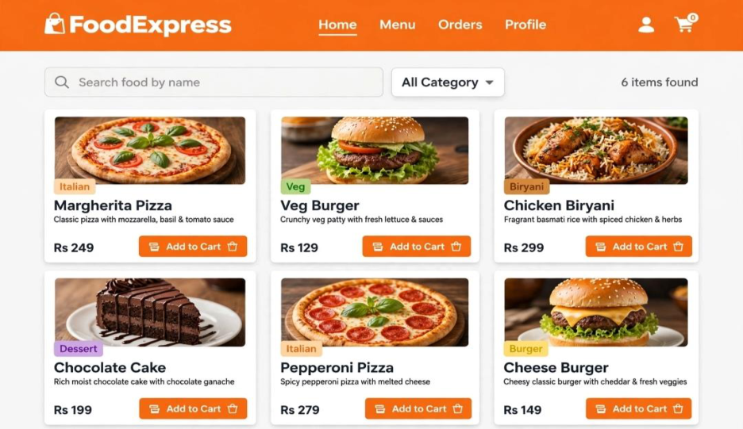
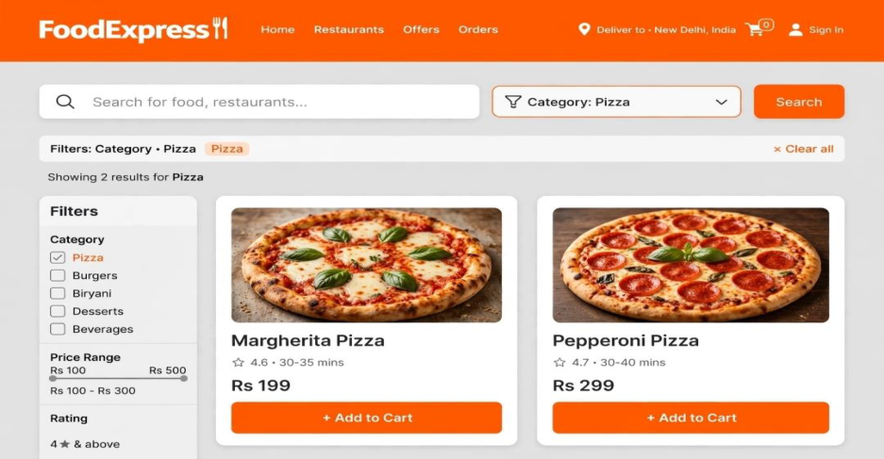

Screenshot 2 – Filter by Category (Pizza)
Screenshot 3 – Search by Name

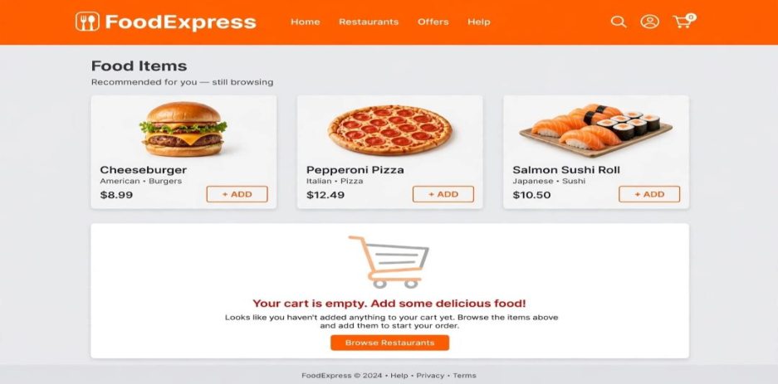
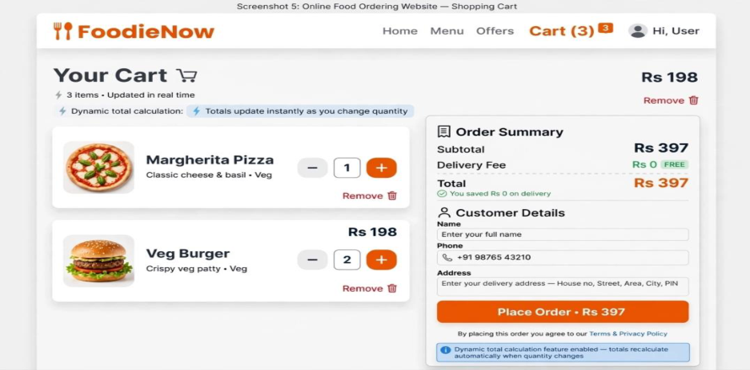

Screenshot 4 – Cart Empty Message
Screenshot 5 – Cart with Quantity + Total
Calculation + Order Summary + Customer Validation

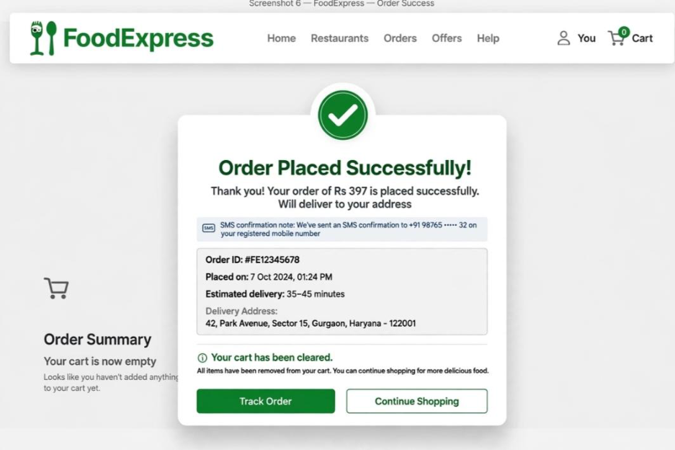

Screenshot 6 – Order Submitted
Successfully
5. Technical Explanation
HTML
1.Creates the structure of the website.
2.Organizes headings, links, sections and content.
CSS
1.Gives style and layout to the website.

2.Makes the page attractive and responsive.
JavaScript
1.Adds interactive features.
2.Helps with search and filtering transport information.
7. Conclusion
The Online Food Ordering Website makes food selection and
ordering easy. It allows customers to search for food, manage their
shopping cart, and calculate the total price. HTML, CSS, and
JavaScript are used to create an interactive website.
8. Future Enhancements
1.Add online payment facilities.
2.Provide real-time order tracking.
3.Add customer login and registration.
4.Send order confirmation notifications.
5.Connect the website to a database.

